2 October 2019

General government debt decreased

Government deficit and debt – the second quarter of 2019

In the Q2 2019, the general government sector balance reached the surplus of CZK 27.2 billion, which corresponds to 1.92% of the GDP. Revenues of the general government sector reached 42.8% of the GDP, while expenditure amounted to 40.9% of the GDP. The government debt ratio declined by 2.15 percentage points (p. p.), year-on-year (y-o-y), to 33.11% of the GDP.

In the Q2 2019, the general government sector balance decreased by CZK 16.5 bn, y-o-y. The central government balance got worse by CZK 20.1 billion, y-o-y, and reached the deficit of CZK 5.9 billion, while local government performance ended up with the surplus of CZK 28.2 bn, which was higher by CZK 3.7 bn, y-o-y. Social security funds performance remained unchanged, y-o-y, and reached the surplus of CZK 4.8 billion.

The general government sector balance, Q2 2017 – Q2 2019
Period | Q2 2017 | Q3 2017 | Q4 2017 | Q1 2018 | Q2 2018 | Q3 2018 | Q4 2018 | Q1 2019 | Q2 2019
CZK bn | 41.9 | 33.1 | 1.3 | 3.4 | 43.7 | 18.5 | −7.2 | −1.9 | 27.2
% of GDP | 3.31 | 2.57 | 0.10 | 0.27 | 3.28 | 1.37 | −0.51 | −0.15 | 1.92
Note: Data in the table are not seasonally adjusted and cannot be compared quarter-on-quarter.

The total general government sector revenues increased by 5.4%, y-o-y. Especially the following contributed to the y-o-y increase in revenues: increase of taxes on income (+9.0% to CZK 124.0 bn), growth of revenues from received social contributions (+8.0% to CZK 226.0 bn), and of taxes on production and imports (+5.1% to CZK 175.0 bn). On the contrary, a decrease in revenues was in property income (−18.2% to CZK 15.7 bn) and current transfers (−10% to CZK 11.4 bn). The total government expenditure increased by 9.0%, y-o-y. The following contributed the most to the expenditure growth: increase of capital transfers (+36.8% to CZK 13.7 bn), of compensation of employees (+10.6% to CZK 139.6 bn), and of investment expenditure (+9.6% to CZK 56.5 bn).

The government debt ratio decreased from 35.26% to 33.11% of the GDP in the year-on-year comparison. The increasing nominal GDP contributed to a decrease in indebtedness by 1.93 p. p. The nominal debt of the general government decreased by CZK 11.8 bn to CZK 1 817.1 bn, y-o-y, and thus its contribution to the decrease of the debt ratio amounted to 0.22 p. p. In the quarter-on-quarter comparison, the debt ratio decreased by 0.86 p. p., which was contributed to by the increasing nominal GDP (0.51 p. p.) as well as by the decreasing debt (0.35 p. p.), which dropped by CZK 19.1 bn.

Regarding the debt structure, the y-o-y decrease of the debt was caused by a decrease in the volume of received deposits (CZK −3.8 bn) and of received loans (CZK −36.7 bn). On the contrary, the value of issued debt securities increased by 1.8%. The volume of short-term securities dropped by CZK 72.6 bn, while the value of long-term securities increased by CZK 101.3 bn. In the q-o-q comparison, there was an increase of received loans by CZK 1.4 bn, while other debt components decreased. Issued debt securities with the share of 91.5% remain to be the main instrument.

Debt of the general government sector, Q2 2017 – Q2 2019

The general government sector balance after seasonal adjustment as well as adjustment for calendar effects ended up with a surplus of CZK 7.3 bn, which is 0.52% of the GDP. In the q-o-q comparison, the adjusted surplus dropped by CZK 7.3 bn. The development of the general government sector balance adjusted by seasonal and calendar effects is shown in the chart below.

Seasonally adjusted general government sector balance, Q2 2017 – Q2 2019
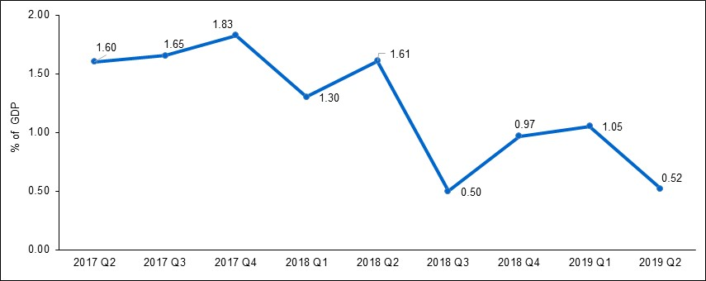

Notes:

Quantification of fiscal indicators of government deficit and debt mentioned above is based on the ESA2010 methodology. Data published in this release are methodologically consistent with the data used for the statistics of the excessive deficit procedure (EDP) purposes and for the assessment of how Maastricht convergence criteria are met.

The government surplus/deficit is represented by the item B.9 “net borrowing (−) or net lending (+)” in the system of national accounts. It refers to the ability of the general government sector to finance other sectors of the economy (+) or the need of the general government sector to be financed (−) by other sectors of the economy in the given period.

The general government debt is the amount of consolidated liabilities of the general government sector comprising the following items: currency and deposits, debt securities, and loans. In case of foreign exchange debt instruments hedged against the currency risk, the value in CZK is obtained by means of the contractual exchange rate.

The general government sector balance is compared with the amount of the GDP in the given quarter at current prices. The amount of consolidated general government debt is compared with the sum of quarterly GDP for the last four quarters at current prices. Fiscal indicators of quarterly government deficit and debt are published within the Transmission programme (Table 25 and Table 28) on the website www.czso.cz in the “GDP, National Accounts” section.
(http://apl.czso.cz/pll/rocenka/rocenka.indexnu_gov?mylang=EN)

Unless otherwise stated, data are not seasonally adjusted as well as they are not adjusted for calendar effects.

Responsible head at the CZSO: | Petr Musil, Director of the Government and Financial Accounts Department, phone number: (+420) 274 052 308, e-mail: petr.musil@czso.cz
Contact person: | Jaroslav Kahoun, Head of Government Accounts Unit, phone number: (+420) 274 054 232, e-mail: jaroslav.kahoun@czso.cz
Next News Release will be published on: | 14 January 2020

