14 January 2019

Surplus as well as indebtedness decreased

Government deficit and debt – the third quarter of 2018

In Q3 2018, the general government sector balance reached the surplus of CZK 21.0 billion; expressed as a percentage of GDP, the surplus corresponds to 1.55% of GDP. Income of the general government sector reached 40.9% of GDP, while expenditure amounted to 39.3% of GDP. The indebtedness declined by 1.21 p. p., year-on-year (y-o-y), to 33.90% of GDP.

In Q3 2018 the general government sector balance decrease by CZK 11.6 bn compared to the same period of the previous year, which was contributed to mainly local government. The local government sector balance declined by CZK 11.2 bn to CZK -5.6. bn due the increase in current and capital expenditure. The central government sector balance (-0.6 bn to 20.0 bn) as well as social security fund (+0.2 bn to 6.6 bn) remained stable.

The general government sector balance, Q3 2016 – Q3 2018
Period | 2016 Q3 | 2016 Q4 | 2017 Q1 | 2017 Q2 | 2017 Q3 | 2017 Q4 | 2018 Q1 | 2018 Q2 | 2018 Q3
CZK bn | 25.9 | -18.6 | 2.4 | 41.9 | 32.5 | 1.4 | 8.1 | 43.5 | 21.0
% of GDP | 2.14 | -1.50 | 0.20 | 3.31 | 2.52 | 0.11 | 0.66 | 3.27 | 1.55
Note: Data in the table are not seasonally adjusted and cannot be compared quarter-on-quarter.

The total government revenues increased by 9.0% compared to the same period of the previous year. Especially the following contributed to the y-o-y increase in revenues: growth of revenues from received social contributions (+9.0% to CZK 205.3 bn), taxes on income (+9.3% to CZK 102.3 bn), capital transfers (+69.3% to CZK 11.4 bn), current transfers (+9.4% to CZK 11.6 bn), and property income (+70.8% to CZK 5.5 bn). The total government expenditure increased by 12.1%, y-o-y. The following contributed the most to the expenditure growth: increase of the volume of investment expenditure (+38.6% to CZK 60.0 bn), compensation of employees (+13.6% to CZK 128.1 bn) and intermediate consumption (+12.6% to CZK 77.2 bn).

The government debt ratio decreased from 35.11% to 33.90% of GDP in the year-on-year comparison. The increasing nominal GDP contributed to a decrease in indebtedness by 1.92 p. p. The nominal debt of the general government increased by 37.2 bn to 1 776.5 bn and its contribution amounted to +0.71 p. p. In the quarter-on-quarter comparison, the debt ratio decreased by 1.37 p. p. The development of the nominal amount of the debt contributed to a decrease by 0.98 p. p., while the influence of the increasing GDP was 0.39 p. p.

Regarding the structure of debt the y-o-y increase was caused by received loans (+29.8%) as well as by issued debt securities (+0.2%), which remain to be the main instrument with the share of 89.5% in the total debt. A quarter-on-quarter decrease was observed as for all components of the debt; emitted debt securities decreased by 2.6% and received loans by 1.5%.

Debt of the general government sector, Q3 2016 – Q3 2018
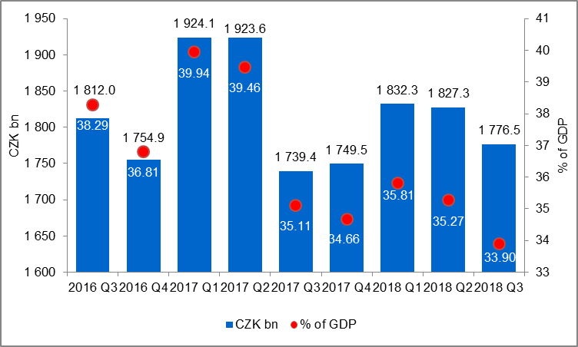

Notes:
Indicators of government deficit and debt mentioned above are based on the methodology ESA2010 and the Manual on government deficit and debt. Quarterly indicators published in this release are methodologically consistent with the annual indicators used for the Excessive deficit procedure (EDP) purposes and for the assessment of how Maastricht convergence criteria are met.

Government surplus/deficit is represented by the item B.9 “net borrowing (-) or net lending (+)” in national accounts. It refers to the ability of general government sector to finance other sectors (+) or the need of general government sector to be financed (-) by other economic sectors. Deficit is compared with nominal GDP in given quarter.

General government debt is defined as sum of the items Currency and deposits, Debt securities and Loans. General government debt at the end of a given quarter is compared with the sum of nominal GDP in four previous quarters.

Fiscal indicators of quarterly government deficit and debt are regularly published within the Transmission programme (table 25, table 28) on the web www.czso.cz in the section “GDP, National Accounts” (http://apl.czso.cz/pll/rocenka/rocenka.indexnu_gov?mylang=EN)

Responsible head at the CZSO: | Petr Musil, Director of the Government and Financial Accounts Department, phone number: (+420) 274 052 308, e-mail: petr.musil@czso.cz
Contact person: | Jaroslav Kahoun, Head of Government Accounts Unit, phone number: (+420) 274 054 232, e-mail: jaroslav.kahoun@czso.cz
Next News Release will be published on: | 3 April 2019

