March 25, 2024

Overall economy confidence increases in March

Business cycle survey – March 2024
The composite confidence indicator (economic sentiment indicator), in the basic index form – increased by 3.6 points to a value of 94.2, m-o-m, reflecting different developments in its components. The business confidence indicator rises by 3.1 points to a value of 93.0, and the consumer confidence indicator increased by 5.9 points to a value of 99.9.

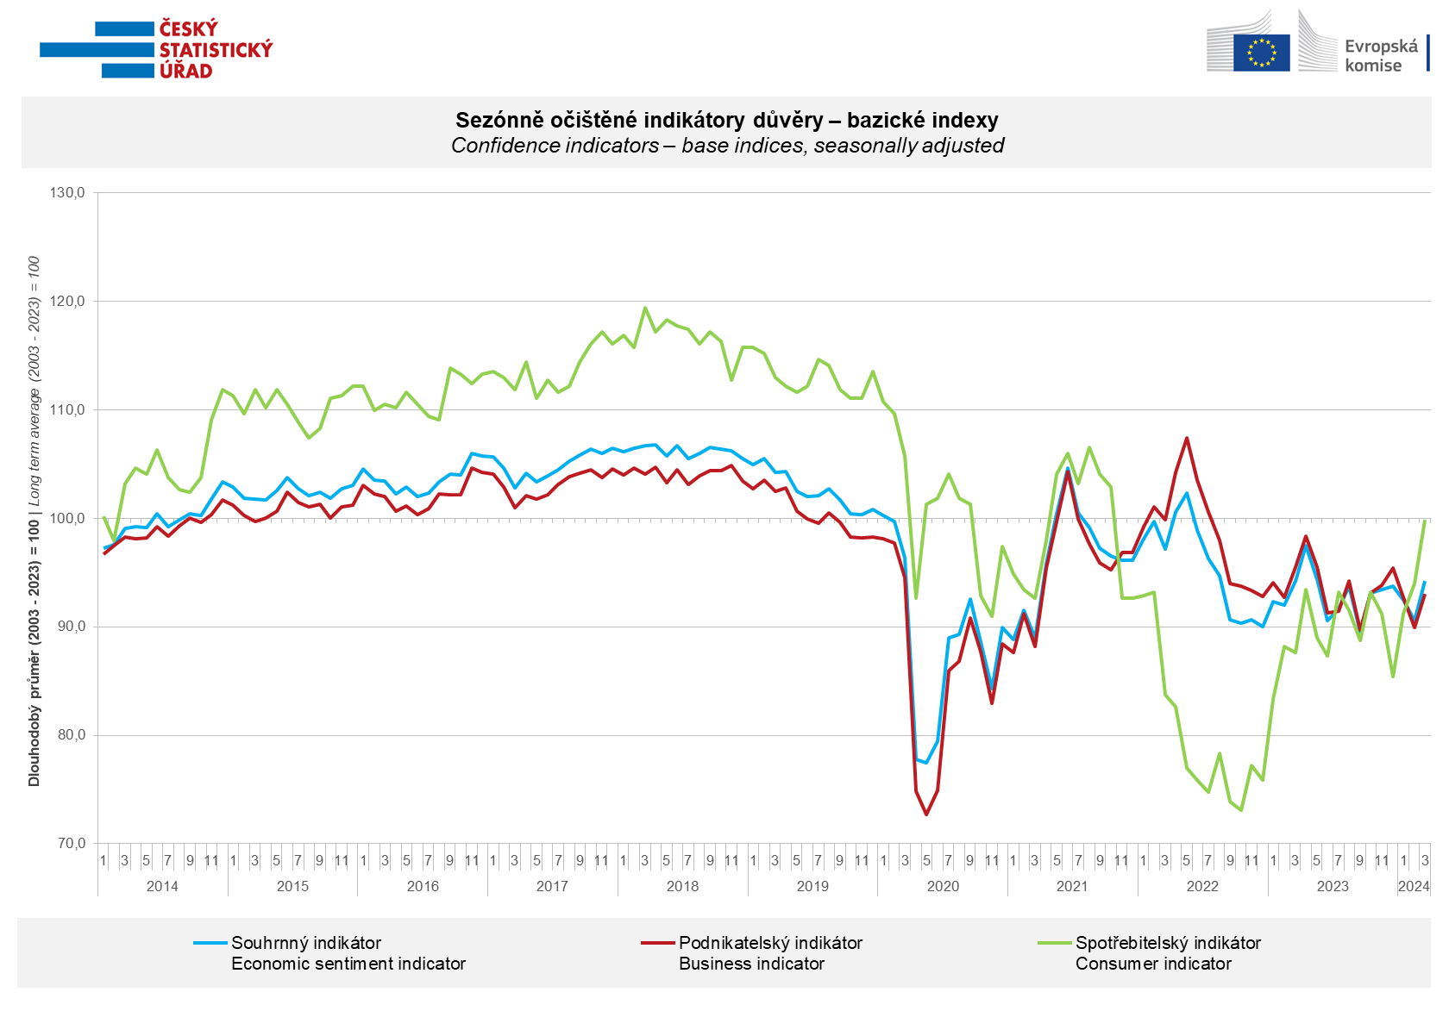

Confidence in the economy among entrepreneurs increased in the industry (+3.7 points), in the trade (+4.9 points) and the selected services sector (+ 3.1 points) in March. The decrease is monitored in the construction sector by 4.8 points.

Consumer confidence increased for the third time in a row. The confidence indicator rose by 5.9 points to a value of 99.9. The number of respondents expecting a deterioration in the overall economic situation in the next twelve months decreased compared to February. The number of consumers assessing their current financial situation worse than in the previous twelve months has unchanged. The number of respondents expecting a deterioration in their financial situation in the next twelve months significantly increased. The share of consumers who believe that the current time is not suitable for making major purchases has not changed compared to the previous month.

***
More detailed information on the development of business and consumer confidence can be found in the supplementary information to the RI business surveys.

***
In January 2024, we change the base to calculate the basis index in a news release by the Czech Statistical Office. For 2024, we calculate the long-term average from January 2003 to December 2023. The long-term average is changed one a year in news release publication data in January.

Notes:

Responsible manager: Juraj Lojka, Director of Business Statistics Coordination and Business Cycle Surveys Department, tel. +420731439291, e-mail: juraj.lojka@czso.cz
Contact person: Jiri Obst, Head of Business Cycle Surveys Unit, tel. +420604815440, e-mail: jiri.obst@czso.cz
Data source: CZSO business survey, Data Collect consumer survey (https://www.datacollect.cz)
Data collection date: Business part: March 18, 2024
Consumer part: March 15, 2024
Next News Release: April 24, 2024

This press release wasn´t edited for language.

Detailed time series of Balances and basic
indices of confidence indicators: https://www.czso.cz/csu/czso/kpr_ts
Business and Consumers Surveys are co-financed by grant agreements of the European Commission DG ECFIN.
https://ec.europa.eu/info/business-economy-euro/indicators-statistics/economic-databases/business-and-consumer-surveys_en
Link to European database: https://ec.europa.eu/eurostat/web/euro-indicators/database

Annex:
Additional information to NR Business cycle survey
Table Confidence Indicators – basic indices
Graph 1 Confidence indicators – base indices, seasonally adjusted (2003–2024)
Graph 2.1 Confidence Indicators for industry, construction, trade, and in selected services – base indices, seasonally adjusted (2003–2024)
Graph 2.2 Balances of seasonally adjusted confidence indicators for industry, construction, trade, and in selected services (2003–2024)
Graph 3 Economic Sentiment Indicators – international comparison, seasonally adjusted (2007-2024)

