January 24, 2024

Consumer trust increased at the beginning of the year, while business trust declined
Business cycle survey – January 2024
The composite confidence indicator (economic sentiment indicator), in the basic index form – decreased by 1.3 points to a value of 92.5 m-o-m, reflecting different developments in its components. The business confidence indicator declined by 2.8 points to a value of 92.7, and the consumer confidence indicator increased by 5.8 points to a value of 91.2.

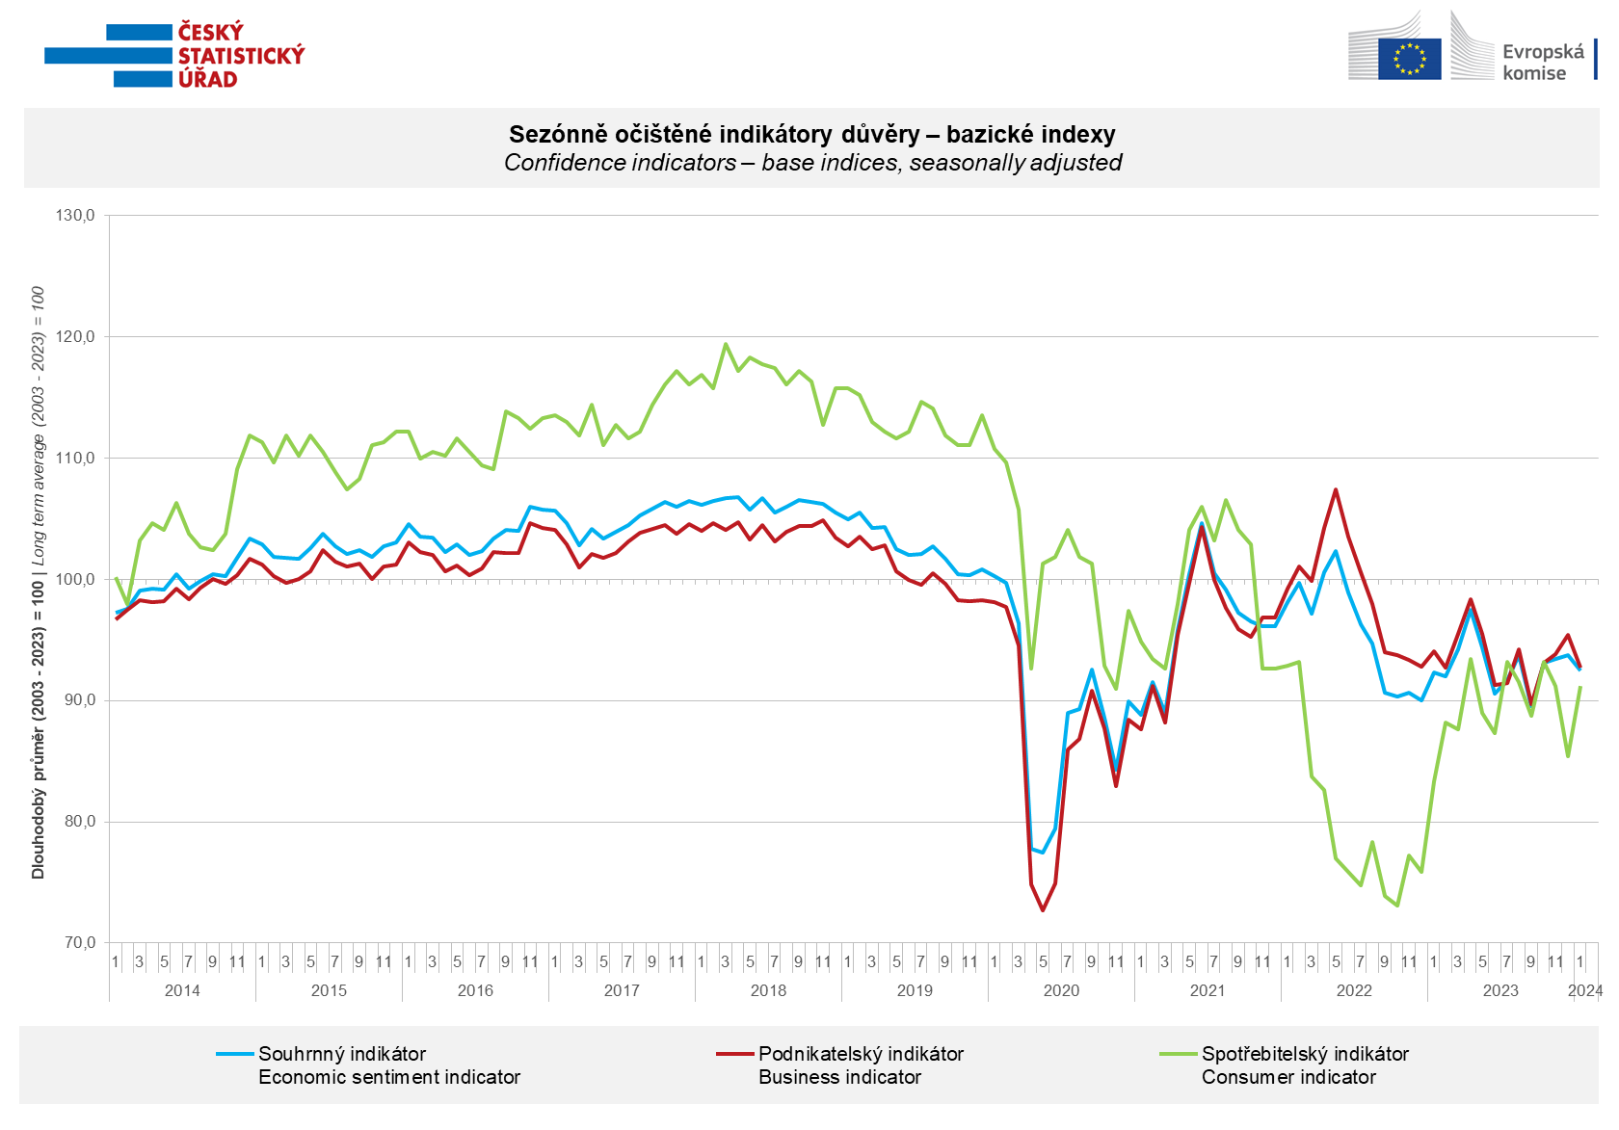

Confidence in the economy among entrepreneurs increased only in the construction industry in January (+7.8 points). In all other monitored sectors, it decreased; in the industry by 5.5 points, in trade by 0.3 points, and in selected services by 1.3 points.

Consumer confidence in the economy increased m-o-m and returned to its November value (91.2). The number of respondents expecting a worsening of the overall economic situation in the next twelve months significantly decreased compared to December. Also, the number of households assessing their current financial situation worse than in the previous twelve months decreased, along with the number of respondents expecting their financial situation to worsen in the next twelve months. The proportion of consumers who believe that the current time is not suitable for making major purchases has slightly decreased.
***
More detailed information on the development of business and consumer confidence can be found in the supplementary information to the RI business surveys.

***
In January 2024, we change the base to calculate the basis index in a news release by the Czech Statistical Office. For 2024, we calculate the long-term average from January 2003 to December 2023. The long-term average is changed one a year in news release publication data in January.

Notes:

Responsible manager: Juraj Lojka, Director of Business Statistics Coordination and Business Cycle Surveys Department, tel. +420731439291, e-mail: juraj.lojka@czso.cz
Contact person: Jiri Obst, Head of Business Cycle Surveys Unit, tel. +420604815440, e-mail: jiri.obst@czso.cz
Data source: CZSO business survey, Data Collect consumer survey (https://www.datacollect.cz)
Data collection date: Business part: January 18, 2024
Consumer part: January 15, 2024
Next News Release: February 23, 2024

This press release wasn´t edited for language.

Detailed time series of Balances and basic
indices of confidence indicators: https://www.czso.cz/csu/czso/kpr_ts
Business and Consumers Surveys are co-financed by grant agreements of the European Commission DG ECFIN.
https://ec.europa.eu/info/business-economy-euro/indicators-statistics/economic-databases/business-and-consumer-surveys_en
Link to European database: https://ec.europa.eu/eurostat/web/euro-indicators/database

Annex:
Additional information to NR Business cycle survey
Table Confidence Indicators – basic indices
Graph 1 Confidence indicators – base indices, seasonally adjusted (2003–2024)
Graph 2.1 Confidence Indicators for industry, construction, trade, and in selected services – base indices, seasonally adjusted (2003–2024)
Graph 2.2 Balances of seasonally adjusted confidence indicators for industry, construction, trade, and in selected services (2003–2024)
Graph 3 Economic Sentiment Indicators – international comparison, seasonally adjusted (2007-2024)
Graph 4 Production Capacity Utilisation in Manufacturing Industry (2003-2024)
Graph 5 Limits of Production in Industry (2005-2024)
Graph 6 Limits of Production in Construction (2005-2024)
Graph 7 Limits of Production in Selected Services (2005-2024)

