20 March 2024

Population of the Czech Republic exceeded 10.9 million

Population change – year 2023
The population of the Czech Republic increased from less than 10.83 million to 10.90 million in 2023. The net migration reached 94.7 thousand, but the balance of the natural change contributed to the population decrease by 21.6 thousand. The number of marriages and live births fell by more than 10% year-on-year; and there were also fewer deaths and slightly fewer divorces.
According to the population balance, the population of the Czech Republic increased by 73.0 thousand in 2023 and the population stood at almost 10,901 thousand at the end of the year. “The population growth was due to the positive net migration in 2023, which amounted to 95 thousand. There were 141.3 thousand people immigrated from abroad to the Czech Republic; by 60% fewer than in 2022. This drop mainly resulted from a more moderate influx of refugees from Ukraine. On the other hand, there were 46.6 thousand people with terminated stay in the Czech Republic in 2023. Also here, the significant part of migrants were people granted temporary protection”, says Michaela Němečková from the Demographic Statistics Unit of the Czech Statistical Office. The number of emigrants was more than doubled year-on-year. As a result of natural change, the population of the Czech Republic decreased by 21.6 thousand, by 2.7 thousand more than in 2022.
The number of live births decreased year-on-year by 10.2 thousand, or 10%, to 91.1 thousand. The 2023 generation was the least numerous in the last 22-year-period. A similar decline could be expected for the total fertility rate. The number of deaths in 2023 fell by 7.4 thousand, or 6%, year-on-year to 112.8 thousand.
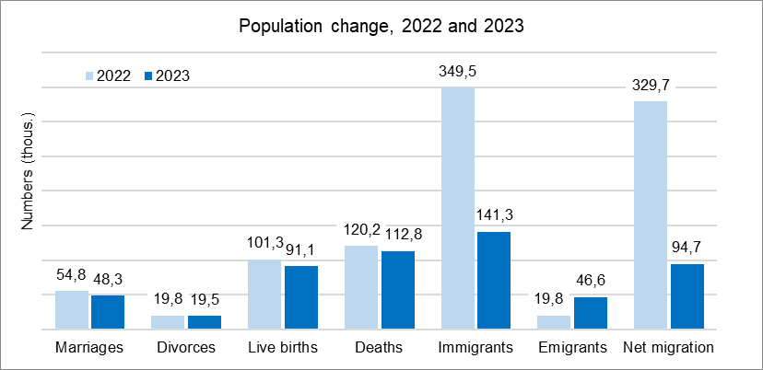
A total of 48.3 thousand couples entered into marriage in 2023. It was by 6.6 thousand, or 12%, fewer than in 2022. The number of divorces was 19.5 thousand, by 0.4 thousand fewer compared to 2022. The proportion of marriages terminated in divorce slightly decreased by almost 1 p. p. to 37%, while the average duration of marriage at divorce of 13.5 years remained the same as a year earlier.
On March 21, 2024, the Population change, 2022 and 2023, chart was updated due to an inaccurate label of the number of divorces in 2022. The correct value is 19.8 (thousand).
Notes:
All data refer to citizens of the Czech Republic and foreigners with permanent residence in the Czech Republic, third-country nationals with temporary residence in the territory of the Czech Republic based on a long-term visa (over 90 days) or a permanent residence permit, nationals of the EU Member States, Norway, Switzerland, Iceland, Liechtenstein and their dependants with notified temporary residence in the territory of the Czech Republic and foreigners with valid asylum status in the Czech Republic. Since 2022, the population includes persons granted temporary protection in the Czech Republic with usual residence in the Czech Republic. The data contain also information on events (marriages, births, and deaths) of Czech citizens with the permanent residence in the Czech Republic that occurred abroad and were registered by the special registry office in Brno.
All data for 2023 are preliminary.

Responsible manager: Mgr. Robert Šanda, director of Population Statistics Department,
tel. +420 274 052 160, e-mail: robert.sanda@czso.cz
Contact person: Mgr. Michaela Němečková, Demographic Statistics Unit,
tel. +420 274 052 184, e-mail: michaela.nemeckova@czso.cz
Data source: Demographic statistics – results of processing statistical reports of Obyv series
Divorces – Information system of the Ministry of Justice of the CR
Migration data – Information System of Inhabitants Records (Ministry of the Interior of the CR) and Alien Information System (Directorate of Alien Police)
End of data collection: 15 March 2024
Related publication: 130062-22 Population of the Czech Republic – year 2023
https://www.czso.cz/current-product/41180
Related time series: https://www.czso.cz/csu/czso/oby_ts
Next News Release: 28 June 2024

Annexes:
Tab. 1 Population (absolute and relative figures, year-to-year changes)
Chart 1 Population, quarterly data (numbers)
Chart 2 Population change, 1st – 4th quarter (numbers)
Chart 3 Live births, quarterly data (numbers)
Chart 4 Deaths, quarterly data (numbers)
Chart 5 Marriages, quarterly data (numbers)
Chart 6 Divorces, quarterly data (numbers)

