2 April 2024

General government sector balance remained in a deficit in the 4th quarter of 2023

Government deficit and debt – the fourth quarter of 2023
In the Q4 2023, the general government sector balance ended up with a deficit corresponding to 5.6% of the GDP. The government debt ratio decreased by 0.2 percentage point (p. p.), year-on-year (y-o-y), to 44.0% of the GDP.

In the Q4 2023, the general government sector deficit reached CZK 107.4 billion, which means that it worsened by CZK 8.6 billion in the year-on-year comparison. The central government ended up with a deficit of CZK 79.3 billion that increased by CZK 12.3 billion, y-o-y. Performance of the local government sector also ended up with a deficit, which reached CZK 17.7 bn and did not change much in the year-on-year comparison. Performance of social security funds (of health insurance companies) also ended up with a deficit of CZK 10.4 bn.

“The general government sector ended up with a deficit of CZK 107.4 billion in the fourth quarter of 2023. Increasing expenditure on social benefits contributed the most to the result. The government debt ratio reached 44.0% of the GDP and decreased by 0.2 p. p., y-o-y,” Helena Houžvičková, Director of the Government and Financial Accounts Department of the Czech Statistical Office (CZSO), stated.

The general government sector balance, Q4 2021 – Q4 2023
Period | Q4 2021 | Q1 2022 | Q2 2022 | Q3 2022 | Q4 2022 | Q1 2023 | Q2 2023 | Q3 2023 | Q4 2023
CZK bn | -96.8 | -63.4 | 2.6 | -55.7 | -98.8 | -108.9 | 18.4 | -41.7 | -107.4
% of the GDP | -6.0 | -4.1 | 0.2 | -3.2 | -5.5 | -6.3 | 1.0 | -2.2 | -5.6
Note: Data in the table are not seasonally adjusted; they cannot be compared quarter-on-quarter.

The total government revenues increased by 9.1%, y-o-y, and reached 42.2% of the GDP. Especially the following contributed to the y-o-y increase in revenues: received taxes on income and received social contributions. The total government expenditure increased by 9.1%, y-o-y, and reached 47.8% of the GDP. Expenditure on social benefits and subsidies increased the most.

The nominal debt of the general government increased by CZK 230.8 bn to CZK 3 228.4 bn. The government debt ratio decreased from 44.2% to 44.0% of the GDP, year-on-year; the influence of the nominal change of the debt was +3.2 p. p., while the increasing nominal GDP contributed to a decrease in indebtedness by –3.4 p. p. In the quarter-on-quarter comparison, the debt increased by CZK 14.3 bn, the nominal change of the debt was 0.2 p. p., whereas an increase in the nominal GDP contributed to a decrease in the indebtedness by –0.6 p. p., which resulted in a decrease in the debt ratio by 0.4 p. p., quarter-on-quarter.

In the fourth quarter of 2023, the quarter-on-quarter change of the debt (the increase by CZK 14.3 bn) was considerably different from the general government sector balance (the deficit of CZK 107.4 bn). The general government sector borrowed by CZK 93.1 bn less than what the general government sector balance was. The government expenditure was financed from assets created in preceding periods.

Regarding the debt structure, mainly issued debt securities increased, year-on-year (CZK +346.2 bn).

Debt of the general government sector, Q4 2021 – Q4 2023
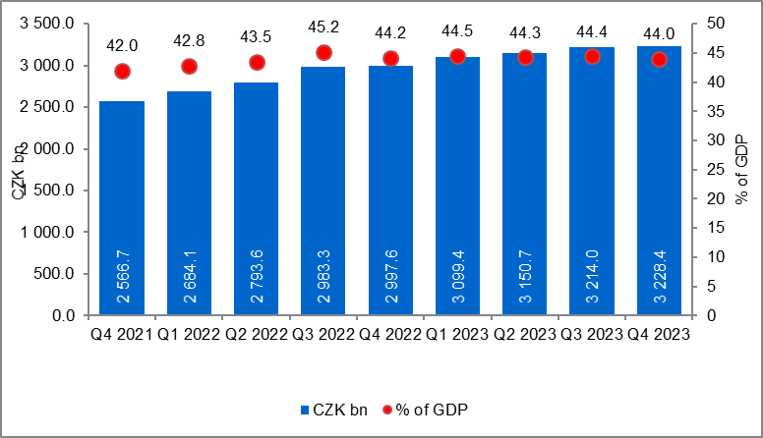
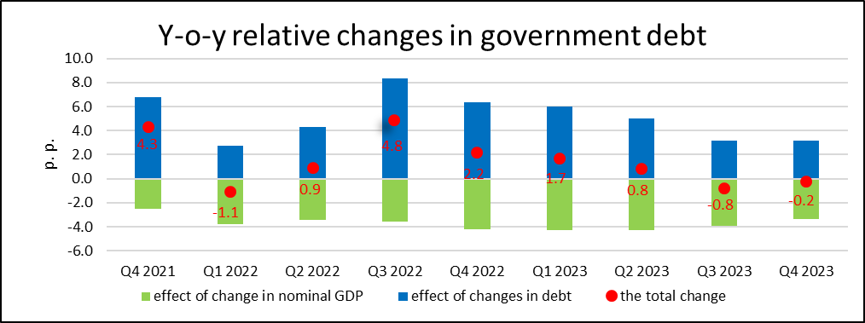

The general government sector balance after seasonal adjustment as well as adjustment for calendar effects ended up with a deficit of CZK 64.1 bn, which corresponded to 3.5% of the GDP. The general government sector balance improved by CZK 0.7 bn, q-o-q. The development of the general government sector balance adjusted by seasonal and calendar effects is shown in the chart below.

Seasonally adjusted general government sector balance, Q4 2021 – Q4 2023
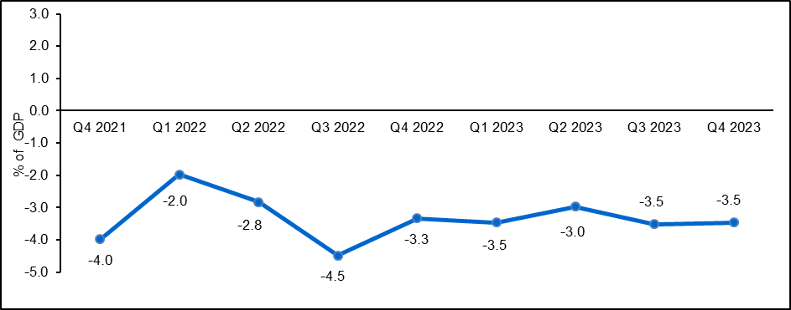
Notes:
Quantification of fiscal indicators of government deficit and debt mentioned above is based on the ESA2010 methodology. Data published in this news release are methodologically consistent with the data used for the statistics of the excessive deficit procedure (EDP) purposes and for the assessment of how Maastricht convergence criteria are met.

The government surplus/deficit is represented by the item B.9 “net borrowing (−) or net lending (+)” in the system of national accounts. It refers to the ability of the general government sector to finance other sectors of the economy (+) or the need of the general government sector to be financed (−) by other sectors of the economy in the given period.

The general government debt is the amount of consolidated liabilities of the general government sector comprising the following items: received deposits, issued debt securities, and received loans. In case of foreign exchange debt instruments hedged against the currency risk, the value in CZK is obtained by means of the contractual exchange rate.

The general government sector balance is compared with the amount of the GDP in the given quarter at current prices. The amount of the consolidated general government debt is compared with the sum of quarterly GDP for the last four quarters at current prices. Fiscal indicators of quarterly government deficit and debt are published within the Transmission programme (Table 25 and Table 28) on the CZSO’s website General government sector in the “GDP, National Accounts” section. Unless otherwise stated, data are not seasonally adjusted as well as they are not adjusted for calendar effects. Time series of seasonally adjusted sector accounts for the government sector (the item of net lending / net borrowing) Time series of seasonally adjusted sector accounts for S.13.

Responsible head at the CZSO: | Helena Houžvičková. Director of the Government and Financial Accounts Department,  phone number: (+420) 704 688 734,  e-mail: helena.houzvickova@czso.cz
Contact person: | Jaroslav Kahoun, Head of the Government Accounts Unit, phone number: (+420) 274 054 232, e-mail: jaroslav.kahoun@czso.cz
The next news release will be published on: | 2 July 2024

