2 October 2023

General government sector balance ended up with a surplus in the Q2 2023

Government deficit and debt – the second quarter of 2023
In the Q2 2023, the general government sector balance ended up with a surplus that corresponded to 1.5% of the GDP. The government debt ratio increased by 0.8 percentage point (p. p.), year-on-year (y-o-y), to 44.3% of the GDP.

In the Q2 2023, the general government sector balance reached the surplus of CZK 26.9 bn, which is an improvement by CZK 24.7 bn, compared to the corresponding period of the previous year. The balance of the central government continued to remain in the deficit of CZK 25.1 bn, which improved by CZK 46.8 bn, y-o-y. The local government sector ended up with the surplus of CZK 50.7 bn; however, its performance worsened by CZK 16.0 bn, y-o-y. Social security funds (of health insurance companies) performance ended up with the surplus of CZK 1.3 bn.

“In the Q2 2023, the general government sector balance ended up with the surplus of CZK 26.9 billion. In the year-on-year comparison, on the income side, received property income and taxes on income increased the most. The debt ratio of the general government sector increased by 0.8 percentage point, year-on-year, and reached 44.3% of the GDP,” Helena Houžvičková, Director of the Government and Financial Accounts Department of the Czech Statistical Office (CZSO), stated.

The general government sector balance, Q2 2021 – Q2 2023
Period | Q2 2021 | Q3 2021 | Q4 2021 | Q1 2022 | Q2 2022 | Q3 2022 | Q4 2022 | Q1 2023 | Q2 2023
CZK bn | -40.1 | -42.7 | -96.8 | -63.8 | 2.2 | -56.1 | -100.2 | -105.3 | 26.9
% of the GDP | -2.6 | -2.7 | -6.0 | -4.1 | 0.1 | -3.2 | -5.6 | -6.1 | 1.5
Note: Data in the table are not seasonally adjusted and cannot be compared quarter-on-quarter.

The total revenues of the general government sector increased by 13.2%, compared to the corresponding period of the previous year, and reached 45.8% of the GDP. Especially the following contributed to the y-o-y increase in revenues: an increase of revenues from property income and from taxes on income. The total government expenditure increased by 9.9%, y-o-y, and reached 44.3% of the GDP. Expenditure on social benefits and on compensation of employees increased the most.

The nominal general government debt increased, year-on-year, by CZK 357.0 bn to CZK 3 150.7 bn. The government debt ratio increased, year-on-year, from 43.5% to 44.3% of the GDP. The influence of the nominal change of the debt was +5.0 p. p., while the increasing nominal GDP contributed to a decrease in the indebtedness by –4.2 p. p. In the quarter-on-quarter comparison, the debt increased by CZK 51.3 bn, the nominal change of the debt was 0.7 p. p., whereas the increase of the nominal GDP contributed to a decrease of indebtedness by –0.9 p. p., which means that the debt ratio decreased, quarter-on-quarter, by –0.2 p. p.

In the Q2 2023, the change in the debt (an increase by CZK 51.3 bn) was considerably different from the general government sector balance (the surplus of CZK 26.9 bn). The general government sector borrowed by CZK 51.3 bn more despite it ended up with the surplus, which resulted in an increase of the value of assets held, especially of deposits

Regarding the debt structure, especially the issued debt securities increased, year-on-year (CZK +350.5 bn).

Debt of the general government sector, Q2 2021 – Q2 2023
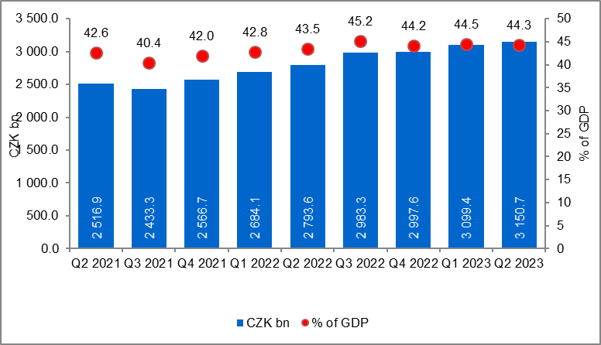
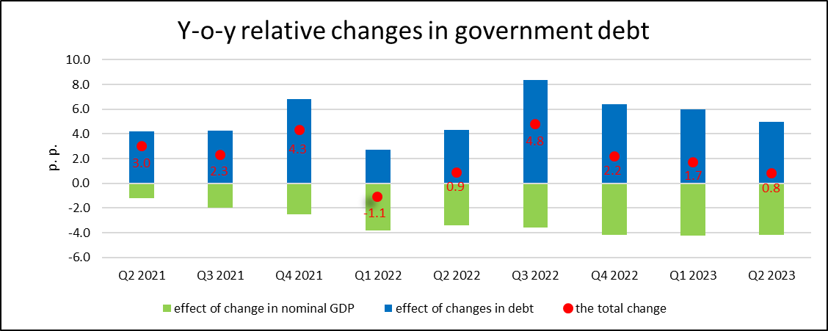

The general government sector balance after seasonal adjustment as well as adjustment for calendar effects ended up with the deficit of CZK 59.8 bn, which corresponded to 3.3% of the GDP. In the q-o-q comparison, the balance improved by CZK 6.5 bn. The development of the general government sector balance adjusted by seasonal and calendar effects is shown in the chart below.

Seasonally adjusted general government sector balance, Q2 2021 – Q2 2023
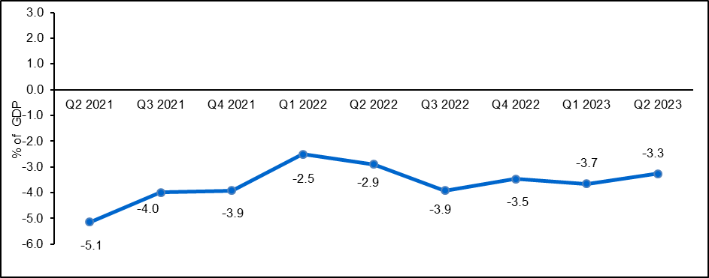
Notes:
Quantification of fiscal indicators of government deficit and debt mentioned above is based on the ESA2010 methodology. Data published in this news release are methodologically consistent with the data used for the statistics of the excessive deficit procedure (EDP) purposes and for the assessment of how Maastricht convergence criteria are met.

The government surplus/deficit is represented by the item B.9 “net borrowing (−) or net lending (+)” in the system of national accounts. It refers to the ability of the general government sector to finance other sectors of the economy (+) or the need of the general government sector to be financed (−) by other sectors of the economy in the given period.

The general government debt is the amount of consolidated liabilities of the general government sector comprising the following items: received deposits, issued debt securities, and received loans. In case of foreign exchange debt instruments hedged against the currency risk, the value in CZK is obtained by means of the contractual exchange rate.

The general government sector balance is compared with the amount of the GDP in the given quarter at current prices. The amount of the consolidated general government debt is compared with the sum of quarterly GDP for the last four quarters at current prices. Fiscal indicators of quarterly government deficit and debt are published within the Transmission programme (Table 25 and Table 28) on the CZSO’s website General government sector in the “GDP, National Accounts” section. Unless otherwise stated, data are not seasonally adjusted as well as they are not adjusted for calendar effects. Time series of seasonally adjusted sector accounts for the government sector (the item of net lending / net borrowing) Time series of seasonally adjusted sector accounts for S.13.

Responsible head at the CZSO: | Helena Houžvičková. Director of the Government and Financial Accounts Department,  phone number: (+420) 704 688 734,  e-mail: helena.houzvickova@czso.cz
Contact person: | Jaroslav Kahoun, Head of the Government Accounts Unit, phone number: (+420) 274 054 232, e-mail: jaroslav.kahoun@czso.cz
The next news release will be published on: | 5 January 2024

