3 July 2023

General government sector balance ended up with a deficit in the 1st quarter of 2023

Government deficit and debt – the first quarter of 2023
In the Q1 2023, the general government sector balance ended up with a deficit corresponding to 5.9% of GDP. The government debt ratio increased by 1.7 percentage point (p. p.), year-on-year (y-o-y), to 44.5% of GDP.

In the Q1 2023, the general government sector deficit reached CZK 100.9 billion (bn), which was by CZK 31.9 bn worse result, year-on-year. Only the central government sector ended up with a deficit of CZK 136.6 billion, the balance of which slumped by CZK 59.4 bn, year-on-year. On the other hand, the local government sector balance ended up with a surplus of CZK 35.0 bn and it improved by CZK 29.9 bn, year-on-year; social security funds (health insurance companies) ended up with a slight surplus of CZK 0.8 bn.

“In the first quarter of 2023, the general government sector ended up with a deficit that amounted to CZK 100.9 bn. This result was the most contributed to by social benefits paid. The government debt ratio increased by 1.7 p. p, year-on-year, and reached the amount that corresponded to 44.5% of GDP,” Helena Houžvičková, Director of the Government and Financial Accounts Department of the Czech Statistical Office (CZSO), stated.

The general government sector balance, Q1 2021 – Q1 2023
Period | Q1 2021 | Q2 2021 | Q3 2021 | Q4 2021 | Q1 2022 | Q2 2022 | Q3 2022 | Q4 2022 | Q1 2023
CZK bn | -131.1 | -40.1 | -42.7 | -96.8 | -69.0 | -8.7 | -66.0 | -103.8 | -100.9
% of GDP | -9.5 | -2.6 | -2.7 | -6.0 | -4.5 | -0.5 | -3.8 | -5.8 | -5.9
Note: Data in the table are not seasonally adjusted and cannot be compared quarter-on-quarter.

The total government revenues increased by 12.6%, y-o-y, and reached 40.6% of GDP. The y-o-y increase in revenues was mainly contributed to by an increase in revenues from received taxes on income, from received social contributions, and taxes on production and imports. The total government expenditure increased by 16.0%, year-on-year, and reached 46.5% of GDP. Expenditure on social benefits, subsidies, and compensation of employees increased the most.

The nominal debt of the general government increased by CZK 415.3 billion to CZK 3 099.4 billion. The government debt ratio increased from 42.8% to 44.5% of GDP, year-on-year; the influence of the nominal change of the debt was +6.0 p. p., while the increasing nominal GDP contributed to a decrease in indebtedness by –4.3 p. p. The debt increased by CZK 102.3 billion, quarter-on-quarter, which means that the debt ratio increased by 0.3 p. p. The increase in the nominal GDP contributed to a decrease in the indebtedness by –1.1 p. p.

Regarding the debt structure, especially the following increased, y-o-y: issued debt securities (CZK +308.4 bn) and received loans (CZK +91.5 bn).

Debt of the general government sector, Q1 2021 – Q1 2023
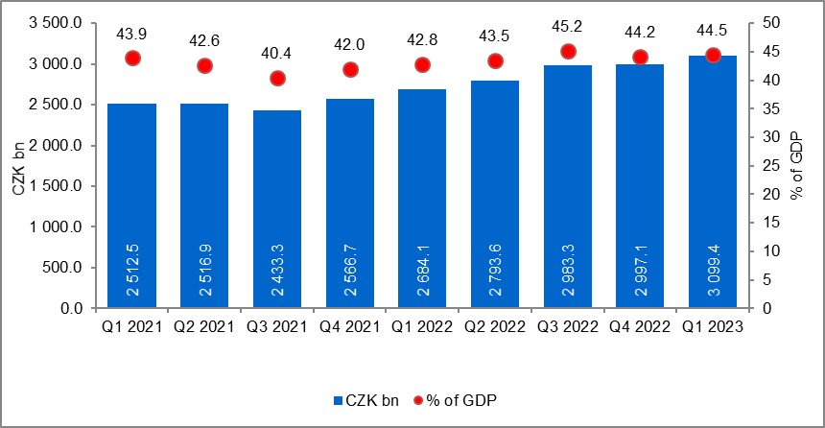

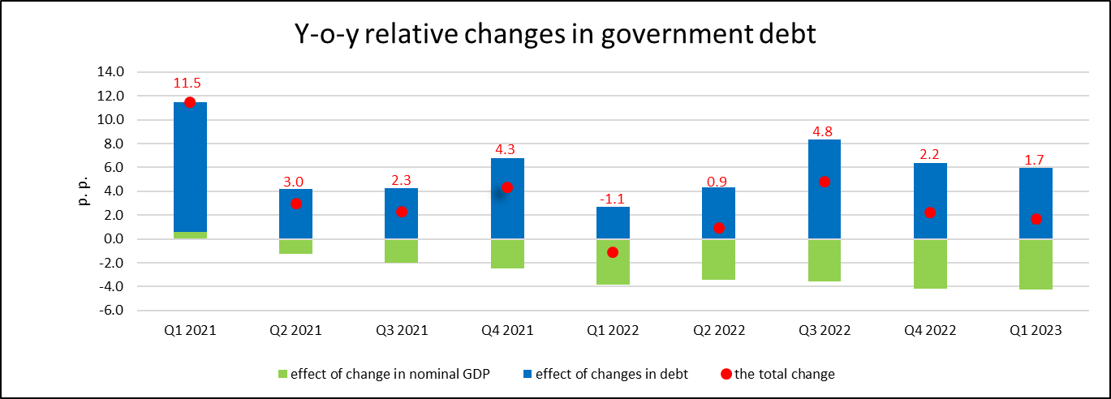

The general government sector balance after seasonal adjustment as well as adjustment for calendar effects ended up with a deficit of CZK 76.7 bn, which corresponded to 4.2% of GDP. The general government sector balance worsened by CZK 4.3 bn, q-o-q. The development of the general government sector balance adjusted by seasonal and calendar effects is shown in the chart below.

Seasonally adjusted general government sector balance, Q1 2021 – Q1 2023
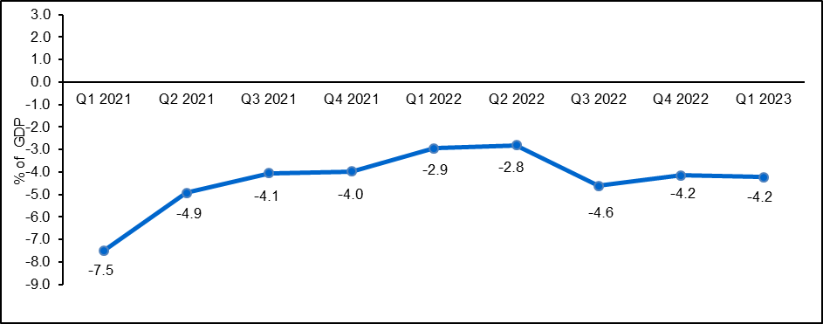
Notes:
Quantification of fiscal indicators of government deficit and debt mentioned above is based on the ESA2010 methodology. Data published in this news release are methodologically consistent with the data used for the statistics of the excessive deficit procedure (EDP) purposes and for the assessment of how Maastricht convergence criteria are met.

The government surplus/deficit is represented by the item B.9 “net borrowing (−) or net lending (+)” in the system of national accounts. It refers to the ability of the general government sector to finance other sectors of the economy (+) or the need of the general government sector to be financed (−) by other sectors of the economy in the given period.

The general government debt is the amount of consolidated liabilities of the general government sector comprising the following items: received deposits, issued debt securities, and received loans. In case of foreign exchange debt instruments hedged against the currency risk, the value in CZK is obtained by means of the contractual exchange rate.

The general government sector balance is compared with the amount of the GDP in the given quarter at current prices. The amount of the consolidated general government debt is compared with the sum of quarterly GDP for the last four quarters at current prices. Fiscal indicators of quarterly government deficit and debt are published within the Transmission programme (Table 25 and Table 28) on the CZSO’s website General government sector in the “GDP, National Accounts” section. Unless otherwise stated, data are not seasonally adjusted as well as they are not adjusted for calendar effects. Time series of seasonally adjusted sector accounts for the government sector (the item of net lending / net borrowing) Time series of seasonally adjusted sector accounts for S.13.

Responsible head at the CZSO: | Helena Houžvičková, Director of the Government and Financial Accounts Department,  phone number: (+420) 704 688 734,  e-mail: helena.houzvickova@czso.cz
Contact person: | Jaroslav Kahoun, Head of the Government Accounts Unit, phone number: (+420) 274 054 232, e-mail: jaroslav.kahoun@czso.cz
The Next News Release will be published on: | 2 October 2023

