June 26, 2023

Overall confidence in the economy fell again

Business cycle survey – June 2023
The composite confidence indicator (economic sentiment indicator) – in the basis index form – decreased by 3.8 points to 90.3 m-o-m, with the same developments of its components. The business confidence indicator decreased by 4.2 percentage points to 91.0 and the consumer confidence indicator decreased by 1.7 points to 86.8.

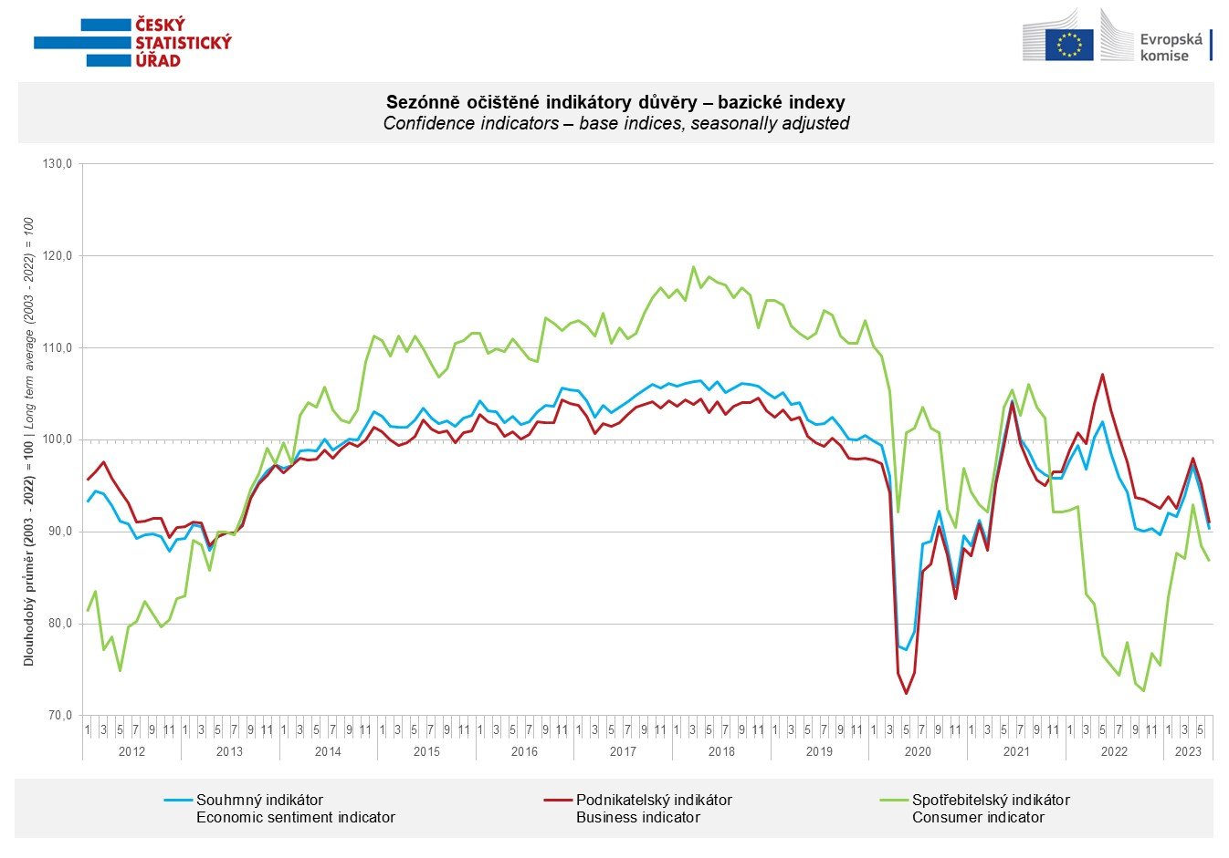

Among entrepreneurs confidence in the economy again decreased significantly in industry (-6.6 points) and to a lesser extent in trade (-4.3 points) and selected services (-2.3 points). Construction is thus the only monitored sector where confidence increased in June (+1.8 points).

Consumer confidence in the economy fell for the second month in a row. The reason was a significant increase in the number of respondents expecting the deterioration of the overall economic situation in the Czech Republic in the next twelve months. The number of households assessing their current financial situation worse compared to the previous twelve months did not change. After a significant increase in May, the number of households who fear a deterioration in their own financial situation in the next twelve months has slightly decreased. The share of respondents who believe that the current time is not suitable for making large purchases did not change m-o-m.

***
More detailed information on the development of business and consumer confidence can be found in the supplementary information to the RI business surveys.

Notes:

Responsible manager: Juraj Lojka, Director of Business Statistics Coordination and Business Cycle Surveys Department, tel. +420731439291, e-mail: juraj.lojka@czso.cz
Contact person: Jiri Obst, Head of Business Cycle Surveys Unit, tel. +420604815440, e-mail: jiri.obst@czso.cz
Data source: CZSO business survey, Data Collect consumer survey (https://www.datacollect.cz)
Data collection date: Business part: June 19, 2023
Consumer part: June 16, 2023
Next News Release: July 24, 2023

This press release wasn´t edited for language.

Detailed time series of Balances and basic
indices of confidence indicators: https://www.czso.cz/csu/czso/kpr_ts
Business and Consumers Surveys are co-financed by grant agreements of the European Commission DG ECFIN.
https://ec.europa.eu/info/business-economy-euro/indicators-statistics/economic-databases/business-and-consumer-surveys_en
Link to European database: https://ec.europa.eu/eurostat/web/euro-indicators/business-and-consumer surveys

Annex:
Additional information to NR Business cycle survey
Table Confidence Indicators – basic indices
Graph 1 Confidence indicators – base indices, seasonally adjusted (2003–2023)
Graph 2.1 Confidence Indicators for industry, construction, trade, and in selected services – base indices, seasonally adjusted (2003–2023)
Graph 2.2 Balances of seasonally adjusted confidence indicators for industry, construction, trade, and in selected services (2003–2023)
Graph 3 Economic Sentiment Indicators – international comparison, seasonally adjusted (2007-2023)

