January 24, 2023

Overall confidence in the economy increased on the threshold of the new year

Business cycle survey – January 2023
The composite confidence indicator (economic sentiment indicator) – in the basis index form – increased by 2.3 points compared to December to 92.0, with the same developments of its components. The business confidence indicator increased by 1.3 percentage points to 93.8 and the consumer confidence indicator increased by 7.4 percentage points to 82.9.

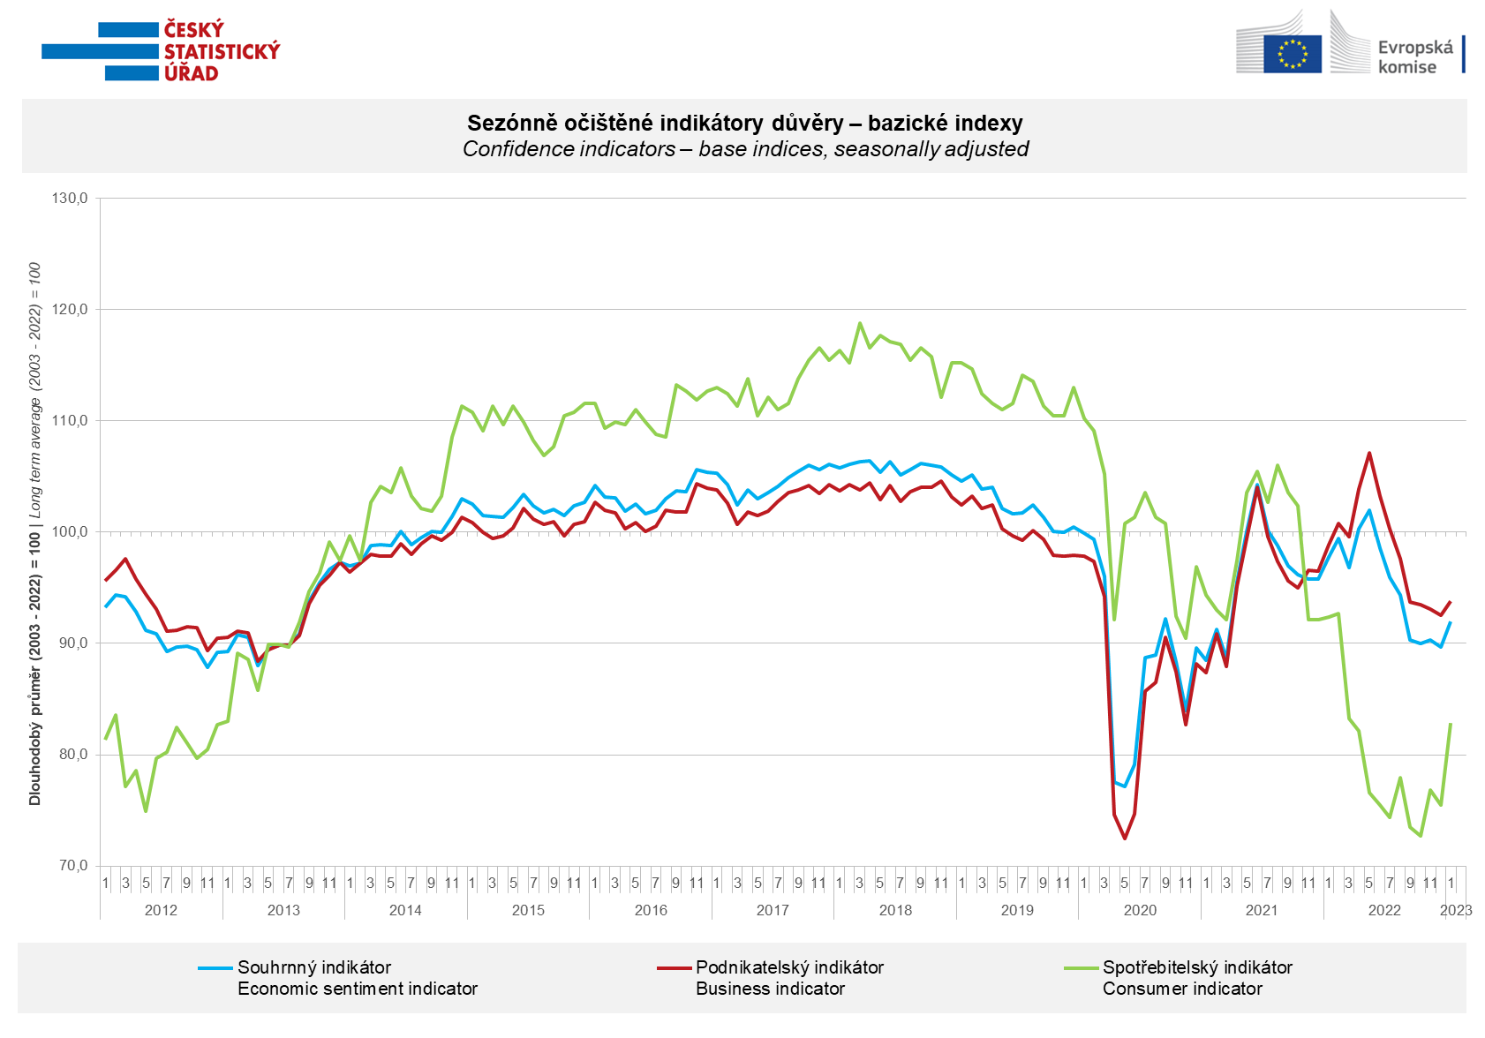

The confidence of entrepreneurs increased in January in the sectors of industry, trade and slightly also in selected sectors of services. In construction, it decreased for the second time in a row.

Confidence in the economy increased significantly among consumers. In January, the number of households assessing their current financial situation as worse than in the previous twelve months decreased m-o-m. Compared to December, also the number of respondents expecting further deterioration in the next 12 months decreased. Compared to last month, households are also less worried about the deterioration of the overall economic situation. In addition, at the beginning of the new year, the share of consumers who believe that the current time is not suitable for making large purchases has decreased.

***
More detailed information on the development of business and consumer confidence can be found in the supplementary information to the RI business surveys.

***
In January 2023, we change the base to calculate the basis index in a news release by the Czech Statistical Office. For 2023, we calculate the long-term average from January 2003 to December 2022. The long-term average is changed one a year in news release publication data in January.

Notes:

Responsible manager: Juraj Lojka, Director of Business Statistics Coordination and Business Cycle Surveys Department, tel. +420731439291, e-mail: juraj.lojka@czso.cz
Contact person: Jiri Obst, Head of Business Cycle Surveys Unit, tel. +420604815440, e-mail: jiri.obst@czso.cz
Data source: CZSO business survey, Data Collect consumer survey (https://www.datacollect.cz)
Data collection date: Business part: January 18, 2023
Consumer part: January 16, 2023
Next News Release: February 24, 2023

This press release wasn´t edited for language.

Detailed time series of Balances and basic
indices of confidence indicators: https://www.czso.cz/csu/czso/kpr_ts
Business and Consumers Surveys are co-financed by grant agreements of the European Commission DG ECFIN.
https://ec.europa.eu/info/business-economy-euro/indicators-statistics/economic-databases/business-and-consumer-surveys_en
Link to European database: https://ec.europa.eu/eurostat/web/euro-indicators/business-and-consumer surveys

Annex:
Additional information to NR Business cycle survey
Table Confidence Indicators – basic indices
Graph 1 Confidence indicators – base indices, seasonally adjusted (2003–2023)
Graph 2.1 Confidence Indicators for industry, construction, trade, and in selected services – base indices, seasonally adjusted (2003–2023)
Graph 2.2 Balances of seasonally adjusted confidence indicators for industry, construction, trade, and in selected services (2003–2023)
Graph 3 Economic Sentiment Indicators – international comparison, seasonally adjusted (2007-2023)
Graph 4 Production Capacity Utilisation in Manufacturing Industry (2003-2023)
Graph 5 Limits of Production in Industry (2005-2023)
Graph 6 Limits of Production in Construction (2005-2023)
Graph 7 Limits of Production in Selected Services (2005-2023)

