March 24, 2023

Overall confidence in the economy increased in March Business cycle survey – March 2023
The composite confidence indicator (economic sentiment indicator) – in the basis index form – increased by 2.2 points compared to February to 93.9, with the different developments of its components. The business confidence indicator increased by 2.7 percentage points to 95.2 and the consumer confidence indicator decreased slightly by 0.6 points to 87.1.
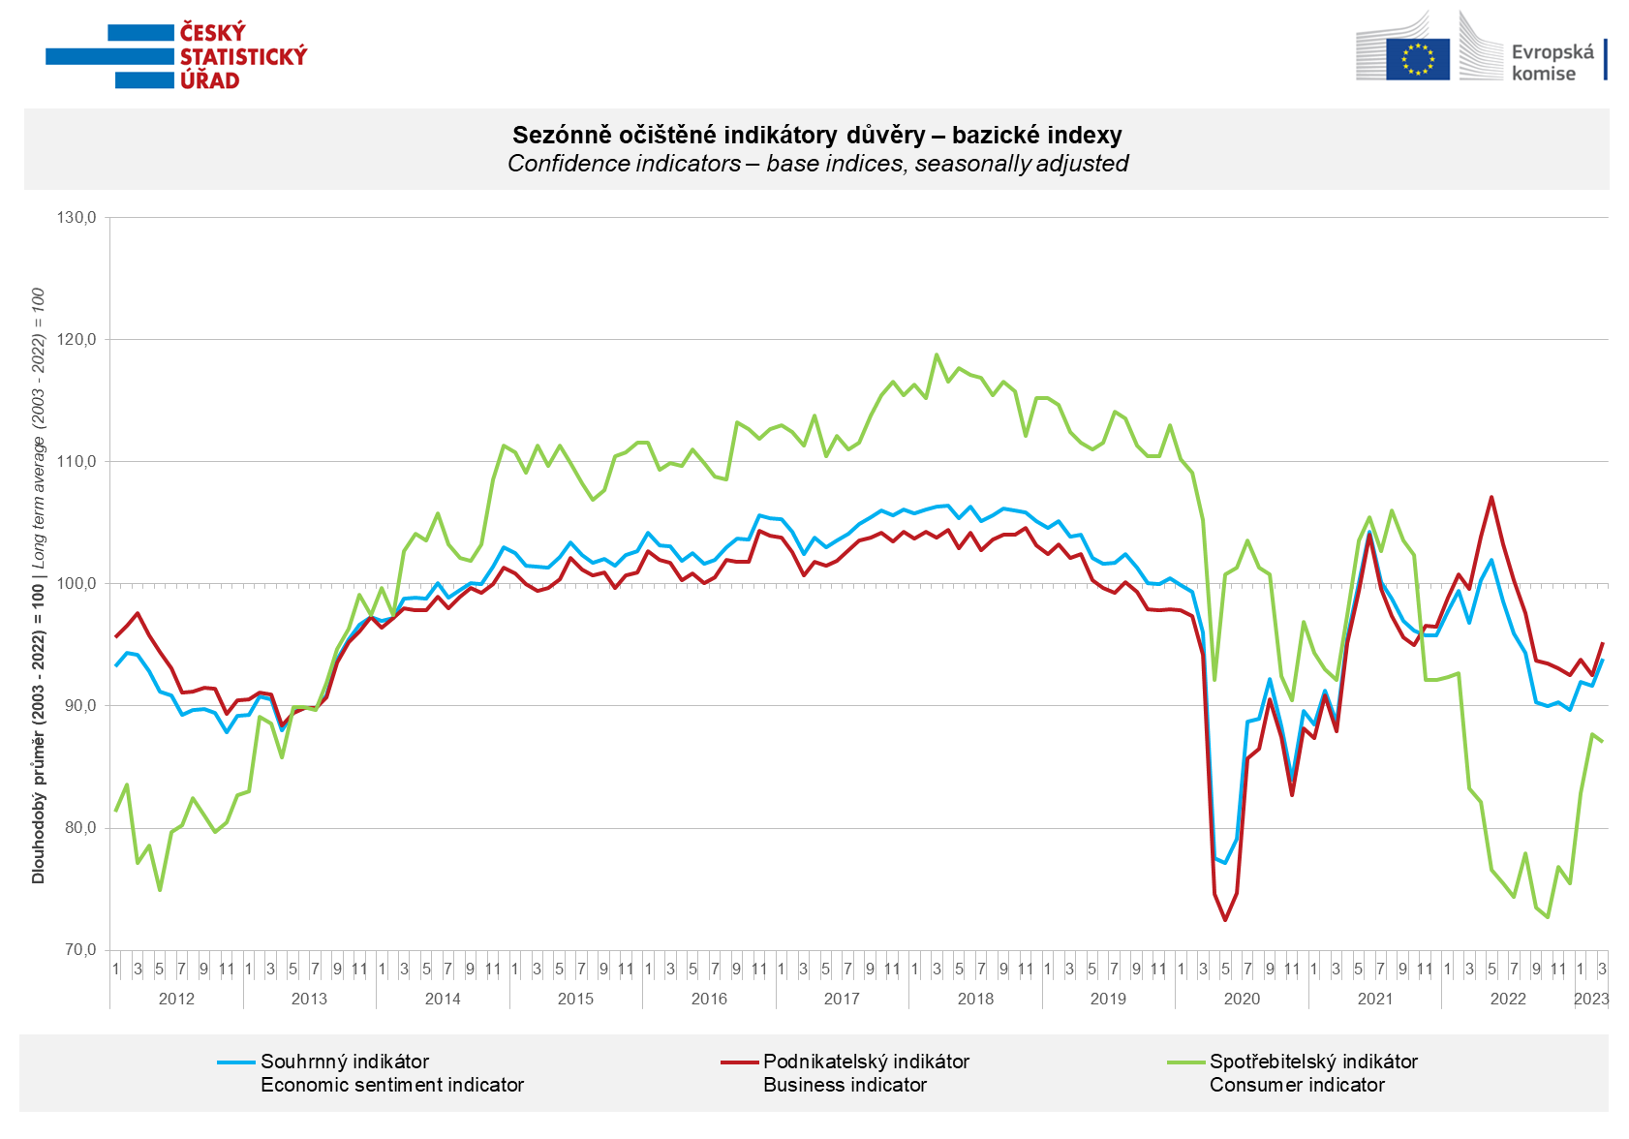

Confidence in the economy among entrepreneurs increased in industry and trade in March. In construction and selected services, it decreased compared to last month.

Among consumers, confidence in the economy decreased slightly m-o-m. Households are less worried about the deterioration of the overall economic situation. However, they rate their current financial situation more poorly compared to the previous twelve months. However, the number of respondents expecting a worsening of their financial situation in the next 12 months has hardly changed. The share of consumer who believe that the current time is not suitable for making large purchases increased m-o-m.

***
More detailed information on the development of business and consumer confidence can be found in the supplementary information to the RI business surveys.

***
In January 2023, we change the base to calculate the basis index in a news release by the Czech Statistical Office. For 2023, we calculate the long-term average from January 2003 to December 2022. The long-term average is changed one a year in news release publication data in January.

Notes:

Responsible manager: Juraj Lojka, Director of Business Statistics Coordination and Business Cycle Surveys Department, tel. +420731439291, e-mail: juraj.lojka@czso.cz
Contact person: Jiri Obst, Head of Business Cycle Surveys Unit, tel. +420604815440, e-mail: jiri.obst@czso.cz
Data source: CZSO business survey, Data Collect consumer survey (https://www.datacollect.cz)
Data collection date: Business part: March 17, 2023
Consumer part: March 16, 2023
Next News Release: April 24, 2023

This press release wasn´t edited for language.

Detailed time series of Balances and basic
indices of confidence indicators: https://www.czso.cz/csu/czso/kpr_ts
Business and Consumers Surveys are co-financed by grant agreements of the European Commission DG ECFIN.
https://ec.europa.eu/info/business-economy-euro/indicators-statistics/economic-databases/business-and-consumer-surveys_en
Link to European database: https://ec.europa.eu/eurostat/web/euro-indicators/business-and-consumer surveys

Annex:
Additional information to NR Business cycle survey
Table Confidence Indicators – basic indices
Graph 1 Confidence indicators – base indices, seasonally adjusted (2003–2023)
Graph 2.1 Confidence Indicators for industry, construction, trade, and in selected services – base indices, seasonally adjusted (2003–2023)
Graph 2.2 Balances of seasonally adjusted confidence indicators for industry, construction, trade, and in selected services (2003–2023)
Graph 3 Economic Sentiment Indicators – international comparison, seasonally adjusted (2007-2023)

