August 24, 2023

Consumer confidence fell, but overall confidence in the economy continues to rise
Business cycle survey – August 2023

The composite confidence indicator (economic sentiment indicator) – in the basis index form – increased by 2.0 points to 93.4 m-o-m, with the different developments of its components. The business confidence indicator increased by 2.8 percentage points to 93.9 and the consumer confidence indicator decreased by 1.7 points to 91.0. 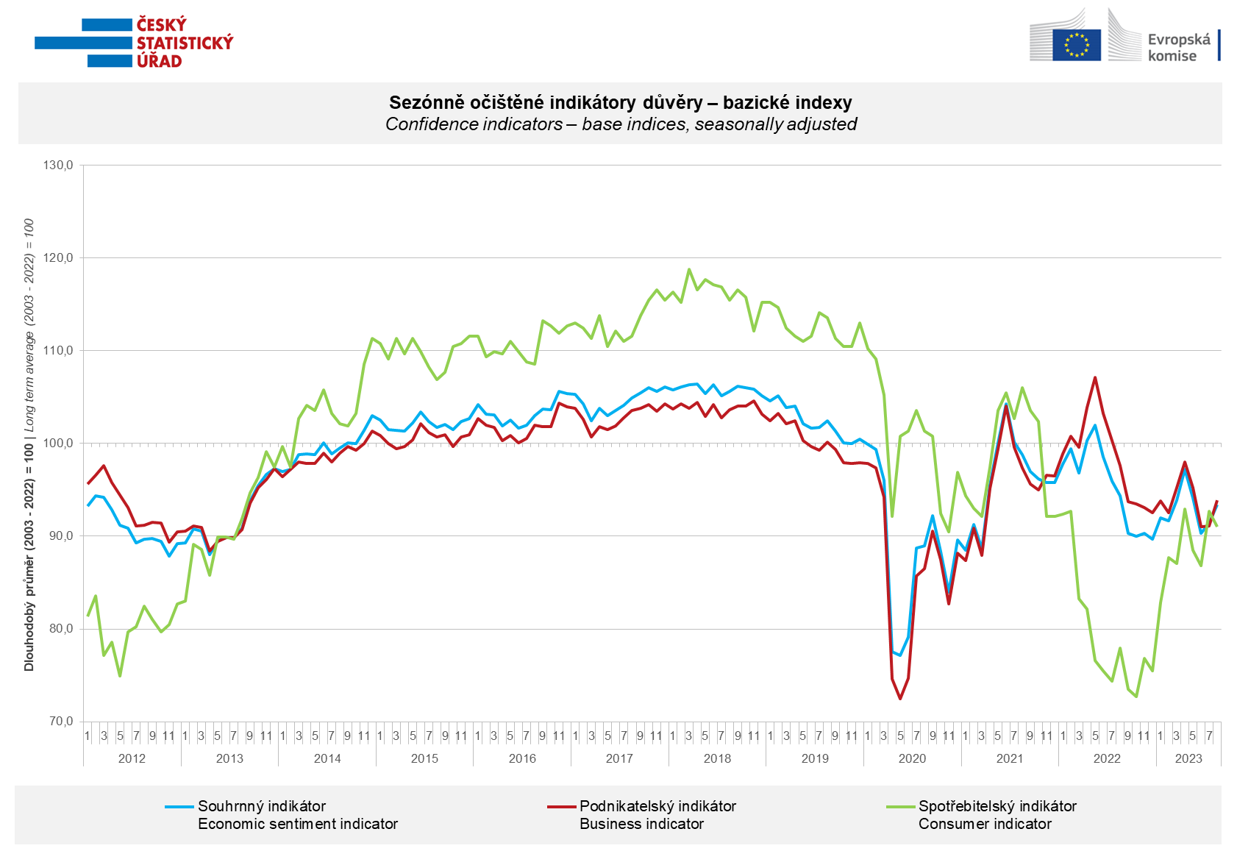

Among entrepreneurs, confidence in the economy increased in August in industry (+3.7 points), in selected services (+3.0 points) and in construction (+1.2 points), it decreased only in trade (-4.0 points).

Consumer confidence in the economy decreased compared to July. The number of respondents expecting a deterioration of the overall economic situation in the Czech Republic in the next twelve months increased slightly. The number of households rating their current financial situation worse compared to the previous twelve months did not change. The number of households who fear a worsening of their own financial situation in the next twelve months increased only slightly. The share of respondents who believe that the current time is not suitable for making large purchases increased.

***
More detailed information on the development of business and consumer confidence can be found in the supplementary information to the RI business surveys.

Notes:

Responsible manager: Juraj Lojka, Director of Business Statistics Coordination and Business Cycle Surveys Department, tel. +420731439291, e-mail: juraj.lojka@czso.cz
Contact person: Jiri Obst, Head of Business Cycle Surveys Unit, tel. +420604815440, e-mail: jiri.obst@czso.cz
Data source: CZSO business survey, Data Collect consumer survey (https://www.datacollect.cz)
Data collection date: Business part: August 17, 2023
Consumer part: August 15, 2023
Next News Release: September 25, 2023

This press release wasn´t edited for language.

Detailed time series of Balances and basic
indices of confidence indicators: https://www.czso.cz/csu/czso/kpr_ts
Business and Consumers Surveys are co-financed by grant agreements of the European Commission DG ECFIN.
https://ec.europa.eu/info/business-economy-euro/indicators-statistics/economic-databases/business-and-consumer-surveys_en
Link to European database: https://economy-finance.ec.europa.eu/economic-forecast-and-surveys/business-and-consumer-surveys_en

Annex:
Additional information to NR Business cycle survey
Table Confidence Indicators – basic indices
Graph 1 Confidence indicators – base indices, seasonally adjusted (2003–2023)
Graph 2.1 Confidence Indicators for industry, construction, trade, and in selected services – base indices, seasonally adjusted (2003–2023)
Graph 2.2 Balances of seasonally adjusted confidence indicators for industry, construction, trade, and in selected services (2003–2023)
Graph 3 Economic Sentiment Indicators – international comparison, seasonally adjusted (2007-2023)

