December 27, 2023

Entrepreneurs believe more in the economy at the end of the year, while consumers, on the other hand, are sceptical
Business cycle survey – December 2023
The composite confidence indicator (economic sentiment indicator) – in the basis index form – slightly increased again by 0.3 points to 93.4 m-o-m, reflecting different developments in its components. The business confidence indicator rose by 1.7 percentage points to 95.2 while the consumer confidence indicator decreased by 5.8 points to 84.9.
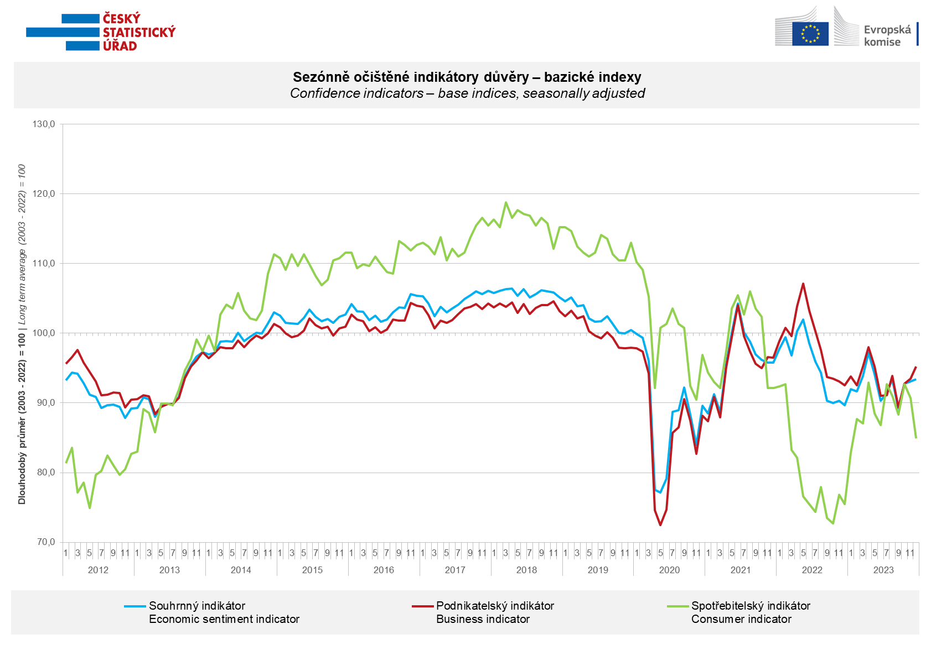

Entrepreneurs' confidence in the economy increased in December in industrial sector (+2.3 points), selected services (+1.5 points), and trade sector (+2.6 points). However, in the construction industry, it decreased compared to the previous month (-5.4 points).

Consumer confidence in the economy decreased significantly on a month-to-month basis. The number of respondents expecting a worsening of the overall economic situation in the next twelve months increased compared to November. Additionally, there was an increase in the number of households evaluating their current financial situation worse than in the previous twelve months, along with the number of respondents expecting its deterioration in the next twelve months. The proportion of consumers who believe that the current time is not suitable for making major purchases remained nearly unchanged.
***
More detailed information on the development of business and consumer confidence can be found in the supplementary information to the RI business surveys.

Notes:

Responsible manager: Juraj Lojka, Director of Business Statistics Coordination and Business Cycle Surveys Department, tel. +420731439291, e-mail: juraj.lojka@czso.cz
Contact person: Jiri Obst, Head of Business Cycle Surveys Unit, tel. +420604815440, e-mail: jiri.obst@czso.cz
Data source: CZSO business survey, Data Collect consumer survey (https://www.datacollect.cz)
Data collection date: Business part: December 18, 2023
Consumer part: December 15, 2023
Next News Release: January 24, 2024

This press release wasn´t edited for language.

Detailed time series of Balances and basic
indices of confidence indicators: https://www.czso.cz/csu/czso/kpr_ts
Business and Consumers Surveys are co-financed by grant agreements of the European Commission DG ECFIN.
https://ec.europa.eu/info/business-economy-euro/indicators-statistics/economic-databases/business-and-consumer-surveys_en
Link to European database: https://ec.europa.eu/eurostat/web/euro-indicators/database

Annex:
Additional information to NR Business cycle survey
Table Confidence Indicators – basic indices
Graph 1 Confidence indicators – base indices, seasonally adjusted (2003–2023)
Graph 2.1 Confidence Indicators for industry, construction, trade, and in selected services – base indices, seasonally adjusted (2003–2023)
Graph 2.2 Balances of seasonally adjusted confidence indicators for industry, construction, trade, and in selected services (2003–2023)
Graph 3 Economic Sentiment Indicators – international comparison, seasonally adjusted (2007-2023)

