9 May 2023

Industrial production increased by 0.8%, year-on-year, in the first quarter

Supplementary information to the News Release on Industry – March 2023
Industry in the first quarter
Industrial production was in real terms by 0.7% lower, quarter-on-quarter (q-o-q), in the Q1 2023. In the year-on-year comparison, it increased by 0.8%. The first quarter of 2023 had by 1 working day more compared to the corresponding quarter of the previous year.
Industrial production was stagnating in the first quarter of 2023. In individual months, the development varied and the results depended on the current situation in the automobile industry, in which a low comparison basis from the last year was reflected on one side and partial problems with supplies of components emerged again on the other side. In the first quarter of 2023, production of the industry (economic activity) increased by 26.1% (the contribution to the growth of industry in total was 4.5 percentage points (p. p.)). Most of economic activities (industries), however, decreased their production, year-on-year, in the first quarter of 2023. Within manufacturing, decreased demand and energy intensity of production were mainly reflected in manufacture of basic metals (a decrease by 18.5%), in chemical industry (a decrease by 16.6%), and in manufacture of other non-metallic mineral products (a decrease by 15.2%), mainly in production of glass and building materials. Production decreased by a tenth, year-on-year, in mining and quarrying and in electricity, gas, steam and air conditioning supply.
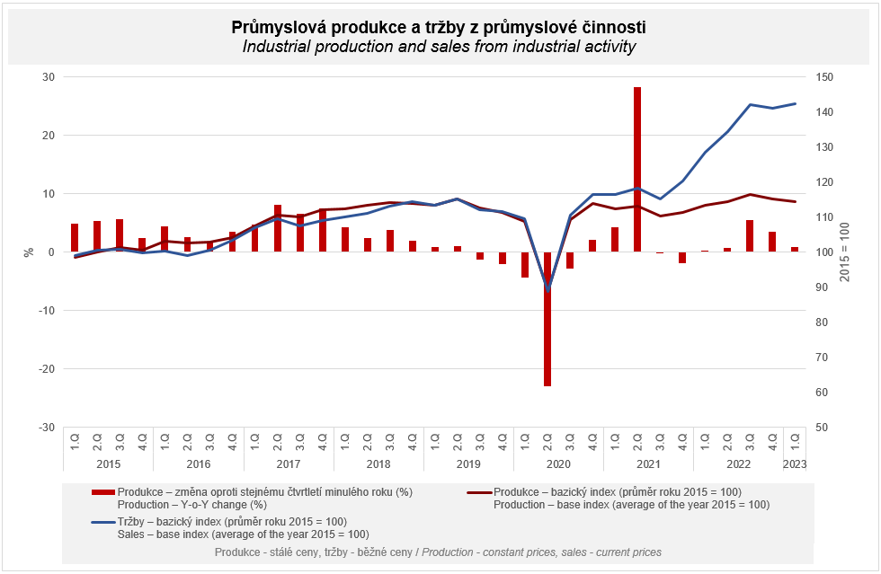
Sales from industrial activity at current prices increased by 11.1%, y-o-y, in the Q1 2023. Direct export sales of industrial enterprises increased at current prices by 8.6%. Domestic sales, which also include indirect export via non-industrial enterprises, increased at current prices by 14.1%.
An increase of sales was recorded by most of economic activities of industry. The following contributed the most to the result: manufacture of motor vehicles, trailers and semi-trailers (a contribution of +6.3 p. p., an increase by 30.0%), manufacture of food products (a contribution of +1.2 p. p., an increase by 19.6%), and manufacture of machinery and equipment (a contribution of +0.8 p. p., an increase by 12.5%). On the other hand, sales from industrial activity decreased the most in manufacture of basic metals (a contribution of -0.8 p. p., a decrease by 16.3%), manufacture of chemicals and chemical products (a contribution of -0.6 p. p., a decrease by 14.0%), and in wood processing industry (a contribution of -0.4 p. p., a decrease by 15.8%).

The value of new orders at current prices in surveyed industrial CZ-NACE activities in the Q1 2023 increased by 2.2%, year-on-year. Non-domestic new orders decreased by 1.3%. Domestic new orders increased by 10.2%.
The following contributed the most to the increase of the value of new orders in total: manufacture of motor vehicles, trailers and semi-trailers (a contribution of +3.3 p. p., an increase by 9.4%), manufacture of other transport equipment (a contribution of +0.4 p. p., an increase by 19.5%), and manufacture of machinery and equipment (a contribution of +0.4 p. p., an increase by 3.5%). The highest decrease was recorded by manufacture of basic metals (a contribution of -1.2 p. p., a decrease by 16.5%) and manufacture of chemicals and chemical products (a contribution of -0.7 p. p., a decrease by 10.3%).
The following also contributed the most to the increase of the value of domestic new orders: manufacture of motor vehicles, trailers and semi-trailers (a contribution of +7.8 p. p., an increase by 28.7%), mainly manufacture of parts and accessories. Manufacture of motor vehicles also positively contributed to the development of non-domestic new orders, the value of which increased, year-on-year, in this economic activity (industry) “only” by 3.5%. Non-domestic new orders decreased the most in manufacture of computer, electronic and optical products (a contribution of -1.5 p. p., a decrease by 17.9%) and in manufacture of basic metals (a contribution of -0.9 p. p., a decrease by 18.5%).

The average registered number of employees in industry in the Q1 2023 was by 1.1% lower compared to the corresponding period of the previous year. Their average gross monthly nominal wage increased by 10.4%.

Notes:

Contact person: Veronika Doležalová, Head of Industrial Statistics Unit, phone number (+420) 734 352 291, e-mail: veronika.dolezalova@czso.cz

Related outputs: time series in the Public database, the Industry chapter

