6 February 2024

Industrial production decreased by 0.4% in 2023

Supplementary information to the News Release on Industry – December 2023
Industry in 2023
Industrial production was lower by 0.4%, year-on-year (y-o-y), in 2023. The year 2023 had by two working days less than the year 2022. Most of the production in most of economic activities of industry decreased, year-on-year. Mainly economic activities (industries) that need a lot of energy such as manufacture of other non-metallic mineral products (a decrease by 17.8%) and manufacture of basic metals (a decrease by 14.4%) had difficulties. Production of electricity, gas, steam and air conditioning supply decreased by a tenth and also coal mining decreased (a decrease by 14.4%). Even a recovery in manufacture of motor vehicles, trailers and semi-trailers (in which there was an increase by 16.1%) and in manufacture of other transport equipment (growth by 17.8%) was unable to reverse the decreasing trend. Year 2023 was successful for pharmaceutical industry, in which production increased by 9.3%.

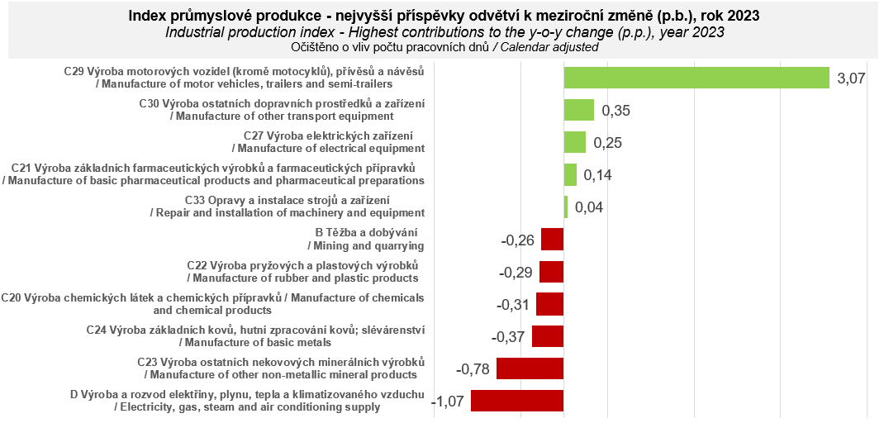

In the Q1 2023, industrial production in total recorded a very slight growth by 1.2%, y-o-y. The positive result was the most contributed to by the automotive industry (a year-on-year increase by 28.2%, a contribution +4.91 percentage points (p. p.)), which was, however, influenced by a lower comparison basis to a considerable extent. In the Q2 2023, industrial production still kept a roughly comparable year-on-year increase by 1.1%, namely again mainly thanks to the automotive industry, in which a considerable growth from the previous periods was still seen (+21.3%; +4.11 p. p.). Development in manufacture of other transport equipment, in which important orders (contracts) for the army and railways were implemented, also had a favourable impact. In the Q3 2023, the trend already changed and industrial production recorded a rather considerable decrease by 3.5%, year-on-year. A decrease in electricity, gas, steam and air conditioning supply was accompanied by a deepening decrease in production of glass, ceramics, porcelain, and building materials and mainly in manufacture of machinery and equipment. An absolute majority of economic activities of industry recorded a decrease mainly due to a decreasing demand for production.
A year-on-year decrease in industrial production, although less considerable, also continued in the Q4 2023, in which only in October there was a temporary deviation from the downward trend (due to a lower comparison basis in the automotive industry and invoicing of some extraordinary orders (contracts)). The total decrease by 0.5% was the most influenced by a considerable change in manufacture of machinery and equipment; this economic activity (industry) changed during the last half-year from a constantly increasing one to an industry generating the biggest negative contributions, namely due to a low demand for production. That also held true for many other economic activities of industry, especially for production of glass, ceramics, porcelain, and building materials. On the other hand, a bigger slump was prevented in the very end of the year by a favourable development in the automotive industry and also by implementation of some large extraordinary orders (contracts) in manufacture of other transport equipment.

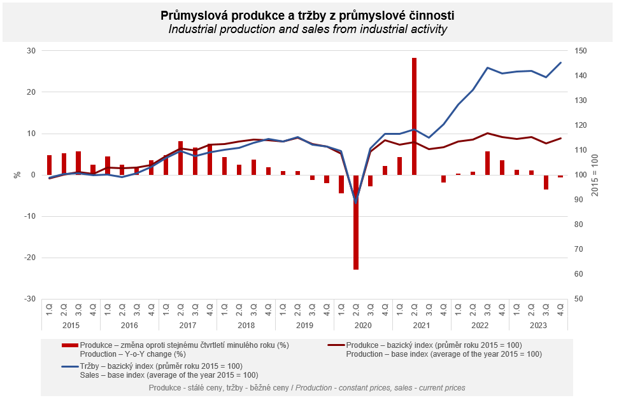

Sales from industrial activity at current prices increased by 4.0%, year-on-year, in 2023. Direct export sales of industrial enterprises increased at current prices by 1.7%. Domestic sales, which also include indirect export via non-industrial enterprises, increased at current prices by 6.7%.
The following contributed the most to the increase: manufacture of motor vehicles, trailers and semi-trailers (a contribution +4.3 p. p, an increase by 19.3%), electricity, gas, steam and air conditioning supply (a contribution +1.8 p. p, an increase by 24.6%), and manufacture of electrical equipment (a contribution +0.4 p. p, an increase by 6.2%). Sales in mining of black and brown coal increased by almost a fifth.
On the other hand, sales from industrial activity decreased the most in manufacture of basic metals (a contribution -1.1 p. p, a decrease by 23.7%), manufacture of chemicals and chemical products (a contribution -0.8 p. p, a decrease by 18.8%), and in manufacture of wood and of products of wood and cork, except furniture; manufacture of articles of straw and plaiting materials (a contribution -0.5 p. p, a decrease by 20.8%).

The value of new orders at current prices in surveyed industrial CZ-NACE activities decreased by 1.7%, year-on-year, in 2023. Non-domestic new orders decreased by 3.0%. Domestic new orders increased by 1.1%.
The following contributed the most to the decrease in the value of new orders: manufacture of basic metals (a decrease by 21.6%), manufacture of chemicals and chemical products (a decrease by 18.1%), and manufacture of computer, electronic and optical products (a decrease by 6.5%). The highest positive contributions came from the following ones: manufacture of motor vehicles, trailers and semi-trailers (growth by 6.1%), manufacture of electrical equipment (an increase by 2.8%), and manufacture of basic pharmaceutical products and pharmaceutical preparations (an increase by 10.5%).

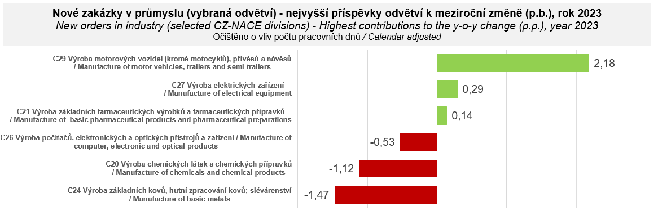

The average registered number of employees in industry in 2023 was by 1.8% lower compared to the corresponding period of the previous year. Their average gross monthly nominal wage increased by 8.7%.

Contact person: Veronika Doležalová, Head of Industrial Statistics Unit, phone number (+420) 734 352 291, e-mail: veronika.dolezalova@czso.cz

Related outputs: time series in the Public database, the Industry chapter

