August 24, 2022

Overall confidence in the economy decreased for the third time in a row

Business cycle survey – August 2022
The composite confidence indicator (economic sentiment indicator) – in the basis index form – decreased by 1.6 percentage points to 94.1, m-o-m, with the different developments of its components. Business confidence indicator decreased by 2.6 percentage points to 97.6, the consumer confidence indicator increased by 3.5 percentage points to 77.1.
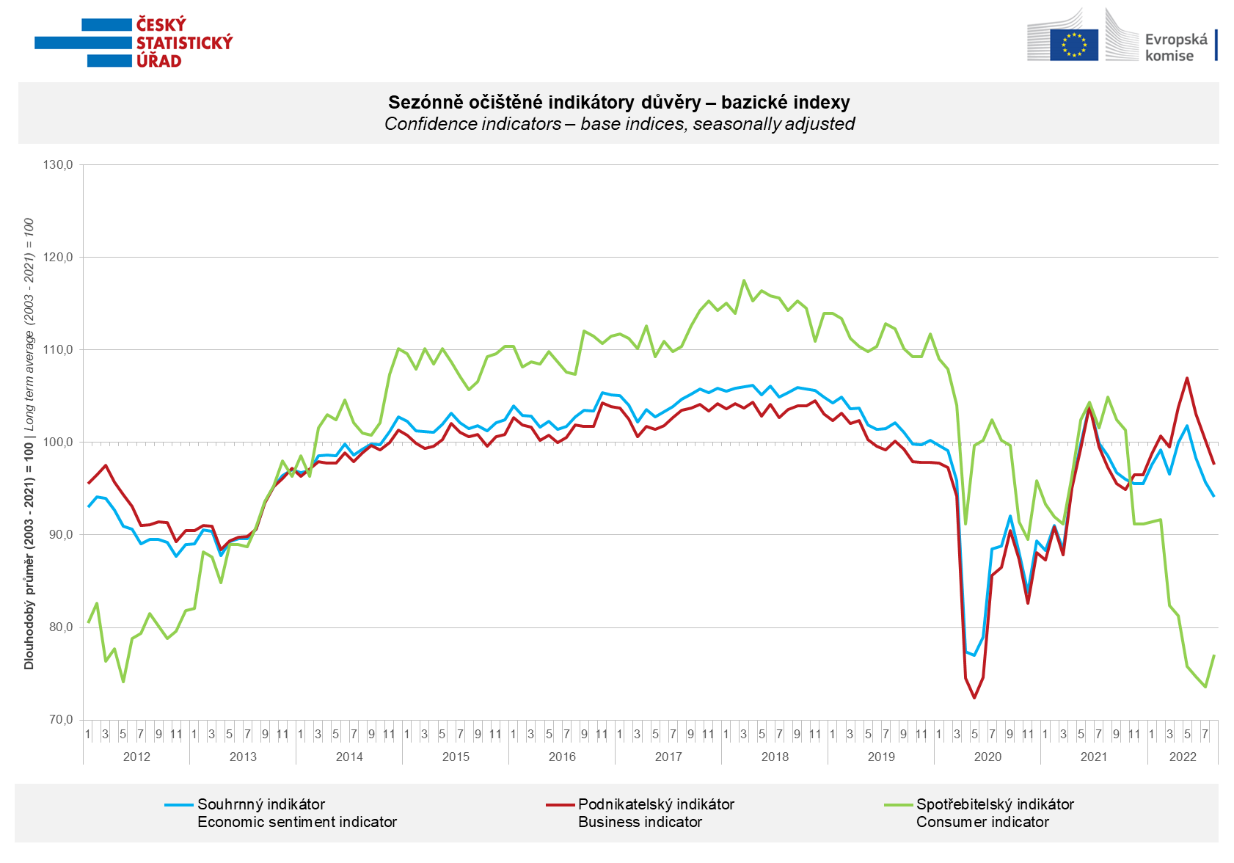

Confidence in the economy fell among entrepreneurs across all sectors. The value of business confidence indicator thus fell below its long-term average again.

Among consumers, confidence in the economy increased m-o-m after five months of continuous decline. Compared to July, respondents are less worried about the deterioration of the economic situation and their own financial situation. The number of consumers rate their financial situation worse than in the previous twelve months is also decreased m-o-m. Conversely, the number of respondents who believe that the next twelve months will not be a good time to make large purchases has slightly increased.

***
More detailed information on the development of business and consumer confidence can be found in the supplementary information to the RI business surveys.

Notes:

Responsible manager: Juraj Lojka, Director of Business Statistics Coordination and Business Cycle Surveys Department, tel. +420731439291, e-mail: juraj.lojka@czso.cz
Contact person: Jiri Obst, Head of Business Cycle Surveys Unit, tel. +420604815440, e-mail: jiri.obst@czso.cz
Data source: CZSO business survey, Data Collect consumer survey (https://www.datacollect.cz)
Data collection date: Business part: August 18, 2022
Consumer part: August 15, 2022
Next News Release: September 26, 2022

This press release wasn´t edited for language.

Detailed time series of Balances and basic
indices of confidence indicators: https://www.czso.cz/csu/czso/kpr_ts
Business and Consumers Surveys are co-financed by grant agreements of the European Commission DG ECFIN.
https://ec.europa.eu/info/business-economy-euro/indicators-statistics/economic-databases/business-and-consumer-surveys_en
Link to European database: https://ec.europa.eu/eurostat/web/euro-indicators/business-and-consumer surveys

Annex:
Additional information to NR Business cycle survey
Table Confidence Indicators – basic indices
Graph 1 Confidence indicators – base indices, seasonally adjusted (2003–2022)
Graph 2.1 Confidence Indicators for industry, construction, trade, and in selected services – base indices, seasonally adjusted (2003–2022)
Graph 2.2 Balances of seasonally adjusted confidence indicators for industry, construction, trade, and in selected services (2003–2022)
Graph 3 Economic Sentiment Indicators – international comparison, seasonally adjusted (2007-2022)

