October 24, 2022

Confidence in the economy has been falling for the fifth month in a row

Business cycle survey – October 2022
The composite confidence indicator (economic sentiment indicator) – in the basis index form – decreased by 0.3 percentage points to 89.8, m-o-m, with the same developments of its components. The business confidence indicator decreased by 0.2 percentage points to 93.4; the consumer confidence indicator decreased by 0.8 percentage points to 71.9, the lowest value since the start of monitoring.
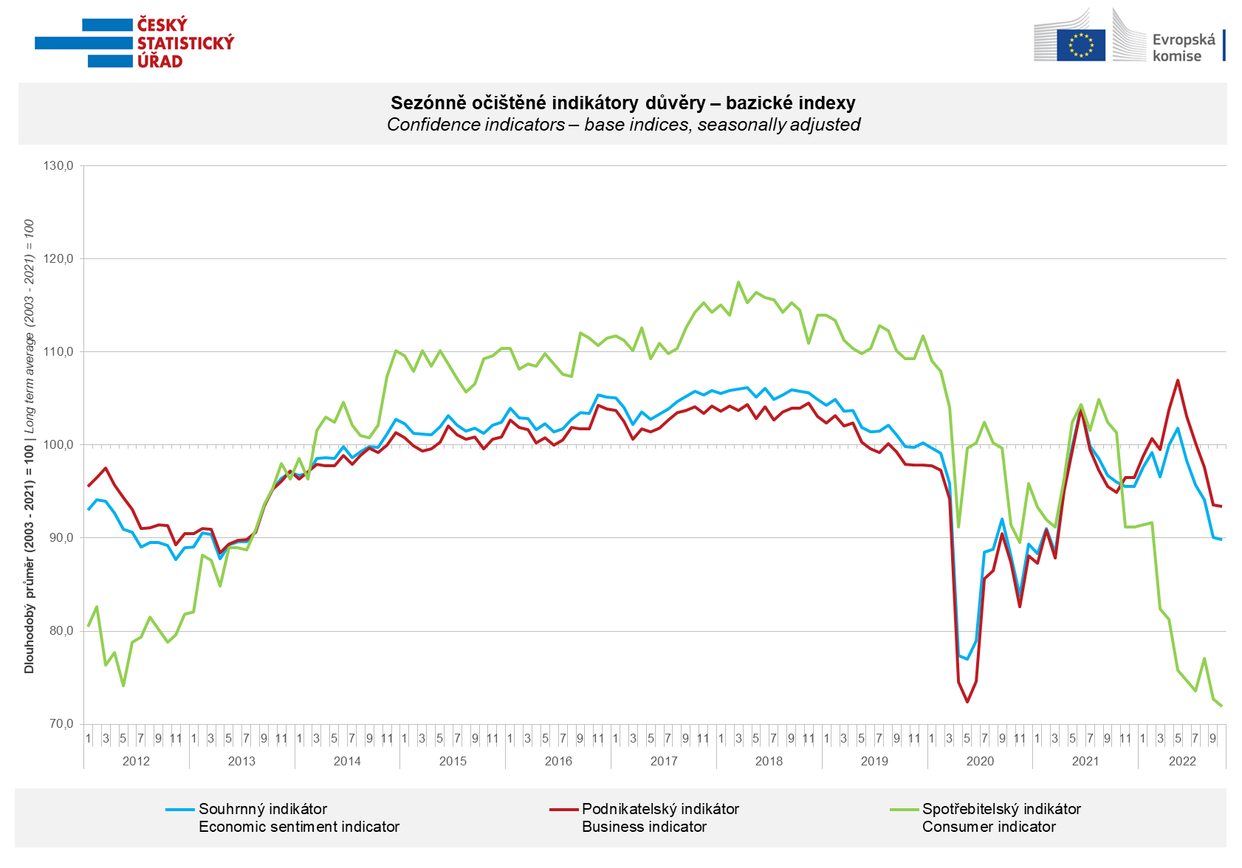

Confidence in the economy decreased in October among entrepreneurs in industry and construction. After a four-month decline, it increased in trade and slightly also in selected service sectors.

"Great uncertainty about future developments, material shortages, deteriorating demand and high prices. In recent months, these are the four basic factors fundamentally affecting the development of business people's confidence in the industry. If we add the drop in confidence in the construction industry and only moderate growth in selected service sectors, the result is the fifth month-on-month drop in the business sphere. Unfortunately, he was unable to reverse even the increase in confidence in trade to the highest value in the last four months," said Jiří Obst, head of the CZSO's business cycle survey department.

The decline in consumer confidence continued in October. Respondents are still significantly worried about the deterioration of the overall economic and financial situation. The number of respondents evaluating their financial situation as worse compared to the period of the previous twelve months also increased. The number of respondents who do not find the current time suitable for making large purchases decreased slightly compared to September. The number of respondents fearing further price increases was also reduced. On the contrary, fears of unemployment growth have increased.

"Even in October, the decline in consumer confidence in the economy did not stop, and this year it hit its historic low for the third time. Households' fears of worsening their financial situation are at an all-time high. There is also great concern about the development of the overall economic situation and the increase in unemployment. On the contrary, decreasing concerns about further price growth can be perceived positively," said Silvie Vyplašilová from the CZSO's business cycle survey department.

***
More detailed information on the development of business and consumer confidence can be found in the supplementary information to the RI business surveys.

Notes:

Responsible manager: Juraj Lojka, Director of Business Statistics Coordination and Business Cycle Surveys Department, tel. +420731439291, e-mail: juraj.lojka@czso.cz
Contact person: Jiri Obst, Head of Business Cycle Surveys Unit, tel. +420604815440, e-mail: jiri.obst@czso.cz
Data source: CZSO business survey, Data Collect consumer survey (https://www.datacollect.cz)
Data collection date: Business part: October 17, 2022
Consumer part: October 17, 2022
Next News Release: November 24, 2022

This press release wasn´t edited for language.

Detailed time series of Balances and basic
indices of confidence indicators: https://www.czso.cz/csu/czso/kpr_ts
Business and Consumers Surveys are co-financed by grant agreements of the European Commission DG ECFIN.
https://ec.europa.eu/info/business-economy-euro/indicators-statistics/economic-databases/business-and-consumer-surveys_en
Link to European database: https://ec.europa.eu/eurostat/web/euro-indicators/business-and-consumer surveys

Annex:
Additional information to NR Business cycle survey
Table Confidence Indicators – basic indices
Graph 1 Confidence indicators – base indices, seasonally adjusted (2003–2022)
Graph 2.1 Confidence Indicators for industry, construction, trade, and in selected services – base indices, seasonally adjusted (2003–2022)
Graph 2.2 Balances of seasonally adjusted confidence indicators for industry, construction, trade, and in selected services (2003–2022)
Graph 3 Economic Sentiment Indicators – international comparison, seasonally adjusted (2007-2022)
Graph 4 Production Capacity Utilisation in Manufacturing Industry (2003-2022)
Graph 5 Limits of Production in Industry (2005-2022)
Graph 6 Limits of Production in Construction (2005-2022)
Graph 7 Limits of Production in Selected Services (2005-2022)

