March 24, 2022

Consumer confidence in the economy is the lowest since January 2013

Business cycle survey – March 2022
The composite confidence indicator (economic sentiment indicator) – in the basis index form – decreased by 2.6 percentage points to 96.6, m-o-m, with both components decreasing. Business confidence indicator decreased by 1.2 percentage points to 99.5, the consumer confidence indicator decreased by 9.3 percentage points to 82.4.

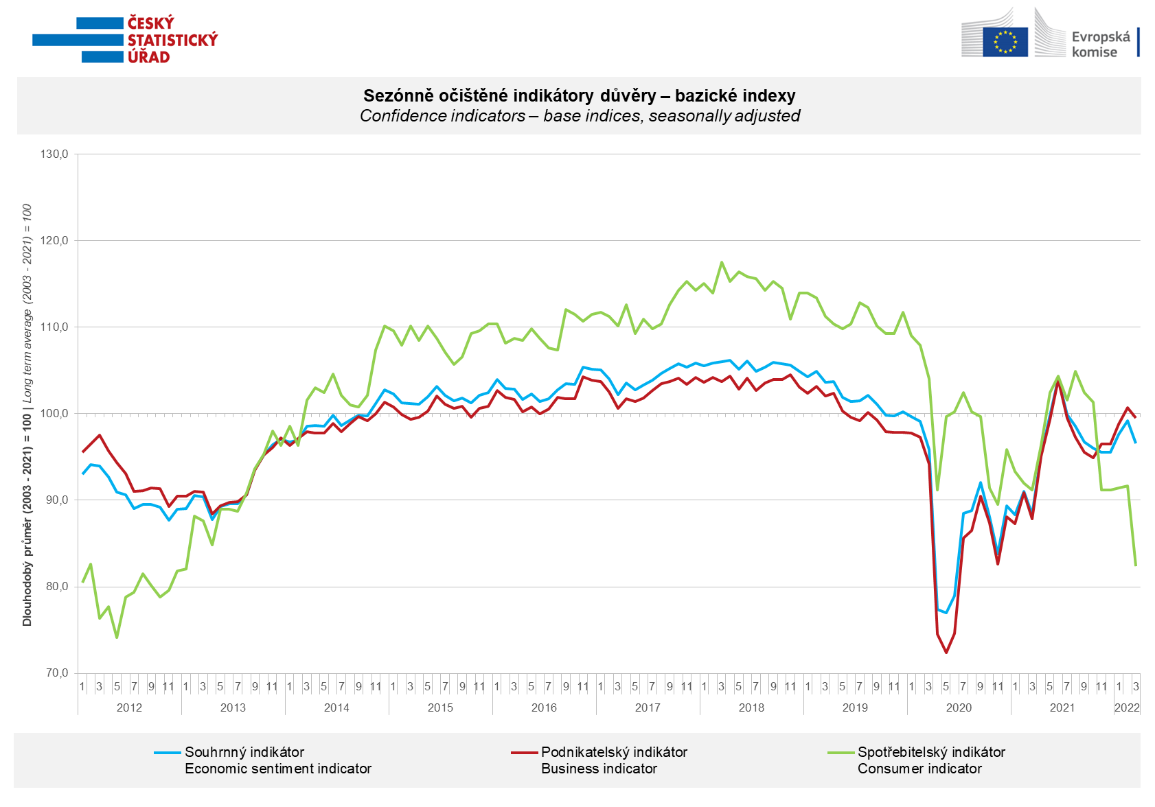

The month-on-month decline in economic sentiment among entrepreneurs was mainly due to a sharper decline in confidence in industry and construction. Entrepreneurs´ confidence in trade also fell, while in selected service sectors it increased compared with February.

March consumer confidence fell to its lowest level since January 2013. The number of households worried about the deterioration of the overall economic situation and their own financial situation in the next twelve months increased significantly.

***
More detailed information on the development of business and consumer confidence can be found in the supplementary information to the RI business surveys.

Notes:

Responsible manager: Juraj Lojka, Director of Business Statistics Coordination and Business Cycle Surveys Department, tel. +420731439291, e-mail: juraj.lojka@czso.cz
Contact person: Jiri Obst, Head of Business Cycle Surveys Unit, tel. +420604815440, e-mail: jiri.obst@czso.cz
Data source: CZSO business survey, Data Collect consumer survey (https://www.datacollect.cz)
Data collection date: Business part: March 1 - 17, 2022
Consumer part: March 1 - 17, 2022
Next News Release: April 25, 2022

This press release wasn´t edited for language.

Detailed time series of Balances and basic
indices of confidence indicators: https://www.czso.cz/csu/czso/kpr_ts
Business and Consumers Surveys are co-financed by grant agreements of the European Commission DG ECFIN.
https://ec.europa.eu/info/business-economy-euro/indicators-statistics/economic-databases/business-and-consumer-surveys_en
Link to European database: https://ec.europa.eu/eurostat/web/euro-indicators/business-and-consumer surveys

Annex:
Additional information to NR Business cycle survey
Table Confidence Indicators – basic indices
Graph 1 Confidence indicators – base indices, seasonally adjusted (2003–2022)
Graph 2.1 Confidence Indicators for industry, construction, trade, and in selected services – base indices, seasonally adjusted (2003–2022)
Graph 2.2 Balances of seasonally adjusted confidence indicators for industry, construction, trade, and in selected services (2003–2022)
Graph 3 Economic Sentiment Indicators – international comparison, seasonally adjusted (2007-2022)

