June 24, 2022

Confidence in the economy has fallen below the long-term average

Business cycle survey – June 2022
The composite confidence indicator (economic sentiment indicator) – in the basis index form – decreased by 3.5 percentage points to 98.3, m-o-m, with the simultaneous decline of its components. Business confidence indicator decreased by 3.9 percentage points to 103.1, the consumer confidence indicator decreased by 1.1 percentage points to 74.7. 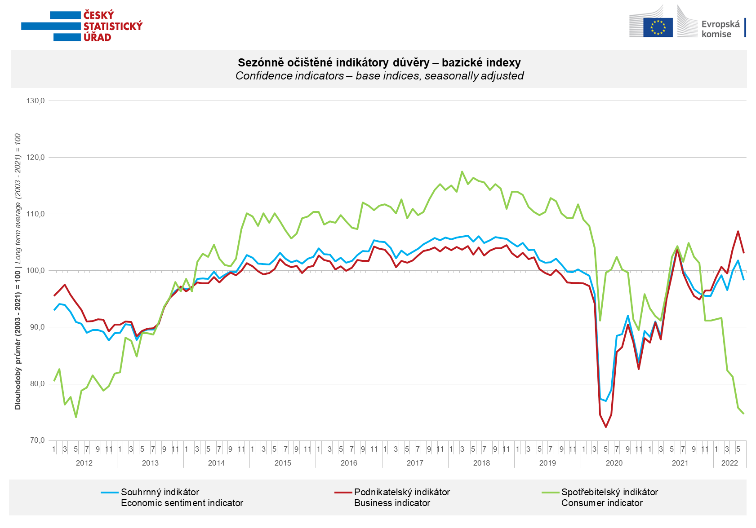

Confidence among entrepreneurs fell in June across all sectors. The confidence indicator in services fell the most, m-o-m.

Consumer confidence in the economy fell for the fourth month in a row to the second lowest value in the survey history. A record number of respondents (highest since the beginning of the survey) fear a deterioration in their own financial situation. Near its historical maximum is the number of consumers who rate their financial situation worse than in the previous twelve months. The number of households worried about rising unemployment has also increased.

***
More detailed information on the development of business and consumer confidence can be found in the supplementary information to the RI business surveys.

Notes:

Responsible manager: Juraj Lojka, Director of Business Statistics Coordination and Business Cycle Surveys Department, tel. +420731439291, e-mail: juraj.lojka@czso.cz
Contact person: Jiri Obst, Head of Business Cycle Surveys Unit, tel. +420604815440, e-mail: jiri.obst@czso.cz
Data source: CZSO business survey, Data Collect consumer survey (https://www.datacollect.cz)
Data collection date: Business part: June 17, 2022
Consumer part: June 17, 2022
Next News Release: July 26, 2022

This press release wasn´t edited for language.

Detailed time series of Balances and basic
indices of confidence indicators: https://www.czso.cz/csu/czso/kpr_ts
Business and Consumers Surveys are co-financed by grant agreements of the European Commission DG ECFIN.
https://ec.europa.eu/info/business-economy-euro/indicators-statistics/economic-databases/business-and-consumer-surveys_en
Link to European database: https://ec.europa.eu/eurostat/web/euro-indicators/business-and-consumer surveys

Annex:
Additional information to NR Business cycle survey
Table Confidence Indicators – basic indices
Graph 1 Confidence indicators – base indices, seasonally adjusted (2003–2022)
Graph 2.1 Confidence Indicators for industry, construction, trade, and in selected services – base indices, seasonally adjusted (2003–2022)
Graph 2.2 Balances of seasonally adjusted confidence indicators for industry, construction, trade, and in selected services (2003–2022)
Graph 3 Economic Sentiment Indicators – international comparison, seasonally adjusted (2007-2022)

