9 May 2022

Industrial production increased by 0.4%, year-on-year, in the first quarter

Supplementary information to the News Release on Industry – March 2022
Industry in the first quarter
Industrial production was in real terms by 2.3% higher, quarter-on-quarter (q-o-q), in the Q1 2022. In the year-on-year comparison, it increased by 0.4%. The first quarter of 2022 had by 1 working day more compared to the corresponding quarter of the previous year.
The whole first quarter of 2022 was characterised by production growth in an absolute majority of economic activities of industry on one side and by continuing problems in manufacture of motor vehicles and related industries on the other side. Namely these problems prevented industry as a whole from reaching a more significant growth and from reaching the level of production volume of the pre-covid period.
The highest contributions to the year-on-year industrial growth in the Q1 2022 were recorded by the following industries (economic activities): manufacture of electrical equipment (contribution +0.39 percentage point (p. p.), increase by 5.3%), manufacture of machinery and equipment (contribution +0.38 p. p., increase by 5.1%), and manufacture of other non-metallic mineral products (contribution +0.31 p. p., increase by 8.7%). Manufacture of motor vehicles took 2 p. p. off the total result, the industry (economic activity) recorded a year-on-year decrease by 10.3%.
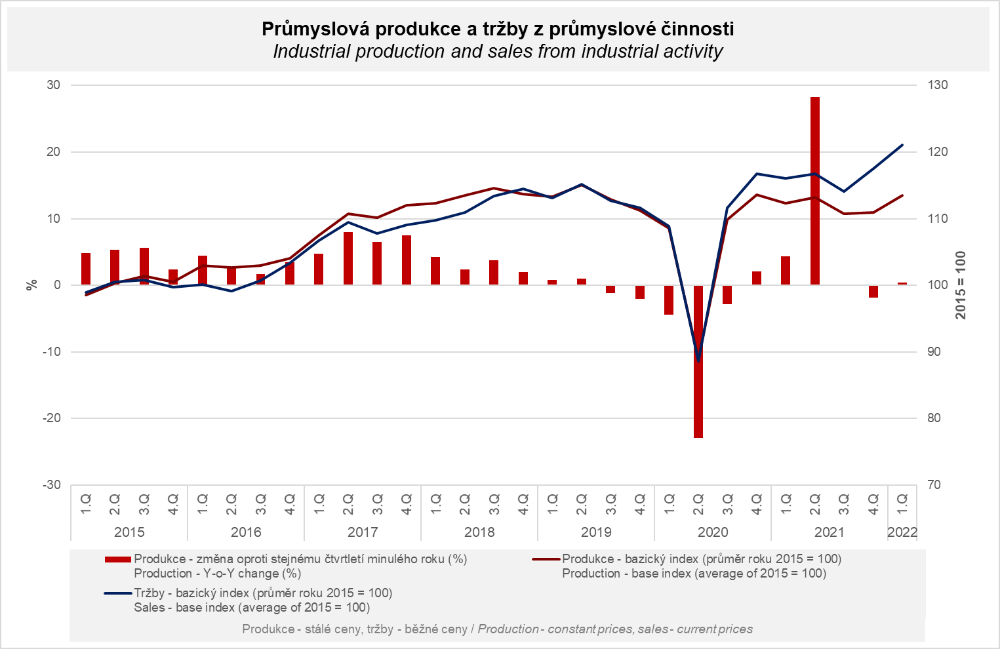

Sales from industrial activity at current prices increased by 9.5%, y-o-y, in the Q1 2022. Direct export sales of industrial enterprises increased at current prices by 4.3%. Domestic sales, which also include indirect export via non-industrial enterprises, increased at current prices by 16.8%.
A year-on-year decrease of sales was only recorded by manufacture of motor vehicles, trailers and semi-trailers, namely by 12% (contribution -3.2 percentage points). Sales from abroad decreased more. The following contributed the most to the increase: electricity, gas, steam and air conditioning supply (contribution +1.71 p. p., increase by 22.3%), manufacture of basic metals (contribution +1.44 p. p., increase by 36%), and manufacture of fabricated metal products (contribution +1.36 p. p., increase by 16.9%).
Moreover, an absolute majority of industries (economic activities) recorded a double digit year-on-year growth of sales, which was significantly influenced by price growth of both raw materials and finished products – it mainly applied to mining and quarrying, manufacture of basic metals, manufacture of chemicals and chemical products, and wood processing industry. That is also the reason why, during the last months, there was a significant “scissor” effect between the development of production at constant prices and sales at current prices.

The value of new orders at current prices in surveyed industrial CZ-NACE activities in the Q1 2022 increased by 5.3%, year-on-year. Non-domestic new orders increased by 5.7%. Domestic new orders increased by 4.4%.
The following contributed the most to the increase of the value of new orders: manufacture of fabricated metal products (contribution +2.04 p. p., increase by 17.4%), manufacture of chemicals and chemical products (contribution +1.68 p. p., increase by 32.6%), and manufacture of electrical equipment (contribution +1.41 p. p., increase by 14%). A decrease was only recorded by manufacture of motor vehicles, trailers and semi-trailers (contribution -2.89 p. p., decrease by 7.1%) and manufacture of other transport equipment (contribution -0.1 p. p., decrease by 5%).

The average registered number of employees in industry in the Q1 2022 was by 0.1% lower compared to the corresponding period of the previous year. Their average gross monthly nominal wage increased by 7.0%.

Notes:

Contact person: Veronika Doležalová, Head of Industrial Statistics Unit, phone number (+420) 734 352 291, e-mail: veronika.dolezalova@czso.cz

Related outputs: time series in the Public database, the Industry chapter

