6 February 2023

Industrial production in 2022 increased by 1.7%

Supplementary information to the News Release on Industry –December 2022
Industry in 2022
Industrial production was higher by 1.7%, year-on-year, in real terms, in the year 2022.
In the Q1 2022, industrial production in total decreased by 0.4%, year-on-year. Problems with supplies of components for motor vehicles continued, most of economic activities of industry, however, reported a year-on-year growth of production. The Q2 2022 brought a partial improvement in the automotive segment; however, in many other industries the growth stopped. Industrial production dropped by 0.2% in that period. As for the whole first half-year in total, industry was stagnating, year-on-year. Higher growth rate of production in the Q3 2022 (an increase by 5.2%) was significantly influenced by the preceding year, which was affected by outages of production in the automotive industry. In the Q4 2022, when besides the low comparison basis also difficulties with supplies for manufacture of motor vehicles, trailers and semi-trailers started to emerge again, production only increased by 2.4%. At the end of the year, consequences of the energy crisis were more reflected in economic activities (industries) with high energy intensity, for example in manufacture of other non-metallic mineral products (e.g. glass and construction materials) or in manufacture of basic metals, in which production was cut at the end of the year. Electricity, gas, steam and air conditioning supply decreased by over a tenth, year-on-year, as a consequence of cut down on consumption both owing to savings and warmer weather.

For the whole year 2022 in total, manufacture of motor vehicles, trailers and semi-trailers contributed the most to the growth; production increased there by 11.7%, y-o-y, and contributed with 2 percentage points (p. p.) to the total growth. The second highest contribution came from manufacture of electrical equipment (+0.4 p. p., growth by 6.0%) and further from manufacture of machinery and equipment (+0.3 p. p., growth by 4.3%). The highest negative contributions were recorded by manufacture of fabricated metal products (-0.4 p. p., drop by 3.8%), electricity, gas, steam and air conditioning supply (-0.3 p. p., drop by 3.1%), and manufacture of other transport equipment (-0.2 p. p., drop by 10.8%).
The following small, yet traditional industries (economic activities) of Czech manufacturing recorded recovery during the year: manufacture of wearing apparel and manufacture of leather and related products. Production in manufacture of wearing apparel increased by 12.3%, year-on-year, in 2022; in manufacture of leather and related products it increased by almost a fifth.

In 2022, production of industry as a whole reached the level of the pre-covid period or rather it slightly exceeded it. Compared to the year 2019, industrial production increased by 0.6% in 2022. Nevertheless, the structure of economic activities (industries) is highly differentiated. Compared to the pre-pandemic period, production increased by over 10% in the following economic activities: manufacture of basic pharmaceutical products and pharmaceutical preparations, manufacture of paper and paper products, and other manufacturing. However, the level from the year 2019 was exceeded already in 2022 by the automotive industry and some related industries, such as manufacture of electrical equipment. Production in manufacture of motor vehicles, trailers and semi-trailers increased by 2.1% in 2022 compared to 2019. On the other hand, in mining and quarrying, production decreased by a tenth, namely due to phase-out in coal mining.

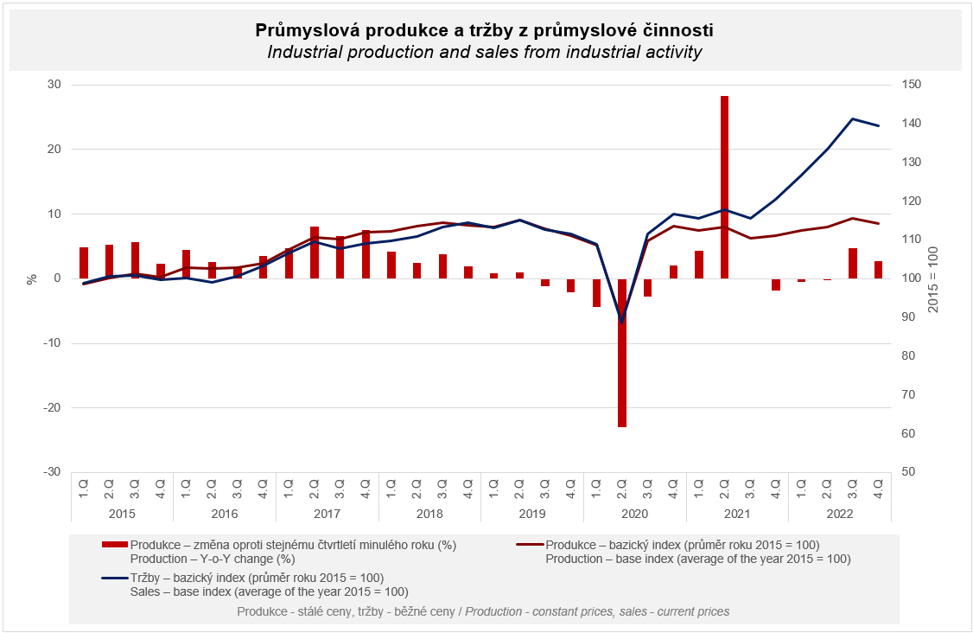

Sales from industrial activity at current prices increased by 15.0%, year-on-year, in 2022. Direct export sales of industrial enterprises increased at current prices by 11.3%. Domestic sales, which also include indirect export via non-industrial enterprises, increased at current prices by 19.8%.
Sales from industrial activity increased in all economic activities of industry. The following contributed the most to the increase: manufacture of motor vehicles, trailers and semi-trailers (a contribution +2.7 p. p, an increase by 11.8%), electricity, gas, steam and air conditioning supply (a contribution +2.0 p. p, an increase by 32.6%), and manufacture of fabricated metal products (+1.2 p. p, an increase by 14.4%).

The value of new orders at current prices in surveyed industrial CZ-NACE activities increased by 10.4%, year-on-year, in 2022. Non-domestic new orders increased by 8.0%. Domestic new orders increased by 15.6%.
The value of new orders only decreased, year-on-year, in manufacture of other transport equipment. The following contributed the most to the increase: manufacture of motor vehicles, trailers and semi-trailers (+3.1 percentage points (p. p.), an increase by 8.5%), manufacture of fabricated metal products (+1.7 p. p., an increase by 13.5%), and manufacture of electrical equipment (+1.3 p. p., an increase by 12.6%).

The average registered number of employees in industry in 2022 was by 0.1% lower compared to the corresponding period of the previous year. Their average gross monthly nominal wage increased by 8.2%.

Notes:

Contact person: Veronika Doležalová, Head of Industrial Statistics Unit, phone number (+420) 734 352 291, e-mail: veronika.dolezalova@czso.cz

Related outputs: time series in the Public database, the Industry chapter

