9 May 2018

Young Self-Employed Are on the Decrease, Self-Employed Seniors Are on the Rise
The share of the self-employed in the total number of working persons in the Czech Republic has been decreasing. In 2017 the percentage of the self-employed reached 17.1%. Nevertheless, the Czech Republic still belongs to countries with the highest share of the self-employed in the whole EU28. Over a half of the self-employed experience troubles related to their work. They mostly complain of administrative burden and delayed customer payments.
According to results of the Labour Force Sample Survey (LFSS) the number of persons in the main job reached 5 221.6 thousand persons in 2017. It is the highest number ever in history of the independent Czech Republic. The growth in the number of working persons in recent years has been driven mostly by an increase in the number of employees. The number of the self-employed, including contributing family workers, increased just by 28.1 thousand persons, especially due to a growth in the self-employed with no employees, i.e. own-account workers. This development resulted in a decline of the self-employed share in the total number of working persons. In 2017 the share reached 17.1%, which is by 0.6 percentage point (p.p.) less than in 2010.

Numbers of working persons by their status in employment in the main job from 2010 to 2017
Working persons  by status in employment | Working persons  (Thousand persons) |  | Increase/decrease  2017/2010 |  | Structure by status in employment in 2017  (%)
 | Year  2010 | Year  2017 | (Thousand persons) | (%)
Total | 4885.2 | 5221.6 | 336.4 | 6.9 | 100.0
Employees | 4019.2 | 4327.6 | 308.3 | 7.7 | 82.9
Self-employed,  incl. contributing family workers | 865.9 | 893.9 | 28.1 | 3.2 | 17.1
Self-employed with employees | 178.1 | 163.8 | -14.3 | -8.0 | 3.1
Self-employed without employees (own-account workers) | 658.3 | 705.5 | 47.1 | 7.2 | 13.5
Contributing family workers | 29.5 | 24.7 | -4.8 | -16.3 | 0.5
Source: CZSO, Labour Force Sample Survey

The self-employed are dominated by males (over two thirds of all the self-employed), and males also prevail in economic activities of construction, manufacturing, and in wholesale and retail trade; repair of motor vehicles and motorcycles. There is a considerable number of males working in professional, scientific and technical activities and in information and communication, in which a high level of formal educational attainment is often required. Females, on the contrary, outnumber males in the self-employed engaged especially in education and in human health and social work activities. Females definitely dominate the self-employed in other service activities, which cover, for example, hairdressing and cosmetics activities, wellness and mental well being activities, laundry and dry cleaning.

Numbers and shares of the self-employed, incl. contributing family workers, in total employment of respective economic activities of the national economy in 2017
Self-employed,  incl. contributing family workers |  | Total |  |  | Males |  |  | Females
 |  | Thous. persons | Percentage in total employment in the CZ-NACE section |  | Thous. persons | Percentage in total employment in the CZ-NACE section |  | Thous. persons | Percentage in total employment in the CZ-NACE section
Total |  | 893.9 | 17.1 |  | 596.7 | 20.5 |  | 297.2 | 12.9
CZ-NACE Section
Agriculture, forestry and fishing | A | 42.3 | 28.9 |  | 33.2 | 31.6 |  | 9.1 | 22.1
Manufacturing | C | 105.9 | 7.3 |  | 87.4 | 9.1 |  | 18.5 | 3.8
Construction | F | 162.7 | 41.5 |  | 158.0 | 44.2 |  | 4.7 | 13.8
Wholesale and retail trade; repair of motor vehicles and motorcycles | G | 125.6 | 20.9 |  | 82.1 | 29.6 |  | 43.4 | 13.5
Transportation and storage | H | 29.6 | 9.0 |  | 26.1 | 10.8 |  | 3.5 | 4.0
Accommodation and food service activities | I | 33.0 | 19.1 |  | 21.2 | 27.0 |  | 11.7 | 12.5
Information and communication | J | 35.0 | 23.5 |  | 30.8 | 27.2 |  | 4.2 | 11.7
Financial and insurance activities | K | 28.8 | 25.1 |  | 14.2 | 29.8 |  | 14.6 | 21.7
Real estate activities | L | 19.7 | 46.5 |  | 13.2 | 65.0 |  | 6.5 | 29.5
Professional, scientific and technical activities | M | 114.3 | 42.9 |  | 62.6 | 46.9 |  | 51.7 | 38.9
Administrative and support service activities | N | 25.9 | 19.8 |  | 13.1 | 19.0 |  | 12.7 | 20.8
Education | P | 22.4 | 6.5 |  | 6.8 | 8.5 |  | 15.6 | 5.9
Human health and social work activities | Q | 25.9 | 6.9 |  | 8.2 | 11.1 |  | 17.7 | 5.9
Arts, entertainment and recreation | R | 28.2 | 30.2 |  | 17.2 | 39.8 |  | 10.9 | 21.9
Other service activities | S | 54.6 | 61.8 |  | 11.4 | 45.7 |  | 43.2 | 68.2
Source: CZSO, Labour Force Sample Survey

The population of the Czech Republic, similarly as populations of other European countries, has been aging, which is also reflected in the age structure of the self-employed. Moreover, it remains a question if the young are willing to do business at such a scale as it used to be in the 1990s.

Between 2010 and 2017 the number of the self-employed increased by 28.1 thousand persons, namely due to an increment of the self-employed after they have reached the age of sixty years (41.2 thousand persons). A great increase in the number of the self-employed saw the age group of 40–44 years, which is related to natality in the 1970s. Conditions in the self-employed aged below 40 years are completely different, their number declined by 63.3 thousand persons from 2010 to 2017. Both the number of the self-employed employers of this age and the number of own-account workers, i.e. the self-employed with no employees, declined.

Detailed data clearly show that since 2010 a share of the self-employed, including contributing family workers, in the number of working persons of all age groups fell, except for the group of quinquagenarians.

Increase/decrease in the number of the self-employed from 2010 to 2017by age group
Indicator | Number of the self-employed with/no employees, incl. contributing family workers in 2017 | Increase/decrease  2017/2010 |  |  | Percentage of the self-employed in total employment  in the age group  in 2017 | Increase/decrease 2017/2010  in the share of the self-employed in the age group
 | Thousand persons | Thousand persons |  | % | % | Percentage point (p.p.)
Total | 893.9 | 28.1 |  | 3.2 | 17.1 | -0.6
Age group
(years)
Up to 29 | 75.8 | -19.6 |  | -20.5 | 9.2 | -1.7
30 to 34 | 86.4 | -29.9 |  | -25.7 | 14.7 | -1.9
35 to 39 | 117.6 | -15.8 |  | -11.9 | 16.6 | -1.6
40 to 44 | 152.8 | 34.6 |  | 29.2 | 18.1 | -0.9
45 to 49 | 131.0 | 2.0 |  | 1.5 | 19.5 | -1.7
50 to 54 | 119.8 | 10.3 |  | 9.4 | 19.0 | 0.1
55 to 59 | 94.1 | 5.2 |  | 5.9 | 18.0 | 0.5
60 to 64 | 67.9 | 22.8 |  | 50.4 | 22.4 | -2.1
65+ | 48.6 | 18.4 |  | 61.1 | 38.0 | -1.8
Source: CZSO, Labour Force Sample Survey

Continuous increase in the average age of working persons has been confirming the aging process of the population. It is clear from the development after 2010 as well. The average age of all working persons grew by 1.4 years and reached 43.2 years in 2017. Yet the average age of employees increased a bit less, by 1.3 years to reach 42.6 years. On the contrary, the average age of the self-employed with employees grew by 2.3 years to reach 48.2 years and the average age of own-account workers increased by 2.0 years to attain 45.7 years at the same time. The average age that grew most was that of contributing family workers by 3.2 years to attain 46.4 years. Data for this group may, however, be affected by a lower total number of these persons and thus resulting higher sampling error.
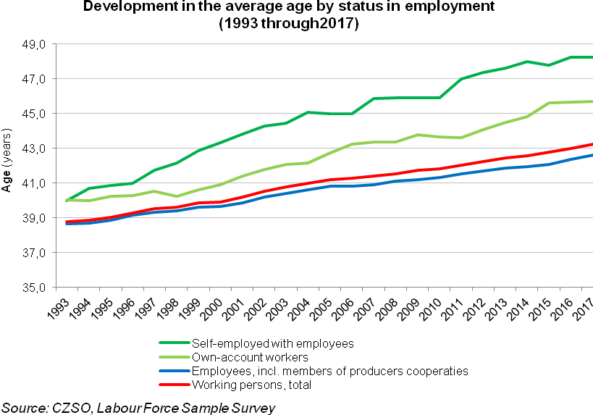

The Labour Force Sample Survey enables to quantify differences in status in employment among countries of the EU28. The comparison used the share of the self-employed without contributing family workers, own-account workers, in 2016.

The share of the self-employed without contributing family workers in the number of working persons in 2016 reached 14.7% for the whole EU, yet in the Czech Republic, although it was monotonously decreasing, it reached 16.6%, which is the sixth highest value of all Member States. Except for Poland, the Czech Republic neighbours feature a lower share of the self.-employed. It is significantly lower in Austria and especially in Germany.

The highest share of the self-employed was in Greece, followed by Italy, Romania, Poland, and Portugal. In Greece, a great portion of the self-employed of productive age work in trade, agriculture, and in economic activities connected with tourism. In Italy, they frequently do business in trade and professional, scientific and technical activities. In both the aforementioned countries the self-employed are predominantly the self-employed with no employees, own-account workers. In Romania and Poland, besides a high share of the self-employed in agriculture, a great portion of persons work in the primary sector as contributing family workers by status in employment. A high share of the self-employed in Portugal is significantly affected by a great number of the self-employed with no employees aged 65+ years.
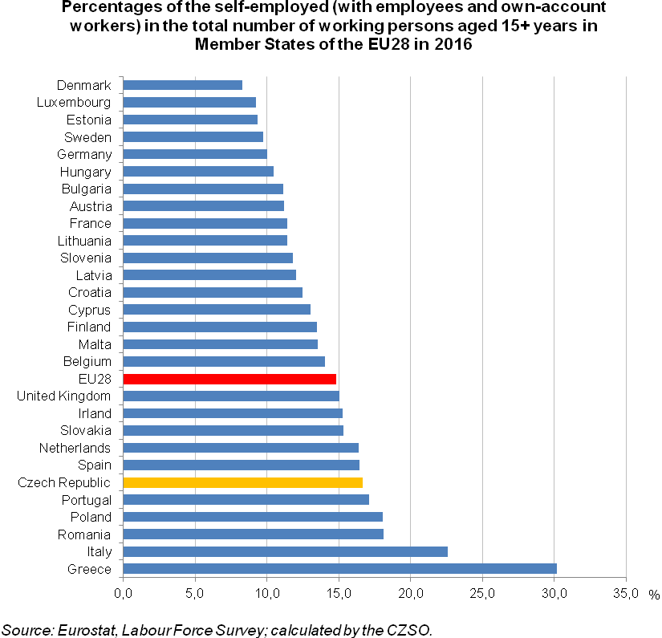

In numerous economic activities the Czech Republic features shares of the self-employed which are among the highest in the European Union. A share of the self-employed without contributing family workers in the Czech Republic in the section of other service activities in 2016 was the highest in the whole European Union (EU 30.9%, CR 60.2%) and the second highest shares were those in information and communication (EU 15.3%, CR 23.9%) and in financial and insurance activities (EU 10.3%, CR 26.5%).

A higher share of the self-employed in the Czech Republic, compared to the EU28, was in other economic activities as well. The third highest shares of all the European Union Member States was those in the Czech Republic in construction (EU 27.3 %, CR 40.2%) and in professional, scientific and technical activities (EU 32.2%, CR 45.6%). A share of the self-employed in administrative and support service activities was the fourth highest in the EU28 (EU 13.0%, CR 17.4%), and the same holds for the share in real estate activities (EU 23.1%, CR 45.1%). A high share of the self-employed, the sixth highest overall, was the share in a large economic activities of wholesale and retail trade; repair of motor vehicles and motorcycles (EU 16.5%, CR 20.4%).

The difference in between the Czech Republic and the five Member States with the highest shares of the self-employed follows, first of all, from the size of the primary sector activities of agriculture, forestry and fishing. Countries in the South of Europe and Poland feature a high employment in these activities and, moreover, an essential portion of working persons are the self-employed concerning their status in employment. On the contrary, while the total number of working person in these activities in the Czech Republic is low, the lowest shares of the self-employed were recorded in these activities in the Czech Republic along with Slovakia.

In 2017 more detailed data on the group of the self-employed in main job were investigated within the LFSS in the ad hoc module for 2017 (AHM 2017), which was obligatory for all Member States of the European Union. The AHM 2017 comprised also questions enabling to compare the group of the self-employed (with employees and own-account workers) with the group of employees. The data were investigated at the first visit in households and grossed up to demographic data for the whole 2017. The reference period was twelve calendar months. The different methods of investigation and grossing-up affected the AHM 2017 results compared to results of the standard LFSS in a minimum way and therefore these data can be combined in mutual relations.

A vast majority of the self-employed in the Czech Republic has two clients, at least. Out of the total number of 852 thousand responses obtained from the self-employed, including 16 thousands persons, who had no client in the last year, there were 58.4 thousand self-employed who had just one client. These self-employed worked most frequently in services and trade.

The self-employed with at least two clients were further questioned if in their case there were at least 75% income generated from one client. The positive answer was received from 103.4 thousand persons. It was craft and related trades workers and professionals who gave such answer most often. This is also reflected in response structure by economic activities sections. Most of these persons worked in construction, manufacturing, and in professional, scientific and technical activities. The number of the self-employed, whose income was entirely or at least from 75% depended on one client, reached 162 thousand persons, which is about 19% of all the self-employed.

Within the AHM 2017 reasons why the respondent became a self-employed were surveyed. A majority of the self-employed, 267 thousand persons, i.e. almost 60%, stated they had a good opportunity for, or doing business as a self-employed is usual in the type of activity they work in, 241 thousand persons. Then, after a gap, followed the respondents who gave they wanted to have loose working hours, 96 thousand persons, i.e. 11%. This reason was often given by the self-employed in professional, scientific and technical activities. Just a bit less persons, 90 thousand persons, i.e. 10.5%, stated they became the self-employed for other reason, not specified in detail. Overall going self-employed was a voluntary decision of the respondent. Keeping the traditional family business was given as the main reason by 37.5 thousand persons, i.e. over 4%.

Answers which revealed that the respondent was forced by circumstances to go business were essentially less frequent. There were 47 thousand self-employed, that is just a bit more than 5% of all responses, who were not able to find a job as an employee. The number of the self-employed, who started to do business because their original employer asked them to become the self-employed, was mere 22 thousand persons, i.e. less than 3% of the self-employed. The cases the respondent was forced to go business for other reasons were more frequent. There were 55 thousand of such cases, i.e. over 6%. This reason was most frequently given by the self-employed in the economic activities section of activities of households as employers; undifferentiated goods- and services-producing activities of households for own use.

Majority of respondents (56%) encountered some kind of trouble during a year. The self-employed were mostly troubled with inadequate administrative burden and delayed customer payments or unpaid work. These reasons were given both by the employers and own-account workers. Among other reasons the more frequent were so-called other troubles related to business and insufficient income in time of illness. It was, first of all, craft and related trades workers and service and sales workers who experienced troubles with insufficient income.

Number of the self-employed (with employees and with no employees) by main trouble related to their work and by major group of the national version of the International Standard Classification of Occupations (CZ-ISCO) in 2017
 |  |  |  | Thousands persons
The self-employed  incl. contributing family workers |  |  |  | Main troubles of the self-employed related to their work
 |  |  |  | Total number of the self-employed experiencing troubles |  | 1 |  | 3 |  | 4 |  | 5 |  | 6 |  | 7 | 8 |  | ¹⁾
Total |  |  |  | 473.2 |  | 18.9 |  | 113.8 |  | 186.2 |  | 45.4 |  | 28.4 |  | 28.9 | 47.3
By CZ-ISCO major group
Managers |  | 1 |  | 44.6 |  | 1.0 |  | 14.4 |  | 20.0 |  | 1.4 |  | 3.1 |  | 1.7 | 2.6
Professionals |  | 2 |  | 63.5 |  | 2.9 |  | 10.7 |  | 32.8 |  | 2.5 |  | 2.6 |  | 4.6 | 6.9
Technicians and associate professionals |  | 3 |  | 64.6 |  | 2.5 |  | 14.8 |  | 28.4 |  | 5.0 |  | 4.2 |  | 3.9 | 5.3
Clerical support workers |  | 4 |  | 13.2 |  | . |  | 1.2 |  | 7.5 |  | 1.4 |  | 1.2 |  | . | 1.2
Service and sales workers |  | 5 |  | 94.4 |  | 1.8 |  | 9.1 |  | 38.2 |  | 13.8 |  | 7.3 |  | 7.1 | 15.7
Skilled agricultural, forestry and fishery workers |  | 6 |  | 17.8 |  | 2.7 |  | 3.0 |  | 7.3 |  | 1.2 |  | . |  | - | 3.0
Craft and related trades workers |  | 7 |  | 144.8 |  | 6.7 |  | 53.7 |  | 41.3 |  | 16.6 |  | 6.8 |  | 7.7 | 10.9
Plant and machine operators, and assemblers |  | 8 |  | 26.8 |  | . |  | 6.6 |  | 9.5 |  | 3.6 |  | 1.9 |  | 2.8 | 1.7
Source: CZSO, Labour Force Sample Survey, AHM 2017
¹⁾ Explanatory notes:
1 – Limited affection of labour price determination |  |  |  |  | 6 – Period of financial troubles
3 – Delayed payments or unpaid deliveries |  |  |  |  | 7 – Lack of work
4 – Excessive administrative burden |  |  |  |  | 8 – Other trouble
5 – Insufficient income during illness
Note: A minimum number of respondents (solely 4 thousand persons) gave an insufficient access to financial resources for the enterprise as a trouble (code 2, not shown in the Table).

Within the AHM 2017 all working persons were asked on their level of job satisfaction. Job satisfaction of the respondents is high in general. There were 94.2% of all working persons who reported very high or partial job satisfaction. The employers showed very high job satisfaction (97.1%), but there were other groups of working persons, which showed high job satisfaction as both contributing family workers and own-account workers. The lowest share of job satisfaction was in the largest group of employees. Nevertheless, there were 94% persons job satisfied in this group.

Differences in between males and females are very small. Females in the position of the self-employed with employees showed the highest level of job satisfaction (98.2%) at all.

Job satisfaction by status in employment
 |  |  |  |  | Percentage
Working persons | Total of responses | Very high job satisfaction | Partial job satisfaction | Rather job unsatisfied | No job satisfaction
Status in employment according to the national version of the International Classification of Status in Employment (CZ-ICSE)
 | Total
Total | 100.0 | 49.4 | 44.8 | 4.7 | 1.0
Employees | 100.0 | 48.3 | 45.7 | 4.9 | 1.1
Self-employed with employees | 100.0 | 60.7 | 36.4 | 2.8 | 0.2
Self-employed with no employees | 100.0 | 53.3 | 42.0 | 3.7 | 1.0
 | Males
Total | 100.0 | 49.0 | 45.9 | 4.1 | 0.9
Employees | 100.0 | 47.8 | 46.9 | 4.3 | 1.0
Self-employed with employees | 100.0 | 58.9 | 37.8 | 3.0 | 0.2
Self-employed with no employees | 100.0 | 52.5 | 43.4 | 3.4 | 0.7
 | Females
Total | 100.0 | 50.0 | 43.4 | 5.4 | 1.2
Employees | 100.0 | 48.9 | 44.3 | 5.7 | 1.1
Self-employed with employees | 100.0 | 66.7 | 31.5 | 1.9 | 0.0
Self-employed with no employees | 100.0 | 55.0 | 39.2 | 4.1 | 1.7
Source: CZSO, Labour Force Sample Survey, AHM 2017
Note: Results for contributing family workers are not given because of their lower reliability.

A high level of job satisfaction has been confirmed also by data on statements if the self-employed would rather work as employees or vice versa, how many employees would rather go doing business as the self-employed. A number of the self-employed willing to work as employees was 83.2 thousand persons, i.e. almost 10% of all own-account workers. A number of employees who would rather go business as the self-employed was higher, 148 thousand persons, yet expressed relatively it was a very small share and reached mere 3.4% of all employees.

In majority of major groups of the national version of the International Standard Classification of Occupations (CZ-ISCO) numbers of employees willing to go business as the self-employed were higher than those of the self-employed willing to work as employees. Working persons in services and trade form an exemption. Among them the number of the self-employed who would rather work as employees was higher than the number of employees considering going business as the self-employed. A similar situation was recorded in the major group of skilled agricultural, forestry and fishery workers, yet in this case the difference is small.

Numbers of the self-employed and employees who would like to change their status in employment
 |  |  |  | Thousand persons
Working persons |  | The self-employed, which would like to work as employees | Employees, which would like to work as the self-employed | Difference
Total |  | 83.2 | 147.7 | 64.5
By CZ-ISCO main group
Managers | 1 | 1.5 | 6.9 | 5.4
Professionals | 2 | 9.6 | 23.7 | 14.1
Technicians and associate professionals | 3 | 10.4 | 23.0 | 12.6
Clerical support workers | 4 | 2.9 | 11.3 | 8.4
Service and sales workers | 5 | 33.0 | 23.6 | -9.4
Skilled agricultural, forestry and fishery workers | 6 | 2.2 | . | -1.5
Craft and related trades workers | 7 | 20.0 | 23.5 | 3.5
Plant and machine operators, and assemblers | 8 | 3.6 | 25.5 | 21.9
Elementary occupations | 9 | - | 9.4 | 9.4
Source: CZSO, Labour Force Sample Survey, AHM 2017
Authors
Marta Petráňová, Bohuslav Mejstřík
Unit for Labour Forces, Migration and Equal Opportunities
Czech Statistical Office
Tel.: +(420) 274 054 357; +(420) 274 052 203
E-mail: marta.petranova@czso.cz; bohuslav.mejstrik@czso.cz

