***2. Regional evaluation of FSS 2016 results***

*Regional results for the FSS 2016 are available at:*

<https://www.czso.cz/csu/czso/farm-structure-survey-regions-2016>

*Out of 26 525 agricultural holdings in 2016, the largest proportion farmed in* Jihomoravský *Region (14.2%) and the second largest share in* Středočeský *Region including* Hl. m. Praha *(13.2%). Natural persons represented more than 90% in* Královéhradecký *Region and* Zlínský *Region, and, on the contrary, only 81.0% of holdings in* Karlovarský *Region.*

*The largest part of the utilised agricultural area was concentrated in* Středočeský *Region including* Hl. m. Praha *(16.2%) and* Jihočeský *Region (12.0%). The highest average area was recorded for holdings of natural persons in* Karlovarský *Region (78.3 ha) and* Ústecký *Region (76.9 ha) and for holdings of legal persons in* Královéhradecký *Region (974.3 ha) and* Olomoucký *Region (940.4). By contrast, the lowest average area was recorded for holdings of natural persons in* Jihomoravský *Region (22.1 ha) and* Zlínský *Region (23.1 ha) and for holdings of legal persons registered in* Liberecký *Region (473.6 ha).*

***Graph 17: Average utilised agricultural area and the share of own land***



*Distinct differences among regions were found in the ownership of the utilised agricultural land. In* Karlovarský *Region the share of own land almost reached one half of the UAA (47.4%) while in all other regions it reached from one fifth (20.6% for* Zlínský *Region and 20.8% for* Vysočina *Region) to 38.5% for* Ústecký *Region. Even larger differences were recorded among holdings of natural persons: they owned 38.6% of the UAA in* Zlínský *Region and, on the contrary, 68.1% of the UAA in* Karlovarský *Region. Holdings of legal persons owned the largest part of the UAA in* Karlovarský *Region (35.6%) and the smallest one in* Vysočina *Region (11.4%).*

***Fig. 1: Share of own land in agricultural holdings***

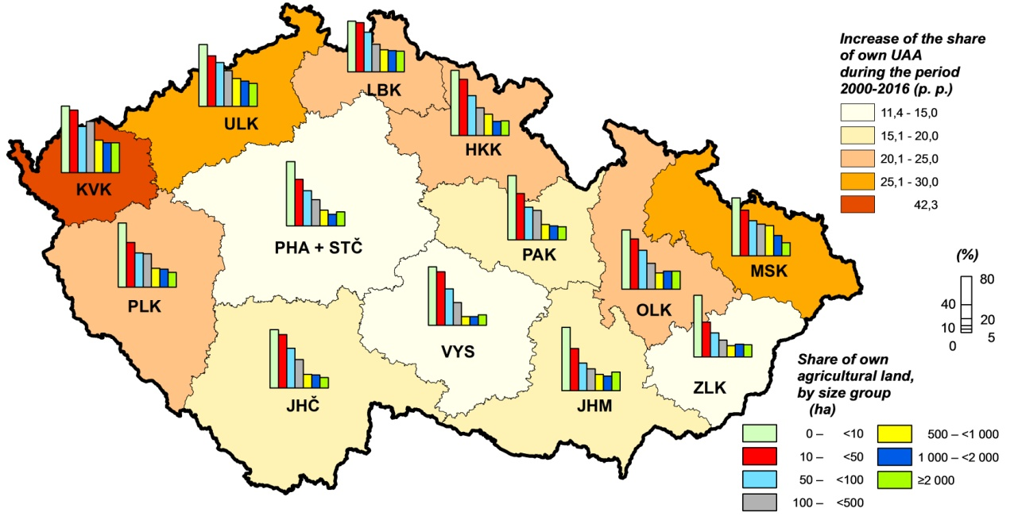

*Organic production methods were applied in the largest range in* Karlovarský *Region where more than one third (38.3%) of the holdings dealt with organic farming on more than a half (54.0%) of the UAA. The smallest share of holdings utilising solely organic production methods was found in* Jihomoravský *Region (3.7% of holdings and 4.0% of the UAA).*

***Fig. 2: Organic farming***

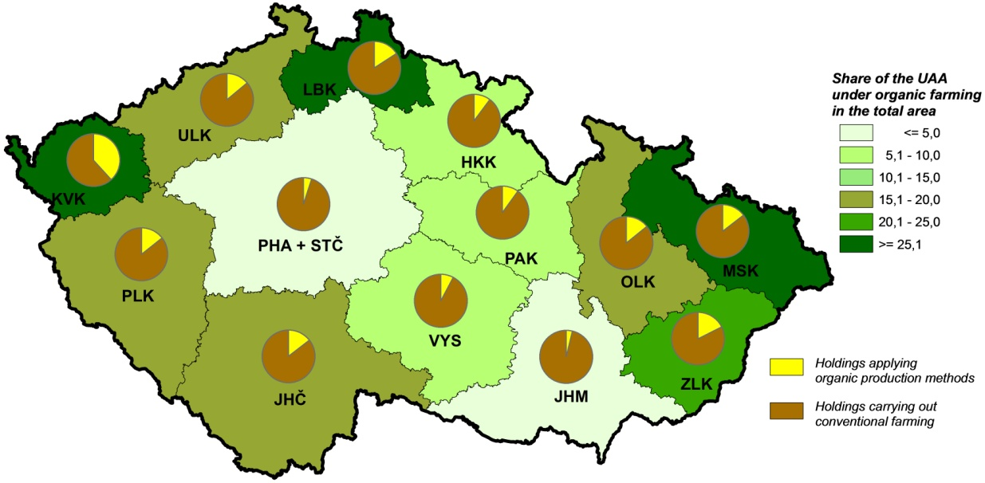

*In general, arable land dominated (71.5%) on the utilised agricultural area with some exceptions: in* Karlovarský *Region and* Liberecký *Region the majority of the UAA was covered by permanent grassland (64.0% and 59.6%, respectively) and a smaller part by arable land (35.9% and 39.2%, respectively). The largest share of arable land was recorded in* Jihomoravský *Region (88.8%) and* Středočeský *Region including* Hl. m. Praha *(86.9%) where the shares of permanent grassland were the smallest (6.1% and 12.1%, respectively). Growing of permanent crops was important only locally. Vineyards comprised 4.0% of the UAA in* Jihomoravský *Region and less than 1% of the UAA in* Zlínský *Region,* Ústecký *Region,* Středočeský *Region including* Hl. m. Praha *and* Vysočina *Region. Hop gardens grew on 1.4% of the UAA in* Ústecký *Region and less than 1% of the UAA in* Středočeský *Region including* Hl. M. Praha *and in* Olomoucký *Region. Orchards represented 1.2% of the UAA in* Liberecký *Region and the level of 1% of the UAA was surpassed also in* Jihomoravský *Region and* Zlínský *Region.*

***Graph 18: Share of arable land***



*Cereals were the crop group which was most frequently planted on arable land in all regions; the greatest share was recorded for* Jihomoravský *Region (62.7%) and* Ústecký *Region (62.5%), and the smallest one for* Vysočina *Region (47.6%) and* Pardubický *Region (49.0%). Cereal areas consisted of wheat in one half (*Olomoucký *Region, 54.4%) to almost three quarters (*Ústecký *Region, 73.1%) of their area. In* Jihomoravský *Region, maize for grain was an important crop (45.2% of the total area of maize). Growing of potatoes was concentrated in* Vysočina *Region (38.8% of the total area of potatoes) and in* Středočeský *Region including* Hl. m. Praha *(22.3%). In* Středočeský *Region including* Hl. m. Praha, *the largest shares of rape and turnip rape (22.0%), as well as of soya (23.0%), other oleaginous crops (20.2%), vegetables (41.1%) or strawberries (55.0% of their area) were planted. Some crops were largely grown in particular regions; e. g.* Pardubický *Region was specialised in medicinal plants and plants for seasoning (24.6% of their total area),* Jihomoravský *Region dominated growing of sunflower (51.3% of the total area of sunflower) and* Olomoucký *Region focused on flowers and ornamental plants (40.6% in of their total area).*

***Graph 19: Share of cereals in arable land***



*Permanent grassland was the most frequent type of land use in organic crop production with the only exception of* Jihomoravský *Region where it represented only one third (30.9%) of the UAA under organic farming while organically farmed arable land covered 58.3% of the UAA under organic farming. The largest share of permanent grasslands was in* Ústecký *Region (94.3%) where arable land comprised only 4.5% of the UAA under organic production methods. More than one half of all permanent grasslands were farmed organically in* Karlovarský *Region (75.7% of their area),* Ústecký *Region (64.4%),* Moravskoslezský *Region (56.8%),* Zlínský *Region (56.1%) and* Olomoucký *Region (54.0%). Orchards were organically farmed mostly in* Karlovarský *Region (97.6% of their area) and* Vysočina *Region (69.1%). In* Jihomoravský *Region, orchards covered 5.7% of the organically farmed UAA.*

*The largest share of arable land where organic production methods were applied was recorded in* Karlovarský *Region (15.2% of its area). The most frequent crops on arable land organically farmed were cereals (from 34.3% of arable land organically farmed in* Ústecký *Region to 59.7% in* Karlovarský *Region); plants harvested green (from 22.2% for* Jihomoravský *Region to 51.2% for* Zlínský *Region); and in* Jihomoravský *Region and* Ústecký *Region also industrial crops (15.0% and 14.3%, respectively, of arable land organically farmed).*

***Graph 20: Share of permanent grassland in the UAA under organic production***



*As for raising of cattle, there were distinct differences among regions. The largest shares in cattle totals were recorded for* Jihočeský *Region (16.0%) and* Vysočina *Region (15.3%), but both regions differed in cattle types: the largest number of dairy cows was concentrated in* Vysočina *Region (20.1% of their total number) while of other cows in* Jihočeský *Region (19.3% of their total number). In* Vysočina *Region the cattle density was the highest both for cattle totals (60 head per 100 ha of the UAA) and for dairy cows (21 head per 100 ha of the UAA) while for other cows the highest value (19 head per 100 ha of the UAA) was reached in* Karlovarský *Region. The lowest densities were recorded in* Jihomoravský *Region for cattle totals (18 head per 100 ha of the UAA) and for other cows (1 head per 100 ha of the UAA) and in* Ústecký *Region for dairy cows (2 head per 100 ha of the UAA).*

***Graph 21: Raising of cattle***



*Raising of pigs was concentrated in* Středočeský *Region including* Hl. m. Praha *and in* Vysočina *Region (both 20.2%) while only 1.0% of pigs was recorded in* Karlovarský *Region. Pig density was the highest in* Vysočina *Region (112 head per 100 ha of arable land) and the lowest in* Moravskoslezský *Region (31 head per 100 ha of arable land).*

*Holdings dealing with raising of poultry were mainly in* Středočeský *Region including* Hl. m. Praha *(23.6% of the total number), especially ones dealing with raising of chicken for breeding (24.5%), hens (24.8%) and chicken for fattening (23.2%). The lowest shares of poultry were recorded in* Liberecký *Region (0.3%) and* Karlovarský *Region (0.9%). The highest poultry density was in* Pardubický *Region (2 423 head per 100 ha of arable land) and* Královéhradecký *Region (1 522 head per 100 ha of arable land), the lowest one in* Vysočina *Region (137 head per 100 ha of arable land). The level of 1 000 head per 100 ha of arable land was surpassed also for chicken for fattening in* Pardubický *Region (1 433 head per 100 ha of arable land).*

***Graph 22: Pig density***

*(head per 100 ha of arable land)*



***Graph 23: Raising of poultry***



*The highest shares of sheep were recorded in* Jihočeský *Region (12.5% of their total number) and in* Středočeský *Region including* Hl. m. Praha *(12.2%). The lowest share, only 3.9%, was kept in* Jihomoravský *Region. Sheep density was the highest in* Liberecký *Region (20 head per 100 ha of the UAA) and* Zlínský *Region (17 head per 100 ha of the UAA).*

*Out of other livestock species, goats were raised mostly in* Středočeský *Region including* Hl. m. Praha *(14.6% of their total number) as well as horses (17.9%). Raising of rabbits was concentrated in* Pardubický *Region (15.4%). The highest numbers of beehives were recorded in* Jihomoravský *Region and* Středočeský *Region including* Hl. m. Praha *(16.7% and 15.8%, respectively, of the total number of beehives).*

*Organically reared animals represented an important part of livestock in several regions. It concerned especially* Karlovarský *Region where 65.3% of cattle (25.1% of dairy cows), 2.4% of pigs, 65.9% of sheep, 47.4% of goats, and 62.0% of horses, donkeys and their hybrids were raised at organic farms. Another example is* Liberecký *Region with the highest share of organically reared goats (54.8%) and poultry (9.9%). The lowest proportions of organically reared animals were recorded in* Jihomoravský *Region (2.6% for cattle; 13.7% for horses, donkeys and their hybrids),* Pardubický *Region (26.1% for sheep) and* Olomoucký *Region (12.5% for goats). No pigs were organically reared in* Moravskoslezský *Region and* Liberecký *Region and no poultry in* Olomoucký *Region.*

***Graph 24: Dairy cows organically reared Graph 25: Sheep organically reared***



***Fig. 3: Shares of livestock organically reared***

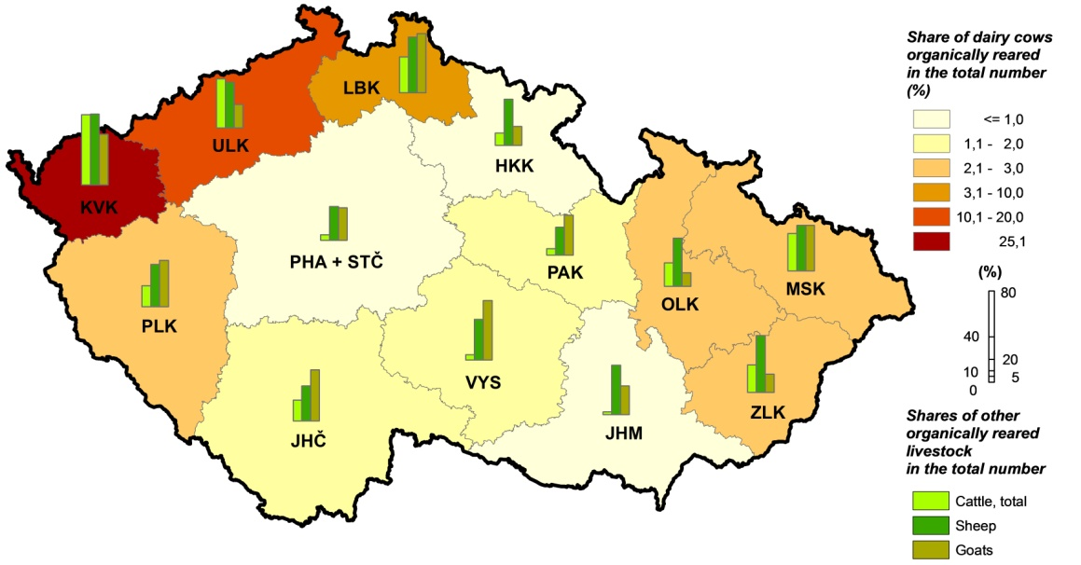

*The largest proportion of working persons in agriculture was concentrated in* Středočeský *Region including* Hl. m. Praha *(14.7%) and* Jihomoravský *Region (13.5%). The largest share of labour force regularly employed was recorded in* Karlovarský *Region (81.6%) and* Zlínský *Region (79.2%), the lowest one in* Ústecký *Region (46.3%). The highest number of workers per one holding was in* Pardubický *Region (9.5 persons), the lowest one, on the other hand, in* Liberecký *Region (4.2 persons). The average number of workers per 100 ha of the UAA ranged from 2.7 persons in* Karlovarský *Region to 6.9 persons in* Jihomoravský *Region. The share of women in persons regularly employed was the highest in* Jihomoravský *Region (37.0%) and* Pardubický *Region (35.0%) and the lowest in* Plzeňský *Region (28.8%) and* Ústecký *Region (28.9%).*

*The share of Annual Work Units (AWU) in the total number of working persons was the highest in* Karlovarský *Region (64.7%).* Ústecký *Region differed from all other regions with the share lower than one half – only 41.5%. This finding, together with low proportion of labour forces regularly employed, shows that local agricultural holdings focused on activities with a high proportion of seasonal works (e.g. harvest of fruits and vegetables).*

***Graph 26: Working persons per 100 ha of the utilised agricultural area***



*Labour force not regularly employed (i.e. working on the basis of a contract for work or for services) was most common in* Středočeský *Region including* Hl. m. Praha *(7 555 persons) and* Ústecký *Region (6 893 persons). One person worked on average 159 hours; in regions this number ranged from 124 hours in* Olomoucký *Region to 180 in* Vysočina *Region. Other persons working in agriculture were those employed not directly by agricultural holdings (self-employed persons or persons employed by job agencies). The largest number of persons of both sub-categories worked in* Středočeský *Region including* Hl. m. Praha *(204 self-employed persons and 981 persons employed by job agencies). The average number of hours worked by persons employed not directly by agricultural holdings was 667 hours; ranging from the lowest in* Středočeský *Region including* Hl. m. Praha *(489 hours) to the highest in* Karlovarský *Region (1 232 hours).*

*The age structure did not differ distinctly among regions. The largest share of young workers was recorded in* Moravskoslezský *Region with 21.6% for the age group up to 34 years. More than 20% of workers up to 34 years were also in* Ústecký *Region (20.1%). On the contrary, the lowest shares were in* Jihomoravský *Region (16.2%) and* Zlínský *Region (16.9%). The share of workers aged 35–54 years ranged from 43.5% for* Královéhradecký *Region to 49.7% for* Pardubický *Region. The age group of 55 years and over was most common in* Zlínský *Region (39.6%) and* Jihomoravský *Region (39.5%); the lowest shares were recorded in* Pardubický *Region (31.4%) and* Vysočina *Region (33.2%).*

***Graph 27: Age structure of labour force regularly employed***



***Fig. 4: Changes in the age structure during 2010-2016***

