- Structure of agricultural holdings broken down by types of farming

The EU agricultural holdings classification system provides an additional view to Czech agricultural structures in term of type of farming. The basic information on the number of holdings in particular regions broken down by types of farming is given in Annex B1. The results show that Czech agricultural production is concentrated mainly in three prevailing types of farming; specialist grazing livestock, specialist field crops and mixed crops-livestock. Moreover, the distribution of particular types of farming depends on regional soil-climatic and economic conditions.
The largest share of the holdings is formed by specialist grazing livestock, whose development was conditioned by support of breeding suckler cows in frame of CAP and is typical for the Less Favoured Areas. The grazing livestock specialists forms more than one third of the total agricultural holdings in the Czech Republic (34.6%). Nevertheless, ca 70% of these farms represents the small-scale holdings, which is caused by the large share of natural person holdings within this specialisation (90.6%). Agricultural holdings specialized in grazing livestock utilise less than a quarter (23.8%) of agricultural land resources. The share of these holdings on total animal production expressed in livestock units is 28.9%. As for particular regions, the largest proportion of cattle rearing is concentrated in Karlovy Vary Region (67%), followed by Liberec Region (61%) and Zlín Region (52%). In absolute numbers, most of grazing livestock specialists operate in South Bohemia Region (1 465 holdings).

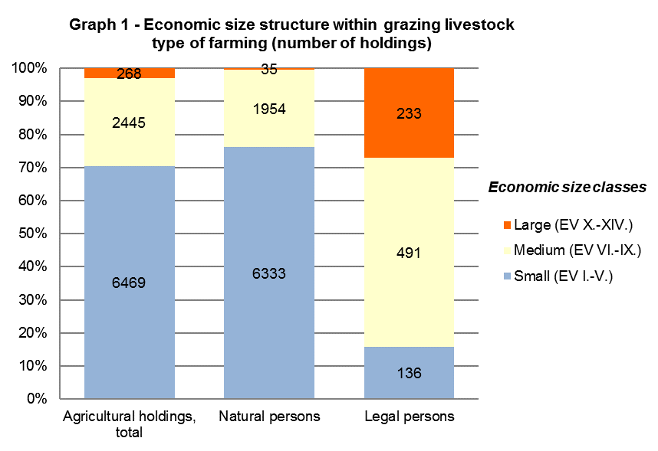

In detail, the group of grazing livestock specialists consists of specialist dairying (9.9%), specialist cattle – rearing and fattening (41.3%), cattle – rearing and fattening combined (3.1%) and sheep, goats and other grazing livestock (45.7%). A more intensive form of production is typical for the specialist dairying compared with other types of farms. In the frame of grazing livestock type of farming, dairy farms include 43% of total livestock units. One holding of dairying specialist therefore rears on average 223 livestock units. Another significant type of farming is specialist cattle-rearing and fattening, sharing 50% of agricultural land and 43% of livestock units within the abovementioned general type of farming. Average number of livestock units in this type of farming reaches 54 LSU per holding. The most frequent type of farming regarding the number of holding is sheep, goats and other grazing livestock type (4 197 holdings). However, the share of 94% of the total number of these farms is covered by small holdings; therefore, its economic significance within the agricultural sector is negligible.
Specialist field crops plays an important role among analysed types of farming, with significant impact on the economy of Czech agriculture. Approximately less than one third of Czech farms is specialized in field crops production (30%). The share on the total acreage of utilized agricultural is 35%. Concerning the legal form, the majority (88%) of field crops specialists is formed by natural person. In terms of the size structure, medium-scale holdings prevail within the group of field crops holdings (47%). As for regional evaluation, most of the field crops specialists is situated in the Central Bohemian Region (1 749 holdings) with the largest proportion of this type of farming (52%), if we leave aside the capitol city of Prague as non-agricultural separate region. Important position is held also by Vysočina Region (1 039 holdings) and South Moravian Region (829 holdings). In general, the regions suitable for field crops planting are naturally determined by altitude and soil-climatic conditions.
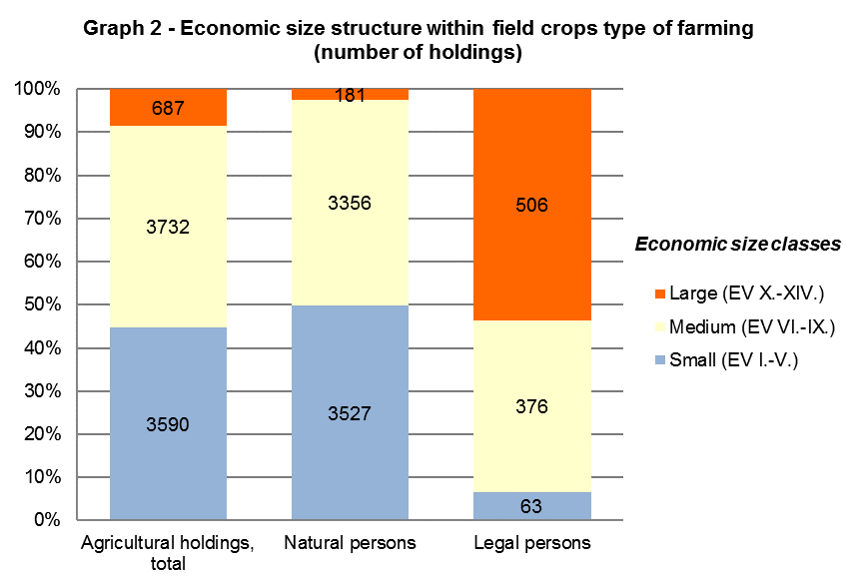
In detail, the general type of specialist field crops consists of specialist cereals, oilseeds and protein crops and general field cropping (specialized in combined cropping of field crops, root crops and field vegetables). More than two thirds (69%) of these holdings belong to group of farms specialized in cereals and oilseeds cropping. The remaining 31% of field crops specialists were classified as general field cropping. The lower proportion of small-scale holdings (41%) is typical for the group of the cereals and oilseeds specialists. The average acreage reaches 167 hectares per holding in this type of farming. Within agricultural holdings specialized in general field cropping, the proportion of small size farms is more significant (54%); which results in lower value of the average acreage (112 ha/holding).
The group of agricultural holdings specialized in mixed production is primarily composed of mixed crops-livestock farms. On a small scale, holdings oriented on mixed cropping and mixed livestock production are also involved. With the total number of 5 387 holdings, the mixed production type of farming represents the third most frequent agricultural specialization in the Czech Republic. Nevertheless, in consideration of high share of large-scale legal persons (13% within the mixed production type of farming), the group of mixed production specialists concentrates the substantial part of Czech agricultural production. Mixed production farms cover 40% of total utilized agricultural area and 43% of the total number of livestock units. The most of mixed production farms is situated in Vysočina Region (729 holdings) with the 29% share on total number of agricultural holdings in this region. The high proportion of mixed production farms also occurs in Central Bohemian Region (704 holdings) and South Bohemian Region (700 holdings). In general, the share of mixed production holdings varies from 20% to 30% in particular regions, with the exception of Karlovy Vary Region, South Moravian Region, Liberec Region, Zlín Region and Ústí nad Labem Region.
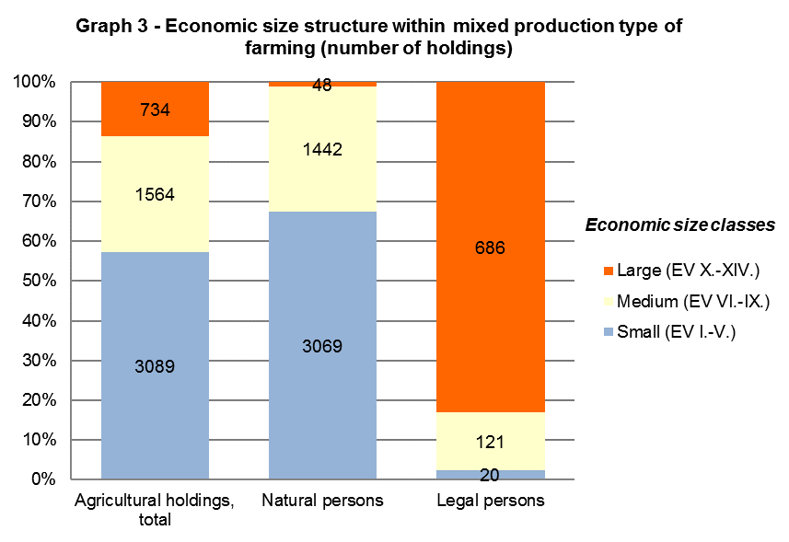
The combination of field crops and grazing livestock production is the prevailing type of farming (59% of holdings) within the group of mixed production specialists, followed by various crops and livestock combined (25%), mixed livestock, mainly grazing livestock (12%), mixed cropping (5%) and mixed livestock, mainly granivores (3%). In frame of mixed production type of farming, holdings specialized in combined field crops and grazing livestock production cover the highest share of both utilized agricultural area (74%) and number of livestock units (65%). This group of farms reaches 320 ha/holding and 141 LSU/holding on average.
The number of holding specialized in rearing of granivores was decreasing in recent years due to the economic crisis in pig farming industry. The Farm Structure Survey 2016 involved 351 holdings within this type of farming. High proportion of legal persons (42%) and large-scale holdings (36%) is typical for this group. Agriculture holdings belonging to specialist granivores can be characterized by intensive way of rearing. These holdings concentrate 24% of the total number of livestock units in the Czech Republic. On average, granivores specialists reach 1 108 LSU/holding.
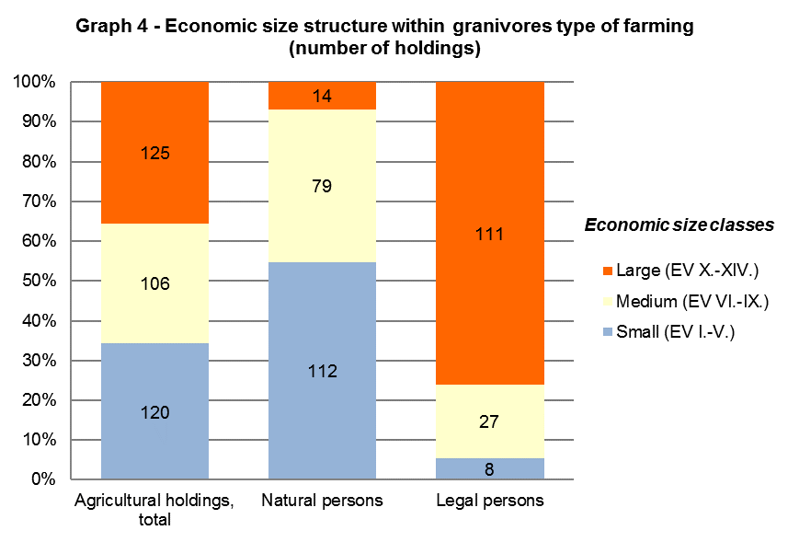

Principal type of farming specialist granivores includes specialist pig (43%), specialist poultry (44%) and various granivores combined type, i.e. combination of specialist pig and poultry (13%).
Despite the marginal share on total utilized agricultural area (1%), holdings specialized in horticulture and permanent crops generate the significant part of Czech agricultural production. Holdings of natural person prevail within this type of farming (91%); therefore, the largest proportion is formed by small size holdings (70%). In frame of both horticulture and permanent crops specialist, the average acreage is 11 ha/holding. The regional distribution is predominantly determined by climatic conditions. The production is concentrated into traditional fruit crop and wine-producing regions. In South Moravian Region operate 2 321 horticulture and permanent crops holdings, which form approximately two thirds (66%) of these holdings in the Czech Republic.
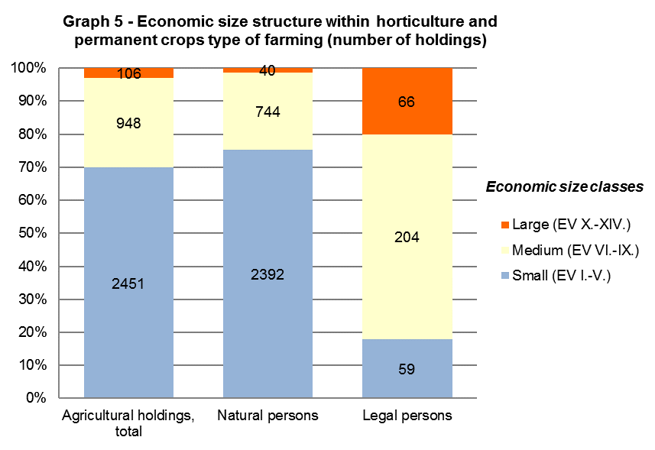
The principal type of farming horticulture is represented by 406 holdings. This group consists of specialist horticulture outdoors (46%) and other horticulture (54%). Other horticulture involves holdings specialized in nurseries and mushroom production. Holdings specialised in indoor horticulture (green houses, foil covers) have not been included in the Farm Structure Survey.
The specialist permanent crops represents the larger group concerning number of holdings (3 099 holdings). This group is divided into specialist vineyards (68%), specialist fruit (27%) and various permanent crops combined (5%). More than three quarters (76%) of specialist vineyards type of farming belong to small size economic classes. Specialist vineyards reach average acreage of 8 ha/holding. In case of specialist fruit, small size holdings form 72% within this specialization. Fruit farms utilize 16 ha/holding on average.
The Farm Structure Survey 2016 included a small group of 91 non-classified holdings, whose type of farming and economic size class could not have been determined. These holdings utilize fallow land for which EU typology methods set the value of standard output as equal to zero, therefore they cannot be classified into one of the type of farming or economic size groups.

