October 16, 2018

PRODUCER PRICE INDICES IN Q3 2018

In Q3 2018, compared to Q2 2018, agricultural producer prices (+1.6%), industrial producer prices (+1.2%) and construction work prices, according to an estimate (+1.1%) were all higher. Prices of market services for businesses were lower by 0.5%.

In comparison with Q3 2017, agricultural producer prices went down by 2.3% in Q3 2018. Prices of industrial producers (+3.3%), construction work prices, according to an estimate (+3.6%) and prices of market services for businesses (+1.6%) all went up.

Compared to **Q2 2018,** **agricultural producer** prices rose by 1.6% in **Q3 2018**.Increasing were prices of potatoes (+6.3%), oil plants (+4.4%), cereals (+3.1%) and pigs for slaughter (+2.6%). Lower were prices of fresh fruit (-40.6%), fresh vegetables (-13.9%), milk (-2.1%), eggs (-1.4%) and cattle for slaughter (-1.2%).

Prices of **agricultural producers** in **Q3 2018** compared to **Q3 2017** decreased by 2.3%. Prices of crop products went up by 1.1% and prices of animal products fell by 6.1%. Higher prices in crop products were mainly affected by prices of cereals (+6.0%) and fresh vegetables (+23.2%). On the decrease were prices of fresh fruit (-36.5%), potatoes (-3.2%) and oil plants (-4.2%). Among animal products price decreases were recorded in pigs for slaughter (-19.7%), milk   
(-3.2%), poultry (-2.2%), cattle for slaughter (-0.5%) and eggs (-0.4%).

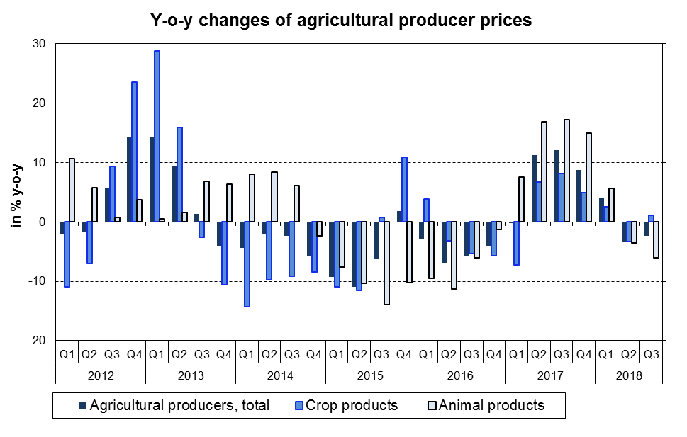

In comparison with Q2 2018, prices of **industrial producers** were higher by 1.2% in **Q3 2018**. Prices went up primarily in ‘coke, refined petroleum products’. Prices were higher in ‘chemicals and chemical products’ (+3.8%), ‘wood, wood products, paper, printing’ (+1.4%) and ‘computer, electronic and optical products’ (+1.3%). Prices rose in ‘food products, beverage, tobacco’ and ‘electricity, gas, steam and air conditioning’ (+0.7% both). On the decrease were prices only in ‘electrical equipment’ (-0.1%).



Prices of **industrial producers** increased in Q3 2018 by 3.3 % y-o-y. Prices went up particularly in ‘coke, refined petroleum products’. Prices were higher in ‘mining and quarrying’ (+9.4%). Price rose in ‘chemicals and chemical products’ (+7.8%), it was a significant increase by 10.1 p.p. compared to 2Q 2018. On the increase were prices in ‘basic metals, fabricated metal products’ (+3.8%). On the decrease were prices only in ‘transport equipment’ (-0.8%) and ‘food products, beverages, tobacco’ (-0.9%).



According to an estimate, **construction work** prices in **Q3 2018** compared to **Q2 2018** (after specification) were higher by 1.1% and prices of construction material input grew by 1.3%.

According to an estimate, **construction work** prices **in Q3 2018** **compared to the corresponding period of 2017 (after specification)** rose by 3.6%, prices of construction material input increased by 4.4%.

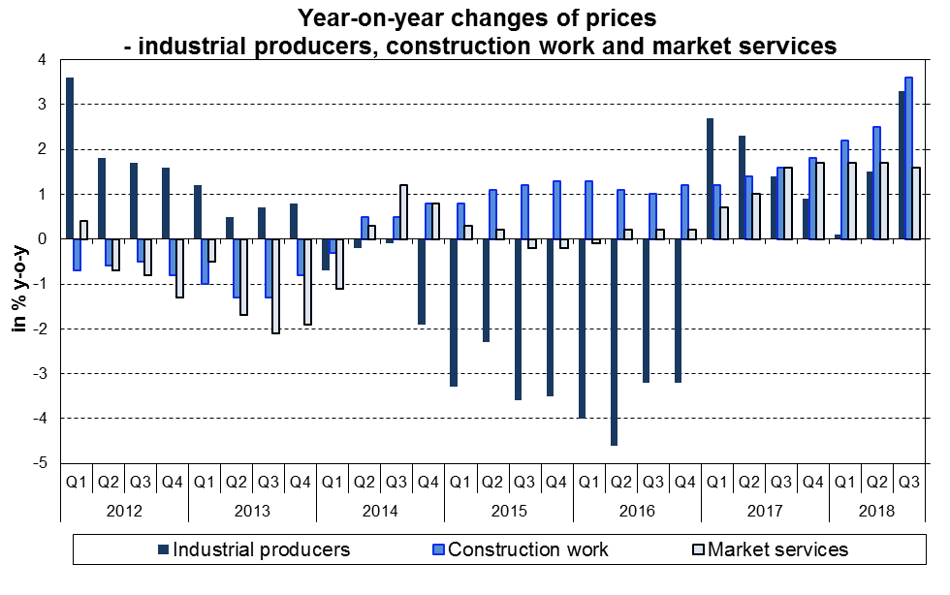

**In comparison to Q2 2018,** prices of **market services for businesses** dropped by 0.5% in **Q3 2018**. Lower were especially prices of ‘advertising and market research services’ (-9.8%), ‘employment services’ (-2.6%) and ‘management consulting services’ (-1.6%). Higher were prices of ‘insurance, reinsurance and pension funding services, except compulsory social security’ (+1.3%), ‘land transport services’ (+1.0%) and ‘financial services, except insurance and pension funding’ (+0.4%). Prices of market services excluding advertising services grew by 0.2%.

**In Q3 2018,** prices of **market services for businesses** rose by 1.6% in total compared to **Q3 2017**.Price increases were recorded in ‘postal and courier services’ (+5.3%), ‘insurance, reinsurance and pension funding services, except compulsory social security’ (+5.4%), ‘land transport services’ (+1.6%), ‘legal and accounting services’ (+1.5%) and ‘advertising and market research services’ (+0.6%). Lower prices were in ‘warehousing and support services for transportation’ (-2.6%). Prices of market services excluding advertising services went up by 1.7%.

***Text not edited for language.***

Contact:

Ing. Miloslav Beranek

E-mail: miloslav.beranek@czso.cz

Phone: (+420) 274 052 665