16 August 2018

External Trade Price Indices Development in Q2 2018

In Q2 2018, compared to Q1 2018, export prices and import prices increased by 1.3% and 1.8%, respectively. Terms of trade reached the value of 99.5%. Compared year-on-year, in Q2 2018 export prices fell by 1.6%, import prices declined by 2.4%, and terms of trade reached the value of 100.8%.

# Quarter-on-quarter (q-o-q) comparison

Export prices in Q2 2018, compared to Q1 2018, increased by 1.3% (in Q1 2018 they did not changed, q-o-q). A highest price increase was recorded in 'mineral fuels, lubricants and related materials' by 4.9%, followed by price increases in 'manufactured goods classified chiefly by material' by 1.9%, 'chemicals and related products’ by 1.3%, and in 'machinery and transport equipment’ by 1.0%. Prices did not see a decline in any of the groups of goods measured.

Import prices in Q2 2018, compared to Q1 2018, increased by 1.8% (in Q1 2018 they decreased by 0.5%, q-o-q). A highest growth was recorded for 'mineral fuels, lubricants and related materials' by 8.8% and for 'machinery and transport equipment’ and for 'chemicals and related products’ both identically by 1.5%. The only prices that declined were those of ‘food and live animals’ by 0.3%.

The terms of trade figures in Q2 2018, compared to Q1 2018, reached the value of 99.5% (in Q1 2018 they stayed at 100.5%). Negative values of terms of trade were recorded namely for 'mineral fuels, lubricants and related materials' (96.4%), 'crude materials, inedible, except fuels' (99.0%), and for 'machinery and transport equipment’ (99.5%). Positive values of terms of trade were recorded namely for ‘food and live animals’ (100.7%), and for 'manufactured goods classified chiefly by material' (100.6%).

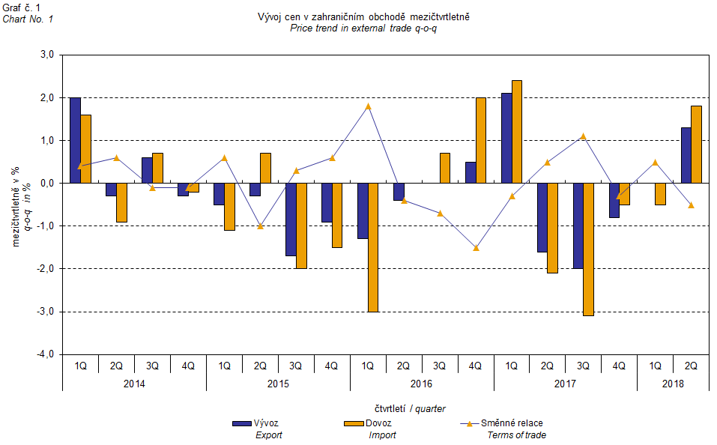

The external trade price development was also significantly affected by the CZK exchange rate to the major foreign currencies. The q-o-q exchange rate index includes two most important currencies from the Czech Republic’s external trade point of view, i.e. EUR and USD. Q-o-q indices of the CZK exchange rate to these currencies were weighted by the weight, which pertains to those foreign currencies in the export price index and import price index, respectively.

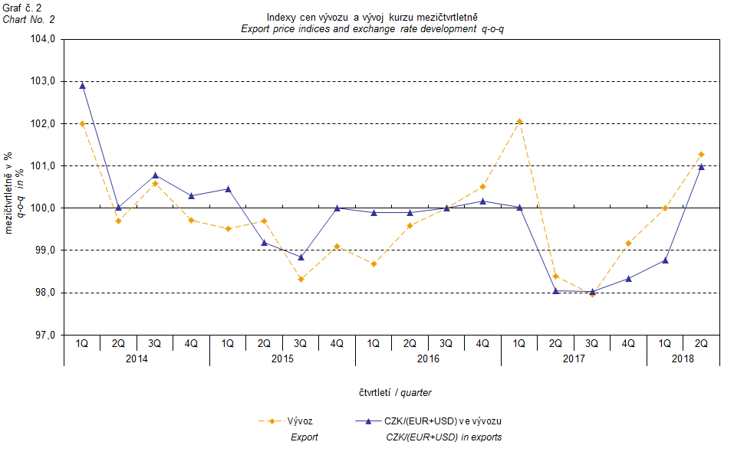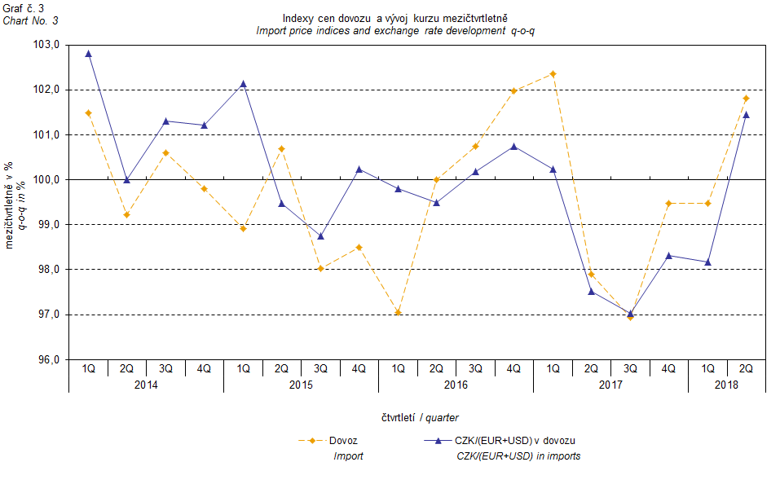

It can be seen from the aforementioned Graphs Nos. 2 and 3 that in both cases of imports and exports external trade prices have a strong relation to exchange rate impacts. Contracts with foreign entities are, as a rule, signed for a longer period of time and the longer the contract period is, the stronger the relation to exchange rates is.

# Year-on-year (y-o-y) comparison

Export prices in Q2 2018 decreased by 1.6%, y-o-y (in Q1 2018 they fell by 4.4%, y-o-y). Major declines were recorded for prices of ‘food and live animals’ by 3.6%, 'miscellaneous manufactured articles' by 3.4%, and 'machinery and transport equipment’ by 2.8%. The most growing prices were those of 'mineral fuels, lubricants and related materials' by 6.5% and of 'manufactured goods classified chiefly by material' by 1.6%.

Import prices in Q2 2018 declined by 2.4%, y-o-y (in Q1 2018 they declined by 6.1%, y-o-y). Prices that declined most were those for 'crude materials, inedible, except fuels' by 13.1%, ‘food and live animals’ by 7.3%, and 'machinery and transport equipment’ by 4.8%. Conversely, prices that grow most were those for 'mineral fuels, lubricants and related materials' by 16.3%.

Terms of trade in Q2 2018 decreased year-on-year to reach the value of 100.8% (in Q1 2018 they were 101.8%) and so they nevertheless remained in positive values, see Graph No. 4 below. The highest positive values of terms of trade were recorded for 'crude materials, inedible, except fuels' (113.3%), followed by ‘food and live animals’ (104.0%), 'manufactured goods classified chiefly by material' (102.2%), and 'machinery and transport equipment' (102.1%). Negative values of terms of trade was recorded namely for 'mineral fuels, lubricants and related materials' (91.6%) and for 'chemicals and related products’ (99.0%).

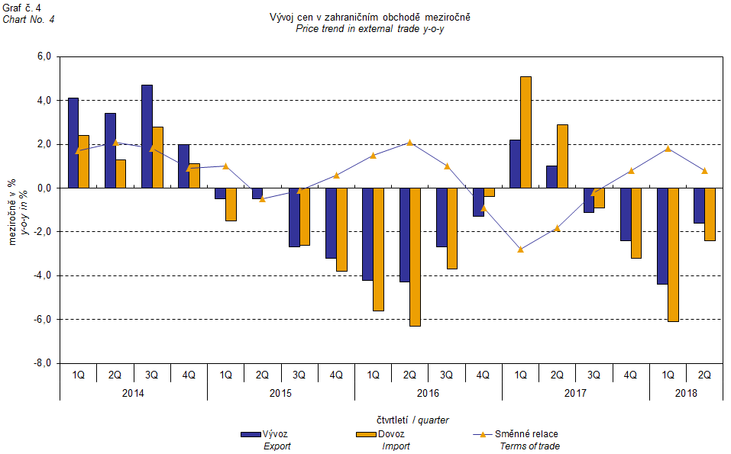

# External trade price indices y-o-y adjusted for exchange rate influence

The CZSO also carries out calculations of year-on-year external trade price indices adjusted for effects of exchange rate. The method is prices in foreign currencies reported in the current month are **converted** into Czech crowns by the **exchange rate** of the same month **of the last year**. Then they are used for the weighted mean calculation along with prices reported in CZK. The year-on-year adjusted price index for a month is then calculated the way that this exchange rate adjusted base price index of a month is related to the non-adjusted base price index of the same month of the last year. Adjusted quarter-on-quarter price indices are calculated in an analogous way since 2017. **Differences among adjusted and non-adjusted price indices may be substantial**. They can be clearly seen in Graphs Nos. 6 and 7 for Q1 2018, for instance.

The method employed does not enable, for many practical reasons, to carry out 100% exchange rate adjustment because all trade transactions concluded in foreign currencies are not reported in foreign currencies. This share is up to 26%. It follows from the aforementioned, that **at the full exchange rate adjustment differences** in between the price indices published and the exchange rate adjusted price indices **would be** **even larger**.

The aforementioned exchange rate adjusted indices can be used to form the exchange rate adjusted breakdown of price indices increments. Table 1 gives the **published and exchange rate adjusted breakdowns of increments** of export and import price indices, expanded to the most important two-digit code groups of the SITC 7. These breakdowns illustrate, in a good manner, how many percentage points each of the groups “exchange rate contributed” to the index.

It holds in general, that the effects of exchange rate decrease the value of price indices in external trade if CZK is strengthening to foreign currencies in total. Conversely, the effects of exchange rate push the price indices up if CZK is weakening to foreign currencies in total.

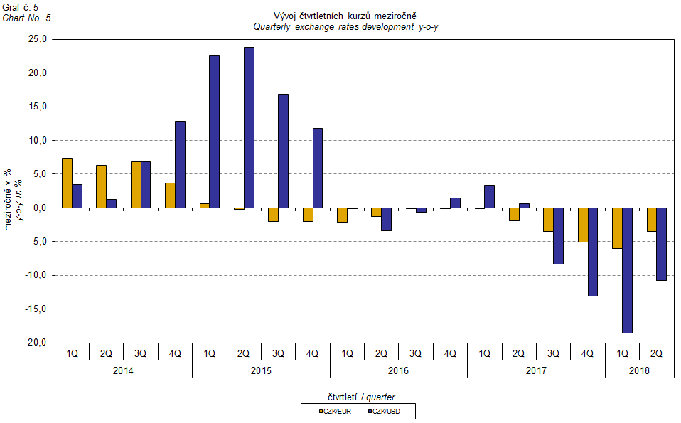

It is obvious from the following Graphs Nos. 6 and 7, how significant was the exchange rate impact on the value of export and import price indices.

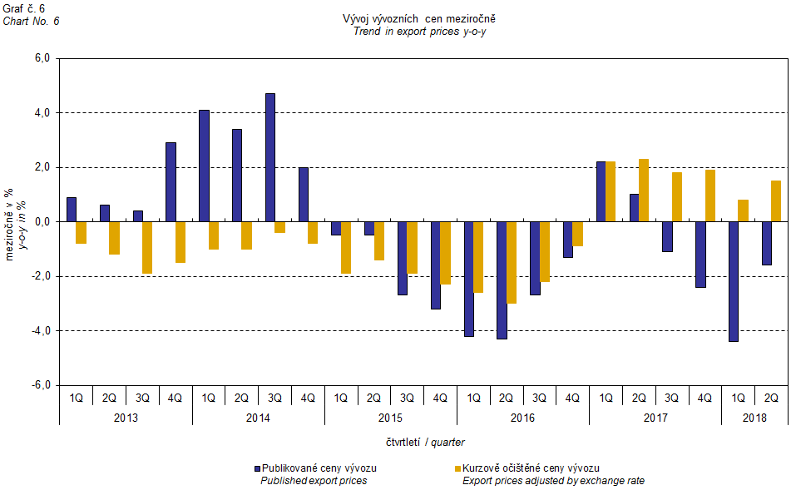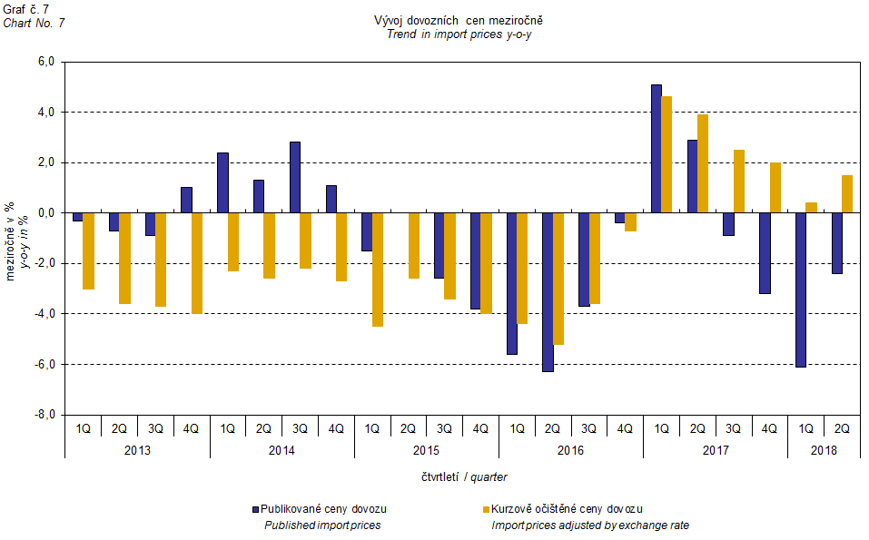

Graph No. 8 shows exchange rate influence on the value of year-on-year terms of trade.

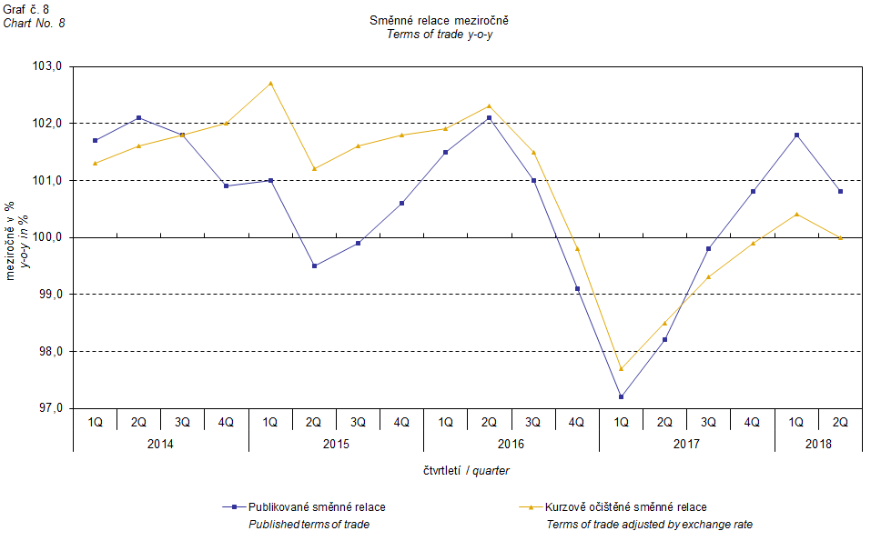

Graph No. 9 demonstrates how the value of terms of trade would develop if the observed groups of goods would not include that of 'mineral fuels, lubricants and related materials'.

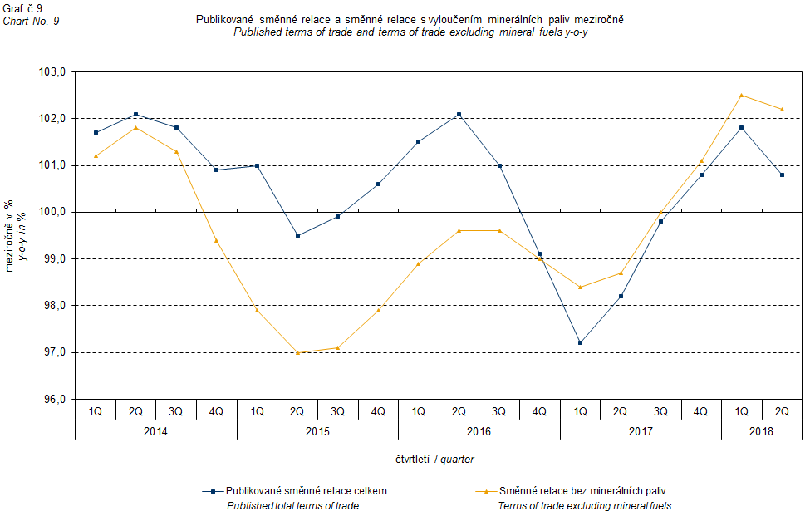

It can be observed in Graph No. 9 that the effects of 'mineral fuels, lubricants and related materials' were increasing the overall value of y-o-y terms of trade till Q4 2016. In Q1 2017 the situation began to reverse and 'mineral fuels, lubricants and related materials' have had a downward effect on the value of terms of trade. It is, of course, related to the world market price development, especially in crude oil. Import prices, which, compared to export prices, include a higher proportion of crude materials, respond in a more sensitive way to price turbulences and therefore when prices of crude materials go up, terms of trade, as a rule, go down, and, conversely, when prices of crude materials fall, terms of trade grow.

# Closing summary

The exchange rate effects in Q2 2018 caused a decline in export and import price indices   
year-on-year. If there were no exchange rate effects the indices would be growing. Export prices declined less than import prices, year-on-year, and therefore terms of trade reached positive values. If exchange rate unadjusted, terms of trade would be at 100.0%. Values free of the exchange rate effects correspond to exchange rate adjusted indices, see Graphs Nos. 6, 7, and 8.



Closing table gives published external trade price indices **without adjustment**.



**Developed by:** Vladimír Klimeš, Prices Statistics Department

**Director of the Department:** Jiří Mrázek, telephone: (+420) 274 052 533