14 June 2017

International meeting on the influence of digital and sharing economy on GDP took place at the CZSO
Eurostat Task Force meeting on price and volume calculations in national accounts, which took place in Prague, finished. The participants were 15 foreign experts and experts from the CZSO.
The two-day meeting had the following agenda: capture of trends in the digital economy and non-market services. The main part of the discussion was devoted to information and communication services, e.g. to recording of the value of applications provided for free or for a reduced price. All these services are already part of national accounts. The meeting was aimed at formulation of recommendations as to how to correctly capture their price development and thus to enumerate their real change on the level of all countries.

“Experts succeeded in finding a consent regarding capture of services within the sharing economy, such as ride-sharing services and sharing of accommodation. They presented also their approaches to measurement of price development of social media advertising,” Petr Musil from the National Accounts Department of the CZSO said.

Also Paul Konijn from Eurostat appreciated the importance of the meeting in Prague: “The meeting in Prague was very successful in shaping the issues for which recommendations will be produced. They rise from the inclusion of e-platforms in GDP, the measurement of price change of information and communication services, the intricacies of accounting for global production and quality adjustment for health and education services.”

According to Jennifer Ribarsky from the OECD activities of the Task Force will continue: “This Task Force meeting was important on advancing the measurement issues related to the sharing economy and the digital economy on GDP statistics. While the conceptual framework for the national accounts is conceptually sound further work should be done to appropriately capture price and volumes changes. The Task Force will further investigate these issues, such as the impact of consumers shifting from buying goods from physical shops to buying goods online.” Next meeting of the Task Force will take place in Luxembourg in the end of October 2017. A final report with recommendations will be issued in early 2018.

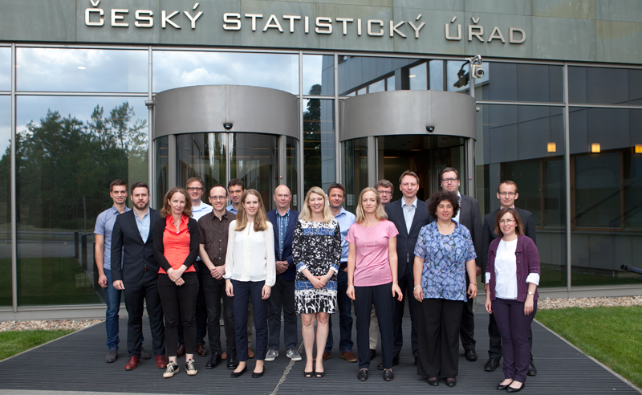
National accounts experts met in Prague to discuss digital economy, sharing economy, and non-market services.

Contact:
Petra Báčová
Spokeswoman of the CZSO
T (+420) 274 052 017 | M (+420) 778 727 232
E petra.bacova@czso.cz | Twitter @statistickyurad

