5 May 2017

Important results of Prague meeting of international experts on the environment
An international meeting of the UN Expert Group on Environment Statistics will finish at the Czech Statistical Office today. Participating were 36 experts from 13 international organizations and 17 countries. During the 3-day summit they negotiated many current topics.
“The expert group succeeded to finalize the methodology for a new version of the Framework, which will determine the format of national environment statistics in the years to come. We have achieved a significant progress. We have successfully completed negotiations on chapters on mineral resources and water sources. Now we can focus on other development goals,” President of the CZSO, Iva Ritschelová, who has been presiding over the group already for several years, comments the results of the meeting.

Also Marcus Newbury from the UN Statistics Division in New York is satisfied with the outcomes: “All participants evaluated the meeting positively as for its contents and very good organization by the CZSO as well as the fact that the meeting took place for the first time in the history of EGES outside the UN Headquarters in New York. The Capital City of Prague truly enchanted all the participants.”

Also Nancy Chin, a representative of the same UN organization said: “The meeting was a great success, the fruitful dialogue outcomes will allow the UNSD to continue to lead and coordinate the implementation of the work programme on environment statistics. All participants are very grateful to the Czech Statistical Office for its kind hospitality in hosting this meeting.”

A draft manual on the Framework for the Development of Environment Statistics (FDES), which was the key topic of the meeting, will be on the agenda of the 49th UN Statistical Commission in 2018. Afterwards, the Framework will be gradually implemented both on national and international levels.

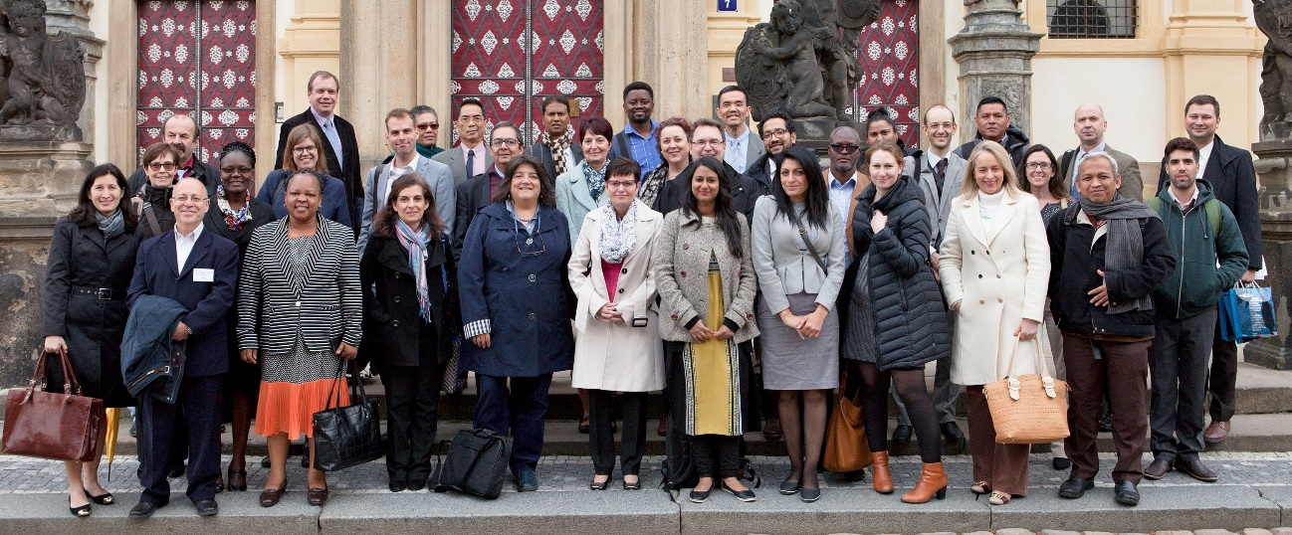EGES participants on a social event in the evening yesterday

Contact:
Petra Báčová
Spokeswoman of the CZSO
T (+420) 274 052 017 | M (+420) 778 727 232
E petra.bacova@czso.cz | Twitter @statistickyurad

