3 May 2017

Statisticians from all over the world negotiate environmental issues at the Czech Statistical Office
The headquarters of the Czech Statistical Office (CZSO) in Prague hosts an international meeting of an expert group of the United Nations. 36 experts from all over the world discuss development of the environment statistics. The Czech Republic hosts this important meeting for the first time.
The Expert Group on Environment Statistics (EGES) has had its meetings only in New York until now. The already fourth meeting of the group moved to the CR thanks to an initiative of the CZSO President Iva Ritschelová, who presides over the international group of the UN: “I am very proud that I can welcome here renowned experts on the environment statistics. For example, the following came: Marcus Newbury and Nancy Chin from the UN Statistics Division in New York, Roberta Pignatelli from the European Environment Agency, and Rayén Quiroga from the Economic Commission for Latin America and the Caribbean. Also colleagues from Belize, Botswana, Brazil, Finland, Jamaica, Mexico, Philippines, Tanzania or Zimbabwe came.” Besides National Statistical Institutes of developed and developing countries, also many other international organizations are represented in EGES: Eurostat, UNESCAP, United Nations Economic Commission for Europe, etc.

The meeting will focus on finalization of a methodological manual to the new Framework for the Development of Environment Statistics, which is to be on the agenda of the 49th meeting of heads of National Statistical Institutes in 2018. Within the current EGES meeting, last chapters on statistics of energy sources, mineral resources, and water sources are being elaborated. However, experts will discuss also waste statistics, forestry statistics or air quality.

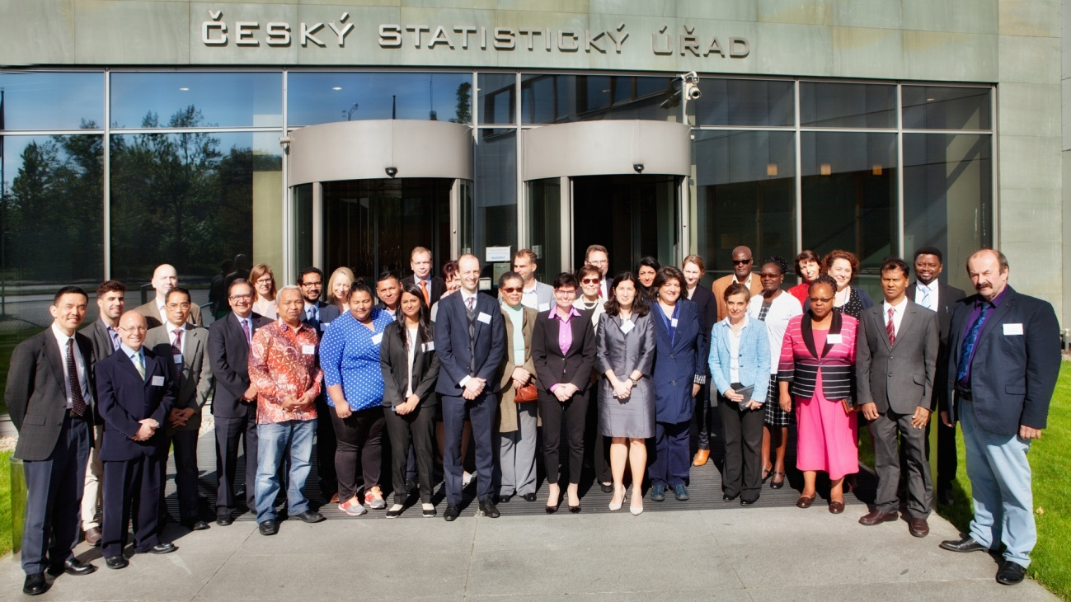
Meeting of the EGES team in Prague is chaired by the President of the Czech Statistical Office Iva Ritschelová.

Contact:
Petra Báčová
Spokeswoman of the CZSO
T (+420) 274 052 017 | M (+420) 778 727 232
E petra.bacova@czso.cz | Twitter @statistickyurad

