22 February 2017

News Releases with new charts

News Releases of the Czech Statistical Office have a more modern look: they contain new charts, which are designed in line with current visual trends.

“New News Releases contain not only an updated look of charts included as a standard, but also a new graphic expression of international comparison. We received very positive response from the public,” Iva Ritschelová, President of the CZSO, says.

The new graphic design of News Releases (which are released according to the published Calendar of News Releases always on the date determined in advance at 9 a.m.) concerns all data related to the year 2017. As for News Releases, which contain data reflecting still the year 2016 the previous graphic design is kept to maintain continuity.

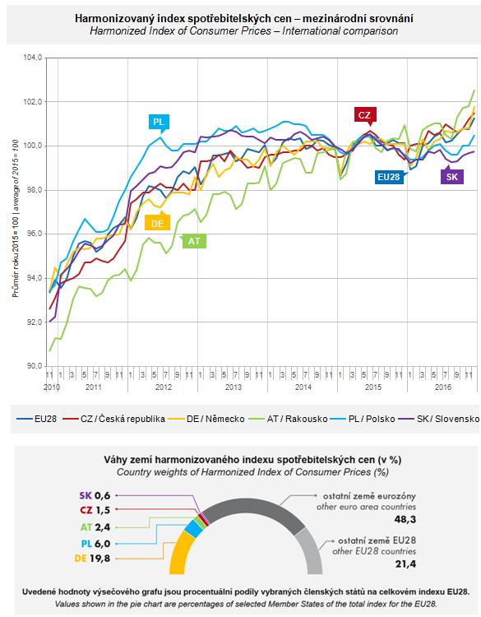

Contact:
Petra Báčová
Spokeswoman of the CZSO
T (+420) 274 052 017 | M (+420) 778 727 232
E petra.bacova@czso.cz | Twitter @statistickyurad

