4 August 2017

Did Czech Republic Reach Full Employment?
Conditions on the labour market are very in favour of job seekers, companies try to motivate them by signing bonuses, higher pay, and by other non-pay benefits as, for instance, advantageous calling by mobile phone, contributions to sport activities, or company kindergarten. Who was seeking a job in June 2010 scarcely achieved success at the job interview. At that time there was one vacant job per 15.2 job applicants due to economic recession. Seven years after the job search duration has been shortened and not just that. The Labour Office of the Czech Republic (LO CR) had 183 000 vacant jobs and 297 439 job applicants registered in its databases. So there were mere 1.6 job applicant per vacant job. If unemployment in the Czech Republic may get be reduced further is in question.
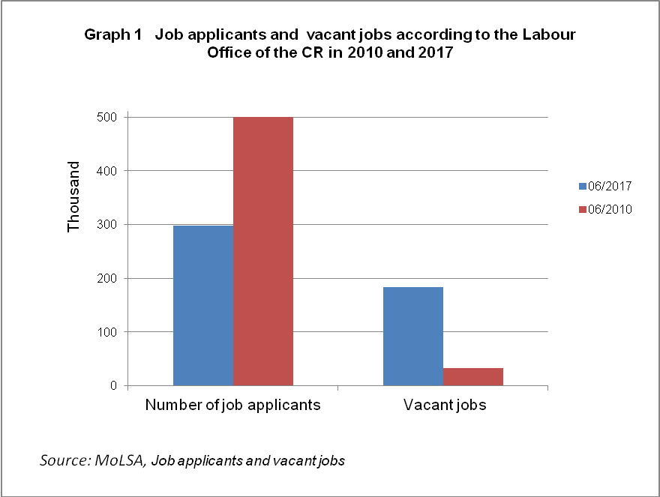

The latest data of the Labour Force Sample Survey (LFSS), which is performed by the Czech Statistical Office (CZSO) in private households, indicate the Czech economy has reached its level of full employment. This means the conditions when a stock of available labour force in the Czech Republic, companies could use in making their expansion (expansion of production, opening of new units and operations, exchange of working persons on leave, etc.), is missing. Then the companies are forced to raise their wage level and headhunt labour force from their competitions. The working persons have had ever better and better options to change jobs and to find a better remuneration.

The fact the available labour force stock is exhausted is confirmed especially in comparison of trends in the employment rate and unemployment rate. While the unemployment rate has been ever lower and in Q2 2017 reached its record value in history, employment has no room to grow and become to stagnate. In males employment got stabilised at about 2 835 thousand persons and in females at the number of about 2 235 thousand persons, markedly higher than in 2008, see Graph 2.

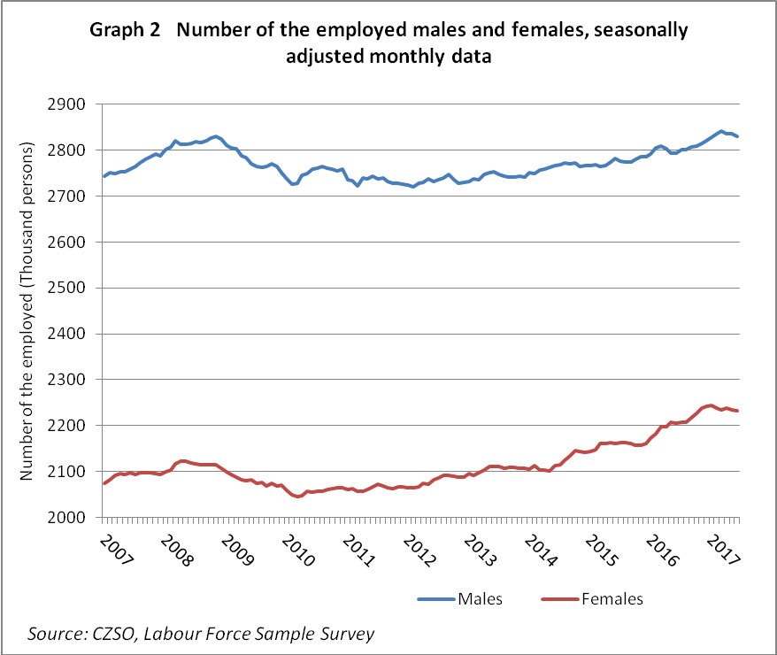

The Czech Republic still has a reserve of potential labour force at the number of approx. 120 thousand persons, who do not work and state they would like to work yet they do not comply with the international definition of the unemployed which requires they seek a job in an active manner and are able to join a job. Majority of persons willing to work, however, is not able to start in a potential job due to personal, health or other reasons as, for instance, the need to take care of children. These inactive persons could be activated under changed conditions, for instance, under better conditions for harmonising of family and professional life and/or higher flexibility of working hours.

Two sources of data on unemployment
The State Statistical Service uses data from two data sources, which operate with two crucial indicators of different definition and to apply them it must be kept in mind their content in terms of methodology as follows.

- Share of unemployed persons from the database of the LO CR published by the MoLSA
On the turn of 2012 and 2013 the methodology of the calculation for the indicator of registered unemployment was changed upon an agreement of the Czech Statistical Office and the Ministry of Labour and Social Affairs (MoLSA). Till the end of 2012 the MoLSA published the registered unemployment rate, which measured all available job applicants kept in the LO CR register to economically active persons (estimated on the basis of the LFSS). Since January 2013 they publish merely the new indicator named the share of unemployed persons. It is the number of available job applicants aged 15 – 64 years and kept in the LO CR register subdivided by the whole population aged 15 – 64 years.

The main reason that led to a change to the methodology of the calculation of the registered unemployment indicator was the option to get a higher regional detail of the new indicator, the second one was frequent comparisons of the unemployment rates within the Czech Republic and also among respective Member States of the European Union and therefore potential confusion of the registered unemployment rate of the MoLSA and the unemployment rate calculated from data of the Labour Force Sample Survey carried out by the CZSO.

- Unemployment rate according to the LFSS published by CZSO
The Czech Statistical Office acquires regular information on conditions of the labour market by means of the LFFS. The Survey objective is to subdivide the population to the economically active population (labour force) and inactive population. The economically active population comprises the employed persons and the unemployed ones. The unemployed person is such a person which is jobless at present yet seeks a job in an active manner and is able to join a job. The economically inactive population consists of persons who are neither employed nor seek a job as, for instance, children, pensioners, handicapped persons, persons on maternal or parental leave.

Then the unemployment rate is determined as a ratio of the unemployed persons to the whole labour force. The unemployed persons are those who stated that in the reference week they did not work one hour for salary or remuneration and do not have a job in which they would have been absent from. The labour force is the number of all economically active persons aged 15 – 64 years. Because it is an estimated number based on the sample the resulting value always suffer from a sampling error.

The LFSS is based on requirements of an EU regulation that is based on standards of the International Labour Organisation (ILO) and is not subject to national legislation. Changes to Czech law have therefore no direct impact on the LFSS results on unemployment, on the contrary to those in the LO CR registration.

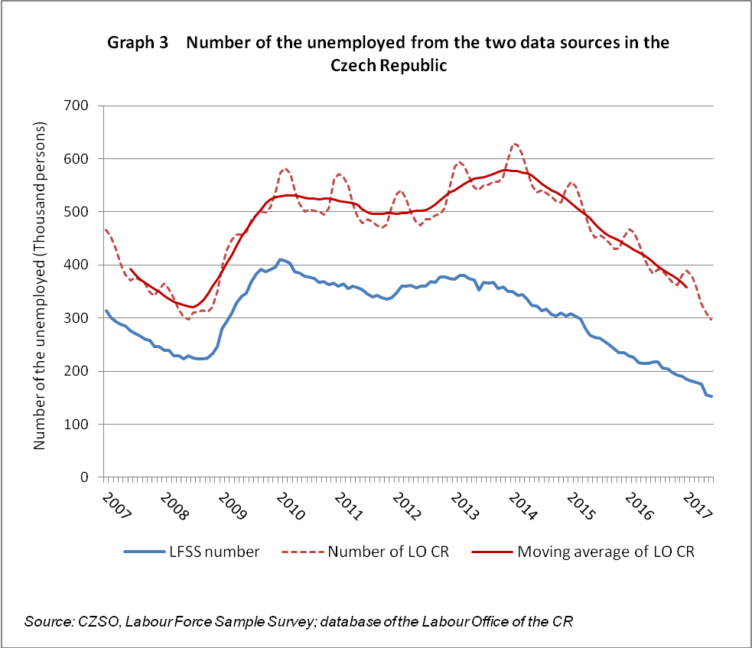

It is seen in Graph 3 data from the two aforementioned sources cannot be compared, yet as a rule they are coherent that means they show similar trends. In 2008 the period of low unemployment finished, after the year 2009 of recession unemployment started to moderately decline first, yet then it began to grow again. In 2013 unemployment according to LFSS stopped at its second peak and then rapidly dropped in next years. It has been declining still in June 2017 the seasonally adjusted unemployment rate reached the value of 2.9%. The results of the LO CR register showed the second peak as late as in 2014.
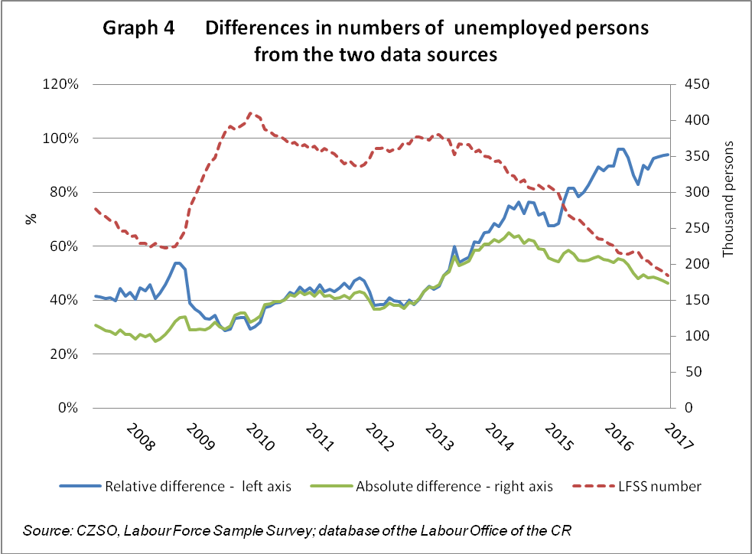

Results of the two data sources show permanent and significant difference which somewhat changes over time, see Graph 4. While the absolute difference in between the data from the two sources has been reducing since 2014 the relative difference (%) markedly has increased as the total number of the unemployed captured by the LFSS has been rapidly declining. Recently in the whole Czech Republic there are almost two times job applicants kept in the LO CR register than the number of the unemployed captured by the LFSS.

Regional comparison
The ranking of the Czech Republic regions by unemployment rate according to the LFSS did not change much in the period from 2010 to 2016. The lowest unemployment rate is in Prague, as usual, followed by Středočeský Region, Plzeňský Region, and Jihočeský Region. The highest unemployment rate remains in the three regions of Karlovarský Region, Ústecký Region, and Moravskoslezský Region. Since 2016 it has been the Moravskoslezský Region which has the highest unemployment rate according to the LFSS. The main reason for is, first of all, a significant drop in unemployment in the Ústecký Region and Karlovarský Region. The MoLSA indicator trend confirmed that. According to the LO CR, however, the highest share of unemployed persons remained in the Ústecký Region also in 2016.
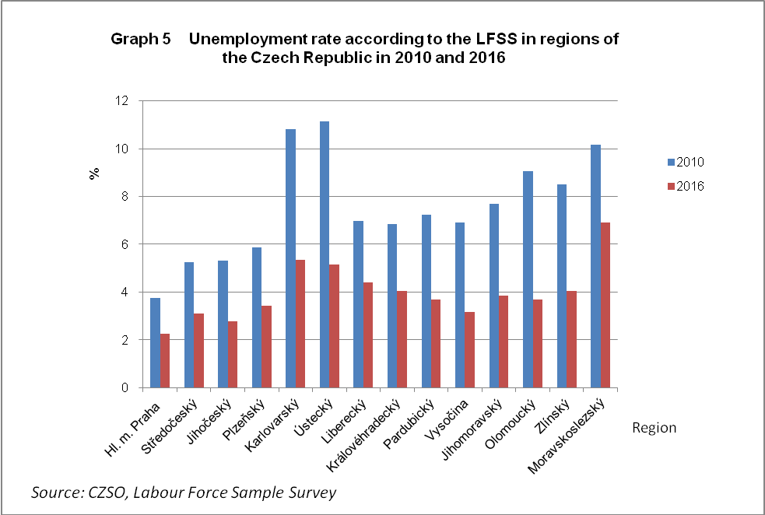

Table 1 Registered unemployment according to the MoLSA in regions of the Czech Republic in the period 2010 to 2016 and in June 2017
 |  |  |  |  |  |  |  |  |  |  |  |  | Percentage
Territory | Registered  unemployment rate |  |  |  |  | Share of the unemployed
 | 2010 |  | 2011 |  | 2012 | 2013 |  | 2014 |  | 2015 |  | 2016 |  | 06/2017
Hl. město Praha Region | 3.5 |  | 3.6 |  | 3.9 | 4.8 |  | 5.3 |  | 4.6 |  | 3.9 |  | 2.9
Středočeský Region | 5.6 |  | 5.6 |  | 5.7 | 6.5 |  | 6.6 |  | 5.7 |  | 4.7 |  | 3.3
Jihočeský Region | 5.6 |  | 5.6 |  | 5.7 | 6.5 |  | 6.4 |  | 5.2 |  | 4.4 |  | 2.7
Plzeňský Region | 6.3 |  | 5.8 |  | 5.4 | 6.2 |  | 5.9 |  | 4.9 |  | 3.9 |  | 2.5
Karlovarský Region | 8.5 |  | 8.2 |  | 8.0 | 9.0 |  | 8.5 |  | 7.3 |  | 6.1 |  | 4.0
Ústecký Region | 9.8 |  | 9.7 |  | 10.0 | 11.1 |  | 11.1 |  | 9.7 |  | 8.5 |  | 6.4
Liberecký Region | 8.0 |  | 7.5 |  | 7.4 | 8.2 |  | 8.1 |  | 6.8 |  | 5.6 |  | 4.1
Královéhradecký Region | 5.7 |  | 5.5 |  | 5.7 | 6.8 |  | 6.7 |  | 5.3 |  | 4.1 |  | 2.7
Pardubický Region | 6.9 |  | 6.3 |  | 6.2 | 7.0 |  | 6.6 |  | 5.2 |  | 4.3 |  | 2.6
Vysočina Region | 7.2 |  | 6.9 |  | 6.7 | 7.4 |  | 7.2 |  | 6.2 |  | 5.3 |  | 3.5
Jihomoravský Region | 7.8 |  | 7.5 |  | 7.5 | 8.2 |  | 8.4 |  | 7.2 |  | 6.3 |  | 4.7
Olomoucký Region | 8.4 |  | 8.0 |  | 8.1 | 9.1 |  | 9.1 |  | 7.4 |  | 6.1 |  | 4.4
Zlínský Region | 7.7 |  | 7.0 |  | 6.9 | 7.9 |  | 7.5 |  | 6.3 |  | 5.2 |  | 3.5
Moravskoslezský Region | 8.7 |  | 8.3 |  | 8.5 | 9.8 |  | 10.1 |  | 8.9 |  | 7.9 |  | 6.2
Czech Republic | 7.0 |  | 6.7 |  | 6.8 | 7.7 |  | 7.7 |  | 6.6 |  | 5.6 |  | 4.0
Source: MoLSA, LO CR, Share of unemployed persons

The lowest unemployment over a long term in Prague is due to a unique position of the Capital City. There are the majority of registered offices of companies, seats of authorities and offices of public administration, schools, hospitals, retail shops and other services there.

International comparison
According to the updated overview of Eurostat the employment rate in the productive age of 20 – 64 years in the Czech Republic is the fifth highest in the European Union. The Czech Republic is surpassed only by Sweden, Germany, Estonia, and United Kingdom. While concerning employment in males the Czech Republic is by far the best in the European Union, in employment of females the country is rather mediocre. The unemployment rate in the Czech Republic has already been the lowest among the all Member States of the European Union for longer time. For more information see https://www.czso.cz/csu/czso/cri/postaveni-ceskeho-trhu-prace-v-ramci-eu-1-ctvrtleti-2017.

Authors
Květa Odehnalová, Dalibor Holý
Unit for Labour Forces, Migration and Equal Opportunities
Czech Statistical Office
Tel.: +(420) 274 052 694
E-mail: kveta.odehnalova@czso.cz; dalibor.holy@czso.cz

