Summary information on agricultural holdings in 2016
The presented outputs of the Farm Structure Survey show summarized grossed-up data for 26 246 agricultural holdings (23 402 holdings of natural persons and 3 123 holdings of legal persons) which reached defined threshold values in 2016.
Table 1 Agricultural holdings in years 2000-2016⁾
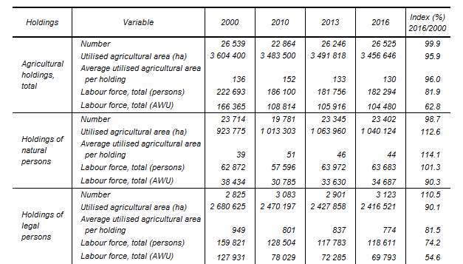
Compared to the 2000 survey the number of agricultural holdings almost did not change (−0.1%). The number of holdings of legal persons increased (+10.5%); it concerns especially limited liability companies (+40.2%), a significant decline occurred in the number of cooperatives (−32.2%). The number of holdings of natural persons slightly decreased (−1.3%).
In 2016 in total 3 457 thousand hectares of agricultural area were utilised, i.e. 43.8% of the total area of the Czech Republic compared to 45.7% in 2000. During the last 16 years the total UAA decreased by 148 thousand hectares. The possession of the agricultural land changes in the course of time: since 2000 holdings of natural persons gained (+12.6%) while holdings of legal persons lost (−9.9%) certain part of the UAA. The most significant loss – by more than one third (−36.9%) – was recorded for cooperatives. In 2016 holdings of natural persons held 30.1% of the UAA compared to 25.6% in 2000.
There was also a major change in the ownership type: while in 2000 almost all utilised agricultural land was rented (92.4%), in 2016 agricultural holdings owned 26.9% of the UAA. Holdings of natural persons owned one quarter of the UAA in 2000 and nearly one half in 2016; in holdings of legal persons the share of own land rose from 1.3% in 2000 to 17.8% in 2016.
The average area utilised by one holding in the Czech Republic accounts for ca 130 ha. The average area of a holding of natural person was 39 ha in 2000 and it grew by 5 ha, i.e. to 44 ha (+14.1%). The average area of a holding of legal person dropped by 175 ha to 837 ha (−18.5%) during the same period.
During the period 2000-2016 the labour force totals decreased by 40 thousand persons (−18.1%) to 182 thousands persons. Expressed in Annual Work Units, the labour force decline was even more significant; there was a decline by 62 thousands to 104 thousands persons (−37.2%). Labour force loss is mainly due to 41 thousands persons decline in the holdings of legal persons. In holdings of natural persons the labour force number was approximately at the same level. In 2016 the labour force working part-time or seasonally increased in both categories.

Results of 2000 survey were recalculated according to threshold levels used in Agricultural census 2010 and Farm Structure Survey 2013, 2016.

