18 May 2017

External Trade Price Indices Development  
in Q1 2017

Export prices in Q1 2017, compared to Q4 2016, increased by 2.1%, import prices grew by 2.4%, and terms of trade reached 99.7%. Compared year-on year (y-o-y), export prices in Q1 2017 increased by 2.2%, import prices grew by 5.1%, and terms of trade reached the value of 97.2%.

# Quarter-on-quarter (q-o-q) comparison

**Export prices** in **Q1 2017**, compared to **Q4 2016**, increased by 2.1% (in Q4 2016 they grew by 0.5%). Price increases were observed in 'mineral fuels, lubricants and related materials' by 21.0%, 'crude materials, inedible, except fuels' by 9.6%, 'chemicals and related products’ by 3.4%, and in 'machinery and transport equipment’ by 0.6%. No price decrease was recorded in any of the groups of goods monitored.

**Import prices** in **Q1 2017**, compared to **Q4 2016**, increased by 2.4% (in Q4 2016 they increased by 1.9%). Price increases were recorded for 'crude materials, inedible, except fuels' by 10.7%, 'mineral fuels, lubricants and related materials' by 9.4%, 'manufactured goods classified chiefly by material' by 4.0%, and for 'machinery and transport equipment’ by 0.4%. Prices of 'miscellaneous manufactured articles' fell by 0.2%.

The **terms of trade** figures in **Q1 2017**, compared to **Q4 2016**, reached the value of 99.7% (in Q4 2016 they were 98.6%). Negative values of terms of trade were recorded especially in 'manufactured goods classified chiefly by material' (97.9%), ‘food and live animals’ (98.5%), and in 'crude materials, inedible, except fuels' (99.0%). Among the more important groups of goods positive value of terms of trade were recorded in 'mineral fuels, lubricants and related materials' (110.6%), 'chemicals and related products’ (101.0%), and in 'machinery and transport equipment’ (100.2%).

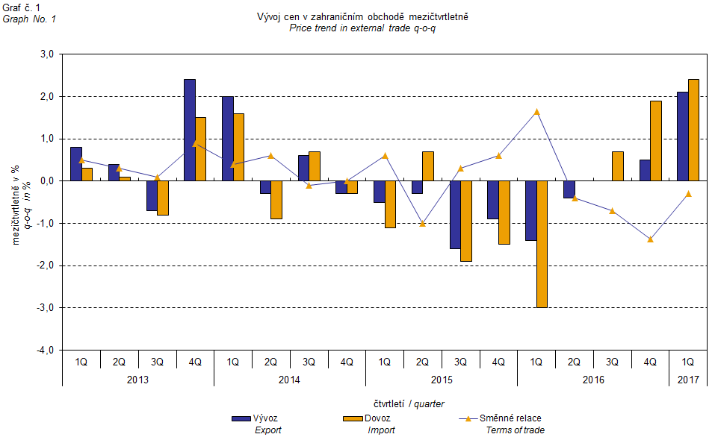

The external trade price development was also significantly affected by the CZK exchange rate to the major foreign currencies. The q-o-q exchange rate index includes two most important currencies from the Czech Republic’s external trade point of view, i.e. EUR and USD. Q-o-q indices of the CZK exchange rate to these currencies were weighted by the weight, which pertains to those foreign currencies in the export price index and import price index, respectively.

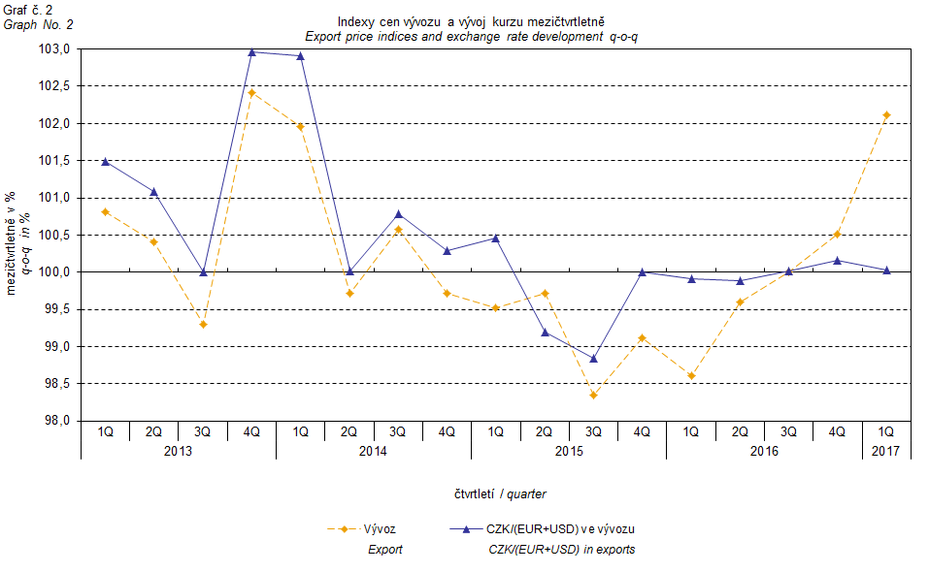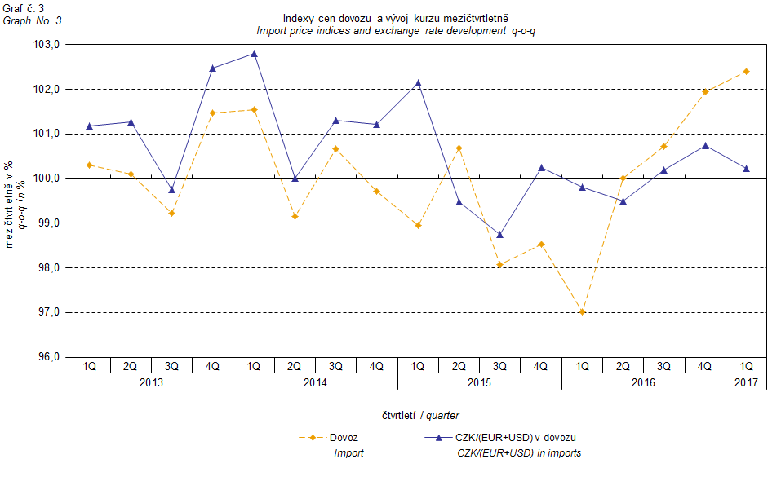

It can be seen from the aforementioned Graphs Nos. 2 and 3 that in both cases of imports and exports external trade prices have a strong relation to exchange rate impacts. Contracts with foreign entities are, as a rule, signed for a longer period of time and the longer the contract period is, the stronger the relation to exchange rates is.

# Year-on-year (y-o-y) comparison

**Export prices** in **Q1 2017** increased by 2.2% (in Q4 2016 they fell by 1.3%), year-on-year. The growing prices were namely those of 'mineral fuels, lubricants and related materials' by 35.9%, 'crude materials, inedible, except fuels' by 15.2%, and 'chemicals and related products’ by 2.8%. Prices of 'machinery and transport equipment’ declined by 0.2%.

**Import prices** in **Q1 2017** grew by 5.1% (in Q4 2016 they fell by 0.4%), year-on-year. Prices grew namely for 'mineral fuels, lubricants and related materials' by 35.1%, 'crude materials, inedible, except fuels' grew by 17.1%, 'manufactured goods classified chiefly by material' by 7.1%, ‘chemicals and related products’ by 3.1%, and for 'machinery and transport equipment’ by 0.5%. The only prices that declined were those for ‘animal and vegetable oils, fats and waxes’ by 0.8%.

**Terms of trade** in **Q1 2017** decreased year-on-year to reach the value of 97.2% (in Q4 2016 they were 99.1%) and thus they stayed in negative values in the second consecutive quarter – see Graph No. 4 below. Rather important negative values of terms of trade were recorded for 'manufactured goods classified chiefly by material' (95.5%), ‘food and live animals’ (96.7%), and for 'machinery and transport equipment' (99.3%). Positive values of terms of trade were recorded, first of all, for 'miscellaneous manufactured articles' (101.1%) and for 'mineral fuels, lubricants and related materials' (100.6%).

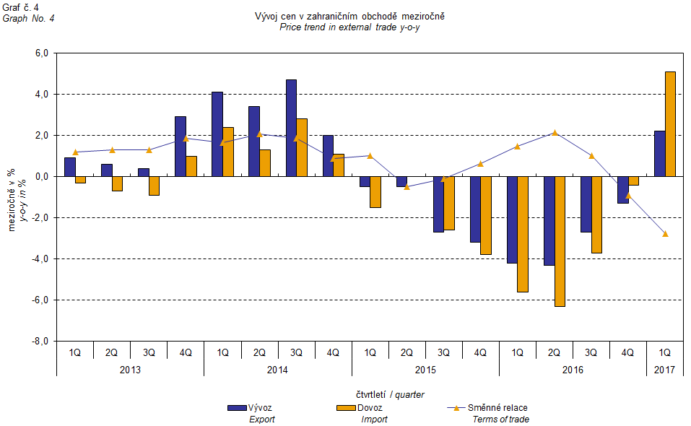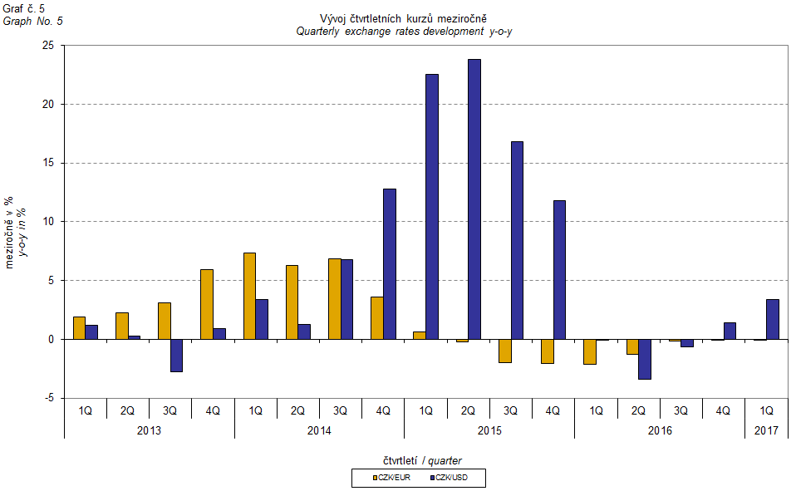

# External trade price indices adjusted y-o-y for exchange rate influence

The CZSO also carries out calculations of year-on-year external trade price indices adjusted for effects of exchange rate. The method is prices in foreign currencies reported in the current month are **converted** into Czech crowns by the **exchange rate** of the same month **of the last year**. Then they are used for the weighted mean calculation along with prices reported in CZK. The year-on-year adjusted price index for a month is then calculated the way that this exchange rate adjusted base price index of a month is related to the non-adjusted base price index of the same month of the last year. Adjusted quarter-on-quarter price indices are calculated in an analogous way since 2017. **Differences among adjusted and non-adjusted price indices may be substantial**. They can be clearly seen in Graphs Nos. 6 and 7 for Q3 2014, for instance.

The method employed does not enable, for many practical reasons, to carry out 100% exchange rate adjustment because all trade transactions concluded in foreign currencies are not reported in foreign currencies. This share is up to 30%. It follows from the aforementioned, that **at the full exchange rate adjustment differences** in between the price indices published and the exchange rate adjusted price indices would be **even larger**.

The aforementioned exchange rate adjusted indices can be used to form the exchange rate adjusted breakdown of price indices increments. Table 1, last but one page, gives the **published and exchange rate adjusted breakdowns of increments** of export and import price indices, expanded to the most important two-digit code groups of the SITC 7. These breakdowns illustrate, in a good manner, how many percentage points each of the groups “exchange rate contributed” to the index.

It holds in general, that the effects of exchange rate decrease the value of price indices in external trade if CZK is strengthening to foreign currencies in total. Conversely, the effects of exchange rate push the price indices up if CZK is weakening to foreign currencies in total. It is obvious from the following Graphs Nos. 6 and 7, how significant was the exchange rate impact on the value of export and import price indices.

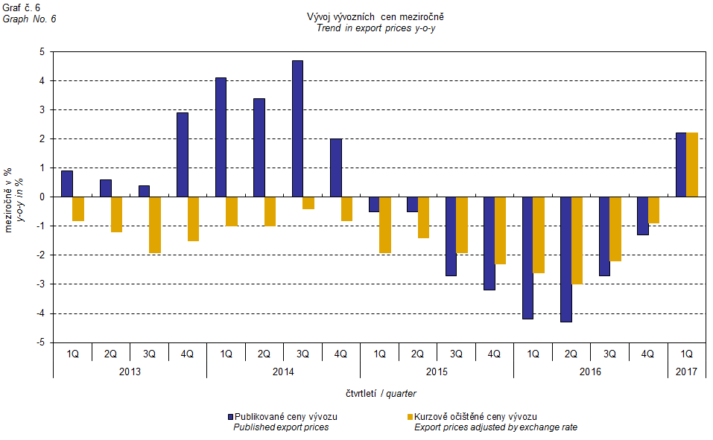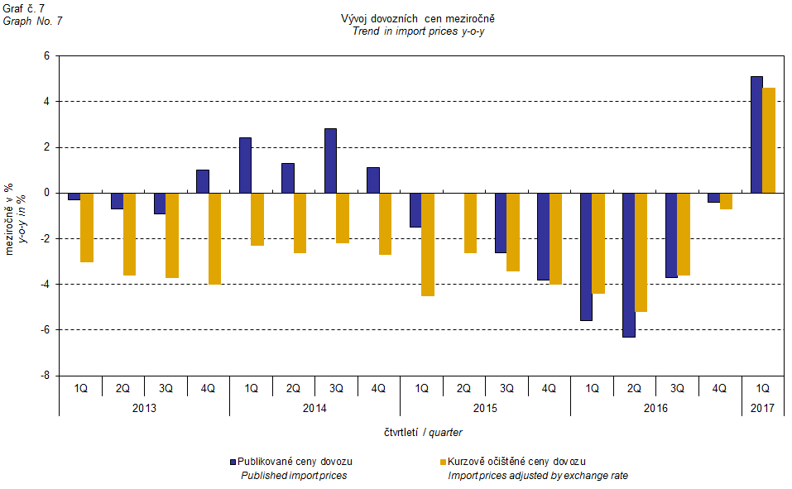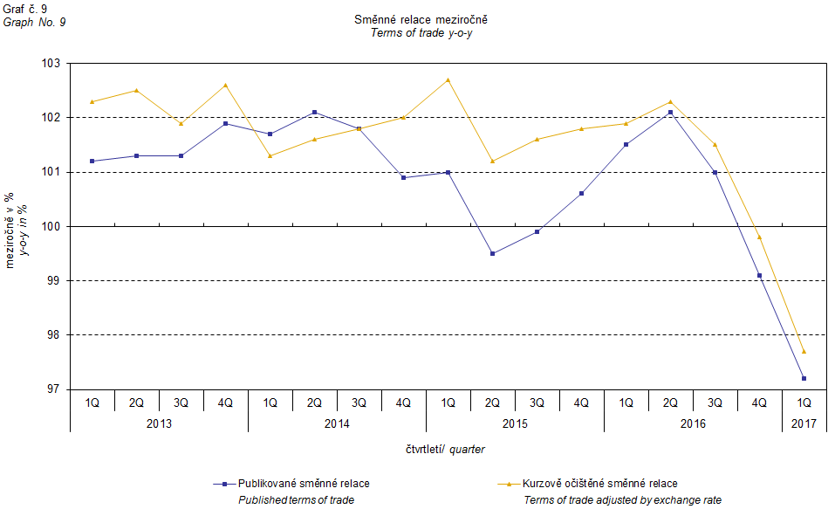

It can be seen from Graph No. 9 how the exchange rate influences the value of the year-on-year terms of trade.

Graph No. 10 demonstrates how the value of terms of trade would develop if the observed groups of goods would not include that of 'mineral fuels, lubricants and related materials'.

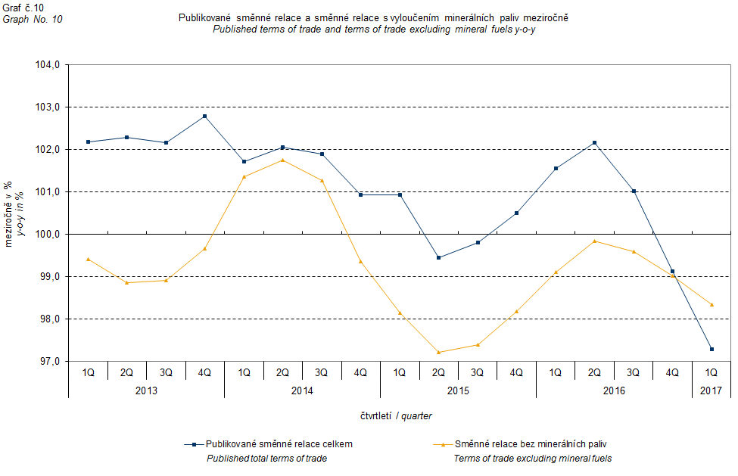

It can be observed in Graph No. 10 that the effects of 'mineral fuels, lubricants and related materials' were increasing the overall value of y-o-y terms of trade till Q4 2016. In Q1 2017 the situation began to reverse and 'mineral fuels, lubricants and related materials' have had again a downward effect on the value of terms of trade. It is, of course, related to the world market price development, especially in crude oil. Import prices, which, compared to export prices, include a higher proportion of crude materials, respond in a more sensitive way to price turbulences and therefore when prices of crude materials go up, terms of trade, as a rule, go down, and, conversely, when prices of crude materials fall, terms of trade grow.

# Closing summary

The exchange rate effects in **Q1 2017** exceptionally showed no effect in export prices **year-on-year**. In the case of import prices the exchange rate effects pushed the prices upward. Export prices were growing slower than import prices, year-on-year, and therefore terms of trade remained in negative values. If exchange rate unadjusted, terms of trade would be negative as well. Values free of the exchange rate effects correspond to exchange rate adjusted indices – see Graphs Nos. 6, 7, and 9.



Closing table gives published external trade price indices **without adjustment**.



**Developed by:** Vladimír Klimeš, Prices Statistics Department

**Director of the Department:** Jiří Mrázek, telephone: (+420) 274 052 533