9 October 2017

Consumer price indices in Q3 2017

In Q3 2017, consumer prices rose by 0.5% compared with Q2 2017. Consumer prices went up by 2.5% in Q3 2017, year-on-year, which was 0.3 percentage point up on Q2 2017.

The quarter-on-quarter (q-o-q) development of consumer prices in Q3 2017 was influenced primarily by a price increase in 'food and non-alcoholic beverages', 'housing, water, electricity, gas and other fuels', and 'alcoholic beverages and tobacco'. In 'food and non-alcoholic beverages', especially prices of fresh butter were higher by 22.3%, cheese by 4.5%, milk by 3.0%, and sausages and smoked meat by 3.0% as well. In 'housing, water, electricity, gas and other fuels', prices of the net actual rentals went up by 0.6% and prices of services for the maintenance and repair of the dwelling by 0.8%. In 'alcoholic beverages and tobacco', prices of spirits rose by 1.7%, beer by 2.0%, and tobacco and tobacco products by 0.6%. The price increase continued in 'restaurants and hotels', where prices of catering services and accommodation services went up (1.0% and 0.8%, respectively). In 'recreation and culture', prices of package holidays rose by 11.2%. A decrease in prices in 'transport' in particular, in which automotive fuel prices dropped by 3.2%, had an influence in the opposite direction, i.e. on the price level reduction. In 'communication', prices of telephone and telefax services went down by 0.7%. An average month-on-month (m-o-m) increase in the overall consumer price index was 0.1% in Q3 2017, i.e. the same as in Q2 2017.

Consumer price indices (the previous quarter = 100)

|  |  |  |  |  |  |
| --- | --- | --- | --- | --- | --- |
|  | 2016 | | 2017 | | |
| DIVISION | Q3 | Q4 | Q1 | Q2 | Q3 |
| TOTAL | 100,2 | 100.4 | 101.4 | 100.2 | 100.5 |
| Food and non-alcoholic beverages | 99.5 | 101.2 | 103.7 | 100.1 | 100.7 |
| Alcoholic beverages and tobacco | 100.4 | 99.9 | 100.8 | 99.8 | 100.9 |
| Clothing and footwear | 97.4 | 104.7 | 95.2 | 104.0 | 96.9 |
| Housing, water, electricity, gas and other fuels | 100.0 | 100.3 | 100.7 | 100.5 | 100.5 |
| Furnishings, household equipment and routine household maintenance | 99.9 | 99.5 | 99.9 | 100.5 | 99.7 |
| Health | 100.6 | 99.7 | 101.4 | 101.8 | 101.1 |
| Transport | 100.7 | 101.1 | 102.4 | 99.7 | 99.4 |
| Communication | 100.4 | 99.2 | 100.4 | 99.9 | 99.1 |
| Recreation and culture | 102.0 | 97.7 | 102.3 | 99.2 | 102.2 |
| Education | 100.7 | 101.3 | 100.2 | 100.0 | 100.5 |
| Restaurants and hotels | 100.5 | 101.4 | 102.7 | 101.0 | 100.9 |
| Miscellaneous goods and services | 100.1 | 100.2 | 100.7 | 100.1 | 99.9 |

Consumer prices increased by 2.5%, year-on-year (y-o-y), in Q3 2017 compared with Q3 2016, i.e. 0.3 percentage point up on Q2. This development came from an acceleration in the price rise in 'food and non-alcoholic beverages', 'housing, water, electricity, gas and other fuels', 'alcoholic beverages and tobacco', and 'restaurants and hotels'. The price drop in 'communication' and a slowdown in the price increase in 'transport', 'miscellaneous goods and services', and 'clothing and footwear' had an influence in the opposite direction, i.e. on the price reduction.

Changes in the price development in Q3 2017 were reflected in the acceleration of y-o-y increase in the market prices to 3.0% (from 2.7% in Q2). Regulated prices went to a growth by 0.3% in Q3 2017 from a 0.1% decline in Q2.



The biggest influence on the growth of the consumer price level came from prices in 'food and non-alcoholic beverages'. Prices of meat rose by 5.4%, of which pork prices by 11.0%. Fish prices went up by 2.0%. The growth of prices in the group of milk, cheese, and eggs amounted to 12.9% in Q3, of which prices of eggs increased by 29.1%, cheese by 14.7%, milk by 13.5%, and yoghurts by 10.0%. Prices of oils and fats were higher by 19.1%, of which prices of fresh butter by 48.6%. Prices of sugar rose by 13.6%. Bread prices went up by 9.3% and prices of rolls and baguettes by 9.6%. Prices of flour went up by 0.3%. Fruit prices rose by 0.2% (1.5% in Q2). Prices of vegetables went down by 4.2% (–4.8% in Q2), of which prices of potatoes rose by 5.0% (–0.6% in Q2). Prices of non-alcoholic beverages went up by 1.9%, of which prices of coffee by 7.0% and tea by 2.0%.



In 'housing, water, electricity, gas and other fuels', prices rose by 2.1%, y-o-y, in Q3 2017. Electricity prices were higher by 0.3% in both the quarters (Q2 and Q3). Prices of natural gas went down by 0.8% (–3.0% in Q2). Prices of the net actual rentals went up by 2.7%, water supply by 1.2% and sewage collection by 0.4%. Prices of heat and hot water went down by 2.3%.

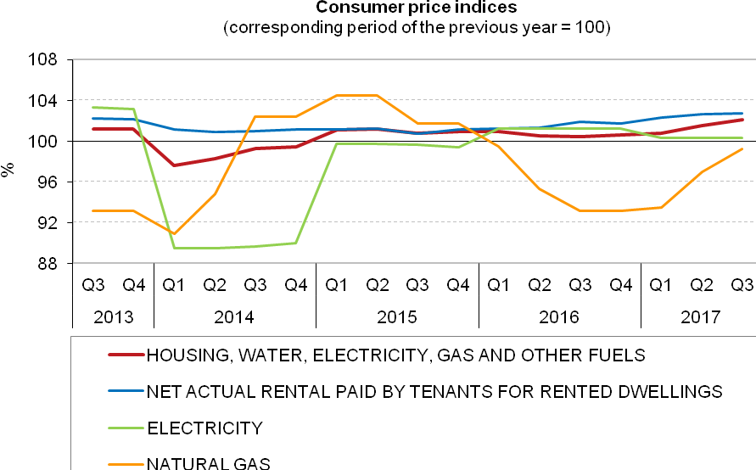

In 'alcoholic beverages and tobacco', prices of tobacco products rose by 2.3% (3.1% in Q2). Prices of spirits went up by 0.8%. Prices of wine and beer dropped (–0.1% and –0.6%, respectively).

A growth of consumer prices in 'restaurants and hotels' was influenced by higher prices of catering services by 7.0% (6.4% in Q2) and prices of accommodation services by 1.8% (2.1% in Q2).

In 'transport', the slowdown in the y-o-y increase in prices occurred, which was mainly caused by the q-o-q drop in automotive fuel prices, which continued. The price of petrol unleaded 95 was CZK 29.85 and the price of diesel oil was CZK 28.71 in September.



In 'communication', prices of telephone and telefax services went down by 1.1%, y-o-y. Prices of postal services rose by 2.5%.



In 'miscellaneous goods and services', prices of financial services went down by 5.2%.

In 'clothing and footwear', prices of garments went down by 0.8% (–0.2% in Q2). Prices of shoes and other footwear rose by 4.2% (3.7% in Q2).

In 'furnishings, household equipment and routine household maintenance', the price drop deepened due to lower prices of goods and services for routine household maintenance by 2.0% (–1.4% in Q2).

The aforementioned consumer price fluctuations had an impact on the rise in prices of **goods in total** by 2.1% and in prices of **services by** 3.2%.



### Harmonized index of consumer prices in the EU28

According to Eurostatdata,they-o-y change of the average harmonized index of consumer prices (HICP) in the EU28 was 1.5% in July and 1.7% in August. In the Czech Republic (CR), the y-o-y increase in the HICP was 2.4% in both these months. According to preliminary calculations, the HICP in the CR rose by 2.5%, y-o-y, in September. It can be seen in the chart below that the inflation development in the CR and in the EU was similar. For most of the reporting period, the increase in the HICP in the CR was higher than the rise in the HICP in the EU. The y-o-y increase in the HICP was positive in all EU countries in August, ranging from 0.4% in Ireland to 4.6% in Lithuania.



The development of consumer price index by COICOP division:



**Consumer price indices in Q3 2017**



Elaborated by experts from the Consumer Prices Statistics Unit of the CZSO

Contact person:

Jiří Trexler

Consumer Prices Statistics Unit of the CZSO

E-mail: [jiri.trexler@czso.cz](mailto:jiri.trexler@czso.cz)

Phone: (+420) 274 054 137