4 December 2017

Trends in employees’ wages – Q3 2017
Results of all statistics employed demonstrate good conditions on the labour market in the Czech Republic continue. Results of Labour Force Sample Survey (LFSS) for Q3 2017 brought a next record-breaking employment rate and decline in unemployment to the lowest level in history. A higher pace in earnings growth corresponds to them when the average wage increased by 6.8%, year-on-year (y-o-y). Results of business statistics performed by the Czech Statistical Office (CZSO) showed also an significant increase in the registered number of employees by 2.0% in Q3 2017.

Results of the LFSS show a permanent increase in total employment, as long as since 2012. In Q 2017 there was a next record-breaking employment rate of 74.1% of the aged 15–64 years brought. The growth in business demand for labour force is strong – the number of vacant jobs reported to labour offices reached 209.9 thousand jobs at the end of October 2017, which is the maximum for the whole existence of the vacant jobs register.

The total number of the unemployed in Q3 2017 declined to 150.1 thousand persons. The number of the long-term unemployed, which dropped below 50 thousand persons, has been falling fast as well. A higher unemployment rate (11.3%) lasts already solely in persons with educational attainment of primary education, yet there was a significant decline thereof. It was reduced in the persons with apprenticeship certificates to reach 3.2%. The unemployment rate in graduates having secondary education with A-level examination is mere 1.9%, and higher education graduates show the unemployment rate of 1.8%, which can be considered as the natural rate of unemployment.

Yet in the Czech Republic there is still a significant number of persons who do not work and do not seek work in an active manner, but being questioned in the LFSS, they state they wish to work. This unused labour force reserve in the number of 121.3 thousand persons was reduced by mere 8.4 thousand persons, y-o-y. That is the lowest decline of the groups measured and remains a challenge for employers as well as for the state employment policy.

Preliminary data of the CZSO business statistics have confirmed the described trend in the growing registered number of employees. In Q3 2017, compared to the same period of the previous year, there were by 76.8 thousand full-time-equivalent (FTE) employees more, which is a relative increase by 2.0%. Let us remember that a decrease (by 1.0%) in the average registered number of employees occurred last time in 2013 and since 2014 the number has been growing monotonously.

Despite in general positive development there are certain sections of the economy, which do not contribute to it. First of all, mining and quarrying continue to experience hard times related to lay-offs. In Q3 2017 the number of employees of these economic activities was reduced by 2.6 thousand persons, i.e. –9.7%. A descend continued in activities of construction by 1.7 thousand person (–0.8%) and there was also some in administrative and support service activities by 1.4 thousand persons (–0.7%). All other sections of economic activities of the CZ-NACE experienced a growth in the number of employees.

The increment of the absolute importance was that in manufacturing, which is, as an industry, the largest employer in the Czech Republic. It was 21.2 thousand persons, i.e. by 1.9% more, relatively. Wholesale and retail trade; repair of motor vehicles and motorcycles grew substantially by 13.1 thousand persons, i.e. by 2.6%, as well. The third rank occupied education in which the number of employees grew by 11.2 thousand persons, which is by 4.2%, relatively. The relatively highest increase was recorded in information and communication by 5.1 thousand persons (+4.8%). The economic activities of information and communication have been showing a long-term growth.

Concerning other industries dominated by government ownership except for education, public administration and defence; compulsory social security demonstrated a year-on-year increase in the number of employees by 2.0 thousand persons, which is +0.7%, relatively. Human health and social work activities saw increase by 5.0 thousand jobs (+1.7%).

Concerning wages, this year was a period of a dynamic growth. The average wage (CZK 29 050) grew nominally by 6.8% in Q3 2017, which is by most in this part of the year since 2008.

Since the beginning of 2014 till Q3 2016 real wages virtually copied the trend in nominal wages because inflation (consumer price index) was just around a half-percent level and thus the real purchasing power of wages was growing fast even if the nominal wage growth was weaker. As this year arrived the trend is definitely no longer valid, the price growth exceeds the inflation target of the Czech National Bank of 2.0% and developments in nominal wages and real ones became to differ more markedly. In Q3 2017 itself inflation reached 2.5% and thus wages increased by 4.2%, y-o-y, in real terms.

Comparing Q3 2017 to other periods of the year, it is always necessary to take into account that results of the comparison are affected by summer holidays and extra bonuses are also paid much less in this quarter.

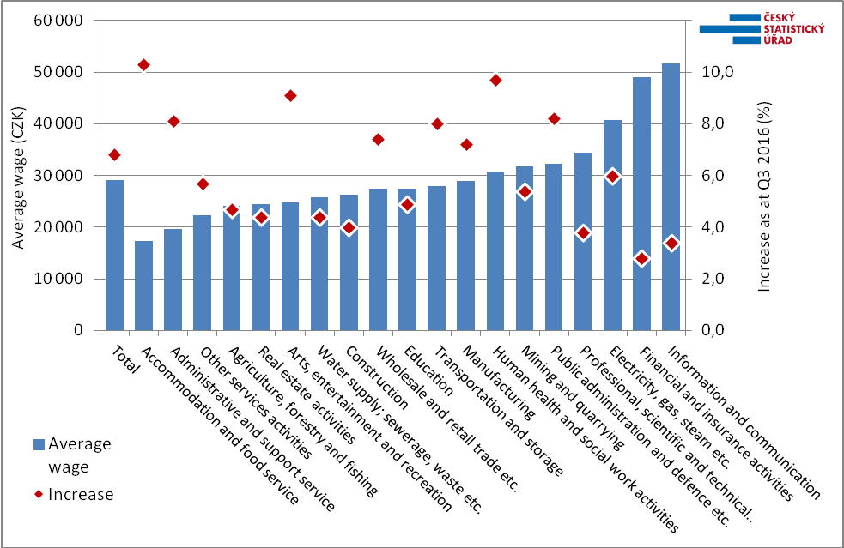

In Q3 2017, similarly to developments in the number of employees, economic activities of respective sections of CZ-NACE also showed rather differentiated developments in the wage growth. None of the sections experienced a decline; year-on-year nominal increases in wages fell from 2.8% to 10.3%. The average wages increased most in those CZ-NACE sections, which wage level was very low. This holds especially for accommodation and food service activities with growth of 10.3% to reach CZK 17 354). Then for administrative and support service activities with the growth of 8.1% to give the average wage of CZK 19 558. Yet even these relatively high paces have not changed the ranking of the aforementioned CZ-NACE sections as the economic activities featuring lowest average wages. The pace over 9% was recorded in human health and social work activities (+9.7%) and in arts, entertainment and recreation (+9.1%).

On the contrary, the financial and insurance activities recorded the lowest increase in the average wage by 2.8% and thus these activities do not occupy anymore the first rank in wages with the average wage of CZK 48 969. The first rank was occupied by the information and communication with the average wage of CZK 51 670 with a year-on-year increase of 3.4%.

Among industrial activities it was manufacturing what was doing the best and it is also the largest employer with 1 145.2 thousand employees. The average wage in manufacturing grew by 7.2% to reach CZK 28 981. Wholesale and retail trade; repair of motor vehicles and motorcycles as the activities with the second largest number of employees were doing well similarly with a wage growth by 7.4% to reach the average wage of CZK 27 404.

The wage growth in Q3 2017 was hampered by a lower number of hours worked, conversely, a share of overtime hours slightly increased, namely in economic activities of industrial nature.

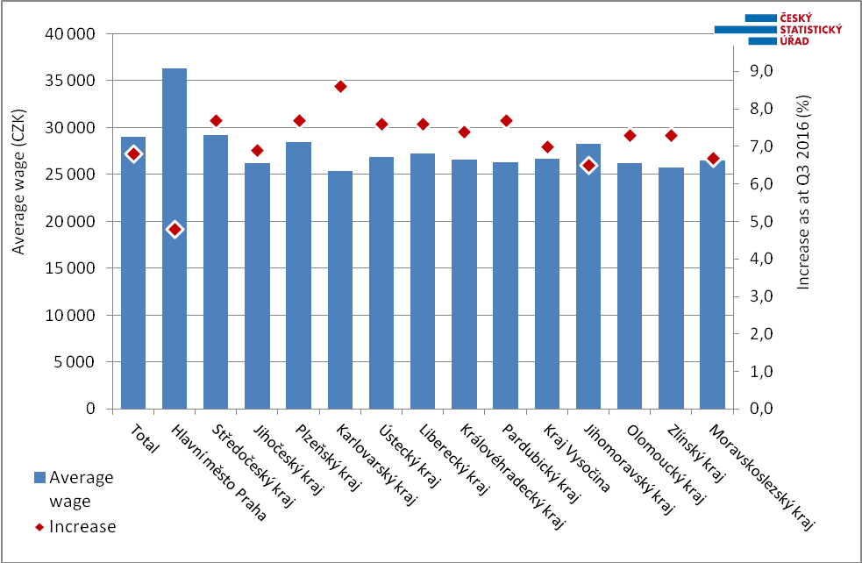

The growth in average wages was most pronounced in the Karlovarský Region (+8.6%), then in the Plzeňský Region, Pardubický Region, and the Středočeský Region while there was +7.7% in all of them, identically. In all regions but in the Capital City of Prague wages grew by over 6.5%. In the Capital City of Prague the growth in average wages was the lowest, +4.8%, as usual. On the other hand, Prague still boasts the fastest growth in the number of employees. In Q3 2017 there was an increment in the number of employees by 3.8% there. No region experienced a drop in the number of employees, the least increases were found in the Plzeňský Region (–0.2%) and in the Karlovarský Region (–0.4%). The highest growth in the number of employees, but that in Prague, was recorded in the Středočeský Region (+3.1%).

* * *

From the standpoint of cumulated data for Q1 to Q3 2017 the overall average wage grew by 6.6%, which is by more than 4.1%, y-o-y, in real terms. Concerning an increase in purchasing power the effects of inflation (consumer price index), which increased by 2.4% y-o-y, while in 2016 it was by mere 0.4%, began to play an essential role. Simultaneously, in the three quarters of 2017 the number of employees converted to full-time equivalent employees significantly increased by 1.8%, that means the economy expanded by 70.0 thousand FTE employees.

The average wage for Q1 to Q3 2017 of CZK 28 761 is by 41% nominally higher than that ten years ago, but the real increment is 16.0%.

* * *

The News Release of the CZSO for Q3 2017 contains also data on the median wage (M), which is calculated from a mathematical model of the earnings distribution. The model shows the wage of a middle employee that means a common wage level and extreme deciles were calculated simultaneously as well. In Q3 2017 the median wage was CZK 25 181, by CZK 1 673 (+7.1%) higher than in the same period of the previous year. The wage interval became slightly narrower year-on-year, yet still remained wide – ten per cent of employees earning the lowest wages got earnings below CZK 12 170 (bottom decile D1), and the opposite tenth of highest earnings, on the contrary, earned wages above CZK 45 740 (top decile D9).

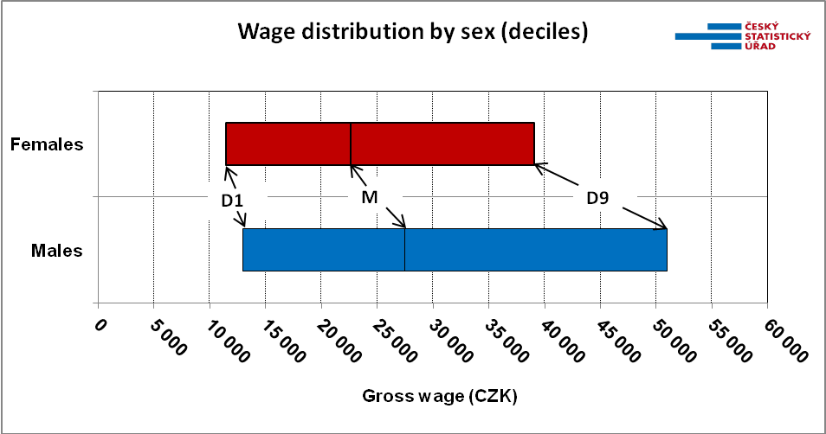

The male wage level is significantly higher: in Q3 2017 the median wage in females was CZK 22 584 while in males it was CZK 27 486. Simultaneously, it holds that wages in males are distributed over a wider interval and especially the area of high earnings as expressed by the top decile (D9) is incomparably higher in males than in females, see the graph above.

Author: Dalibor Holý
Labour Market and Equal Opportunities Statistics Department of the CZSO
Tel.: +(420) 274 052 694
E-mail: dalibor.holy@czso.cz

