9 March 2018

Trends in Employees’ Wages – Q4 2017
The continuing very good conditions on the labour market in the Czech Republic have been confirmed by results of all statistics employed. The Labour Force Sample Survey (LFSS) for Q4 2017 showed a next record-breaking employment rate and a decline in unemployment to the lowest level in history. Results of business statistics performed by the Czech Statistical Office (CZSO) reflect the same – a higher pace in earnings growth when the average wage increased by 8.0% year-on-year (y-o-y) and the median wage grew by almost one percentage point more – and an important increase in the registered number of employees by 1.9% as well.

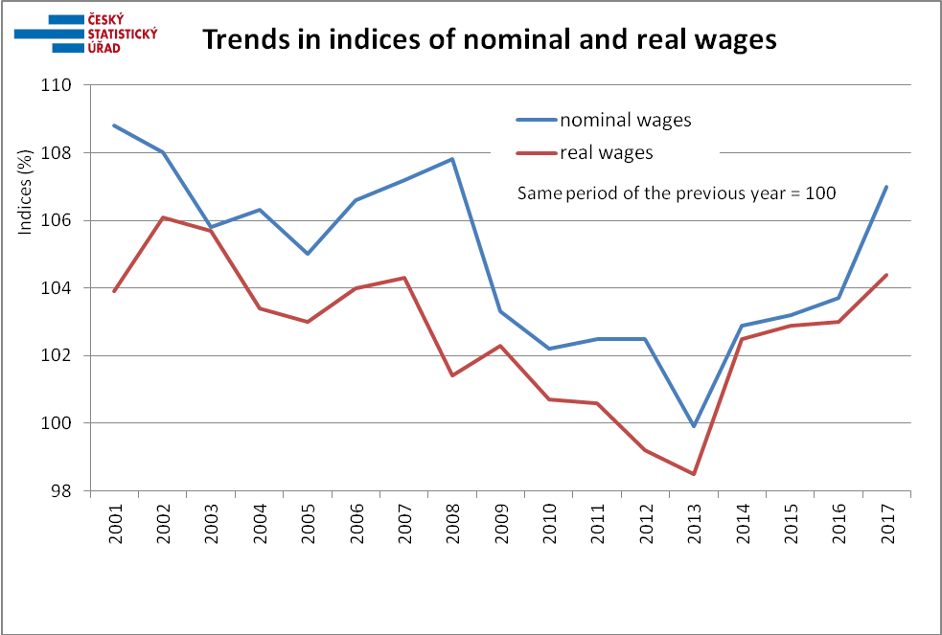

Results of the LFSS show a permanent increase in employment. In the separated Q4 2017 the employment rate of the aged 15–64 years reached 74.3%, which is a next record-breaking level in history of the independent Czech Republic. The employment growth was a bit faster in males, by 1.5 percentage point (p.p.) than in females, by 1.3 p.p.

The increase in business demand for labour force is incredibly strong - the number of vacant jobs reported to labour offices reached 217 thousand at the end of 2017, which is a next record-breaking value for the whole period of the registry existence. Thus there were 1.3 job applicant kept in register at the Labour Office of the Czech Republic per vacant job. These figures may, however, by significantly affected by the fact businesses often report solely jobs suitable for foreign workers.

The other side is the declining number of the unemployed. Here the positive trend also continued when the general unemployment rate dropped to 2.4% in the final period of 2017 which was the lowest value in the European Union compared internationally. However, the unemployment rate still remains higher in females than in males. The rates in sexes are also sharply differentiated by educational attainment, while the unemployment rate in higher education graduates was mere 1.3%, in persons with primary education it was 10.1%.

The number of the unemployed was 128.7 thousand persons. The number of the long-term unemployed i.e. those unemployed for one year and longer, was reduced to reach 40.5 thousand persons in Q4 2017. This means this reservoir of harder employable labour force was almost exhausted while the number of vacant jobs was growing. Besides the unemployed, there are next 119 thousand persons, which are classified as economically inactive yet they state they would like to work. Yet majority of them is able to join a job under current conditions. These are often females taking care of little children.

Preliminary data of the CZSO business statistics have confirmed the prevailing positive trends. In Q4 2017, compared to the same period of the previous year, there was the number of registered employees converted to full-time-equivalent (FTE) employees by 1.9% higher, which is by 75.9 thousand persons more.

It is clear that growing demand for labour force pressed on labour costs, that is earnings, which were also accelerated by a strong economic growth. The nominal growth in the average wage by 8.0% was however confronted with an ever faster growth in consumer prices (inflation) by 2.6%. This led to somewhat lower increase in the real wage by 5.3%. It is nevertheless the highest value for the recent decades, along with the identical data for Q2 2017.

It was government which exerted the most important impulse for the wage growth. Salaries in public administration grew due to a decision on a year-on-year increase in salary tariffs by 10.5%, in education by 9.0%, in human health and social work by 10.8%, and in arts, entertainment and recreation, covering inter alia museums, archives and libraries, the average wage increased by 13.4%, which was the highest increase of all economic activities.

Respective parts of the market economy showed various trends by economic activities at the end of 2017 both from the standpoint of tendency in the number of employees and concerning wage growth. Mining and quarrying was still in the phase of employees layoffs and the number of them dropped by 2.2 thousand persons (-8.4%, in relative figures), yet earnings rapidly increased following previous declines – the average wage increased by 12.5%. Construction is also in long-term depression and saw decline in the number of employees by 1.3 thousand persons. On the other hand, the number of hours worked and the number of employees under agreement on work activities both increased and the average wage grew by 6.7% and extraordinary bonuses were raised as well.

The last economic activities which saw a drop in the number of employees are administrative and support service activities which in Q4 2017 lost 4.4. jobs (-2.2.%) y-o-y, while the average wage in the activities grew by 8.7%. These activities are dominated by labour and employment agencies providing activities related to employment and employee and job hunting.

On the contrary, manufacturing was in undoubtedly well shape with 2.0% increment in the number of employees and an increase in the average wage by 7.5% and extraordinary bonuses were also significantly higher.

The sector of services showed mostly satisfactory values in Q4 2017. It is, first of all, trade (wholesale and retail trade; repair of motor vehicles and motorcycles), in which wages grew by 7.8% at simultaneous increase in the number of employees by 2.5%. Information and communication enjoys a long-term boom with year-on-year increase in the number of employees by 4.8 thousand persons, which means that every 24th employee is new and at the same time wages grew by 4.7%.

A drop in the average wage can be found in none of economic activities; the lowest increase in the average wage (+4.5%) was recorded in financial and insurance activities.

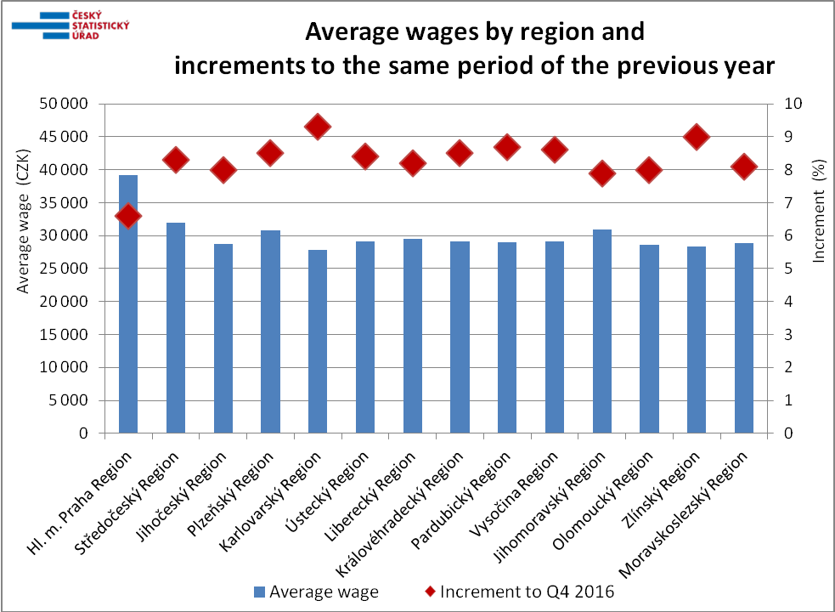

From the regional point of view the value scatter was further narrowed. The growth in average wages was most pronounced in the Karlovarský Region (+9.3%) and in the Zlínský Region (+9.0%), right in regions with a lower wage level. In all regions, but in the Capital City of Prague, wages grew by at least 7.9% as in the Jihomoravský Region. In the Capital City of Prague the growth in average wages was the lowest, +6.6%, as usual. On the other hand, Prague still boasts the fastest growth in the number of employees. In Q4 2017 there was an increment in the number of employees by 3.1% there. No region experienced a drop in the number of employees, the least increases were found in the Plzeňský Region (+0.4%) and in the Karlovarský Region (+0.5%). The highest growth in the number of employees, but that in Prague, was recorded in the Liberecký Region (+2.8%).

* * *

From the standpoint of cumulated data for the whole year 2017the overall average wage grew nominally by 7.0%, which is by 4.4%, y-o-y, in real terms. Concerning an increase in purchasing power the effects of inflation (consumer price index), which increased by 2.5% y-o-y, while in 2016 it was by mere 0.7%, began to play a rather essential role. Simultaneously, in 2017 the number of employees converted to full-time equivalent employees significantly increased by 1.7%, that means the economy expanded by 68.3 thousand full-time jobs. The average wage for 2017 of CZK 29 504 is by 40.8% nominally higher than that ten years ago, but the real increment is 16.5%.

Results for Q4 2017 are in numerous aspects unique and so it is interesting, from macroeconomic point of view, to concentrate more on the overall results for the whole year 2017.

Manufacturing remained the workhorse of the national economy with 1 141.6 thousand full-time jobs. It means there were almost 29% of all employees working in these economic activities. Last year manufacturing showed a very good shape both from the employment and wages point of view. Manufacturing experienced creation of almost 19 thousand new jobs and the average wage grew by 7.2% to reach CZK 29 525.

The next largest economic activities were wholesale and retail trade; repair of motor vehicles and motorcycles with the number of FTE employees of 507.4 thousand persons, annual increment of jobs of 11.2 thousand, average wage increased by 7.4% to reach CZK 27 668. The two aforementioned economic activities are tightly related to transportation and storage in which the number of employees was 261.9 thousand persons and wages increased by 6.5% to attain the average wage of CZK 27 450.

The second largest relative increase in the number of employees, and very permanent one at the same time, and also the highest wage level was in information and communication in which the number of employees reached 111.4 thousand persons (+5.2%) and the average wage increased by 4.5%, y-o-y to reach CZK 52 530. Financial and insurance activities were the second from the top concerning the average wage grown by mere 3.6%, the weakest growth of all economic activities, yet to reach CZK 52 156, and the number of employees increased by one thousand to attain 73.1 thousand persons. Electricity, gas, steam and air conditioning supply are activities with the third highest wage level, the average wage of CZK 43 344, and simultaneously demonstrated a relatively highest growth in the number of employees by 6.2%.

Mining and quarrying, in which 2 400 jobs (-8.7%) disappeared, recorded an important decline and the total number of jobs in these activities moved below 25 thousand yet the average wage of the employees increased by 6.6% to reach CZK 33 442. The second economic activities that experienced a decline in the number of employees was construction in which the number of employees was reduced 2.1 thousand that means a relative reduction by 1.0% but wages grew by +5.1% even in these activities.

Accommodation and food service activities are economic activities in which the wage level is traditionally the lowest, however, the average wage (CZK 17 509) here increased relatively most of all economic activities, by 11.9%. Simultaneously, the number of employees grew by 2 thousand persons (+1.7%). The second fastest growth in wages was recorded in arts, entertainment and recreation, by 9.3% to yield the average wage of CZK 25 439.

* * *

The News Release of the CZSO for Q4 2017 contains also data on the median wage (M), which is calculated from a mathematical model of the earnings distribution. The model shows the wage of a middle employee that means a common wage level and extreme deciles were calculated simultaneously as well.

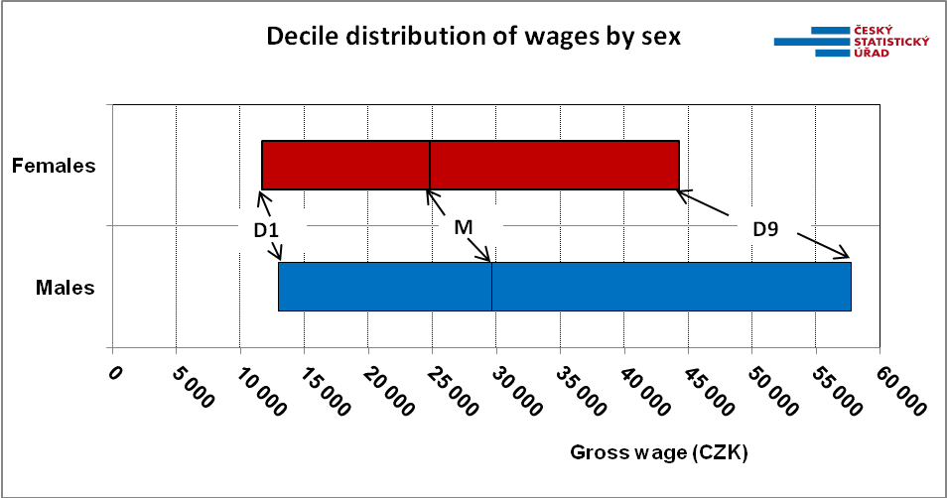

In Q4 2017 the median wage was CZK 27 320, that is by CZK 2 244 (+8.9%) higher than in the same period of the previous year. The wage interval became slightly broader year-on-year – ten per cent of employees earning the lowest wages got earnings below CZK 12 263 (bottom decile D1), and the opposite tenth of highest earnings, on the contrary, earned wages above CZK 51 412 (top decile D9).

The male wage level is significantly higher: in Q4 2017 the median wage in females was CZK 24 790 while in males it was CZK 29 639. Simultaneously, it holds that wages in males are distributed over a wider interval and especially the area of high earnings as expressed by the top decile (D9) is incomparably higher in males than in females, see the graph above.

* * *

The preliminary results of the Average Earnings Information System (ISPV) for the year 2017 bring a more detailed insight in demographic and social classifications. The ISPV, however, applies a different methodology for the calculation of personal earnings of employees. It especially excludes all absence at work and all persons with hours worked shorter than 30 hours per week, and therefore the data may neither be compared to the aforementioned values of the average wages, nor to figures given in tables attached to the News Release of the Czech Statistical Office.

The median wage, according to the ISPV methodology, reached the value of CZK 26 859 in the whole year 2017 and increased by 7.4%, compared to the year 2016. The bottom ten per cent of low-income employees earned wages below CZK 14 117 and, conversely, one tenth of the highest wages were above CZK 48 783. Thus the decile ratio was 3.46, compared to 3.52 in the last year. The wage differentiation was thus reduced by the fasted growth in the lowest wages, namely those in females.

According to the valid Classification of Occupations (CZ-ISCO) managers where the group with highest earnings having the median wage of CZK 48 235 yet also with a very wide decile span from CZK 21 054 to CZK 120 521. The second highest wage level can be found in professionals with their median wage of CZK 35 768 lying within a narrow decile span of CZK 24 379 and CZK 72 814. The third rank is occupied by technicians and associate professionals with the median wage of CZK 31 097 and the decile range from CZK 18 567 to CZK 51 390. Clerical support workers had the median wage of CZK 24 092 and the decile range from CZK 13 367 to CZK 38 545 yet their earnings recorded just a little growth (+6.6%), year-on-year. On the contrary, the fastest growth of the median wage (+10.3%) was found in service and sales workers, of which, however, a great number belong to low-income employees, with the decile range from CZK 11 644 to CZK 31 885 and their median wage was CZK 18 632, which is solely a bit more than two thirds of the overall median wage. Craft and related trades workers and plant and machine operators and assemblers have median wage CZK 25 459 and CZK 24 958, respectively. The lowest wage level can be found, in general, at elementary occupations with the median wage CZK 16 837 and the decile range from CZK 11 454 to CZK 27 243. A significantly faster growth in median earnings by 9.9% was found in armed forces where the median wage reached CZK 33 581.

Wages are also markedly structured by educational attainment of employees when in 2017 employees with higher education earned the highest earnings, their median wage was CZK 37 942 yet their decile span was very wide from CZK 21 458 to CZK 82 092. On the contrary, employees with primary and/or incomplete education had the lowest median wages of CZK 20 009, but their median wages recorded the fastest growth (+9.5%) y-o-y. A quarter of the employees with primary education earned less than CZK 14 884. Employees having secondary education with A-level examination earned more (CZK 27 498) than employees having secondary education without the A-level examination (CZK 22 829), yet less than employees with completed higher professional school or with bachelor degree (CZK 31 220).

If viewed by age group the lowest median wage of CZK 19 604 was earned by employees up to 20 years of age, however it was simultaneously the age group in which the median wages grew most (+9.9%). Employees aged 20–29 years already had markedly higher earnings of CZK 24 954, and the age group 30–39 years recorded the highest median wage of all of CZK 28 116. This is, however, accompanied with an increase in variability of earnings. In other age groups the median wages are a bit declining as for the aged 40–49 years it was CZK 27 356 and for the aged 50–59 years it reached CZK 26 679. For the aged 60+ years the median wage was slightly higher (CZK 27 313), yet this group represent only one third of the working people if compared to the previous age groups. The lowest tenth of earnings (1st decile) remains below the level of CZK 14 500 in every age group.

The citizens of the Czech Republic earn in the Czech economy less (CZK 26 838) than certain larger groups of citizens of foreign states as namely employees from Slovakia having the median wage of CZK 30 078 or from Romania with the median wage of CZK 27 017. Conversely, citizens of the Ukraine had the median wage of mere CZK 21 311, citizens of Bulgaria earned the median wage of CZK 23 672, and citizens from Poland the median wage of CZK 25 467. The median wages grew year-on-year in all the aforementioned groups of foreigners faster than the median wage of the citizens of the Czech Republic.

Author: Dalibor Holý
Labour Market and Equal Opportunities Statistics Department of the CZSO
Tel.: +(420) 274 052 694
E-mail: dalibor.holy@czso.cz

