6 June 2016

Commentary on the Labour Market Development
in Q1 2016
A considerable lack of available labour force becomes to occur on the Czech labour market in many fields. Thus in Q1 2016, it can be observed that the employment growth progressively reaches its limits. Businesses are forced to compete in quest for workers and thus are impelled to offer higher pays. When combined with a low growth in consumer prices this increases the real purchasing power of earnings in a significant manner.

Results of the Labour Force Sample Survey (LFSS) show a permanent increase in total employment already since 2012. Q1 2016 alone brought a record breaking employment rate in the aged 15-64 years at the value of 71.0%, which is related to both economic recovery and the demographic structure of the population of the Czech Republic. An increase in businesses demand for labour force is closing the gap on supply of job seekers and therefore the theme of job quality emerges with urgency now. Working persons move from an uncertain position of own-account workers into the position of employees.

In Q1 2016 an employment growth occurred both in males and in females, in which it was even more pronounced and reached 63.3%. Here it is necessary to remember that in the same period of 2010 it stayed at 55.7%, for instance.

A decrease in the number of the unemployed and a fast growth in the number of job vacancies reported to labour offices have been continuing. A high unemployment rate pertains in persons with primary education (22.2%); the rate was substantially reduced in persons with apprenticeship certificates (a drop by 2.4 p.p. year-on-year to reach 4.9%). Persons with secondary education with A-level examination showed the unemployment rate at 3.0% and university graduates demonstrated a mere 2.0% unemployment rate.

In the Czech Republic, however, there is a significant number of unemployed persons who do not seek a job in an active manner yet they state they would like to work. This labour force reserve at the number of 141 thousand persons probably contributes to the discrepancy in between the number of the unemployed found in the LFSS and the number of job applicants kept in the register of the Labour Office of the Czech Republic.

Preliminary results of the CZSO business statistics have confirmed the described trend in the growth in the number of employees. In the Q1 2016 there were by 81.1 thousand full-time-equivalent (FTE) employees more than in same period of the previous year; that means a relative increase by 2.1%. Let us remind that in 2013 there was a decline in the average registered number of FTE employees by 1.0% and the year 2014 was the time of a positive reversal in this indicator.

Although there is a generally positive trend there are certain parts of the economy, which do not contribute to it. First of all, mining and quarrying experience troublesome conditions related to employees lay-offs – they were reduced by 1.3 thousand (-4.4%) y-o-y in Q1 2016. In activities of electricity, gas, steam and air conditioning supply there was a decline of employees by four hundred persons (-1.5%). Construction and agriculture were stagnating concerning their numbers of employees (0.0%).

In all other sections of CZ-NACE the numbers of employees were growing. The absolutely most important was the contribution in manufacturing, the most important activities providing jobs in the national economy, which rose by 34.8 thousand employees (+3.2%). The number of employees also grew in an important manner by 12.4 thousand (+2.6%) in wholesale and retail trade; repair of motor vehicles and motorcycles. The relatively highest was the growth in the number of employees in real estate activities (+5.5%), that is by 2.4 thousand persons in absolute number. The section of professional, scientific and technical activities also saw a significant increase in the number of employees (+4.2%). The recovered boom of services brought a significant increase in the number of employees in accommodation and food service activities by 2.7 thousand persons (+2.5%). Concerning activities dominated by state ownership then public administration and defence; compulsory social security showed an increase in the number of employees by 3.3 thousand persons y-o-y (+1.2%) while education was virtually stagnating and the number of employees in these activities increased by a mere one hundred.

Concerning wages a growth in their dynamics is unquestionable. In Q1 2016 the average wage increased by 4.4% nominally. This growth was more contributed by the business sphere (4.5%) while in the non-business sphere wages were growing a bit slower (4.1%). Here it is necessary to notify the users that this breakdown is published last time for the year 2016. Since the reference year of 2017 it will not be available any more.

The graph enclosed shows several periods in history as follows: since 2009 the year-on-year increases in the average nominal wage were high yet were eliminated by inflation (the difference in between the two curves) so wages in real terms were growing less; since the recession beginning the growth in the average wage was descending till it reached stagnation in 2013. From the real wage point of view we can see even a decline in 2012 and 2013.

Between the end of 2012 and the beginning of 2013 and the year after the curves are fluctuating due to changes to legislation, that is the introduction of the solidarity tax, which makes the information of the graph gives somewhat uncertain, nevertheless, it is clear that 2014 was the turning point when nominal wages started to head upwards and they have had still the significantly positive trend. It is of the same importance that recently real wages have been almost copying the development in nominal wages because inflation (consumer price index) has been at approx. a mere half per cent level for all the time. This way the real purchasing power of wages has been ever higher and higher and in solely Q1 2016 grew by 3.9%. The real purchasing power showed such pace in 2009 last time when, however, there were massive lay-offs and no increase in employment.

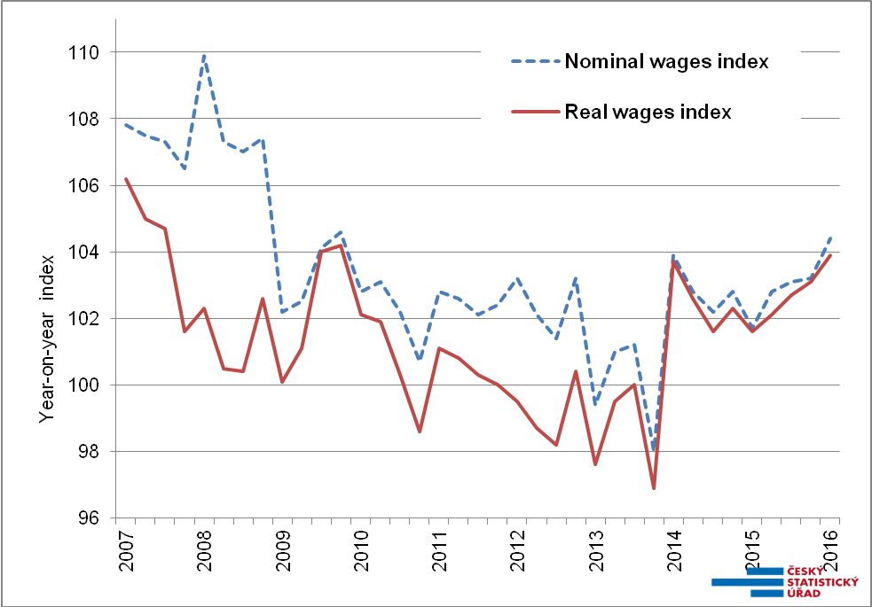
Source: Business statistics of the Czech Statistical Office

In Q1 2016, similarly to their development in the number of employees, economic activities of respective sections of CZ-NACE also showed rather differentiated developments in the wage growth. Nominal increases in wages were from 0.3% to 7.2%. In two sections of economic activities with traditionally lowest average wages, that is in accommodation and food service activities and in administrative and support service activities, the wages grew most by 7.2% and 6.5%, respectively. Yet even such a fast pace of growth did not change the ranking of these activities because in absolute numbers it was an increase by a sole one thousand CZK.

Financial and insurance activities retained its highest wage level (CZK 51 914) but the average wage in these activities grew just moderately by 1.2%. This caused the section of information and communication has been closing the gap on them with CZK 51 518 and the year-on-year increase by 4.4%, which is CZK 2 184 in absolute number.

Among industrial activities it was water supply; sewerage, waste management and remediation activities in which the average wage increased most (6.1%). For the national economy, however, it is an increase in major workhorses of the Czech economy what is of primary importance. That is in manufacturing, which employs 1 113.6 thousand employees and their average wage grew by 4.5%, and in wholesale and retail trade; repair of motor vehicles and motorcycles, in which the average wage increased by 5.4%
Among activities, which are dominated by government ownership, there were nice increases in pay recorded in human health and social work activities and in public administration and defence; compulsory social security (identically 5.8%), a substantially more modest was the increase in education (2.0%).

The News Release contains also data on the median wage, which is calculated from a mathematical model of the earnings distribution. The model shows the wage of a middle employee that means a common wage level. In Q1 2016 the median wage was CZK 22 533, by CZK 1 379 (+6.5%) higher than in the same period of the previous year. This way the wage level of the middle employee grew more than the arithmetic average of earnings. Low wages were growing at the fastest pace while high wages saw merely a below-average growth and income inequalities were reduced.

The wage interval, however, remained wide: 80% of employees earned from CZK 12 117 to CZK 40 997. Concerning sexes, the wage increase was rather more pronounced in males (6.8%) and less in females (6.2%). The male wage level is significantly higher: in Q1 2016 the median wage in females was CZK 20 165 while in males it was CZK 24 570.

The highest growth in the average wage occurred in the Karlovarský Region (8.1%) where the income level is the lowest. Conversely, in the Capital City of Prague the average wage declined by 0.7%. Here it is necessary to remember that the Capital City has been featuring the lowest wage increases for a long time and so extremes in wages have been levelled this way. On the other hand, there has been fast growing numbers of employees in Prague and in Q1 2016 employees increased in number by 3.3% there. No region saw a decline in the number of employees, the lowest increase in the number of employees was again in the Karlovarský Region (+0.1%) and the region, in which the increase in number of employees was the second highest to Prague, was the Olomoucký Region (+3.0%).

Author: Dalibor Holý
Labour Market and Equal Opportunities Statistics Department of the CZSO
Tel.: +(420) 274 052 694
E-mail: dalibor.holy@czso.cz

