5 September 2016

Commentary on the Labour Market Development
in Q2 2016
Results of statistics for Q2 2016 have confirmed the trend towards a faster growth in wages, a high employment rate, and lack of available labour force getting deeper and deeper. According to data of the Labour Force Sample Survey (LFSS) carried out in households, the employment rate in the Czech Republic reached its new record-breaking value (71.7%) and grew by 1.6 percentage point (p. p.), year-on-year. The unemployment rate was one of the lowest in the European Union and the number of vacant jobs reported to the Labour Office moved close to the highest values that were recorded in 2008.

Results of the LFSS show a permanent increase in economic activities of the population - three out of four persons of the productive age (15-64 years) in the Czech Republic are involved in the labour market. It is the outcome of a fast growth in total employment. The number of persons in main job increased by 1.7% year-on-year (y-o-y) to 5 128.5 thousand persons. The number of the self-employed has been stagnating yet the number of working persons in the employment status of employees, which brings higher life security, has been growing.

The employment rate in Q2 2016 reached 71.7%. The growth thereof was faster in females (by 1.9 p. p. to 64.2%) while the male employment rate increased by 1.2 p. p. to 79.0%. The current female employment rate is by about eight and a half percentage points higher than that six years ago. In males it recorded an increase by roughly six per cent. Nevertheless, the employment rate of the Czech females remains substantially lower than that of males and the difference belongs rather to the higher ones in the European Union.

Besides the generation shift the statistical data reflect also a shift in and prolongation of the productive life; younger working persons are fewer and the number of the employed elder than 60 years of age has been growing, which affects the overall indicator most. The whole labour market has been “ageing”.

The decline in unemployment continued as well while the unemployment rate dropped to roughly one half since the years of recession. This trend was confirmed by data from the Labour Office of the Czech Republic, which also brought a fast increase in the number of vacant jobs in the two recent years. At the end of July 2016 there were already 136 thousand vacant jobs reported. What still remains an issue is the vacant jobs do not match in a suitable manner the job applicants, that means the supply on the Czech labour market does not meet the demand.

Preliminary data of the CZSO business statistics have confirmed the trend in the growing number of employees. In Q2 2016, compared to the same period of the previous year, there were by 70.5 thousand full-time-equivalent (FTE) employees more, which is a relative increase by 1.8%.

Despite this overall positive trend there are smaller parts of the economy, which do not contribute to it. Namely conditions in economic activities of mining and quarrying have been bad over a long term resulting in employee lay-offs – in Q2 2016 the number of employees was reduced again, this time by 1.6 thousand, which is -5.4%. In the recent eight years this economic activities have seen already a decrease in the number of employees of 31% of their original number.

Also economic activities of agriculture, forestry and fishing, which are restricted by low purchase prices of food raw materials, experienced a reduction by a thousand employees (-1.1%). Again, we can see a year-on-year decrease in the number of employees in construction, this time by 2.3 thousand (-1.1%). In electricity, gas, steam and air conditioning supply the number of employees was reduced by two hundreds, which is a drop by 0.6%.

All other sections of CZ-NACE recorded growing numbers of employees. The absolutely highest increment by 30.2 thousand, that is a relative increase by 2.8%, was observed, of course, in manufacturing, which is the largest economy section by employees. Nice increments were, however, in majority of activities of the sector of trade and services. The trade itself recorded a substantial 13.2 thousand new employees, i.e. +2.7%, more. There were relatively highest increments in real estate activities (+4.6%) and in professional, scientific and technical activities (+4.3%). The increase in the number of employees in transportation and storage by 7.9 thousand employees, i.e. +3.2% is linked to the boom in manufacturing. In case of accommodation and food service activities the rather important increase at the year beginning now returned to rather moderate one by two hundred employees, i.e. relatively by +0.2%.

Concerning activities dominated by state ownership then public administration and defence; compulsory social security showed an increase in the number of employees by 0.7 thousand persons y-o-y (relatively +0.2%), while this goes to recruitment to armed forces not to offices. There were by 5.8 thousand employees more (+2.1%) in human health and social work activities and in education the number of employees grew by four hundred persons, which relative increase +0.1%.

The average wage grew nominally by 3.9% in Q2 2016. This growth was more contributed by the business sphere (3.9%) while in the non-business sphere wages were growing a bit slower (3.6%). Here it is necessary to notify the users that this breakdown is published last time for the year 2016. Since the reference year of 2017 it will not be available any more.

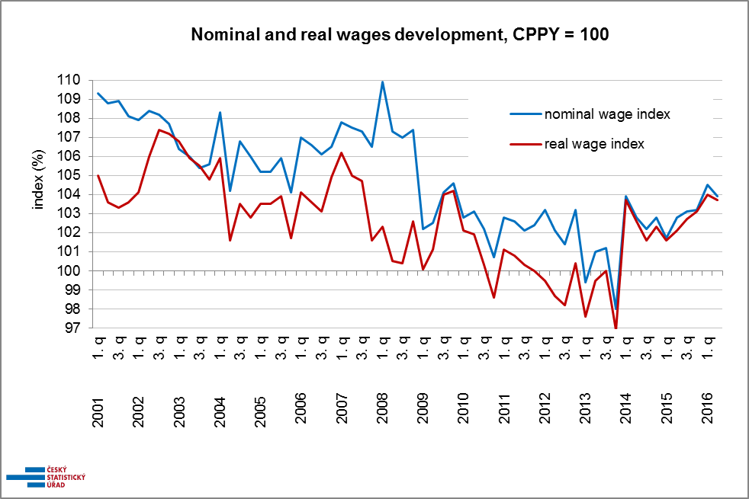
Source: CZSO business statistics

It can be seen in the graph enclosed that wage development has a considerable inertia. In the period to 2013 wage dynamics was gradually losing its pace till a drop in the average wage which occurred not only in real terms, yet even in nominal values. Since 2014 the trend got reversed, conditions have been getting better and in the first two quarters of 2016 the nominal increases in the average wage are relatively very high. Compared to conditions before the recession, that means till 2008, at present inflation is negligible (the growth in consumer prices in Q2 2016 was mere 0.2%, the graph shows it as a difference in between the two curves), so the average wage grows in real terms almost at the same pace as nominally. Therefore there is a strong increase in the purchasing power of earnings.

The second important fact is that the strong growth in wages happens in time when employment grows as well. Thus the growth in the wage volume is even faster than the growth in the average wage.

In Q2 2016, similarly to their developments in the number of employees, economic activities of respective sections of CZ-NACE also showed rather differentiated developments in the wage growth. Nominal increases in wages, compared to the same period of the previous year, were from 1.0% to 6.9%. The lowest value was recorded in the mining and quarrying which, moreover, suffers from lay-offs. Conversely, the highest wage increase was found in financial and insurance activities where it was affected by payments of high extraordinary bonuses. The average wage in banks and insurance companies stayed at the highest level (CZK 53 471) as well and thus it is roughly double the average wage of the rest of economic activities. The second ranked was economic activities of information and communication with the average wage of CZK 48 654.

In two sections of economic activities with traditionally lowest average wages, that is in accommodation and food service activities (CZK 15 437) and in administrative and support service activities (CZK 17 897), the wages grew at above-average pace by 6.0% and 5.2%, respectively.

What is most important for the economy is the growth in wages at the largest employers, that means in manufacturing, which gives jobs to 1 122.2 thousand employees, the average wage increased by 3.9% to CZK 27 619 and in wholesale and retail trade; repair of motor vehicles and motorcycles the average wage grew by 3.7% to CZK 25 390.

Among activities, which are dominated by government ownership, the year-on-year increase was very humble in education (+2.3%), in which the level of the average pay of CZK 25 589 does not correspond to the fact it is the economic section featuring the most educated employees.

The highest growth in the average wage occurred in the Ústecký Region and in the Vysočina Region (identically by 4.6%), closely followed by the Zlínský Region (+4.5%). The lowest increase in the average wage (+3.2%) can be found in the Capital City of Prague, which already becomes a tradition. On the other hand, the Capital City of Prague has been showing over a long-term the fastest growth in the number of employees– in Q2 2016 the number of employees increased by 3.2% there. No region saw a decline in the number of employees, the lowest increase in the number of employees was (again) in the troublesome Karlovarský Region (+0.1%), which moreover demonstrated a moderate increase in wages (+3.6%) as well.

The News Release contains also data on the median wage, which is calculated from a mathematical model of the earnings distribution. The model shows the wage of a middle employee that means a common wage level. In Q2 2016 the median wage was CZK 23 047, by CZK 983 (+4.5%) higher than in the same period of the previous year. This way the wage level of the middle employee grew more than the arithmetic average of earnings which indicates a decline in weight of extremely high earnings.

The wage interval, however, remained noticeably wide: 80% of employees earned from CZK 11 238 to CZK 43 752. Concerning sexes, the wage increase was rather more pronounced in males (+4.5%) and less in females (+4.2%). The male wage level is significantly higher: in Q2 2016 the median wage in females was CZK 20 567 while in males it was CZK 25 176.

* * *

The preliminary results of the Average Earnings Information System (ISPV) for the first half of 2016 bring a more detailed view of wage distributions and social classification. The ISPV, however, applies a different methodology for the calculation of personal earnings of employees, it especially excludes all absence at work, and therefore the data may neither be compared to the aforementioned values of the average wages nor to figures given in tables attached to the News Release of the Czech Statistical Office.

The median wage, according to the ISPV methodology, reached the value of CZK 24 068 in the first half of 2016 and increased by 4.8%, compared to the first half of 2015. Eighty per cent of employees earned wages within the decile interval of CZK 12 672 and CZK 44 757, and the decile ratio was 3.5, compared to 3.6 in the last year. The reduction in wage differentiation was caused by a faster growth in the bottom half of the distribution, that means in employees earning lower pays.

According to the valid Classification of Occupations (CZ-ISCO) managers where the group with highest earnings having the median wage of CZK 43 116 and a very wide decile span from CZK 19 419 to CZK 119 273. The second highest wage level can be found in professionals lying in between deciles of CZK 21 749 and CZK 67 362, while their median wage is CZK 31 843. The third rank is occupied by technicians and associate professionals with the median wage of CZK 28 071 and the decile range from CZK 17 048 to CZK 47 910. Clerical support workers had already earnings below the overall values with the median wage of CZK 21 758 and the decile range from CZK 12 335 to CZK 35 810 and their earnings recorded the least growth (+3.7%), year-on-year.

A great number of service and sales workers belong to low-earnings employees with the decile range from CZK 10 933 to CZK 28 812 and their median wage was CZK 16 109, which is solely two thirds of the overall median wage. Their wages, however, grew at the fastest pace, year-on-year. Craft and related trades workers and plant and machine operators and assemblers have their median wages CZK 23 006 and CZK 22 459, respectively. The lowest wage level can be found, in general, at elementary occupations with the median wage CZK 14 919 and the decile range from CZK 10 286 to CZK 24 265. The fastest growth in earnings, by a whole fourth, can be found in a small group of employees of armed forces, in which the median wage climbed to CZK 29 450 following a double increase in salary tariffs.

Wages are also markedly structured by educational attainment of employees when in the first half of 2016 employees with higher education earned the highest earnings, their median wage was CZK 34 203. Employees with primary and/or incomplete education had the lowest wages (median wage of CZK 17 436), but these wages recorded the fastest growth (+6.6%) this time. Employees having secondary education with A-level examination earned more (CZK 24 852) than employees having secondary education without the A-level examination (CZK 20 353), yet less than employees with completed higher professional school or with bachelor degree (CZK 28 087).

If viewed by age group the lowest median wage is earned by employees up to 20 years of age (CZK 16 340), while in the age 20-29 years it is already CZK 21 919 and the age group 30-39 years recorded the highest median wage of all (CZK 25 183). This is, however, accompanied with an increase in variability of earnings and the lowest tenth of earnings (1st decile) remains below the level of thirteen thousand Czech crowns in every age.

Author: Dalibor Holý
Labour Market and Equal Opportunities Statistics Department of the CZSO
Tel.: +(420) 274 052 694
E-mail: dalibor.holy@czso.cz

