22 March 2017

Development in Wages of Employees

Labour Market in 2016

Results of the Labour Force Sample Survey (LFSS) in households for Q4 2016 and the whole year 2016 indicate good conditions on the domestic labour market. The data revealed the employment rate of the old 15-64 years of the highest value (72.9%) for Q4 2016 since the beginning of this survey. The unemployment rate fell below the level of the value for the year 2008 prior the recession and was the lowest one in all of the EU Member States. Results of the Czech Statistical Office business statistics also showed a significant increase in the registered number of employees which was accompanied with an increase in the average wages.

Results of the LFSS show a permanent increase in the population economic activities and, especially, in employment, which increased by 111.0 thousand persons to reach 5 186.9 thousand persons year-on-year. Numbers of working persons grew markedly in the secondary and tertiary sectors of the economy. At the same time, the unemployment rate dropped to the historic minimum. The number of the unemployed (192.5 thousand persons), as defined by the ILO, this way dived below the two-hundred-thousand boundary. The long-term unemployment also had started to decline when the number of persons seeking a job for a longer time than a year fell to 74.8 thousand persons, which is the lowest number since 1997. The number of vacant jobs reported to the Labour Office of the Czech Republic was growing rapidly and in June 2016 exceeded the value of 130 thousand vacant jobs and then remained oscillating above this limit.

Preliminary data of the CZSO business statistics have confirmed the trends described above. The average registered number of full-time-equivalent (FTE) employees increased by 1.6% in Q4 2016, compared to the same period of the previous year, and attained 60.7 thousand persons. The continuous demand for labour force exerted pressure on the growth in earnings so the overall average wage increased nominally by 4.2%. The median wage, i.e. the wage of a middle employee determined from a mathematical-statistical model of the wage distribution, increased even more markedly by 6.0%. The aforementioned facts give signals that it was rather the wages of employees earning the average and under average wages which grew faster, while high wages grew at a slower pace and the increase in the highest salaries was very modest. Besides economic reasons, one of explanations may be the increasing minimum wage as well.

These facts were also confirmed by data broken down by economic activity. The highest growths in wages, over 7%, can be found in two sections of economic activities: in accommodation and food service activities at 7.3%, which typically features lowest average wages and also the highest share of employees, who earn pays at the level of the minimum wage, and in education at 7.4%, in which salary tariffs were increased since 1 September 2016. Since 1 November 2016 salary tariffs have been increased in public administration in a similar way what was the reason the average wages grew in economic activities of public administration and defence; compulsory social security.

The growth in prices was what, among others, had an important impact on the wage development. The consumer price index had been very low already since the beginning of 2013 and has been fluctuating below 2%. In Q4 2015 it declined to 0.1%, which meant that nearly any increase in wages got reflected in an increase of the purchasing power of earnings. That is even at a low nominal increase wages were growing in real terms. At the end of 2016, however, began to grow faster. In Q4 2016 the consumer price index reached 1.4% which affected the real growth in wages.

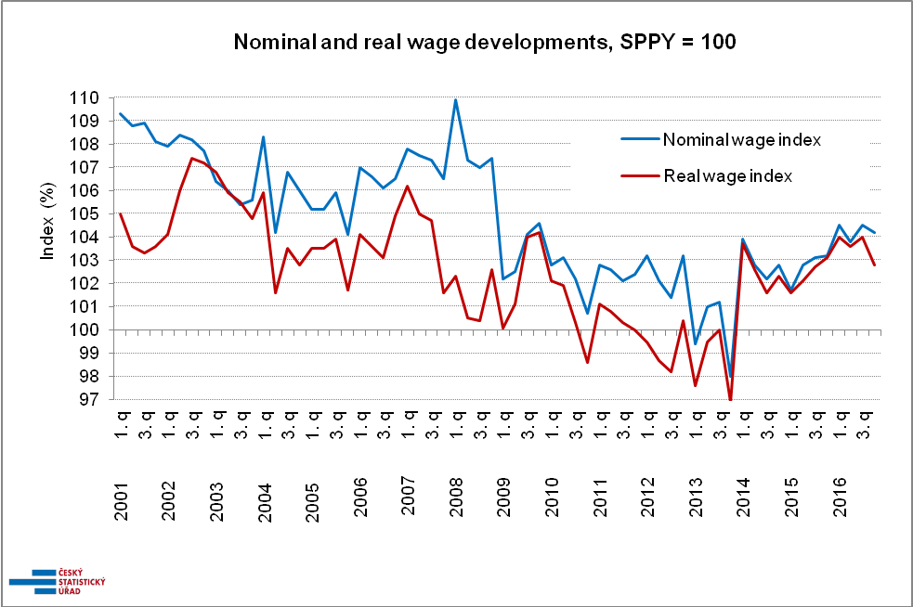
SPPY = same period of the previous year

Statistical results for Q4 2016 are extraordinary in numerous aspects and therefore it is more interesting, from the analytical point of view, to concentrate on the overall data for the whole year 2016.
The workhorse of the national economy is manufacturing which, in terms of employment and wages, was in a very good shape. There were created over 25 thousand new jobs and, moreover, the average wage increased by 4.3% in these activities over the last year. The second largest section of economic activities was wholesale and retail trade; repair of motor vehicles and motorcycles, in which almost 14 thousand new jobs was added year-on-year. This way the section surpassed the half-million limit in the number of employees. The average wage in this section increased by 4.1%. The two aforementioned sections are closely tied to the section of transportation and storage, in which the number of employees exceeded the quarter-million limit and wages grew by 4.1%.

Conversely, adverse trends of a long-term character were demonstrated in other sections. These were, first of all, hard conditions in the section of mining and quarrying, in which the yearly average wage declined by 0.5% and simultaneously the number of employees was reduced by 6%. Three years ago this economic section was giving employment to 32 thousand persons yet at the end of the last year it was mere 26.4 thousand persons. Construction also experienced a permanent decline in the number of employees.

From the regional point of view, the data showed that the Capital City of Prague, in which there has been the fastest growth in the number of employees in recent years, had a unique position. The number of employees there grew most of all regions by 3.5% in 2016 as well. This, to a certain extent, got reflected in an under average growth in wages (+3.5%). The highest growths in wages in the last year were found in the Vysočina Region (+4.9%) and the Ústecký Region (+4.8%). The lowest growth in wages in the last year was recorded in the Moravskoslezský Region (+3.2%), which has been tightly bound to the aforementioned economic activities of mining and quarrying. Concerning the recruitment of employees the lowest increase was seen in the Karlovarský Region (+0.2%), the highest one, following that in the Hl. m. Praha Region, was found in the Středočeský Region (+2.4%).

The labour market in 2016 in certain details departed from the development in the Czech Republic so far. These details were a significant increase in wages, more than doubled compared to the average, of employees of armed forces, a higher influx of Romanian and Bulgarian citizens, and, on the contrary, fading willingness of the citizens of the Slovak Republic to work in the Czech Republic.

Author: Dalibor Holý
Labour Market and Equal Opportunities Statistics Department of the CZSO
Tel.: +(420) 274 052 694
E-mail: dalibor.holy@czso.cz

