***2. REGIONAL EVALUATION OF FSS 2013 RESULTS***

*Regional results for the FSS 2013 are available at:*

[*http://www.czso.cz/csu/2014edicniplan.nsf/engpubl/270166-14-eng_n_2014*](http://www.czso.cz/csu/2014edicniplan.nsf/engpubl/270166-14-eng_n_2014)*.*

*Out of 26 246 agricultural holdings the largest proportion farmed in 2013 in* Jihomoravský *Region (15.0%) and the second largest share in* Středočeský *Region (13.4%). Natural persons represented more than 90% in* Moravskoslezský *Region,* Zlínský *Region,* Liberecký *Region,* Královéhradecký *Region and* Plzeňský *Region, and, on the contrary, only 64.4% of holdings in* Hl. m. Praha*.*

*The largest part of the utilised agricultural area was concentrated in* Středočeský *Region (15.8%) and* Jihočeský *Region (12.0%). The highest average acreage was recorded for holdings of natural persons in* Karlovarský *Region (86 ha) and* Ústecký *Region (85 ha) and holdings of legal persons in* Olomoucký *Region (1 129 ha) and* Plzeňský *Region (1 022 ha). The lowest average acreage had holdings of natural persons in* Jihomoravský *Region (21 ha) and* Zlínský *Region (22 ha) and holdings of legal persons registered in* Hl. m. Praha *(488 ha) and* Liberecký *Region (521 ha).*

*Graph 17:* ***Average acreage of utilised agricultural area and share of own land***



*Distinct differences among regions were found in ownership of utilised agricultural land. In* Karlovarský *Region the share of own land surpassed one half of the UAA (51.1%) while in all other regions it reached from less than one fifth (18.2% for* Zlínský *Region and* Vysočina *Region) to 37.8% for* Ústecký *Region. Even larger differences were recorded among holdings of natural persons: they owned 38.2% of the UAA in* Zlínský *Region and, on the contrary, 69.8% of the UAA in* Karlovarský *Region. Holdings of natural persons owned the largest part of the UAA in* Karlovarský *Region (38.7%) and the smallest one in* Vysočina *Region (8.2%).*

*Fig. 1:* ***Share of own land in agricultural holdings***

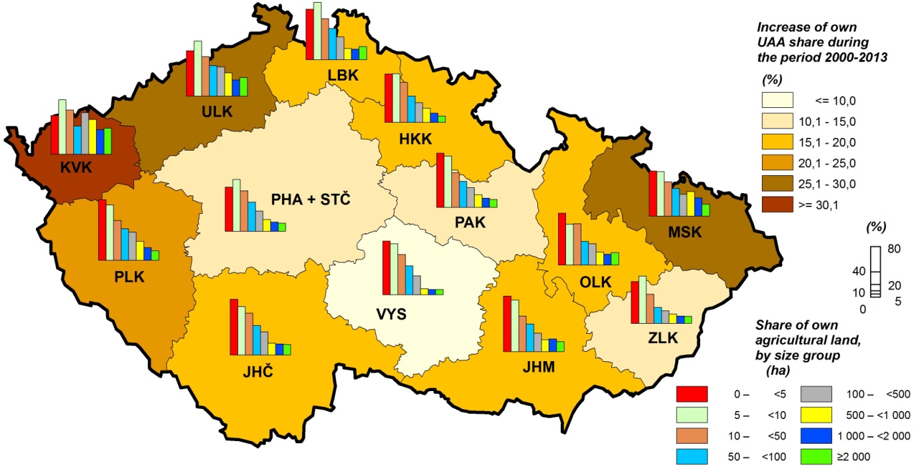

*Organic production methods were applied in the largest range in* Karlovarský *Region, where one third (33.8%) of the holdings dealt with organic farming on more than a half (55.8%) of the UAA. Also the largest proportion of holdings applying solely organic production methods was recorded in this region (30.1% of holdings and 45.5% of the UAA). No organically farming holdings were in* Hl. m. Praha *and out of other regions, and the smallest share was found in* Středočeský *Region (4.1% of holdings and 2.9% of the UAA). The smallest share of holdings utilising solely organic production methods was recorded in* Jihomoravský *Region (0.7% of holdings; 1.1% of the UAA).*

*Fig. 2:* ***Organic farming***

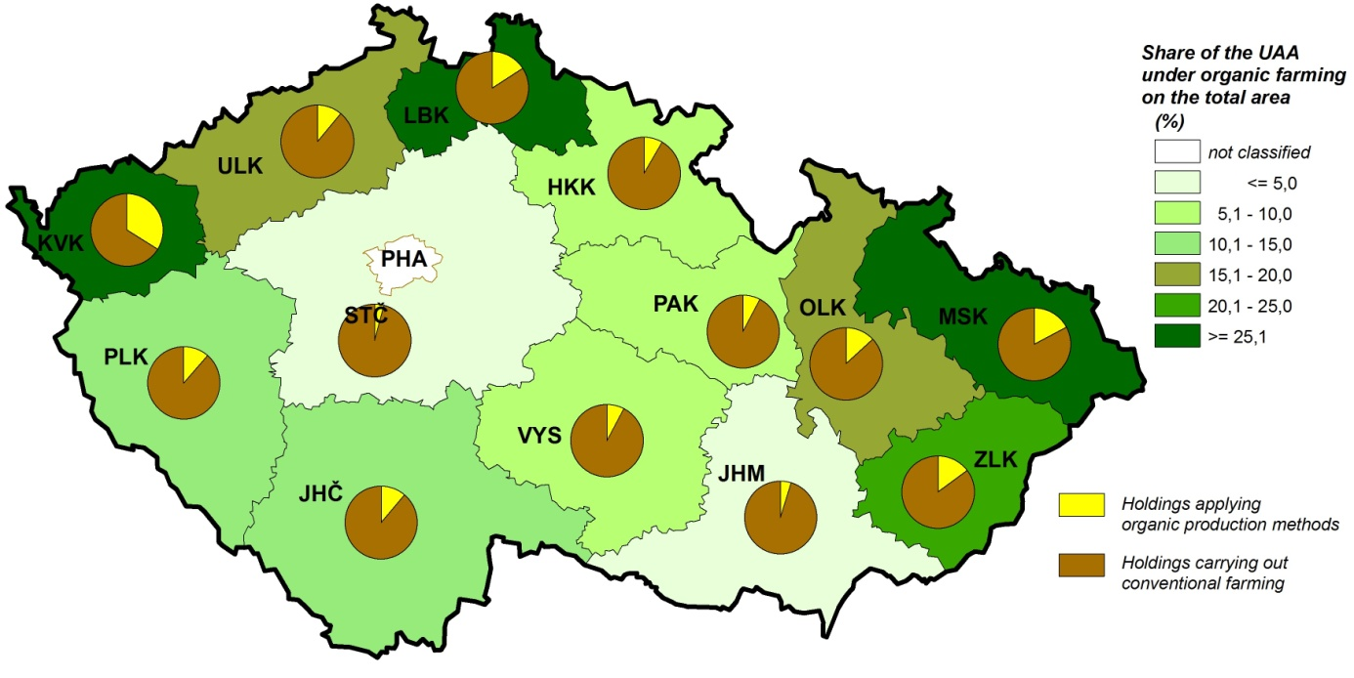

*Arable land dominated (71.3%) on the utilised agricultural area with some exceptions: in* Karlovarský *Region and* Liberecký *Region the majority of the UAA was covered by permanent grassland (65.8% and 61.2%, respectively) and a smaller part by arable land (34.1% and 37.6%, respectively). The largest share of arable land was recorded in* Jihomoravský *Region (88.8%) and* Středočeský *Region including* Hl. m. Praha *(87.4%) where the shares of permanent grassland were the smallest (6.1% and 11.6%, respectively). Growing of permanent crops is only locally important. Vineyards comprise 3.9% of the UAA in* Jihomoravský *Region and less than 1% of the UAA in* Zlínský *Region,* Ústecký *Region, and* Středočeský *Region including* Hl. m. Praha*. Hop gardens grew on 1.5% of the UAA in* Ústecký *Region and less than 1% of the UAA in* Středočeský *Region and* Olomoucký *Region. Orchards represented 1.2% of the UAA in* Jihomoravský *Region and the level of 1% of the UAA was surpassed also in* Liberecký *Region and* Ústecký *Region.*

*Graph 18:* ***Share of arable land***



*The crop group most frequently planted in all regions were cereals; the greatest share was recorded for* Jihomoravský *Region (64.7%) and* Ústecký *Region (64.0%), and the smallest one for* Pardubický *Region (51.1%) and* Vysočina *Region (51.7%). Cereal areas consisted of wheat in one half (*Olomoucký *Region, 51.8%) to two thirds (*Ústecký *Region, 68.5%) of their area. In* Jihomoravský *Region maize for grain was an important crop (44.8% of its total area). Growing of potatoes was concentrated in* Vysočina *Region (37.8% of their area) and in* Středočeský *Region (24.0%). In* Středočeský *Region the largest share of sugar beet (27.7% of its area), rape and turnip rape (21.5%), soya (20.1%) as well as other oleaginous crops (23.4%), vegetables (40.1%) or flowers and ornamental crops (34.8% of their area) was planted. Among crops typical for particular region belonged e. g. sunflower for seed (50.3% in* Jihomoravský *Region), medicinal plants and plants for seasoning (29.2% in* Pardubický *Region) or strawberries (32.6% in* Ústecký *Region). An exceptional crop was fibre flax which was concentrated in 97.7% in* Jihomoravsk*ý Region.*

*Graph 19:* ***Share of cereals on arable land*** *Graph 20:* ***Share of potatoes on arable land***



*The most frequent type of land use under organic production methods was permanent grassland; the only exception was* Jihomoravský *Region where it represented only one third (31.3%) of the UAA under organic farming while arable land organically farmed covered 54.4% of the UAA under organic farming. The largest share of permanent grasslands was in* Liberecký *Region (93.6%) where arable land comprised only 5.6% of the UAA under organic production methods. More than one half of permanent grassland was farmed organically in* Karlovarský *Region (76.6% of their area),* Ústecký *Region (61.2%),* Moravskoslezský *Region (57.0%),* Zlínský *Region (55.5%) and* Olomoucký *Region (54.9%). Orchards were organically farmed the most in* Karlovarský *Region (99.6% of their area) and* Vysočina *Region (80.2%). Vineyards and orchards in* Jihomoravský *Region covered 6.6% and 7.6%, respectively, of all the UAA organically farmed.*

*The largest share of arable land where organic production methods were applied was recorded in* Karlovarský *Region (15.7% of its area). The most frequent crops on arable land organically farmed were cereals (from 33.6% of arable land organically farmed in* Královéhradecký *Region to 65.4% in* Moravskoslezský *Region); plants harvested green (from 27.0% for* Moravskoslezský *Region to 49.7% for* Královéhradecký *Region); and in* Jihomoravský *Region also oleaginous crops (16.9% of arable land organically farmed).*

*Graph 21:* ***Share of permanent grassland in the UAA under organic production***



*As for raising of cattle, there were distinct differences among regions. The largest share for cattle totals were recorded for* Jihočeský *Region (15.8%) and* Vysočina *Region (15.5%) but both regions differed in cattle types: dairy cows prevailed in* Vysočina *Region (19.1% of their number) but other (beef) cows in* Jihočeský *Region (18.8% of their number). In* Vysočina *Region the cattle density was the highest both for cattle totals (59 heads per 100 ha of the UAA) and for dairy cows (20 heads per 100 ha of the UAA) while for other cows the in* Karlovarský *Region highest value (16 heads per 100 ha of the UAA) was reached. The lowest densities were recorded in* Jihomoravský *Region for cattle totals (17 heads per 100 ha of the UAA) and for other cows (1 head per 100 ha of the UAA) and in* Ústecký *Region for dairy cows (2 heads per 100 ha of the UAA).*

*Graph 22:* ***Raising of cattle***



*Raising of pigs was concentrated in* Středočeský *Region (20.1%) and* Vysočina *Region (16.2%) while only 0.1% of pigs were recorded in* Karlovarský *Region. Pigs density was the highest in* Vysočina *Region (93 heads per 100 ha of arable land) and the lowest in* Karlovarský *Region (5 heads per 100 ha of arable land).*

*Holdings dealing with raising of poultry were mainly in* Středočeský *Region including* Hl. m. Praha *(18.9% of the total number), especially ones dealing with raising of chicken for breeding (19.1%). Raising of hens was concentrated in* Královéhradecký *Region (24.8%) and raising of chicken for fattening in* Jihomoravský *Region (18.7%). The lowest shares of poultry were recorded in* Liberecký *Region (0.4%) and* Karlovarský *Region (0.8%). The highest poultry density was in* Pardubický *Region (1 967 heads per 100 ha of arable land) and* Královéhradecký *Region (1 695 heads per 100 ha of arable land), the lowest one in* Vysočina *Region (260 heads per 100 ha of arable land). The level of 1 000 heads of hens per 100 ha of arable land was surpassed in* Královéhradecký *Region (1 055 heads per 100 ha of arable land) and for chicken for fattening in* Pardubický *Region (1 398 heads per 100 ha of arable land).*

*Graph 23:* ***Pig density***

*(heads per 100 ha of arable land)*

**

*Graph 24:* ***Raising of poultry***



*The highest shares of sheep were recorded in* Středočeský *Region including* Hl. m. Praha *and in* Jihočeský *Region (both 11.5% of the total number). The lowest share, only 4.1%, was kept in* Jihomoravský *Region. Sheep density was the highest in* Liberecký *Region (16 heads per 100 ha of arable land) and* Zlínský *Region (14 heads per 100 ha of arable land).*

*Out of other livestock species, goats were raised mostly in* Středočeský *Region including* Hl. m. Praha *(13.4%) as well as rabbits (14.9%). In* Jihočeský *Region there was the highest share of horses (15.6%) and the highest share of holdings raising hoofed game in confinement (23.9%). In* Plzeňský *Region was the highest share of beekeepers (41.9% of beehives). Raising of fur animals had an outstanding position as it was in 88.2% concentrated in* Vysočina *Region.*

*In several regions important part of livestock were organically reared animals. It concerned especially* Karlovarský *Region where 64.1% of cattle (and even 72.3% of other cows), 29.2% of pigs, 64.6% of sheep, 48.7% of goats, 56.9% of horses, donkeys and their hybrids, and 62.9% of rabbits were reared organically. Another example is* Liberecký *Region with the highest share of ecologically reared sheep (67.4%), goats (59.6%) and poultry (8.4%). The largest share of ecologically reared beehives was recorded in* Olomoucký *Region (28.6%). The lowest proportions of organically reared animals were in* Jihomoravský *and* Středočeský *Region.*

*Graph 25:* ***Beef cows ecologically reared*** *Graph 26:* ***Sheep ecologically reared***

**

*Fig. 3:* ***Shares of livestock organically reared***

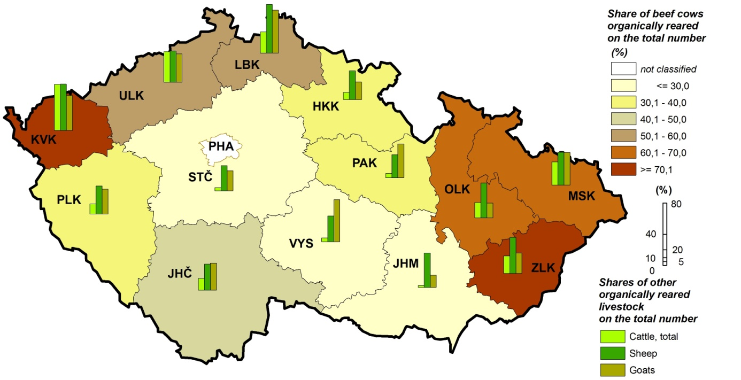

*The largest proportion of working persons in agriculture was concentrated in* Jihomoravský *Region (14.4%) and* Středočeský *Region (14.0%). The largest share of labour force regularly employed was recorded in* Plzeňský *Region (84.0%) and* Karlovarský *Region (82.5%), the lowest one in* Ústecký *Region (42.2%). The highest number of workers per one holding was in* Královéhradecký *Region (10.5 persons), the lowest one in* Liberecký *Region (4.0 persons). The average number of workers per 100 ha of the UAA ranged from 2.8 persons in* Karlovarský *Region to 7.3 persons in* Jihomoravský *Region. The share of women was the highest in* Hl. m. Praha *(45.3%) and* Jihomoravský *Region (40.2%) and the lowest in* Plzeňský *Region (29.1%) and* Karlovarský *Region (29.5%).*

*The share of Annual Work Units (AWU) to total number of working persons was in* Plzeňský *Region the highest (69.1%).* Ústecký *Region differed from all other regions with the share lower than one half – only 35.0%. This finding, together with low proportion of labour forces regularly employed, shows that local agricultural holdings focused on activities with high proportion of seasonal works (e.g. harvest of fruits and vegetables).*

*Graph 27:* ***Working persons per 100 ha of the utilised agricultural area***



*Labour force not regularly employed (i.e. working on the basis of contract of work or for services) were most common in* Ústecký *Region (8 019 contracts) and* Jihomoravský *Region (6 852 contracts). One person worked for 154 hours on average; in regions this number ranged from 117 hours in* Ústecký *Region to 199 in* Vysočina *Region. Further working persons in agriculture were employed not directly by agricultural holdings (self-employed persons or persons employed by job agencies). The largest number of persons of both categories worked in* Středočeský *Region (141 self-employed, 953 by job agencies), no such workers were in* Hl. m. Praha*. The average number of hours worked was 827 hours for self-employed persons and 390 hours for persons employed by job agencies; the first one was in* Pardubický *Region the highest (1 210 hours) and for* Olomouck*ý Region the lowest (386 hours) while the latter ranged from 185 hours in* Zlínský *Region to 2 314 hours for* Karlovarský *Region.*

*The age structure did not differ distinctly among regions. The largest share of young workers was* Moravskoslezský *Region with 21.1% for age group to 35 years. More than 20% of workers up to 35 years were also in* Pardubický *Region (20.4%) and* Ústecký *Region (20.2%), the lowest shares were in* Plzeňský *Region (16.3%) and* Olomoucký *Region (16.8%).* Vysočina *Region was the only region with more than a half of the persons in the category aged 35–55 years (51.4%). The age group of 55 years and over was most common in* Jihomoravský *Region (39.3%) and* Plzeňský *Region (38.7%), the lowest shares were in* Vysočina *Region (30.6%) and* Pardubický *Region (30.7%).*

*Graph 28:* ***Age structure of labour force regularly employed***



*Fig. 4:* ***Changes in the age structure during 2010-2013***

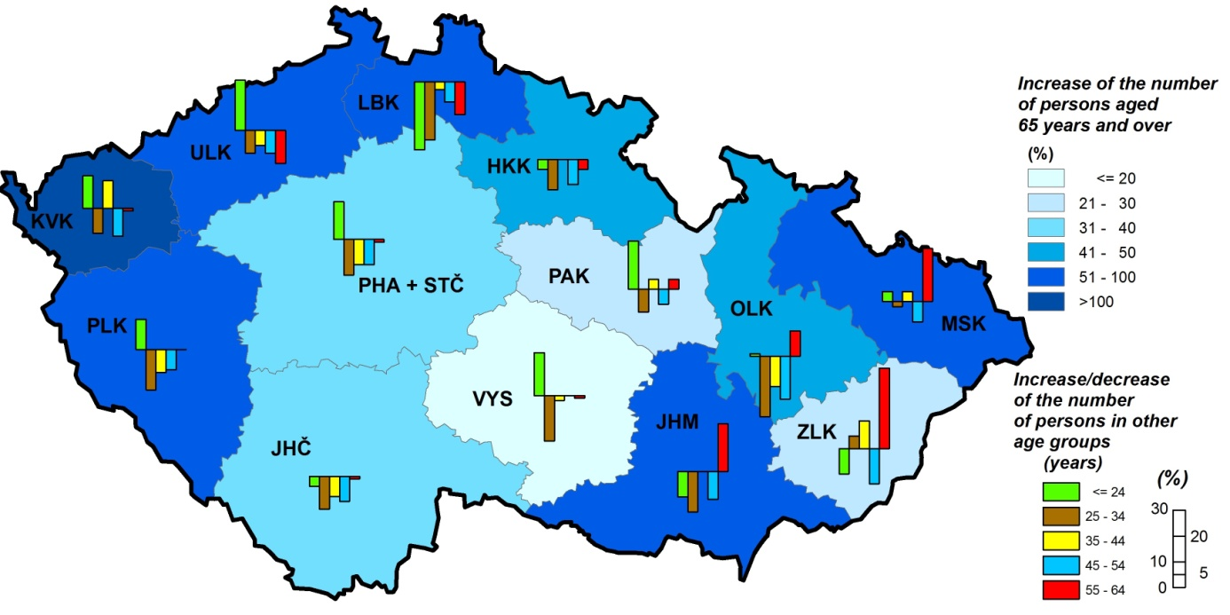

*Machinery and equipment in agricultural holdings differs in regions in relation to their prevailing agricultural activities. The largest number of tractors and tool carriers was recorded in* Pardubický *Region and* Vysočina *Region (both 383 pieces per 100 holdings) and the lowest in* Zlínský *Region (196 pcs.). Number of lorries ranged from 13 pcs. per 100 holdings in* Liberecký *Region to 30 pcs. in* Středočeský *Region including* Hl. m. Praha*. Cultivators and hoeing machines were used the most in* Vysočina *Region (139 pcs. per 100 holdings) and the least in* Karlovarský *Region (50 pcs.). Number of reapers ranged from 16 pcs. per 100 holdings in* Jihomoravský *Region to 55 pcs. in* Liberecký *Region. In* Vysočina *Region there was also the highest number of combine harvesters (59 pcs. per 100 holdings), cutter harvesters (18 pcs.) and root crops or vegetable harvesters (34 pcs.). The lowest values were recorded in* Zlínský *Region for combine harvesters (17 pcs.),* Jihomoravsk*ý Region for cutter harvesters (3 pcs.) and* Karlovarský *Region and* Zlínský *Region for root crops or vegetable harvesters (4 pcs.). The widest equipment with computer technology was recorded in* Pardubický *Region (139 personal computers per 100 holdings, of which 130 were connected to internet), opposite situation was in* Liberecký *Region and* Jihomoravský *Region (66 computers per 100 holdings, of which connected to internet 61 ones in* Liberecký *Region and 62 ones in* Jihomoravský *Region).*

*The largest share of holdings dealing with renewable energy production was recorded in* Vysočina *Region (3.8%) and* Pardubický *Region (3.5%), and the lowest in* Zlínský *Region (1.6%). The largest proportion of holdings utilising biomass energy was situated in* Vysočina *Region (16.1%) while in* Středočeský *Region including* Hl. m. Praha *holdings using solar energy were concentrated (17.2%).*

*Fig. 5:* ***Equipment for renewable energy production***

