STRUCTURE OF AGRICULTURAL HOLDINGS BROKEN DOWN BY TYPES OF FARMING

The updated Community typology for agricultural holdings provides an additional view to Czech agricultural structures. The basic information concerning number of farms in particular regions broken down by types of farming is given in Annex B1. The results show that Czech agricultural production is concentrated mainly in three prevailing types of farming; specialist grazing livestock, specialist field crops and mixed crops-livestock. Moreover, the distribution of particular types of farming depends on regional soil-climatic and economic conditions.
The largest share of the holdings is formed by specialist grazing livestock, whose development was conditioned by support of breeding suckler cows in frame of CAP and is typical for the Less Favoured Areas. The grazing livestock specialists forms more than one third of the total agricultural holdings in the Czech Republic (34%). Nevertheless, ca 70% of these farms represents the small scale holdings, which is caused by the large share of natural person holdings within this specialisation (91%). Agricultural holdings specialized in grazing livestock utilise 23% of agricultural land resources. The share of these holdings on total animal production expressed in livestock units is 24%. As for particular regions, the largest proportion of cattle rearing is concentrated in Karlovarský Region (62%), followed by Liberecký Region (58%), Zlínský Region (55%) and Plzeňský Region (51%). In absolute numbers, most of grazing livestock specialists are situated in Středočeský Region (1 269 holdings).
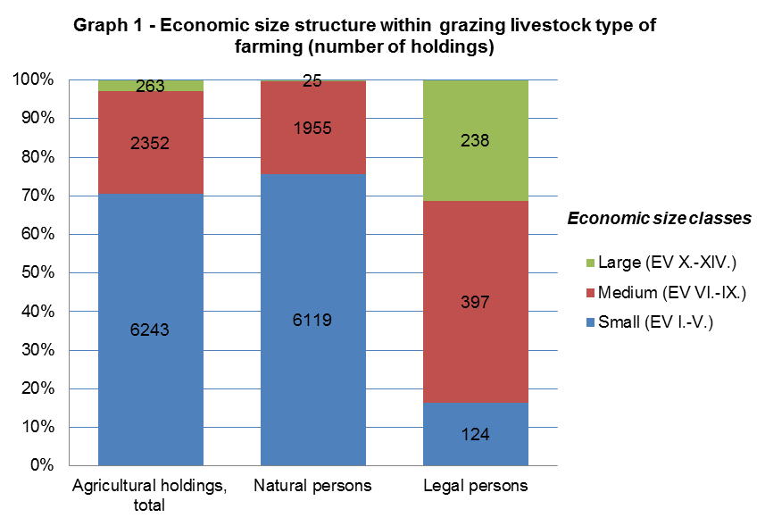
In detail, the group of grazing livestock specialists consists of specialist dairying (14%), specialist cattle – rearing and fattening (39%), cattle – rearing and fattening combined (4%) and sheep, goats and other grazing livestock (43%). A more intensive form of production is typical for the specialist dairying compared with other types of farms. In the frame of grazing livestock type of farming, dairy farms include 44% of total livestock units. One holding of dairying specialist therefore rears on average 153 livestock units. Another important type of farming is specialist cattle-rearing and fattening, sharing 48% of agricultural land and 41% of livestock units within the abovementioned general type of farming. Average number of livestock units in this type of farming reaches 52 LSU per holding. The most frequent type of farming regarding the number of holding is sheep, goats and other grazing livestock type (3 777 holdings). However, the share of 92% of the total number of farms is covered by small holdings in this specialization; therefore its economic significance within the sector is negligible.
Specialist field crops play an important role among analyzed types of farming, representing one of the driving forces of Czech agriculture. Approximately one third of Czech farms is specialized in field crops production (31%). The share on the total acreage of utilized agricultural is identical, i.e. 31%. Concerning the legal form, the majority (91%) of field crops specialists is formed by natural person holdings as well as in case of grazing livestock type of farming. Comparison of these two most frequent types of farming shows the significantly lower share of small size holdings within the group of field crops specialists (50%). As for regional evaluation, most of the field crops specialists is situated in Středočeský Region (1 881 holdings) with the largest proportion of this type of farming (54%), if we leave aside Hlavní město Praha as a non-agricultural separate region. Important position is held also by Vysočina Region (851 holdings), Jihomoravský Region (822 holdings) and Jihočeský Region (722 holdings). In general, the regions suitable for field crops planting are naturally determined by altitude and soil-climatic conditions.
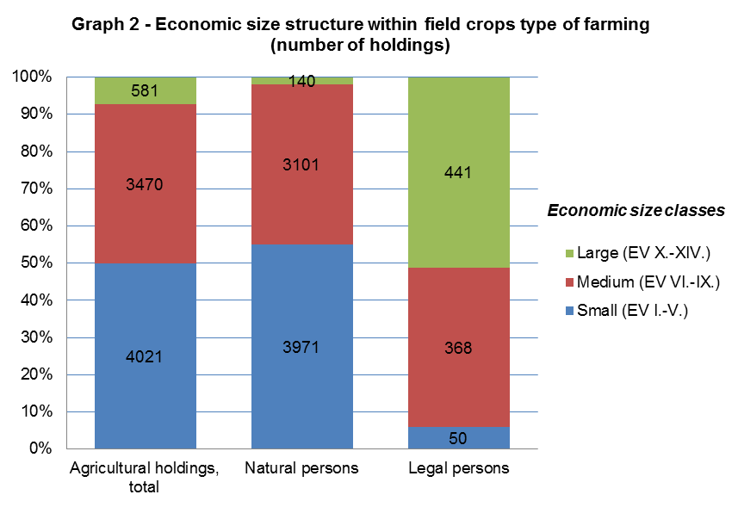
In detail, the general type of specialist field crops consists of specialist cereals, oilseeds and protein crops and general field cropping (specialized in combined cropping of field crops, root crops and field vegetables). Almost two thirds (62%) of these holdings belong to group of farms specialized in cereals and oilseeds cropping. The remaining 38% of field crops specialists were classified as general field cropping. The lower proportion of small-scale holdings (45%) is typical for the group of the cereals and oilseeds specialists. The average acreage reaches 163 hectares per holding in this type of farming. Within agricultural holdings specialized in general field cropping, the proportion of small size farms is more significant (59%); which results in lower value of the average acreage (108 ha/holding).

The group of agricultural holdings specialized in mixed production is primarily composed of mixed crops-livestock farms. On a small scale, holdings oriented on mixed cropping and mixed livestock production are also involved. With the total number of 5 507 holdings, the mixed production type of farming represents the third most frequent agricultural specialization in the Czech Republic. Nevertheless, in consideration of high share of large-scale legal persons (15% within the mixed production type of farming), the group of mixed production specialists concentrates the substantial part of Czech agricultural production. Mixed production farms cover 41% of total utilized agricultural area and 43% of the total number of livestock units. The most of mixed production farms is situated in Vysočina Region (840 holdings) with the 35% share on total number of agricultural holdings in this region. The high proportion of mixed production farms also occurs in Jihočeský Region (806 holdings) and Středočeský Region (776 holdings). In general, the share of mixed production holdings varies from 20% to 30% in particular regions, with the exception of Karlovarský Region, Jihomoravský Region, Liberecký Region and Ústecký Region.
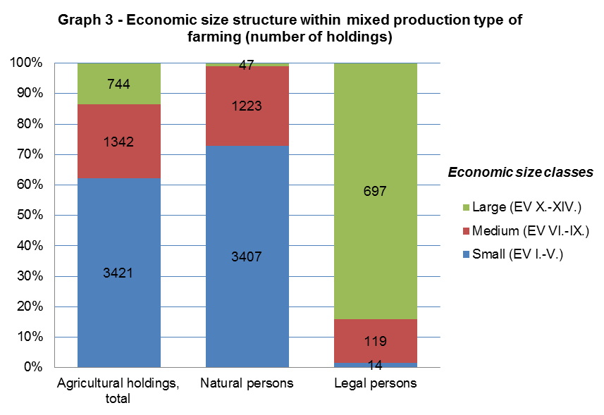
The combination of field crops and grazing livestock production is the prevailing type of farming (54% of holdings) within the group of mixed production specialists, followed by various crops and livestock combined (25%), mixed livestock, mainly grazing livestock (13%), mixed cropping (5%) and mixed livestock, mainly granivores (3%). In frame of mixed production type of farming, holdings specialized in combined field crops and grazing livestock production cover the highest share of both utilized agricultural area (70%) and number of livestock units (62%). This group of farms reaches 344 ha/holding and 151 LSU/holding on average.
The number of holding specialized in rearing of granivores was decreasing in recent years due to the economic crisis in pig farming industry. The Farm Structure Survey 2013 involved 411 holdings within this type of farming. High proportion of legal persons (42%) and large-scale holdings (35%) is typical for this group. Agriculture holdings belonging to specialist granivores can be characterized by intensive way of rearing. These holdings concentrate 26% of the total number of livestock units in the Czech Republic. On average, granivores specialists reach 1 076 LSU/holding.
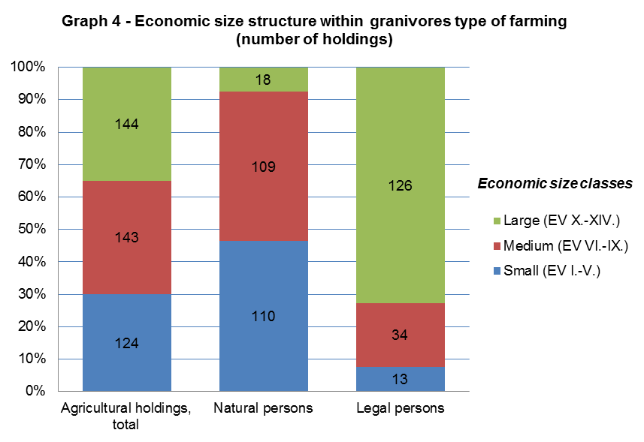
Principal type of farming specialist granivores includes specialist pig (38%), specialist poultry (50%) and various granivores combined type (12%). In contrast with pig farming, the number of holdings specialized in poultry has slightly increased.
Despite the marginal share on total utilized agricultural area (1%), holdings specialized in horticulture and permanent crops generate the significant part of Czech agricultural production. Holdings of natural person prevail within this type of farming (92%); therefore the largest proportion is formed by small size holdings (73%). In frame of both horticulture and permanent crops specialist, the average acreage is 11 ha/holding. The regional distribution is determined by climatic conditions. The production is concentrated into traditional fruit crop and wine-producing regions. In Jihomoravský Region, 2 373 holdings belonging to horticulture and permanent crops specialization is situated, which form 71% of these holdings in the Czech Republic.
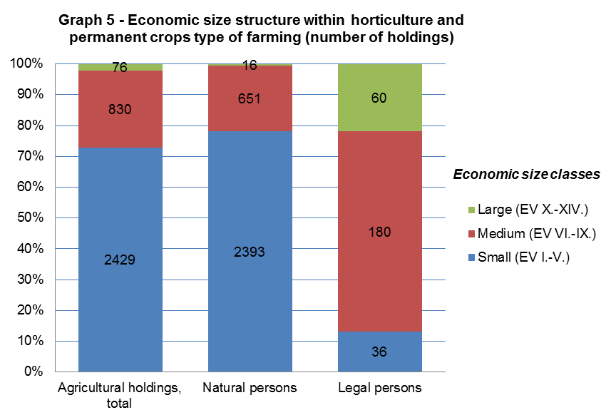
The principal type of farming horticulture is represented by 347 holdings. This group consists of specialist horticulture outdoors (64%) and other horticulture (36%). Other horticulture involves holdings specialized in nurseries and mushroom production. Holdings specialised in indoor horticulture (green houses, foil covers) have not been included in the Farm Structure Survey.
The specialist permanent crops represents the larger group concerning number of holdings (2 988 holdings). This group is divided into specialist vineyards (73%), specialist fruit (22%) and various permanent crops combined (5%). More than 80% of specialist vineyards type of farming belong to small size economic classes. Specialist vineyards reach average acreage of 8 ha/holding. In case of specialist fruit, small size holdings form 66% within this specialization. Fruit farms utilize 22 ha/holding on average.
The Farm Structure Survey included a small group of 64 non-classified holdings, whose type of farming and economic size class could not have been determined. These holdings utilize fallow land, or permanent grassland no longer used for production purposes and eligible for the payment of subsidies. EU typology methods set the value of standard output for these categories as equal to zero; therefore its classification is not possible.

