28. 1. 2014

The Public Trust in the Czech Statistical Office Keeps High
A survey of the Public Opinion Research Centre (CVVM) at the Institute of Sociology of the Czech Academy of Sciences revealed that over two thirds of the Czech Republic population older than 15 years of age trust in the Czech Statistical Office and consider its activities useful. The respondents consider information, published by the Czech Statistical Office, trustful, accurate, and unbiased. Four fifths of the Czech Republic population think the Czech Statistical Office is a professional institution.
After three years, the Czech Statistical Office (CZSO) again ordered a survey called “Image of the Czech Statistical Office in the Czech Public Opinion”. The survey, which was carried out in December 2013, revealed that the Czech Statistical Office enjoys trust of 62% of the Czech Republic population older 15 years of age while “definitely truthful” is for 12% of the population and “rather truthful” is for 50% of the population. 21% of the respondents consider the CZSO “untruthful”. Trust in the CZSO increases with the level of educational attainment and with improving own evaluation of living standard of the respondent’s household. It is interesting that women trust in the CZSO more than men (67% and 56%, respectively), while the answer “don’t know” was given almost at the same frequency by men and women.
Two thirds (66%) of respondents stated that they “rather guess”, which the CZSO deals with; over one fifth (22%) think, they “know exactly”, and 12% of the respondents answered they “don’t know”. It follows from the survey results, furthermore, that the Czech Republic population most often relate the CZSO to the Population and Housing Census (95%) and to the population registration (91%). Over three quarters (77%) of the respondents included the processing of the election results into the CZSO activities. Majority of the Czech Republic population also relates the CZSO to monitoring and publishing data on economic development. Furthermore, the respondents think that the Office activities include also comparison of data on the Czech Republic development with international development and, last but not least, releases of data found as well.
Almost three quarters (72%) of the Czech Republic population older than 15 years of age consider the CZSO to be a useful institution and mere 16% think the Office is useless. Those, who think they know what the CZSO deals with and also those who trust in the CZSO, more believe the CZSO is useful. The CZSO is increasingly perceived as a useful institution with growing educational attainment and improving subjective evaluation of living standard.
The Czech public encounters outcomes of the CZSO mostly in a passive way by means of news in media (81%). If respondents seek CZSO information in an active manner on their own then they mostly use the Internet.
Since 2006, when the first survey of this series was carried out, the CZSO image in the public has been relatively stable and recorded changes just very slightly exceeded the limit of statistical significance.
The analysed data were obtained by means of standardized interviews of the interviewer and respondents based on a questionnaire. The survey was performed from 2 to 9 December 2013, the number of respondents older than 15 years of age was 957, and quota marks were as follows: region, size of the place of residence, sex, age, and educational attainment.

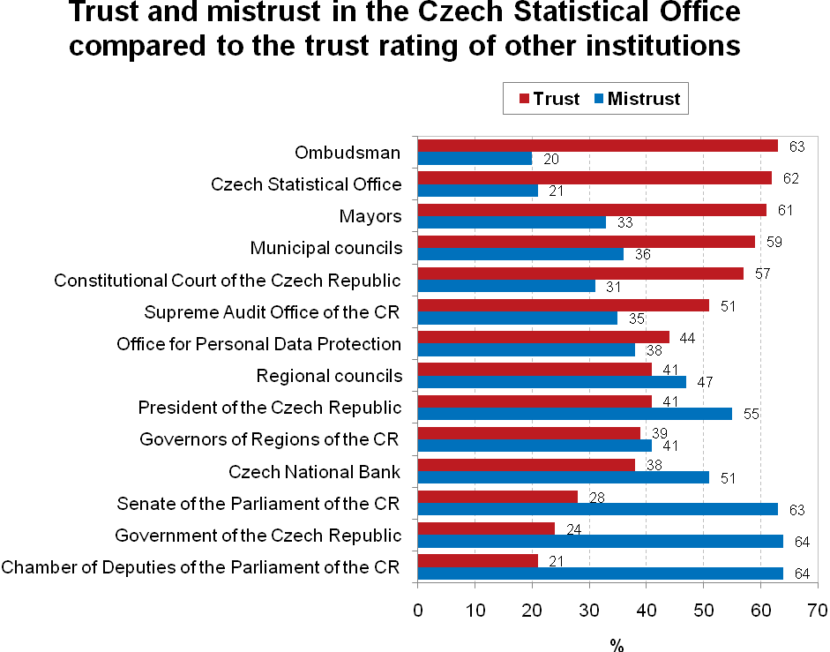
Contact person
Mr Jan Cieslar
CZSO Spokesman
Tel.: 274 052 017
GSM: 724 800 157
E-mail: jan.cieslar@czso.cz

