Standard revision of price index of agricultural producers
The purpose of revision is updating of the system of price indices especially due to accumulated changes in real described section. This updating is focus on selected files of the representatives and reporting units, weight structure, price base and eventually the methodology of calculation. Revision of price indices is doing every 5 years.
During the year 2022 was the agricultural producer price index subjected to standard comprehensive review.
Within this revision was revised selection of representatives and respondents, was set new price and index basis and was introduced a new weighting scheme based on the structure of sales of agricultural production in individual months.
Agricultural producer price indices are calculated from January 2023 to the new weighting schemes derived from the average sales for the years 2019, 2020 and 2021. The indices are calculated on the new price base average of 2020 = 100
The revised time series of basic price indices calculated on the new weighting scheme for the years 2020, 2021, and 2022, is currently published retrospectively at its first publication for January 2023. This new time series of indices has a base - average of 2020 = 100

Comparison of weight representation of agricultural products in the previous and the current revised structure of the agricultural producer price index
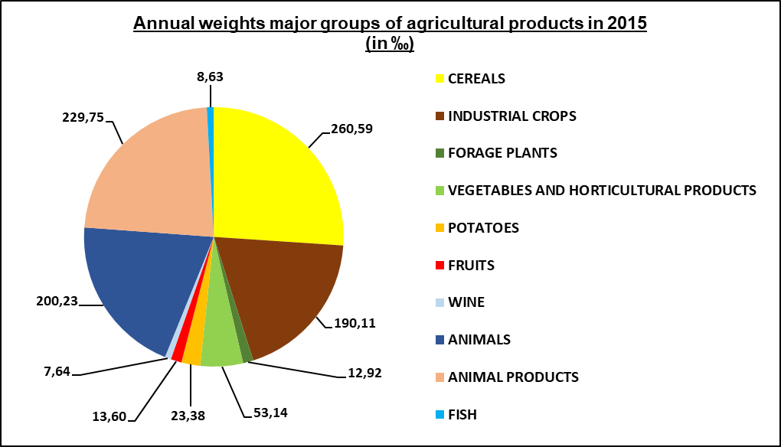

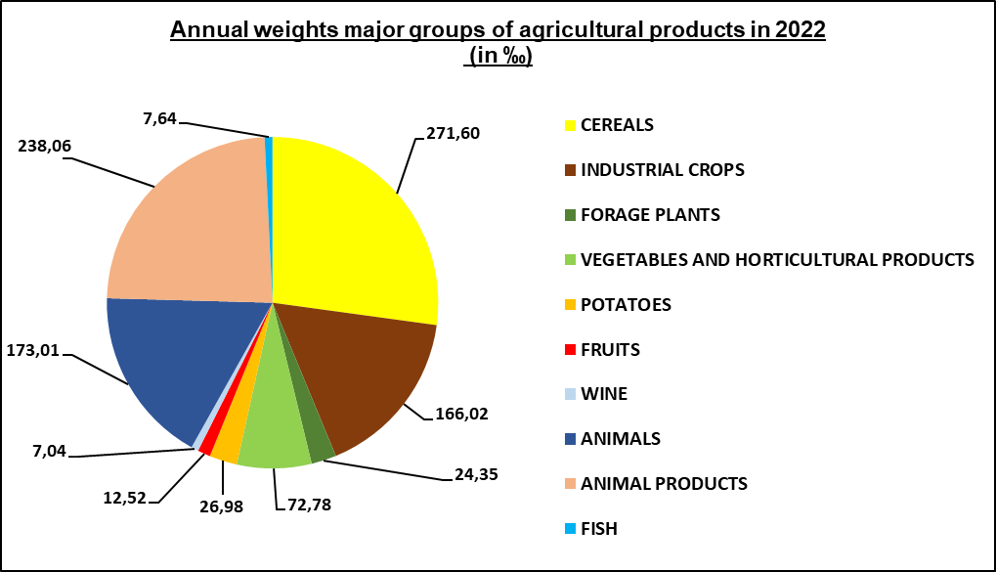

Conversely, in the calculation of the price index of agricultural producers some representatives with the lowest volumes of sales at the domestic market in 2019 – 2021 were excluded:
3070 Savoy cabbage (Kale)

Variable monthly weights of agricultural products in ‰
Kod | Title/Month | 1 | 2 | 3 | 4 | 5 | 6 | 7 | 8 | 9 | 10 | 11 | 12
000000 | Total Agricultural Products including Fishes | 1 000 | 1 000 | 1 000 | 1 000 | 1 000 | 1 000 | 1 000 | 1 000 | 1 000 | 1 000 | 1 000 | 1 000
140000 | Total Agricultural Products | 991,81 | 991,46 | 992,24 | 991,78 | 991,15 | 991,68 | 991,81 | 991,65 | 992,90 | 994,59 | 993,22 | 992,42
141000 | Total Agricultural Products (excluding Fruits and Vegetables) | 957,24 | 960,90 | 868,95 | 914,84 | 974,45 | 942,65 | 920,05 | 914,99 | 915,85 | 765,79 | 883,72 | 948,22
100000 | Crop Products | 551,64 | 532,35 | 575,11 | 549,47 | 514,98 | 544,26 | 551,35 | 542,34 | 611,07 | 703,67 | 628,72 | 584,76
101000 | Crop Products (excluding Fruits and Vegetables) | 517,07 | 501,78 | 451,81 | 472,53 | 498,29 | 495,23 | 479,59 | 465,69 | 534,02 | 474,87 | 519,22 | 540,57
102000 | Fruits and Vegetables | 34,57 | 30,57 | 123,30 | 76,94 | 16,69 | 49,03 | 71,76 | 76,65 | 77,05 | 228,80 | 109,50 | 44,20
010000 | CEREALS | 290,83 | 303,35 | 275,61 | 292,24 | 314,61 | 295,62 | 291,02 | 296,87 | 252,28 | 192,22 | 240,83 | 269,35
011000 | Wheat | 184,00 | 191,92 | 174,37 | 184,89 | 199,05 | 187,03 | 184,12 | 187,82 | 159,61 | 121,61 | 152,37 | 170,41
011110.1011 | Milling soft wheat | 104,48 | 108,97 | 99,01 | 104,98 | 113,02 | 106,20 | 104,55 | 106,65 | 90,63 | 69,05 | 86,52 | 96,76
011110.1012 | Feed soft wheat | 79,53 | 82,95 | 75,36 | 79,91 | 86,03 | 80,84 | 79,58 | 81,18 | 68,98 | 52,56 | 65,85 | 73,65
012000 | Rye | 5,44 | 5,68 | 5,16 | 5,47 | 5,89 | 5,53 | 5,45 | 5,56 | 4,72 | 3,60 | 4,51 | 5,04
012110.1031 | Rye for consupmtion | 5,44 | 5,68 | 5,16 | 5,47 | 5,89 | 5,53 | 5,45 | 5,56 | 4,72 | 3,60 | 4,51 | 5,04
013000 | Barley | 60,32 | 62,92 | 57,17 | 60,62 | 65,26 | 61,32 | 60,36 | 61,58 | 52,33 | 39,87 | 49,95 | 55,87
013110.1023 | Feed barley | 27,65 | 28,84 | 26,21 | 27,79 | 29,91 | 28,11 | 27,67 | 28,23 | 23,99 | 18,28 | 22,90 | 25,61
013210.1021 | Malting barley | 32,67 | 34,08 | 30,96 | 32,83 | 35,34 | 33,21 | 32,69 | 33,35 | 28,34 | 21,59 | 27,06 | 30,26
014000 | Oats | 6,05 | 6,31 | 5,73 | 6,08 | 6,54 | 6,15 | 6,05 | 6,17 | 5,25 | 4,00 | 5,01 | 5,60
014110.1042 | Feed oats | 6,05 | 6,31 | 5,73 | 6,08 | 6,54 | 6,15 | 6,05 | 6,17 | 5,25 | 4,00 | 5,01 | 5,60
015000 | Grain maize | 30,91 | 32,24 | 29,29 | 31,06 | 33,44 | 31,42 | 30,93 | 31,55 | 26,81 | 20,43 | 25,60 | 28,63
015110.1052 | Grain maize | 30,91 | 32,24 | 29,29 | 31,06 | 33,44 | 31,42 | 30,93 | 31,55 | 26,81 | 20,43 | 25,60 | 28,63
019000 | Other cereals | 4,10 | 4,28 | 3,89 | 4,12 | 4,44 | 4,17 | 4,10 | 4,19 | 3,56 | 2,71 | 3,40 | 3,80
019110.1032 | Triticale | 4,10 | 4,28 | 3,89 | 4,12 | 4,44 | 4,17 | 4,10 | 4,19 | 3,56 | 2,71 | 3,40 | 3,80
020000 | INDUSTRIAL CROPS | 176,97 | 147,60 | 128,25 | 133,61 | 143,84 | 135,16 | 133,06 | 135,73 | 182,83 | 197,78 | 216,26 | 225,46
021000 | Oil seeds and oleaginous fruits | 132,26 | 137,89 | 123,44 | 128,51 | 138,35 | 130,00 | 127,98 | 130,55 | 116,45 | 92,22 | 113,87 | 122,71
021110.1210 | Rape | 114,19 | 119,10 | 108,21 | 114,74 | 123,53 | 116,07 | 114,26 | 116,56 | 99,05 | 75,47 | 94,56 | 105,75
021210.1230 | Sunflower | 4,37 | 4,49 | 2,24 |  |  |  |  |  | 5,50 | 7,69 | 7,96 | 4,26
021910.1220 | Poppy seeds | 13,70 | 14,29 | 12,99 | 13,77 | 14,83 | 13,93 | 13,71 | 13,99 | 11,89 | 9,06 | 11,35 | 12,69
022000 | Protein crops | 5,08 | 5,29 | 4,81 | 5,10 | 5,49 | 5,16 | 5,08 | 5,18 | 4,40 | 3,35 | 4,20 | 4,70
022110.1102 | Dried peas for feeding | 5,08 | 5,29 | 4,81 | 5,10 | 5,49 | 5,16 | 5,08 | 5,18 | 4,40 | 3,35 | 4,20 | 4,70
024000 | Sugar beet | 39,63 | 4,42 |  |  |  |  |  |  |  | 58,36 | 77,42 | 80,93
024110.1510 | Sugar beet | 39,63 | 4,42 |  |  |  |  |  |  |  | 58,36 | 77,42 | 80,93
029000 | Other industrial crops |  |  |  |  |  |  |  |  | 61,98 | 43,86 | 20,77 | 17,12
029210.1310 | Hop cones |  |  |  |  |  |  |  |  | 61,98 | 43,86 | 20,77 | 17,12
030000 | FORAGE PLANTS | 26,07 | 27,19 | 24,71 | 26,20 | 28,20 | 26,50 | 26,09 | 26,61 | 22,61 | 17,23 | 21,59 | 24,14
040000 | VEGETABLES AND HORTICULTURAL PRODUCTS | 27,82 | 24,95 | 117,40 | 71,10 | 12,39 | 16,16 | 63,72 | 66,29 | 57,11 | 205,79 | 96,00 | 36,73
041000 | Fresh vegetables | 27,82 | 24,95 | 15,69 | 3,35 | 12,39 | 16,16 | 63,72 | 66,29 | 57,11 | 44,97 | 34,40 | 36,73
041100 | Cauliflower |  |  |  |  |  |  | 2,40 | 2,57 | 2,38 | 1,56
041110.3090 | Cauliflower |  |  |  |  |  |  | 2,40 | 2,57 | 2,38 | 1,56
041200 | Tomatoes |  |  |  |  |  |  | 18,36 | 15,64 | 10,00 | 6,68
041210.3161 | Tomatoes |  |  |  |  |  |  | 18,36 | 15,64 | 10,00 | 6,68
041900 | Other fresh vegetables | 27,82 | 24,95 | 15,69 | 3,35 | 12,39 | 16,16 | 42,95 | 48,08 | 44,73 | 36,72 | 34,40 | 36,73
041910.3100 | White cabbage | 0,25 |  |  |  |  |  | 1,97 | 4,76 | 6,03 | 5,63 | 3,67 | 3,38
041910.3101 | Red cabbage |  |  |  |  |  |  |  | 0,14 | 0,40 | 0,49 | 1,02 | 0,45
041920.3200 | Lettuce |  |  |  | 0,79 | 0,66 | 0,53 | 0,38
041940.3134 | Cucumbers |  |  |  |  |  | 1,89 | 3,11 | 1,32 | 0,69
041950.3032 | Carrots | 13,54 | 8,54 | 7,33 |  |  |  | 22,01 | 22,48 | 13,68 | 12,17 | 11,82 | 12,81
041960.3172 | Onions | 5,34 | 6,80 | 4,38 | 2,56 | 3,42 | 5,31 | 6,18 | 6,40 | 7,33 | 7,49 | 8,21 | 5,37
041999.3012 | Celery | 3,79 | 6,17 | 3,97 |  |  |  |  |  | 5,98 | 3,98 | 4,17 | 9,92
041999.3042 | Parsley | 4,89 | 3,44 |  |  |  |  |  | 5,06 | 4,76 | 4,64 | 5,51 | 4,80
041999.3061 | Kohlrabi |  |  |  |  | 8,31 | 8,43 | 9,09 | 7,73 | 5,78 | 2,29
041999.3150 | Capsicum |  |  |  |  |  |  | 0,21 | 0,20 | 0,08 | 0,04
042000 | Plants and flowers |  |  | 101,72 | 67,74 |  |  |  |  |  | 160,82 | 61,60
042100 | Nursery products |  |  | 101,72 | 67,74 |  |  |  |  |  | 160,82 | 61,60
050000 | POTATOES | 23,20 | 23,64 | 23,25 | 20,48 | 11,63 | 37,96 | 29,42 | 6,48 | 53,96 | 32,33 | 31,17 | 21,62
051000 | Potatoes for consumption | 17,99 | 15,74 | 10,02 | 5,17 | 4,24 | 37,96 | 29,42 | 6,48 | 41,19 | 19,48 | 16,55 | 15,03
051110.1610 | Early potatoes |  |  |  |  |  | 36,41 | 29,42 | 6,48
051210.1620 | Main crop potatoes | 17,99 | 15,74 | 10,02 | 5,17 | 4,24 | 1,55 |  |  | 41,19 | 19,48 | 16,55 | 15,03
052000 | Seed potatoes | 0,87 | 7,90 | 13,23 | 15,31 | 7,39 |  |  |  |  |  | 0,95 | 0,87
052110.1640 | Seed potatoes | 0,87 | 7,90 | 13,23 | 15,31 | 7,39 |  |  |  |  |  | 0,95 | 0,87
059000 | Other potatoes | 4,34 |  |  |  |  |  |  |  | 12,77 | 12,86 | 13,67 | 5,72
059110.1630 | Starch potatoes | 4,34 |  |  |  |  |  |  |  | 12,77 | 12,86 | 13,67 | 5,72
060000 | FRUITS | 6,75 | 5,62 | 5,90 | 5,84 | 4,30 | 32,87 | 8,04 | 10,36 | 19,94 | 23,01 | 13,50 | 7,47
061000 | Fresh fruit | 6,75 | 5,62 | 5,90 | 5,84 | 4,30 | 32,87 | 8,04 | 10,36 | 19,94 | 23,01 | 13,50 | 7,47
061100 | Dessert apples | 5,80 | 5,62 | 5,90 | 5,84 | 4,30 | 2,42 | 1,17 | 1,61 | 12,02 | 19,33 | 12,32 | 6,52
061110.2011 | Dessert apples | 3,33 | 2,79 | 3,20 | 3,40 | 2,07 | 1,03 | 0,25 | 0,70 | 4,01 | 10,59 | 4,64 | 3,12
061120.2012 | Industrial appples | 2,48 | 2,83 | 2,70 | 2,45 | 2,23 | 1,39 | 0,92 | 0,91 | 8,00 | 8,74 | 7,68 | 3,40
061200 | Dessert pears | 0,95 |  |  |  |  |  |  |  | 2,09 | 2,27 | 1,19 | 0,95
061210.2020 | Dessert pears | 0,95 |  |  |  |  |  |  |  | 2,09 | 2,27 | 1,19 | 0,95
061300 | Peaches |  |  |  |  |  |  | 0,23 | 0,51
061310.2030 | Peaches |  |  |  |  |  |  | 0,23 | 0,51
061900 | Other fresh fruit |  |  |  |  |  | 30,45 | 6,64 | 8,24 | 5,84 | 1,40
061910.2060 | Cherries |  |  |  |  |  |  | 3,58
061920.2050 | Plums |  |  |  |  |  |  |  | 6,91 | 5,84 | 1,40
061930.2111 | Strawberries |  |  |  |  |  | 30,45
061990.2040 | Apricots |  |  |  |  |  |  | 0,75 | 0,33
061990.2070 | Sour cherry |  |  |  |  |  |  | 2,31 | 1,00
070000 | WINE (incl. must) |  |  |  |  |  |  |  |  | 22,33 | 35,31 | 9,37
072110.1710 | Grapes for wine production |  |  |  |  |  |  |  |  | 22,33 | 35,31 | 9,37
130000 | Animals and animal products | 440,17 | 459,12 | 417,13 | 442,30 | 476,17 | 447,42 | 440,46 | 449,31 | 381,83 | 290,92 | 364,50 | 407,66
110000 | ANIMALS | 185,26 | 193,23 | 175,56 | 186,16 | 200,41 | 188,31 | 185,38 | 189,10 | 160,70 | 122,44 | 153,41 | 171,57
111000 | Cattle | 54,11 | 56,44 | 51,28 | 54,37 | 58,54 | 55,00 | 54,15 | 55,23 | 46,94 | 35,76 | 44,81 | 50,11
111100 | Cattle excluding calves | 50,90 | 53,09 | 48,23 | 51,14 | 55,06 | 51,73 | 50,93 | 51,95 | 44,15 | 33,64 | 42,15 | 47,14
111110.4110 | Live bullocks for slaughter | 25,07 | 26,15 | 23,76 | 25,20 | 27,13 | 25,49 | 25,09 | 25,60 | 21,75 | 16,57 | 20,76 | 23,22
111120.4210 | Live heifers for slaughter | 8,00 | 8,35 | 7,58 | 8,04 | 8,66 | 8,13 | 8,01 | 8,17 | 6,94 | 5,29 | 6,63 | 7,41
111130.4310 | Live cows for slaughter | 17,82 | 18,59 | 16,89 | 17,91 | 19,28 | 18,11 | 17,83 | 18,19 | 15,46 | 11,78 | 14,76 | 16,50
111200 | Calves | 3,21 | 3,35 | 3,05 | 3,23 | 3,48 | 3,27 | 3,22 | 3,28 | 2,79 | 2,12 | 2,66 | 2,98
111210.4410 | Live calves for slaughter | 3,21 | 3,35 | 3,05 | 3,23 | 3,48 | 3,27 | 3,22 | 3,28 | 2,79 | 2,12 | 2,66 | 2,98
112000 | Pigs | 74,24 | 77,44 | 70,36 | 74,60 | 80,31 | 75,46 | 74,29 | 75,78 | 64,40 | 49,07 | 61,48 | 68,76
112110.4610 | Live pigs for slaughter | 73,27 | 76,42 | 69,44 | 73,63 | 79,26 | 74,48 | 73,32 | 74,79 | 63,56 | 48,43 | 60,67 | 67,86
112120.5610 | Weanling piglets | 0,97 | 1,01 | 0,92 | 0,98 | 1,05 | 0,99 | 0,97 | 0,99 | 0,84 | 0,64 | 0,81 | 0,90
115000 | Poultry | 56,91 | 59,35 | 53,93 | 57,18 | 61,56 | 57,84 | 56,94 | 58,09 | 49,36 | 37,61 | 47,12 | 52,70
115100 | Chickens | 48,10 | 50,17 | 45,58 | 48,33 | 52,03 | 48,89 | 48,13 | 49,09 | 41,72 | 31,79 | 39,83 | 44,54
115110.5011 | Chickens (live - 1st choice) | 48,10 | 50,17 | 45,58 | 48,33 | 52,03 | 48,89 | 48,13 | 49,09 | 41,72 | 31,79 | 39,83 | 44,54
115900 | Other poultry | 8,81 | 9,19 | 8,35 | 8,85 | 9,53 | 8,95 | 8,81 | 8,99 | 7,64 | 5,82 | 7,29 | 8,16
115910.5031 | Broiler turkeys | 5,86 | 6,11 | 5,55 | 5,89 | 6,34 | 5,96 | 5,87 | 5,98 | 5,08 | 3,87 | 4,85 | 5,43
115910.5041 | Ducks (slaughtered) | 2,95 | 3,07 | 2,79 | 2,96 | 3,19 | 3,00 | 2,95 | 3,01 | 2,56 | 1,95 | 2,44 | 2,73
120000 | ANIMAL PRODUCTS | 254,91 | 265,88 | 241,57 | 256,15 | 275,76 | 259,11 | 255,08 | 260,20 | 221,12 | 168,48 | 211,09 | 236,08
121000 | Milk | 229,10 | 238,96 | 217,11 | 230,21 | 247,84 | 232,87 | 229,25 | 233,86 | 198,74 | 151,42 | 189,72 | 212,18
121110.4911 | Cows milk | 229,10 | 238,96 | 217,11 | 230,21 | 247,84 | 232,87 | 229,25 | 233,86 | 198,74 | 151,42 | 189,72 | 212,18
122000 | Eggs | 25,81 | 26,92 | 24,46 | 25,93 | 27,92 | 26,23 | 25,83 | 26,35 | 22,39 | 17,06 | 21,37 | 23,90
122110.5512 | Sorted fresh eggs | 25,81 | 26,92 | 24,46 | 25,93 | 27,92 | 26,23 | 25,83 | 26,35 | 22,39 | 17,06 | 21,37 | 23,90
200000 | Fishes | 8,19 | 8,54 | 7,76 | 8,22 | 8,85 | 8,32 | 8,19 | 8,35 | 7,10 | 5,41 | 6,78 | 7,58
211111.5812 | Carp 1st quality | 7,52 | 7,84 | 7,13 | 7,56 | 8,13 | 7,64 | 7,52 | 7,68 | 6,52 | 4,97 | 6,23 | 6,96
211111.5823 | Trout | 0,67 | 0,69 | 0,63 | 0,67 | 0,72 | 0,68 | 0,67 | 0,68 | 0,58 | 0,44 | 0,55 | 0,62

Valid methodology
The valid methodology for calculating the agricultural producer price index is based on EUROSTAT methodology.
According to the ‘national concept’ all agricultural products are considered as highly seasonal items (weighting proportions in different months are reciprocally diverse). Thus, there is used two-dimension weighting scheme (matrix) for each product. One dimension is intended as a vertical aggregation from a detailed representative up to the highest aggregate index for the whole set of the representatives ‘Agricultural products, total’. The second dimension is for 12 months in the year. A nominal sum ‘1000’ equals the sum of constant weights of the highest aggregation ‘Agricultural products, total’ for all 12 months of the base year. Therefore we use variable weights (clearly shown in the table below) for calculating the price index of agricultural producers.

Together with basic indices calculated to base on the average of 2020 = 100 we still continue in calculating and publishing price indices with derived basics. List of all types of indices is as follows:
- Average 2020 = 100 (basic price index)
- Corresponding period of the last year = 100
- Previous month = 100
- Ratio of two rolling averages

An index of type a), c), d), for any aggregation reflects not only the change in the prices of its subheadings but also change of the weighting structure, such as on the aggregation for the month involved. Conversely, the index type b) compare only the period with the same weight structure and therefore higher aggregation indices reflect only the net change in the price levels of agricultural production.

