Standard revision of the calculation of price indices of market services
The purpose of revision is updating of the system of price indices especially due to accumulated changes in real described section. This updating is focus on selected files of the representatives and reporting units, weight structure, price base and the concept of calculation. Revision of price indices of market services is doing every 5 years.
During the year 2017 a complex standard revision of price indices in market services had taken place. Since January 2018 was started the calculation on the structure of 2015 sales with the new price base “average 2015 = 100”. The new time series of indices with base” average 2015 = 100” replaced the time series of indices with base ”average 2005 = 100”. Previous published indices haven´t been revised.

Within some divisions of services included in CZ-CPA some following groups of services were newly classified:

M702 Management consulting

Table: The structure of the monitored sections of market services and their weight structure in years 2011 and 2015
Code | Name | Weights 2011 (‰) | Weights 2015 (‰)
H49  H50  H52  H53  J58  J61  J62  J63  K64  K65  L68  M69  M70  M71  M73  M74  N77  N78  N80  N81  N82 | TOTAL  Land transport services and transport services via pipelines  Water transport services  Warehousing and support services for transportation  Postal and courier services  Publishing services  Telecommunication services  Computer programming, consultancy and relates services  Information services  Financial services except insurance and pension funding  Insurance, reinsurance and pension funding except compulsory social security  Real estate services  Law and accounting services  Services of head offices; management consulting services  Architectural and engineering services, technical testing and analysis  Advertising and market research services  Other professional, scientific and technical services  Rental and leasing services  Employment services  Security and investigation services  Services to buildings and landscape  Office administrative, office support and other business support services | 1000,000  151,622  0,403  57,229  26,327  20,370  92,690  98,325  22,555  39,884  58,450  85,018  55,101  -  114,737  81,075  5,179  31,444  18,439  16,404  19,567  5,182 | 1000,000  160,004  0,425  78,125  25,835  13,680  82,623  103,070  21,456  55,984  62,381  118,913  28,802  25,548  74,078  58,563  0,966  27,997  26,076  14,435  17,475  3,564

Graph: Weight structure in years 2011 and 2015 (v ‰)
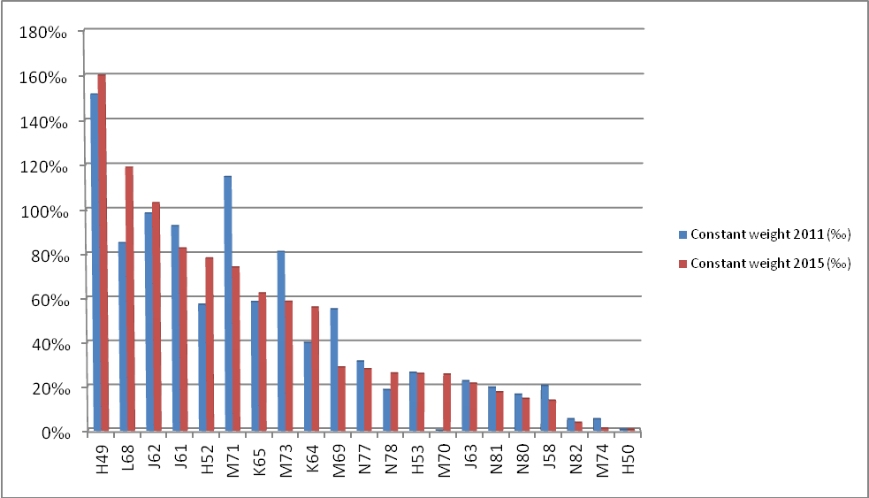
Changing of the weights in the compared periods was caused by changing the amount of production and also by changing in the concept of the coverage of selected services.

The history of revision after the year 1989
The first price indices of selected market services (Inland freight transport and sewerage) were calculated on the 1990 weights, with price and index base “January 1990 = 100”. These prices indices were calculated in January 1994.

After revision 1994, indices for the period 1995 – 2000 were calculated on the 1993 weights, with price and index base December 1993 and the derived index base “1994 average = 100” and “1995 average = 100”.
After revision 2000, indices for the period 2001 – 2006 were calculated on the 1999 weights, with price and index base “December 1999 = 100” and the derived index base “2000 average = 100”.
After revision 2005, indices for the period 2007 – 2012 were calculated on the 2005 weights with price and index base “December 2005 = 100”.
During the year 2008 was changed the classification and since January 2009 are all price indices set up, calculated and published in CZ-CPA 2008 classification.
After revision in 2012, the indices for the period 2013 to 2017 were calculated on the weights from 2011 to index base “2005 average = 100”.
After revision in 2017, the indices for the period 2018 to 2022 are calculated on the weights from 2015 to index base “2015 average = 100”.

