3- August 2015

Share of the Self -Employed in Total Employment in the Czech Republic is One of the Highest in the EU28

Total employment in the Czech Republic is affected by the self-employed in a significant manner. The percentage of the self-employed, i.e. employers and own-account workers is fifth highest in among all EU Member States. There are higher shares in Greece, Italy, Romania, and in Poland, only.

**A. The number of own-account workers has been growing**

Total employment in the Czech Republic reached almost the limit of five million persons (4 974.3 thousand persons, exactly) in 2014. Since 1993 till 2014 the number of the self-employed, including family workers, increased by more than 440 thousand persons, which is almost doubled the number in the first reference year of the Labour Force Sample Survey. On the contrary, the number of employees has been reduced by 340 thousand persons in this period. The relation between the self-employed and employees substantially changed especially in the 1990s.

Since 2005 the number of the self-employed, including family workers, has grown by 132 thousand persons, that means by almost one fifth, yet the number of employees rose by less than 79 thousand persons (by 2%) in the same period. It is clear, the number of own-account workers showed the highest growth, by over one fourth. In the two recent years, however, the growth in employment has been indicated almost exclusively in the group of employees. The development in the first half of this year has confirmed the previous trend.



The structure of the self-employed in the Czech Republic by economic activity is very varied. Majority (almost 60%) of them work in four NACE sections of economic activities as follows: construction, wholesale and retail trade; repair of motor vehicles and motorcycles, professional, scientific and technical activities, and in manufacturing.

In numerous economic activities the share of the self-employed is extraordinary high. In two sections, in S (other service activities) and in L (real estate activities), the self-employed form over a half of all working persons. Almost every second working person in the employment status of the self-employed works also in section M (professional, scientific and technical activities) and a high share of the self-employed can be found in the large section F (construction), as well.

The number of the self-employed depends on which activities are included in respective section. A high share of the self-employed in other service activities relates to the fact the section involves providing of other personal services (as, for instance, laundry and dry cleaning, hairdressers, cosmetic services, and wellness activities). In section L the high share of the self-employed is connected, for example, to purchase and resale of own real estate and leasing and management of own or leased real estate. The section includes also facilitating activities of real estate agencies and, furthermore, contractual real estate management. The section M covers various activities. First of all, legal and accounting activities, consultancies to management, and architectonic and engineering activities belong into the section.

In the Czech Republic it is males who prevail among the self-employed (almost 70% of all the self-employed). The far most of them undertake in construction and in trade organisations, including repair of motor vehicles. The highest share of the self-employed can be found among males in real estate activities (over 60%) and in section M - professional, scientific and technical activities (over 50%). The female self-employed have important shares in total female employment just in section M. The highest share of the female self-employed, almost two thirds of working females, can be found in section S – other service activities.

|  |  |  |  |  |  |  |  |  |  |  |
| --- | --- | --- | --- | --- | --- | --- | --- | --- | --- | --- |
| **Numbers and shares of the self-employed in total employment and in respective sections of economic activities of the national economy in 2014** | | | | | | | | | | |
|  | |  |  | |  |  | |  |  |  |
| Self-employed  incl. family workers | | | Total | | | Males | | | Females | |
| Number (thous.) | Share in total employment  (%) | | Number (thous.) | Share in total employment  (%) | | Number (thous.) | Share in total employment  (%) |
| **Total** |  | | **895.0** | **18.0** | | **617.9** | **21.9** | | **277.2** | **12.8** |
|  |  | |  |  | |  |  | |  |  |
| CZ-NACE | Section | |  |  | |  |  | |  |  |
| Agriculture, forestry and fishing | A | | 36.1 | 26.4 | | 27.5 | 27.1 | | 8.6 | 24.5 |
| Mining and quarrying | B | | . | . | | . | . | | - | - |
| Manufacturing | C | | 98.3 | 7.4 | | 80.7 | 9.2 | | 17.6 | 3.9 |
| Electricity, gas, steam and air conditioning supply | D | | 3.3 | 5.8 | | 2.8 | 6.1 | | 0.5 | 4.9 |
| Water supply, sewerage, waste management and remediation  activities | E | | 3.2 | 5.8 | | 2.7 | 6.4 | | 0.5 | 3.9 |
| Construction | F | | 184.1 | 44.5 | | 179.5 | 46.7 | | 4.6 | 15.7 |
| Wholesale and retail trade; repair of motor vehicles and motorcycles | G | | 139.8 | 23.7 | | 93.0 | 34.2 | | 46.8 | 14.7 |
| Transportation and storage | H | | 32.1 | 10.8 | | 26.9 | 12.6 | | 5.2 | 6.2 |
| Accommodation and food service activities | I | | 34.0 | 17.4 | | 22.1 | 27.3 | | 11.8 | 10.4 |
| Information and communication | J | | 32.8 | 22.1 | | 29.1 | 25.9 | | 3.7 | 10.3 |
| Financial and insurance activities | K | | 32.3 | 26.6 | | 18.9 | 35.1 | | 13.4 | 19.8 |
| Real estate activities | L | | 24.1 | 52.2 | | 15.5 | 61.0 | | 8.6 | 41.3 |
| Professional, scientific and technical activities | M | | 108.5 | 48.8 | | 59.8 | 50.9 | | 48.8 | 46.4 |
| Administrative and support service activities | N | | 23.4 | 18.0 | | 12.7 | 19.2 | | 10.7 | 16.9 |
| Public administration and defence; compulsory social security | O | | 2.3 | 0.7 | | 1.6 | 1.0 | | 0.7 | 0.5 |
| Education | P | | 19.9 | 6.1 | | 7.1 | 9.3 | | 12.9 | 5.2 |
| Human health and social work activities | Q | | 30.7 | 8.7 | | 9.7 | 13.1 | | 21.0 | 7.5 |
| Arts, entertainment and recreation | R | | 18.0 | 22.2 | | 11.2 | 28.6 | | 6.8 | 16.2 |
| Other service activities | S | | 48.1 | 54.9 | | 12.0 | 39.8 | | 36.1 | 62.9 |
|  |  | |  |  | |  |  | |  |  |
| *Source: CZSO, Labour Force Sample Survey* | | | | | | | | | | |

The survey data confirmed there is an interaction of the structure by economic activity and the professional composition of respondents. The highest share of the self-employed is in skilled agricultural, forestry and fishery workers (almost of a half of working persons). However, their effect on the total number of the self-employed is small, because the total number of all working persons in these occupations is mere one per cent of total employment in the national economy. Almost thirty per cent of all craft and related trades workers are the self-employed. Similarly, a high share of the self-employed can be found in the group of managers. The least share of the self-employed is in elementary occupations and in clerical support workers.

It is clear, the nature of activities performed is in an important manner affected by educational attainment. The lowest share of the self-employed is in working persons with primary education (just a bit over ten per cent). There is virtually no difference between the largest groups, i.e. in working persons with secondary education without A-level examination (incl. those with apprenticeship certificates) and those with secondary education with A-level examination (around 18%). The highest share of the self-employed is in persons with higher education in which the share was nearing twenty per cent in 2014. Generally, a higher share of the male self-employed can be seen across all groups of different educational attainments. The share of the self-employed with apprenticeship certificates in the total male employment is doubled compared to that of females. The difference, however, declines with increasing formal education attainment.

|  |  |  |  |  |  |  |  |  |  |  |  |
| --- | --- | --- | --- | --- | --- | --- | --- | --- | --- | --- | --- |
| **Numbers and shares of the self-employed in total employment by educational attainment in 2014** | | | | | | | | | | | |
|  |  | |  | |  |  | |  |  | |  |
| Self-employed  incl. family workers | | | Total | | | Males | | | Females | | |
| Number (thous.) | Share in total employment  (%) | | Number (thous.) | Share in total employment  (%) | | Number (thous.) | Share in total employment  (%) | |
| **Total** | |  | **895.0** | **18.0** | | **617.9** | **21.9** | | **277.2** | **12.8** | |
|  | |  |  |  | |  |  | |  |  | |
| **Educational attainment by CZ-ISCED 2011** | | **Level** |  |  | |  |  | |  |  | |
| Primary education | | 1, 2 | 21.6 | 10.6 | | 12.1 | 12.4 | | 9.6 | 8.9 | |
| Secondary education without A-level examination | | 3, partially | 314.8 | 17.9 | | 250.7 | 21.5 | | 64.2 | 10.8 | |
| Secondary education with A-level examination | | 3, partially | 338.0 | 18.0 | | 215.7 | 22.6 | | 122.3 | 13.3 | |
| Higher education | | 5, 6, 7, 8 | 220.3 | 19.4 | | 139.3 | 23.2 | | 81.0 | 15.2 | |
|  | |  |  |  | |  |  | |  |  | |
| *Source: CZSO, Labour Force Sample Survey* | | | | | | | | | | | |

**B. The average age of the self-employed increases faster than that of employees**

Employment grows yet the age of working persons grows as well. Since 1993 the average age of all working persons has prolonged by almost 4.8 years to reach almost 44 years. The growth was demonstrated namely in the category of the self-employed with employees, by more than 9 years, being concrete. The highest growth was indicated in the group of family workers yet their number is substantially lower than the numbers of other groups of the self-employed. The age of own-account workers also showed an above average increase, by 6 years. On the contrary to the aforementioned groups of working persons, the average age of the largest category of employees grew roughly by mere 4 years.



The total number of employees substantially declined, compared to that in 1993, the first year of measurement, however, the increase in the number of persons of this employment position is rapid among people aged sixty+ years. This is, first al all, a consequence of a raised retirement age limit. The trend in the group of own-account workers (the self-employed with no employees), in which the number of the aged thirty+ years significantly grew, is different. In the group of the self-employed with employees there was a shift when namely the number of the self-employed aged 50+ years increased.

Working people who started their own businesses in the 1990s are getting older. Similarly, the strong generation, which entered the labour market roughly twenty years ago, moved into the middle age. Younger generations are substantially weaker. The process of ageing is documented by the fact that the number of the self-employed aged 65+ years increased almost four times in 2014 from ten thousand persons in 1993. It is clear changes to the age structure of the self-employed affect also other facts as, for instance, numbers of persons with higher educational attainments, who enter the labour market at older age, grow at a relatively faster pace.

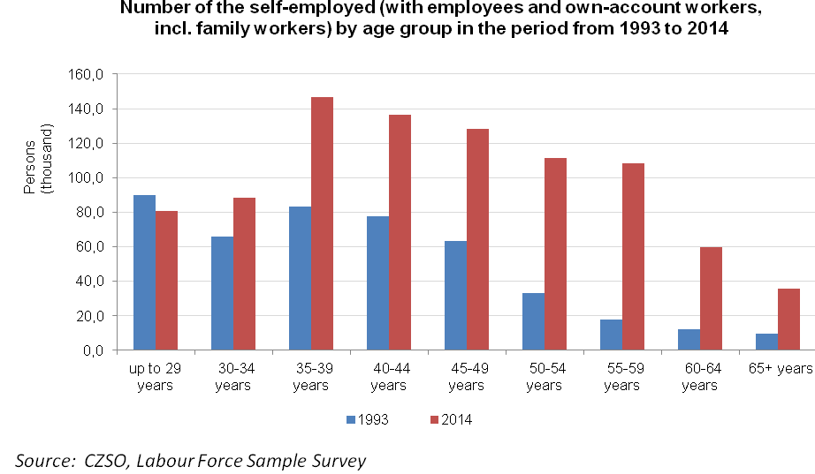

**C. People in the Czech Republic have their own business more often than in majority of the EU Member States**

The standard Labour Force Sample Survey enables to compare working persons by employment position among all the EU Member States. In order to make the comparison data for the age group 15-64 years of the self-employed with employees and own-account workers were taken into account, the number of family workers was not involved. Compared to the other Member States there may be numerous data characteristic to the Czech Republic given.

The share of the self-employed younger than 65 years reached in total 14.4% in the EU28 in 2014 yet in the Czech Republic it was 17%. This is the fifth highest share in all the Member States. Higher shares can be found solely in Greece (the share of the self-employed attains almost one third of all working persons), Italy (22%), Romania, and Poland, with the share of around 18%.

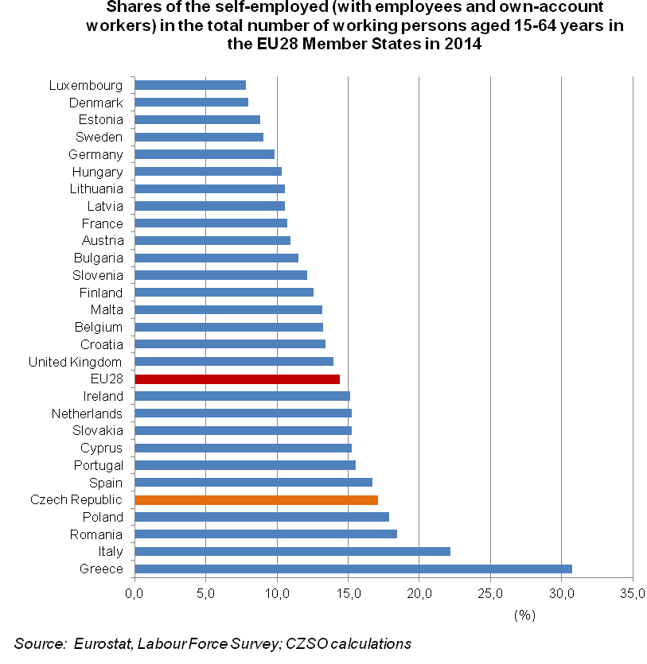

It is obvious, the structure of total employment in Greece is connected to its geographic position, and a greet portion of the population works in trade, agriculture, and in economic activities dependent on tourism. Moreover, these economic activities in Greece show a high share of the self-employed. Concerning Italy, high shares of the self-employed can be found especially in trade and in professional, scientific and technical activities. Poland and Romania, especially, feature high employment in the primary sector and, simultaneously, a high proportion of the self-employed in agriculture. Conditions in Romania and Poland are, moreover, in an important way different from all other Member States concerning family workers. The total number of these persons in the aforementioned two countries reached almost 1.4 million, i.e. they count over a half of family workers of the whole EU. And if we sum up the self-employed and family workers then the group defined this way involves almost 30% of all the Romanian population.

The share of the self-employed with employees in the Czech Republic is under average, yet the difference from other countries is not high. Frequency of the self-employed is in a decisive manner affected by own-account workers (the self-employed with no employees). This category proportion in the Czech Republic is the fifth highest in the EU Member States. Higher shares can be found only in the aforementioned four countries that feature economies with specific structure by economic activity.

In the Czech Republic there is the highest share of the self-employed in construction. The Czech Republic also features the highest share of the self-employed in the number of persons working in financial and insurance activities. The Czech Republic is also the first concerning the number of the self-employed share in other service activities.

High shares of the self-employed in the Czech Republic, compared to the EU28, can be found in other economic activities. The Czech Republic boasts the highest share of them in real estate activities following Malta and the second highest is also administrative and support service activities after Cyprus. The third highest share of the self-employed in the EU can be found in professional, scientific and technical activities. The share of the self-employed is above average also in wholesale and retail trade; repair of motor vehicles and motorcycles. Higher shares of the self-employed in wholesale and retail trade; repair of motor vehicles and motorcycles can be found solely in some of the Mediterranean countries.

|  |  |  |  |  |  |  |  |  |  |  |  |  |  |  |  |  |  |  |  |  |  |  |  |  |
| --- | --- | --- | --- | --- | --- | --- | --- | --- | --- | --- | --- | --- | --- | --- | --- | --- | --- | --- | --- | --- | --- | --- | --- | --- |
| **Shares of the self-employed in the total number of working person aged 15-64 years in selected economic activity sections in the EU28 Member States in 2014** | | | | | | | | | | | | | | | | | | | | | | | | |
|  | |  | |  |  | |  | |  | |  | |  | |  | |  | | |  | |  | | (%) |
|  | | Share of the self-employed in total employment | | Share of the self-employed in total employment  by section of the CZ-NACE Rev. 2 | | | | | | | | | | | | | | | | | | | |  |
| A | | C | | F | | G | | H | | J | | K | | L | M | | N | | S 1) | |
| **EU28** | | **14.4** | | **51.4** | | **6.2** | | **27.1** | | **16.6** | | **10.3** | | **15.1** | | **9.7** | | **22.7** | **31.1** | | **12.6** | | **30.0** | |
| Belgium | | 13.2 | | 62.2 | | 5.6 | | 25.3 | | 17.4 | | 4.2 | | 17.2 | | 10.5 | | 33.7 | 38.8 | | 9.7 | | 33.6 | |
| Bulgaria | | 11.5 | | 41.3 | | 3.9 | | 12.9 | | 18.7 | | 9.2 | | 5.0 | | : | | : | 27.9 | | 3.8 | | 29.7 | |
| **Czech Republic** | | **17.0** | | **24.7** | | **6.8** | | **43.3** | | **22.0** | | **10.0** | | **21.8** | | **25.7** | | **50.9** | **46.9** | | **16.9** | | **54.6** | |
| Denmark | | 8.0 | | 40.0 | | 3.2 | | 18.2 | | 7.5 | | 5.9 | | 11.7 | | : | | 7.8 | 23.4 | | 12.6 | | 17.9 | |
| Germany | | 9.8 | | 38.0 | | 3.5 | | 17.6 | | 9.3 | | 5.0 | | 15.3 | | 10.4 | | 24.9 | 25.2 | | 12.4 | | 20.7 | |
| Estonia | | 8.8 | | 20.3 | | 4.7 | | 13.2 | | 11.4 | | 8.7 | | 9.8 | | : | | 12.4 | 28.6 | | 10.1 | | 39.1 | |
| Ireland | | 15.1 | | 67.9 | | 8.6 | | 36.8 | | 11.7 | | 23.4 | | 13.2 | | 5.0 | | 26.1 | 27.0 | | 12.3 | | 27.5 | |
| Greece | | 30.7 | | 73.5 | | 22.6 | | 38.6 | | 36.5 | | 29.5 | | 11.3 | | 12.8 | | 74.4 | 57.3 | | 12.9 | | 39.1 | |
| Spain | | 16.7 | | 38.2 | | 10.7 | | 30.7 | | 25.6 | | 18.3 | | 12.3 | | 6.7 | | 41.9 | 37.0 | | 7.9 | | 36.5 | |
| France | | 10.7 | | 58.7 | | 4.8 | | 21.1 | | 12.7 | | 4.7 | | 7.3 | | 5.2 | | 17.3 | 19.3 | | 8.3 | | 23.3 | |
| Croatia | | 13.4 | | 56.8 | | 6.5 | | 16.8 | | 12.1 | | 13.0 | | 8.9 | | 3.5 | | 47.1 | 25.4 | | 8.7 | | 33.0 | |
| Italy | | 22.2 | | 40.0 | | 11.2 | | 39.5 | | 35.3 | | 11.5 | | 23.2 | | 16.6 | | 49.3 | 58.0 | | 15.5 | | 38.8 | |
| Cyprus | | 15.2 | | 39.9 | | 15.9 | | 24.2 | | 14.6 | | 12.1 | | : | | 7.2 | | 46.2 | 18.4 | | 40.7 | | 44.4 | |
| Latvia | | 10.6 | | 36.8 | | 6.2 | | 13.1 | | 9.2 | | 4.7 | | 16.2 | | : | | 13.1 | 29.8 | | 11.4 | | 37.8 | |
| Lithuania | | 10.6 | | 43.2 | | 4.3 | | 12.3 | | 12.7 | | 4.7 | | : | | : | | : | 16.9 | | : | | 41.1 | |
| Luxembourg | | 7.8 | | 62.5 | | : | | 5.4 | | 9.3 | | : | | 11.2 | | 3.2 | | : | 23.9 | | : | | 13.5 | |
| Hungary | | 10.3 | | 29.2 | | 4.3 | | 19.2 | | 15.0 | | 7.6 | | 14.2 | | 12.0 | | 26.5 | 32.8 | | 10.4 | | 35.4 | |
| Malta | | 13.2 | | 52.4 | | 8.6 | | 30.6 | | 24.6 | | 15.5 | | 9.1 | | : | | 54.5 | 24.4 | | 6.3 | | 43.2 | |
| Netherlands | | 15.2 | | 49.6 | | 6.6 | | 30.6 | | 13.1 | | 8.6 | | 24.5 | | 16.5 | | 20.2 | 35.2 | | 14.5 | | 35.5 | |
| Austria | | 10.9 | | 59.5 | | 3.8 | | 9.7 | | 9.1 | | 6.3 | | 13.8 | | 5.4 | | 19.9 | 25.7 | | 8.3 | | 15.6 | |
| Poland | | 17.9 | | 64.9 | | 6.1 | | 22.2 | | 20.1 | | 12.9 | | 17.7 | | 14.0 | | 13.7 | 34.8 | | 9.8 | | 33.9 | |
| Portugal | | 15.5 | | 62.2 | | 8.7 | | 22.5 | | 21.6 | | 8.2 | | 12.6 | | 7.6 | | 28.7 | 30.0 | | 7.4 | | 39.8 | |
| Romania | | 18.4 | | 49.8 | | 2.2 | | 26.8 | | 9.5 | | 8.0 | | 4.5 | | : | | : | 15.1 | | : | | 16.0 | |
| Slovenia | | 12.1 | | 35.7 | | 6.0 | | 22.4 | | 12.0 | | 12.2 | | 16.9 | | 4.2 | | : | 32.0 | | 13.4 | | 36.2 | |
| Slovakia | | 15.2 | | 20.9 | | 7.3 | | 41.3 | | 17.1 | | 11.0 | | 20.0 | | 23.6 | | 26.2 | 46.1 | | 10.8 | | 45.9 | |
| Finland | | 12.6 | | 61.4 | | 6.2 | | 23.3 | | 12.4 | | 13.6 | | 9.5 | | 5.0 | | 14.0 | 20.5 | | 10.8 | | 28.7 | |
| Sweden | | 9.1 | | 49.0 | | 5.7 | | 19.5 | | 11.0 | | 6.7 | | 12.3 | | 3.9 | | 10.4 | 17.8 | | 8.1 | | 24.2 | |
| United Kingdom | | 14.0 | | 49.1 | | 6.1 | | 40.0 | | 9.2 | | 17.0 | | 17.4 | | 7.9 | | 16.9 | 24.4 | | 22.1 | | 34.2 | |
|  | |  | |  |  | |  | |  | |  | |  | |  | |  | | |  | |  | |  |
| *Source: Eurostat, Labour Force Survey; Calculations of the CZSO* | | | | | | | | | | | | | | | | | | | | | | | | |
|  |  | |  | |  | |  | |  | |  | |  | |  | |  | | |  | |  | |  |
| 1) Notes: |  | |  | |  | |  | |  | |  | |  | |  | |  | | |  | |  | |  |

A - Agriculture, forestry and fishing

C - Manufacturing

F - Construction

G - Wholesale and retail trade; repair of motor vehicles and motorcycles

H - Transportation and storage

J - Information and communication

K - Financial and insurance activities

L - Real estate activities

M - Professional, scientific and technical activities

N - Administrative and support service activities

S - Other service activities

In the period from 2010 to 2014 the number of the self-employed aged 15-64 years in the EU dropped by almost a half of million. In the same period in the Czech Republic their number has grown by 24 thousand. The numbers of the self-employed in a vast majority of other Member States decreased, as, for instance, by 163 thousand in the neighbouring country of Germany. Two countries of the EU make exception here with rapid increases – United Kingdom by almost 450 thousand and the Netherlands by over 100 thousand. More detailed information on conditions in the Netherlands can be found in the paper of Mies Westerveld in European Journal of Social Security[1].

According to the Office for National Statistics of the United Kingdom[2] the extraordinary increase in the category of the self-employed is characteristic for the following:

- the total growth in employment recently was in a decisive manner caused by an increase in the number of the self-employed;

- the number of persons who terminated their business activities was reduced. In the last five years the number of the self-employed aged 65+ years was more than doubled;

- the self-employed are on average elder than employees (employees average age is 40 years, average age of the self-employed is 47 years);

- the self-employed more frequently work a high number of hours (over 40 hours per week) and also more frequently shorter hours (8 hours and less) than employees;

- the self-employed work most frequently in construction and taxi services. Lately their number has been increased in management consultancy services (section M - professional, scientific and technical activities),

- the real income of the self-employed has decreased by 22% over the last five years.

* * *

Changes in economy has brought essential impacts on social conditions of the society. Numerous activities of services have experienced a vigorous boom, while the primary sector has not been playing a rather important role in the Czech Republic, concerning the number of working persons. In the Czech Republic, the share of working people in industry is much higher than in other Member States of the EU and therefore it can be assumed that in the future the share of persons working in the secondary sector in total employment will decline.

The numbers of working persons in industry, yet also in construction, as well as in trade and numerous activities of the tertiary sphere, are significantly affected by workers who are citizens of foreign countries. According to an expert assessment of the Ministry of Labour and Social Affairs of the Czech Republic labour offices registered 260 thousand people with citizenship of a foreign country in the position of employee at the end of 2014. Foreigners are found most frequently working just in manufacturing, construction, and in trade. Citizens of the EU non-member states are also most often found working as employees in these economic activity sections.

Employees with citizenship other than the EU one often work in a number of economic activities of tertiary sector as accommodation and food service activities and in administrative and support service activities. The support activities also involve, for instance, employment activities, various janitorial and cleaning activities, and combined auxiliary activities. Not a small number of people from the EU non-member states work also in information and communication activities, transportation, yet in professional, scientific and technical activities, furthermore, in education and in human health and social work activities.

As at 31 December 2014 the Ministry of Industry and Trade of the Czech Republic registered 89 thousand foreigners with trade licence, besides the register of employees of the Ministry of Labour and Social Affairs of the Czech Republic (the LFSS already includes a portion of working foreigners who live in apartments). Over 26 thousand of trade licence holders were foreigners from the EU Member States. Almost the same number of trade license holders was coming from Vietnam and Ukraine (24 thousand from both the countries). Almost 60% of all foreigners having trade licence come from these two countries. These working persons have been integrated into the Czech Republic economy for over a long term.

At present, issues of international migration, including migration for work, are in focus of discussions everywhere. It can be assumed that potentially substantial increase in the number of migrants may affect position on the labour market not just the groups of the population, which are currently facing troubles to find their niche at the labour market. This may also happen to working persons (and the self-employed as well) in occupations, in which the influx of foreigners would be most pronounced. The spectrum of such professions is not limited to a narrow band and concerns also occupations with a higher and even high level of professional education.

**Authors**

Marta Petráňová, Bohuslav Mejstřík

*Unit for Labour Forces, Migration and Equal Opportunities*

*Czech Statistical Office*

*Tel.: +(420) 274 054 357; +(420) 274 052 203*

E-mail: [marta.petranova@czso.cz](mailto:marta.petranova@czso.cz); [bohuslav.mejstrik@czso.cz](mailto:bohuslav.mejstrik@czso.cz)

1. European Journal of Social Security: [THE ‘NEW’ SELF-EMPLOYED](http://www.ejss.eu/pdf_file/ITS/EJSS_14_03_0156.pdf)
2. Guardian: [Self-employment in UK at highest level since records began](http://www.theguardian.com/uk-news/2014/aug/20/self-employment-uk-highest-level)