3 February 2016

Just Small Portion of The Young Works in The Czech Republic
Employment of the aged 15-24 years has been declining constantly since 1993 and, at present, it is one of the lowest in the whole European Union. Yet increased economic activities of the young may be one of important factors with positive effects on the labour market development.
The total employment level is essentially affected by a high level of work activities of males and females aged 30-55 years. In the last over twenty years, however, one can observe substantial changes in the number of the youngest working persons and also in the elder working persons in the age group 55-64 years.

In the first years of the independence of the Czech Republic the number of working persons aged 15-24 years fell around 800 thousand persons and in the following years it regularly decreased down to the level of 300 thousand persons in 2015. This drop demonstrates not only dramatic changes to the population development since the 1990s, yet also changes in our country education system, which features a transition to the complete secondary education and, especially, higher education. In the group of the aged 25-29 years, in the age when a vast majority of the young have finished their education, the number of working persons in the last year did not differ substantially from that at the beginning of the reference period, i.e. in 1993. Development in this age group was in an important way affected by the demographic wave of a high natality from the 1970s that led to an increased number of working persons of this age up to the level of 665 thousand persons in 2003. Move of these generations into an older age group projected in a total decrease in the number of working persons of this age to 522 thousand persons in the last year despite the share of working university graduates grew.

The number of working persons who reached 55+ years of age developed differently from employment of the aged 15-24 years. The number in this category is affected by changes to the age structure of the population, yet it is the gradual implementation of legislative measures to elevate the age limit for the old-age retirement which has brought the decisive effect here. In 1993 there were 315 thousand persons aged 55-64 years working, but in 2015 there were already over 770 thousand persons of this group working. This extraordinary increment was, in a great portion, compensated by a dramatic decline in the number of young working persons aged up to 25 years.

The increase in employment in the pre-retirement age of 55-59 years was noticeable namely in females when their number grew by 180 thousand persons to 245 thousand persons in 2015. The number of working males in this five-year age group also increased by 120 thousand persons to almost 280 thousand persons in 2015. In males the number of working persons also significantly grew in the aged 60-64 years, from less than 60 thousand persons in 1993 to 165 thousand persons in the last year. The number of working females of this age also rose but to a lesser extent by 50 thousand persons to less than 83 thousand persons.

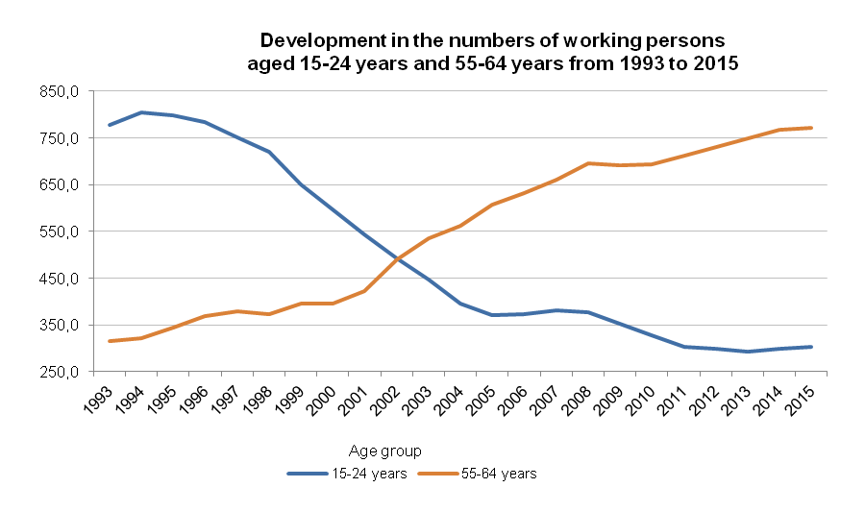

Source: CZSO; Labour Force Sample Survey

Conditions on the labour market in the EU Member States differ in a significant manner. These, besides other factors, are projected in an important way in employment, especially in the young. On one hand, there are countries where the number of working persons in the aged 15-19 years is minimum. The Czech Republic, in which there were mere 4.6% of boys and girls aged up to twenty years working in 2014, belongs to such countries. On the other hand, in certain countries work of these youngsters is very widely applied, and, as an apparent paradox, in countries which feature a substantially higher share of the young population having tertiary education than that in the Czech Republic. These are all Nordic countries, including Denmark, then the Netherlands, United Kingdom, Austria, and, to a certain extent, Germany. In these countries the share of working boys and girls of the youngest age falls within the interval of 22% and 44%.

In the ten-year age group of the young aged 15-24 years the differences are relatively lower yet countries with the highest employment in the youngest age still maintain their margin from other countries. In the aforementioned countries the employment rate is from 41% up to almost 60% in the Netherlands. These values are in contrast to the value for the Czech Republic (27.1%), which is still lower than the EU28 average (32.4%).

Situation substantially changes after attaining the age of 25 years when a major portion of respondents already finished their education and joined work positions. In 2014 in the whole large group of the aged 25-54 years the employment rate in the EU28 was 77.4%; in the Czech Republic it was even 83.8%, i.e. the second highest value next to that for Sweden.

From the viewpoint of employment in the aged 55-59 years the Czech Republic does very well. In 2014 the employment rate in this age group in the Czech Republic reached 76.9%, i.e. the fourth highest value of all EU Member States after Sweden, Germany, and Denmark. Once the age of sixty has been attained, however, the employment rate in the Czech Republic drops below the EU28 level (32.2% cf. 36.6% of the Union average in the aged 60-64 years). This is due to a rapid reduction of economic activities of females of this age.

Working activities of working younger sexagenarian males and females affect substantially the duration of working life in respective Member States of the European Union. The duration of working life indicator measures the number of years a person aged 15 is expected to be active in the labour market throughout his/her life. The duration is calculated on the basis of a probabilistic model combining demographic data and data on the labour market. The duration of working activities in the Czech Republic in 2014 is estimated to be 34.9 year, i.e. a bit less than the EU28 average (35.3 year). Differences in the duration of working life are extremely great in the European Union. The indicator value falls within the interval from 30.6 year to 41.1 year. The highest value can be found is right in countries with high working activities of the young (Denmark, Germany, Netherlands, Sweden, United Kingdom, and Finland).

Duration of working life in the countries of the EU28 in 2014
Territory and country | Total |  |  | Males |  |  |  | Females
 | Years | Country rank |  | Years |  | Country rank |  | Years |  |  | Country rank
EU28 | 35.3 |  |  | 37.8 |  |  |  | 32.7
Belgium | 32.6 | 22 |  | 34.7 |  | 24 |  | 30.4 |  |  | 19
Bulgaria | 32.1 | 25 |  | 33.4 |  | 28 |  | 30.7 |  |  | 17
Czech Republic | 34.9 | 11 |  | 38.0 |  | 11 |  | 31.5 |  |  | 16
Denmark | 39.0 | 3 |  | 40.5 |  | 3 |  | 37.4 |  |  | 2
Germany | 38.0 | 5 |  | 40.2 |  | 4 |  | 35.6 |  |  | 6
Estonia | 36.5 | 10 |  | 37.5 |  | 13 |  | 35.4 |  |  | 7
Ireland | 34.7 | 13 |  | 38.6 |  | 9 |  | 30.5 |  |  | 18
Greece | 32.1 | 26 |  | 35.7 |  | 19 |  | 28.3 |  |  | 26
Spain | 34.8 | 12 |  | 37.1 |  | 14 |  | 32.3 |  |  | 15
France | 34.7 | 14 |  | 36.5 |  | 15 |  | 32.9 |  |  | 13
Croatia | 32.3 | 24 |  | 34.1 |  | 27 |  | 30.3 |  |  | 20
Italy | 30.6 | 28 |  | 35.1 |  | 22 |  | 25.8 |  |  | 28
Cyprus | 36.7 | 7 |  | 39.8 |  | 6 |  | 33.4 |  |  | 12
Latvia | 34.7 | 15 |  | 35.2 |  | 21 |  | 34.2 |  |  | 11
Lithuania | 34.6 | 16 |  | 34.5 |  | 25 |  | 34.7 |  |  | 9
Luxembourg | 33.2 | 18 |  | 36.3 |  | 16 |  | 30.0 |  |  | 22
Hungary | 31.8 | 27 |  | 34.2 |  | 26 |  | 29.4 |  |  | 25
Malta | 33.0 | 20 |  | 39.7 |  | 7 |  | 25.9 |  |  | 27
Netherlands | 39.6 | 2 |  | 42.4 |  | 1 |  | 36.7 |  |  | 4
Austria | 36.6 | 8 |  | 38.7 |  | 8 |  | 34.4 |  |  | 10
Poland | 32.6 | 23 |  | 35.0 |  | 23 |  | 29.9 |  |  | 23
Portugal | 36.6 | 9 |  | 38.2 |  | 10 |  | 35.0 |  |  | 8
Romania | 32.8 | 21 |  | 35.8 |  | 18 |  | 29.7 |  |  | 24
Slovenia | 34.1 | 17 |  | 35.4 |  | 20 |  | 32.7 |  |  | 14
Slovakia | 33.1 | 19 |  | 35.9 |  | 17 |  | 30.2 |  |  | 21
Finland | 37.3 | 6 |  | 37.8 |  | 12 |  | 36.8 |  |  | 3
Sweden | 41.1 | 1 |  | 42.3 |  | 2 |  | 39.8 |  |  | 1
United Kingdom | 38.5 | 4 |  | 41.1 |  | 3 |  | 35.7 |  |  | 5
Source: Eurostat, Labour Force Survey

The aforementioned indicator includes also time for which the respondent was not working yet is compliant with criteria to be enlisted among the unemployed. Virtually, it is therefore an indicator of the duration of economic activities. For this reason differences between countries in the duration of working life are in fact even greater because countries with a long duration of active life boast lower unemployment in the young and, on the contrary, in numerous countries with a shorter active life unemployment is high.

It is seen from data for countries with a high employment of the young aged up to 25 years, that boys and girls of this age not only work at position enabling them to acquire practical work experience in the study field they have chosen, but there is an important portion here of those who work simultaneously with studies due to economic reasons. The employment rate of the young in the Czech Republic reaches roughly a half of the value in the countries having the highest employment in the this age group. The difference in the activity of the young can be demonstrated in the example of Austria. In 2014 in Austria there were in total 4 million persons working, i.e. by almost 900 thousand persons less than in the Czech Republic. However, in the aged 15-24 years there were by 70% more young people working in the neighbouring country than in the Czech Republic. Comparable figures for this age group in both the countries can be found in industry and transport. In construction and in all sections of the tertiary sector the work activities of the young Austrians were significantly higher. This holds especially to wholesale and retail trade, accommodation and food service activities, and tourism. The level of activities of our country young people is substantially surpassed by that of the young Austrians in professional, scientific and technical activities and in administrative and support service activities. Many more young people in the neighbouring country work also in sections of education and health. Differences in numbers of the working young in the Czech Republic and in other countries with the longest duration of work activities can be seen in table below.

Number of working persons aged 15-24 years in selected NACE sections in countries with the highest employment rate and in the Czech Republic in 2014
 |  |  |  |  |  |  |  |  | Thousand persons
The employed |  |  | Czech Republic | Denmark | Germany | Netherlands | Austria | Sweden | Finland | United Kingdom
Aged 15-64, total |  |  | 4 883.5 | 2 640.1 | 38 907.7 | 8 028.5 | 4 034.2 | 4 597.5 | 2 385.9 | 29 530.8
Aged 15-24 years, total |  |  | 299.6 | 384.9 | 3 899.7 | 1 202.2 | 508.2 | 516.6 | 261.8 | 3 736.1
Share (%) of aged 15-24 years in 15-64 years old |  |  | 6.1 | 14.6 | 10.0 | 15.0 | 12.6 | 11.2 | 11.0 | 12.7
NACE Section
Manufacturing |  | C | 109.6 | 26.9 | 782.1 | 64.5 | 92.3 | 37.9 | 27.7 | 263.8
Construction |  | F | 19.6 | 21.4 | 301.1 | 31.6 | 61.2 | 38.9 | 21.7 | 232.7
Wholesale and retail trade; repair of motor vehicles and motorcycles |  | G | 48.0 | 123.5 | 695.8 | 357.6 | 96.4 | 99.5 | 54.9 | 850.2
Transportation and storage |  | H | 14.0 | 12.8 | 129.6 | 36.3 | 17.4 | 26.0 | 15.3 | 88.9
Accommodation and food service activities |  | I | 22.7 | 47.5 | 260.1 | 147.7 | 45.9 | 55.8 | 24.6 | 562.4
Information and communication |  | J | 8.1 | 10.7 | 108.3 | 20.4 | 14.2 | 11.2 | 4.6 | 98.6
Financial and insurance activities |  | K | 5.9 | 4.9 | 107.6 | 9.7 | 12.3 | 7.5 | 3.1 | 111.1
Professional, scientific and technical activities |  | M | 6.7 | 12.9 | 164.3 | 39.3 | 29.7 | 20.9 | 8.8 | 163.4
Administrative and support service activities |  | N | 6.5 | 12.2 | 154.6 | 80.7 | 16.6 | 37.3 | 17.0 | 166.7
Public administration and defence; compulsory social security |  | O | 9.2 | 6.1 | 201.8 | 20.0 | 16.1 | 13.0 | 3.3 | 91.1
Education |  | P | 6.7 | 17.1 | 199.8 | 38.3 | 19.4 | 36.0 | 6.7 | 224.3
Human health and social work activities |  | Q | 12.5 | 45.8 | 515.2 | 107.3 | 35.8 | 66.9 | 31.3 | 372.2
Other service activities |  | S | 6.8 | 7.6 | 95.6 | 17.9 | 15.4 | 15.3 | 9.3 | 122.8
Source: Eurostat, Labour Force Survey

It is natural, that in countries with a high level of work activities of the young they mostly have part-time employments. Although the financial resources earned this way enable the young people to get economically independent. This is also documented by the fact that the young respondents aged 25-34 years live and run households as a single adult household or households of a group of adults consisting of them and their partners much more frequently than, for instance, in the countries of the European South.

Many respondents in the youngest productive age provide, in the countries with a high employment, services necessary both for the children population and for persons of post-productive age. That especially means fields of health and social work and education, including care in crèches and nursery schools. Intergenerational relations may be reinforced this way as well.

* * *

The Czech Republic labour market is characteristic by a high number of working persons, namely from the generations born in the 1970s. A cohort of these people will naturally shift in next years and after a quarter of century will move after the sixty-year limit. Because of the demographic development the group of working persons will be further aging at a fast pace.

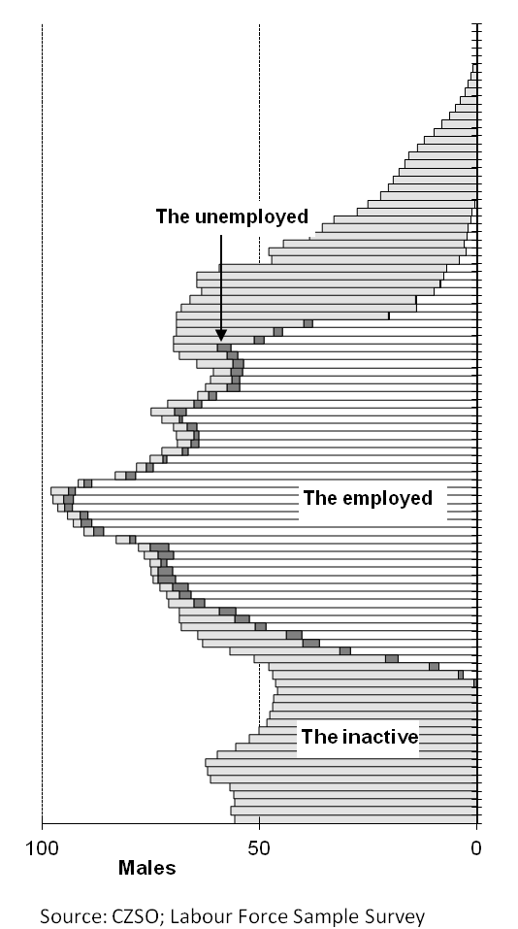 |  |  | 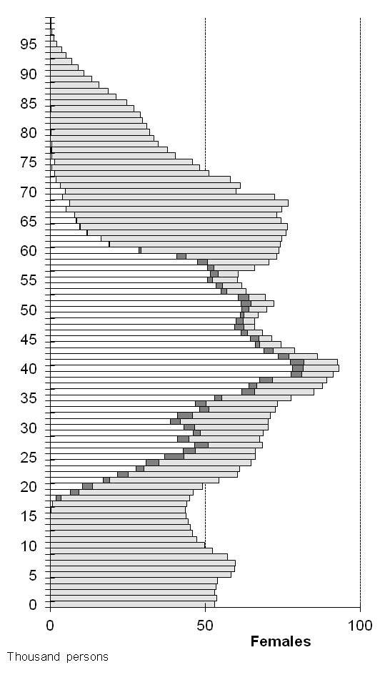

Under the conditions of the Czech Republic, employment is, in an important manner, affected by migration also. In 2014 there were in total 345 thousand of foreign citizens working in the Czech Republic according to an assessment of the Labour Office of the Czech Republic and the register of licensees kept by the Ministry of Industry and Trade. This represent of around 7% of the total employment in the Czech Republic. According to the latest data for 2011 the prevailing majority of these working persons came from Slovakia, Ukraine, and Vietnam. Labour migration may affect the total employment development in next years and it will be structure and professional attainment of migrants which will count.

One of the ways to maintain and further increase employment at a high level of economic activities in groups of middle and elder age seems to be also opportunity of elevated work activities in the young people aged up to 25 years. Our country should get inspired at the neighbours of Germany and Austria or in the Nordic Countries, how to create conditions to employ boys and girls of this age.
Authors
Marta Petráňová, Bohuslav Mejstřík
Unit for Labour Forces, Migration and Equal Opportunities
Czech Statistical Office
Tel.: +(420) 274 054 357; +(420) 274 052 203
E-mail: marta.petranova@czso.cz; bohuslav.mejstrik@czso.cz

