3 February 2015

Average Age of Working Persons Increased by Almost Four Years over Twenty-Five-Year Period
A long-term decline of the employment rate in the youngest productive age since 1993 has been compensated by a growth in the employment rate of persons aged 55 to 64 years. Compared to the leading EU Member States employment in both the groups in the Czech Republic has been still at a lower level.
In 2013 there were in total 4 937 thous. persons working, i.e. 46.9% of the whole population of the Czech Republic. While in the first year of independence of the Czech Republic, in 1993 this share was somewhat higher at 47.2%. Over the period of 1993 through 2013 factors, that affected this share in a contradictory manner, were significantly changing. The number of children under 15 years of age substantially dropped and, simultaneously, the age limit for retirement was increased, on the other hand, unemployment grew, the average life expectancy got prolonged, and the average time of education process was essentially extended.

Not taking into account the pre-productive age component of the population aged from 0 to 14 years and also persons aged 65+ years, then conditions on the labour market are characterised by the general employment rate of the aged 15-64 years (the number of working persons aged 15-64 years to the total number of population aged 15-64 years). A high employment rate was at the beginning of the reference period till 1996 when it was above 69%. Due to the development of conditions on the labour market it was then gradually descending down to 64% in 2004. In the four recent years the employment rate has been growing and in 2013 got close to 68%. According to preliminary data it reached on average for the whole year of 2014 already the level of the initial year 1993 (69%). Significant changes in the employment rate happened mostly in groups of persons of the youngest and elder productive age.

A. Contradictory development in the employment rate in the youngest group and oldest one of the productive age
In 1993 almost one third of persons of the youngest group aged 15-19 years were working; in 2013 there were such persons working at merely just a bit more than 3%. Similarly, the employment rate declined in the group of the aged 20-24 years, that means in the age when a great portion of the young study at tertiary education (by more than a third). The employment rate decreased by a little also in the large group of the aged 25-54 years, in which it was also an effect of an increase in the age of primiparae. Completely opposing trend can be seen in groups of pre-retirement age. The employment rate of females aged 55-59 years increased in a dramatic manner and, at the same time, the employment rate of males of this age grew as well. Compared to the situation twenty years ago younger sexagenarians (aged 60-64 years) work substantially more often as well. Changes in conditions for retirement projected this essential way in females as well as in males. A certain decline in the employment rate of the aged 65+ years is clearly caused by a high increase in the number of persons who attained 70+ years of age. The decline is manifested in an increase in the number of inactive persons.

Employment rate in selected age groups in 1993 and 2013
 |  |  |  |  |  |  | Percentage
 | Age group
 | 15-24 years | of which |  | 25-54 years | 55-59 years | 60-64 years | 65+ years
 |  | 15-19 years | 20-24 years
 | 1993
Total | 46.9 | 31.3 | 65.9 | 86.3 | 46.2 | 17.5 | 5.6
Males | 55.5 | 34.0 | 81.6 | 92.9 | 69.8 | 24.8 | 8.9
Females | 37.9 | 28.5 | 49.4 | 79.7 | 24.9 | 11.4 | 3.7
 | 2013
Total | 25.6 | 3.4 | 42.4 | 83.5 | 73.5 | 30.1 | 5.1
Males | 29.9 | 4.2 | 49.5 | 91.2 | 82.0 | 42.7 | 7.0
Females | 21.0 | 2.5 | 34.9 | 75.5 | 65.3 | 18.6 | 3.7
 | Difference in percentage points (2013/1993)
Total | -21.4 | -27.9 | -23.5 | -2.8 | 27.3 | 12.6 | -0.6
Males | -25.6 | -29.8 | -32.1 | -1.7 | 12.3 | 17.9 | -1.8
Females | -17.0 | -26.0 | -14.5 | -4.2 | 40.4 | 7.2 | -0.0
Source: CZSO - LFSS

These change and the previous demographic development resulted in the fact that relation in between frequencies of working persons of the youngest productive age and the oldest one completely turned around. In 1993 the working persons aged 15-24 years outnumbered the working persons aged 55-64 years two-and-a-half times; twenty years later it was, conversely, the number of working persons in the oldest age group of productive age that was 2.6 times higher than the number of working persons in the youngest ten-year age group of the productive age! Therefore changes in the numbers of working persons in the aforementioned age groups were substantially larger than in the whole age group 25-54 years, in which the number of working persons increased over the period of 1993 through 2013 by almost 100 thousand. The number of working persons aged 65+ years has been affecting total employment just a little so far (91 thous. in 2013 compared to 75 thous. in 1993).

Number of working persons in the Czech Republic in selected age groups in 1993 and 2013
 |  |  |  |  |  | Thousand
 | Age group
 | 15-24 years |  | 25-54 years |  | 55-64 years |  | 65+ years
 | 1993
Total | 778.4 |  | 3704.6 |  | 315.1 |  | 75.4
Males | 470.9 |  | 2000.6 |  | 219.4 |  | 44.6
Females | 307.6 |  | 1704.0 |  | 95.7 |  | 30.8
 | 2013
Total | 293.5 |  | 3802.3 |  | 750.0 |  | 91.2
Males | 175.8 |  | 2126.5 |  | 439.8 |  | 52.0
Females | 117.8 |  | 1675.8 |  | 310.2 |  | 39.2
 | Difference in thousand
Total | -484.9 |  | 97.7 |  | 434.9 |  | 15.8
Males | -295.1 |  | 125.9 |  | 220.4 |  | 7.4
Females | -189.8 |  | -28.2 |  | 214.5 |  | 8.4
Source: CZSO - LFSS

The absolute frequency of working persons of a certain age is significantly affected by shifts in the age structure of the population. It shows all uneven processes in the demographic development since the 1940s till the beginning of this millennium. If sizes of respective age groups of working persons are taken into account then it will be the strong generations born in the 1970s which will be playing the crucial role for total employment level in next years. Therefore it seems to be especially urgent to develop an effective system of lifetime education, which should enable to utilise potential of these persons in the next twenty-five years.

Changes in employment have been manifested in a growing average age of working persons. The average age prolonged by 3.7 years since 1993 and in 2013 attained 42.4 years. The average age of working persons was growing constantly over the whole twenty-year period and in recent years at regular 0.2 year per a year. This just confirmed impacts of demographic development and great changes in the employment rate at the beginning and end of the productive age.

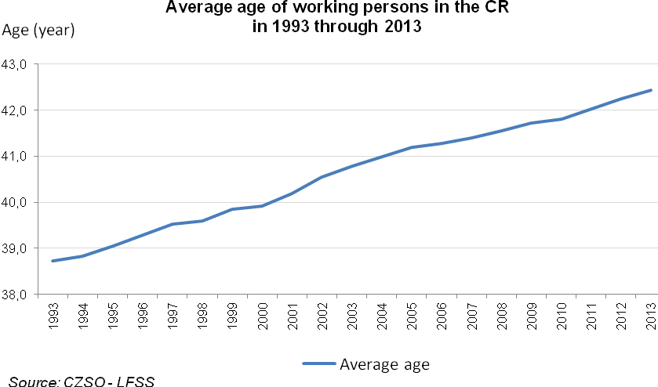

B. Great differences in the employment rate among the EU Member States persist
The Czech Republic is characteristic by economic inactivity of young students at schools of secondary and tertiary education and above-average employment rate at the end of the productive age, following namely from a growth of age limit for retirement. It is just differences in the employment rate of the young and the elder what affects in a substantial manner differences in the total employment among respective EU Member States.

Concerning the age group of 15-24 years, which a vast portion thereof is studying, one third on average of these young persons were working in the EU28. The employment rate in the Czech Republic was under-average at 25.6%. The lowest employment of the young can be found in the whole belt of countries on the South of Europe from Portugal to Romania, lower employment was also in Slovakia and Hungary.

A high employment rate of the young can be found in Germany, Austria, Netherlands, United Kingdom, and in all Nordic countries. In the Netherlands it even exceeded 62%. A high employment rate of the aged 15-24 years can also be found in the EU non-member states as in Norway, Switzerland, and Iceland. Thus differences in the employment rate are fully demonstrated both among the young males and females.

A lower employment rate of the young in the Czech Republic relates to an extraordinary increase in the share of students at secondary and higher schools and universities. A high share of students can, however, be found in all countries where the employment rate of the young reaches highest values. This is confirmed by Eurostat data on the shares of university graduates aged 30-34 years. The difference is that a substantial portion of the young in these countries combines studies and jobs, either for economic reasons or in order to acquire practical experience in the selected study programme.

Employment rate in the age group 15 to 24 years in the EU Member States in 2013
 |  |  |  |  |  |  |  |  | Percentage
Member State | Total |  |  | Males |  |  | Females
 | 15-24 years | of which |  | 15-24 years | of which |  | 15-24 years | of which
 |  | 15-19 years | 20-24 years |  | 15-19 years | 20-24 years |  | 15-19 years |  | 20-24 years
EU28 | 32.3 | 14.8 | 47.8 | 34.1 | 15.4 | 50.8 | 30.4 | 14.2 |  | 44.7
Belgium | 23.6 | 4.9 | 40.6 | 25.3 | 5.3 | 43.7 | 21.9 | 4.4 |  | 37.5
Bulgaria | 21.2 | 3.0 | 34.5 | 24.0 | 3.6 | 38.9 | 18.4 | 2.4 |  | 30.0
Czech Republic | 25.6 | 3.4 | 42.4 | 29.9 | 4.2 | 49.5 | 21.0 | 2.5 |  | 34.9
Denmark | 53.7 | 44.0 | 63.0 | 52.3 | 41.1 | 63.4 | 55.0 | 47.1 |  | 62.6
Germany | 46.8 | 26.6 | 64.3 | 48.3 | 28.3 | 65.6 | 45.2 | 24.7 |  | 62.9
Estonia | 32.4 | 6.5 | 50.7 | 34.0 | 6.1 | 54.0 | 30.7 | 6.9 |  | 47.4
Ireland | 29.0 | 10.4 | 48.9 | 28.5 | 10.0 | 48.5 | 29.6 | 10.8 |  | 49.4
Greece | 11.8 | 2.1 | 22.1 | 14.6 | 3.0 | 26.6 | 9.1 | 1.3 |  | 17.6
Spain | 16.8 | 3.5 | 28.8 | 17.3 | 4.1 | 29.4 | 16.3 | 2.8 |  | 28.2
France | 28.6 | 10.0 | 47.0 | 31.2 | 12.2 | 50.5 | 25.8 | 7.7 |  | 43.4
Croatia | 14.9 | 3.2 | 26.4 | 17.4 | 3.6 | 30.8 | 12.4 | 2.8 |  | 21.7
Italy | 16.3 | 2.7 | 28.8 | 18.8 | 3.3 | 33.0 | 13.7 | 1.9 |  | 24.4
Cyprus | 23.5 | 3.0 | 41.2 | 24.0 | 2.8 | 41.2 | 23.0 | 3.1 |  | 41.1
Latvia | 30.2 | 5.9 | 47.4 | 33.3 | 6.7 | 52.0 | 27.0 | 5.0 |  | 42.5
Lithuania | 24.6 | 3.7 | 42.5 | 27.6 | : | 47.0 | 21.5 | : |  | 37.8
Luxembourg | 21.9 | 8.8 | 35.4 | 24.2 | 10.0 | 39.1 | 19.4 | 7.5 |  | 31.7
Hungary | 19.8 | 2.2 | 34.9 | 22.4 | 2.8 | 39.4 | 17.2 | 1.7 |  | 30.3
Malta | 46.0 | 19.2 | 68.6 | 47.5 | 20.8 | 70.3 | 44.4 | 17.4 |  | 66.9
Netherlands | 62.3 | 52.4 | 71.6 | 61.8 | 51.8 | 71.4 | 62.8 | 53.0 |  | 71.9
Austria | 53.8 | 36.6 | 69.0 | 57.4 | 41.9 | 71.2 | 50.3 | 31.3 |  | 66.8
Poland | 24.2 | 4.2 | 41.0 | 28.6 | 5.2 | 48.3 | 19.5 | 3.2 |  | 33.3
Portugal | 21.7 | 5.8 | 37.1 | 22.9 | 6.6 | 39.0 | 20.4 | 4.9 |  | 35.2
Romania | 23.5 | 7.7 | 35.7 | 27.3 | 8.9 | 41.5 | 19.6 | 6.4 |  | 29.6
Slovenia | 26.5 | 10.4 | 39.7 | 29.7 | 11.8 | 43.7 | 23.0 | 8.9 |  | 35.1
Slovakia | 20.4 | 2.3 | 35.2 | 24.4 | 2.8 | 42.2 | 16.2 | 1.8 |  | 27.9
Finland | 41.5 | 22.8 | 58.8 | 39.1 | 18.4 | 57.4 | 43.9 | 26.9 |  | 60.3
Sweden | 41.7 | 21.0 | 58.9 | 40.5 | 17.8 | 59.6 | 42.9 | 24.5 |  | 58.1
United Kingdom | 46.7 | 26.9 | 63.4 | 46.8 | 25.2 | 65.3 | 46.5 | 28.7 |  | 61.5
Source: Eurostat, Labour Force Survey

Great differences in employment can be observed also in the group of persons of the elder productive age. The employment rate in both the age groups of 55-59 years and 60-64 years is the highest right in the countries featuring a high employment rate of the young, that is in the Nordic countries, Netherlands, United Kingdom, and in Germany. Austria, where effects of a high share of young working persons is in part compensated by a lower employment rate of the elder, forms a certain exemption.

In the Czech Republic there is a very low employment of the young, on one hand, and, on the other hand, the employment rate of the aged 55-64 years is slightly above-average It is, however, above-average merely in males, employment of females of this age group is still bellow the EU average.

Employment rate in the age group 55 to 64 years in the EU Member States in 2013
 |  |  |  |  |  |  |  | Percentage
Member State | Total |  |  | Males |  |  | Females
 | 55-64 years | of which |  | 55-64 years | of which |  | 55-64 years | of which
 |  | 55-59 years | 60-64 years |  | 55-59 years | 60-64 years |  | 55-59 years | 60-64 years
EU28 | 50.2 | 64.8 | 34.5 | 57.5 | 71.8 | 41.9 | 43.3 | 58.1 | 27.6
Belgium | 41.7 | 58.6 | 22.8 | 47.7 | 65.4 | 27.8 | 35.8 | 51.9 | 18.0
Bulgaria | 47.4 | 62.6 | 32.5 | 51.9 | 62.0 | 41.6 | 43.4 | 63.2 | 24.7
Czech Republic | 51.6 | 73.5 | 30.1 | 62.5 | 82.0 | 42.7 | 41.4 | 65.3 | 18.6
Denmark | 61.7 | 77.8 | 44.8 | 66.5 | 80.9 | 51.4 | 56.8 | 74.8 | 38.4
Germany | 63.5 | 75.9 | 49.9 | 69.8 | 80.7 | 57.6 | 57.5 | 71.2 | 42.6
Estonia | 62.6 | 73.8 | 50.6 | 61.4 | 71.6 | 49.9 | 63.6 | 75.7 | 51.2
Ireland | 51.3 | 60.1 | 41.5 | 59.3 | 67.0 | 50.7 | 43.4 | 53.2 | 32.3
Greece | 35.6 | 46.0 | 24.5 | 46.0 | 59.7 | 31.3 | 26.0 | 33.4 | 18.3
Spain | 43.2 | 54.3 | 30.7 | 50.5 | 62.7 | 36.4 | 36.3 | 46.2 | 25.2
France | 45.6 | 67.6 | 23.3 | 48.4 | 71.4 | 24.8 | 43.1 | 64.0 | 21.9
Croatia | 37.8 | 49.3 | 24.9 | 45.0 | 57.1 | 31.2 | 31.0 | 41.9 | 19.2
Italy | 42.7 | 58.7 | 25.9 | 52.9 | 70.4 | 34.2 | 33.1 | 47.5 | 18.1
Cyprus | 49.6 | 62.1 | 36.5 | 61.1 | 72.5 | 49.1 | 38.3 | 51.8 | 24.3
Latvia | 54.8 | 70.4 | 37.8 | 55.2 | 69.2 | 38.7 | 54.6 | 71.3 | 37.1
Lithuania | 53.4 | 67.1 | 37.8 | 56.1 | 68.3 | 41.4 | 51.2 | 66.1 | 35.1
Luxembourg | 40.5 | 54.7 | 22.9 | 48.3 | 63.9 | 28.8 | 32.4 | 45.0 | 16.8
Hungary | 38.5 | 58.4 | 16.0 | 46.2 | 66.1 | 22.2 | 32.3 | 51.8 | 11.3
Malta | 36.3 | 52.6 | 19.7 | 53.9 | 76.0 | 31.1 | 18.7 | 28.9 | 8.5
Netherlands | 60.1 | 71.9 | 47.4 | 70.2 | 80.8 | 58.8 | 50.0 | 63.1 | 36.0
Austria | 44.9 | 63.7 | 23.0 | 54.3 | 73.3 | 31.9 | 36.0 | 54.5 | 14.8
Poland | 40.6 | 55.3 | 24.1 | 51.3 | 64.4 | 36.1 | 31.0 | 46.9 | 13.7
Portugal | 46.9 | 57.4 | 35.8 | 53.5 | 64.3 | 41.9 | 41.0 | 51.2 | 30.3
Romania | 41.5 | 52.8 | 28.8 | 51.5 | 64.7 | 36.4 | 32.7 | 42.1 | 22.3
Slovenia | 33.5 | 47.6 | 16.8 | 41.8 | 57.4 | 23.4 | 25.2 | 37.9 | 10.1
Slovakia | 44.0 | 64.2 | 20.8 | 53.3 | 71.7 | 31.2 | 35.7 | 57.3 | 11.7
Finland | 58.5 | 73.4 | 44.0 | 56.5 | 70.0 | 43.8 | 60.5 | 76.7 | 44.2
Sweden | 73.6 | 81.7 | 65.4 | 76.9 | 84.4 | 69.3 | 70.3 | 79.0 | 61.7
United Kingdom | 59.8 | 72.3 | 46.5 | 66.9 | 77.0 | 56.0 | 53.1 | 67.8 | 37.6
Source: Eurostat, Labour Force Survey

States with a high employment rate of persons in the youngest and elder productive age are simultaneously countries with high economic and social levels. On the contrary, numerous countries with under–average employment at the beginning and end of the productive age face serious issues of economic development.

C. Expected duration of working life varies a lot within the EU
A lower employment rate is in numerous countries affected by high unemployment, especially in the younger productive age. Countries of the South of Europe may serve as a typical example. For this reason Eurostat publishes the indicator of the duration of working life, which takes into account also the cases of jobless persons, when the respondent seeks in an active manner the job and is able to start in a job within a fortnight, at the latest, since the survey date. Therefore the time when the jobless is active on the labour market is also taken into account.

The aforementioned indicator is constructed the way to suit needs of analyses and monitoring of conditions in the labour market in accord with the growth and jobs strategy of Europe 2020. It supplements other indicators and is focused on the whole life cycle of economic activity of persons. Conditions in respective age groups, namely at the beginning and end of the productive age, are better described by the indicator of the general employment rate in these groups.

Methodological note: The indicator of the average expected time of working activities gives the average number of years, for which a persons aged 15 years will be active on the labour market (employed or unemployed, respectively). The indicator is based on demographic data and on data on conditions in the labour market (LFS and LFSS). The calculation also used data from LFS for respective generations of respondents, which are not subject of routine disclosure.

According to the latest data for 2013 differences among countries are high. The duration of working life in Sweden should be by almost eleven years longer than that in Italy. Other countries with longer expected duration of working life are countries having high employment rates in the edge groups of the productive age range and simultaneously having under-average unemployment rates. These are, again, all Nordic states, Netherlands, United Kingdom, and our neighbouring countries of Germany and Austria. The expected duration of working life is the lowest in some of the states in South of Europe, Hungary, and in Poland. It is also interesting that a lower duration of working life can also be found in Belgium and Luxemburg.

Almost in all countries the duration of working life is longer in males than in females. The greatest differences are found in Malta, Italy, and Greece. In general, differences in the expected duration of working life are higher rather in the southern area than in the northern and western areas of Europe. Minimum differences between males and females are in all three Baltic countries; in Lithuania the expected duration of working life is even longer in females than in males.

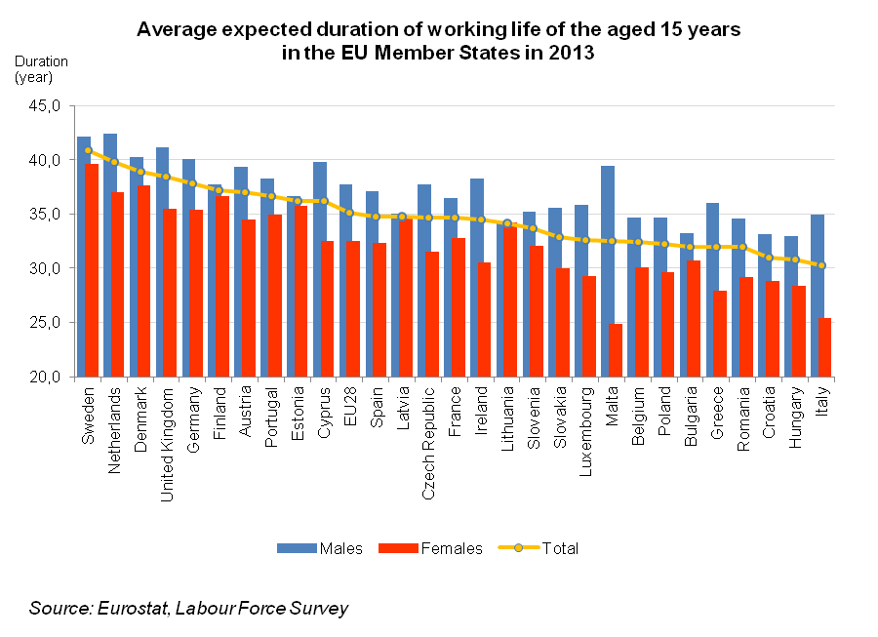

The total duration of working life of the Czech Republic’s fifteen-year old is still shorter than the EU28 average (CR 34.7 years, EU28 35.1 years). While the expected duration of working life of males is identical with the EU28 average, in the group of females it is still shorter than the EU28 average (by 1 year in 2013). It is necessary to take into account that this indicator features a rather intrinsic heterogeneity, the total employment rate in the group of aged 15-64 years in the Czech Republic is above average yet the unemployment rate is one of the lowest in all Member States.
Authors
Marta Petráňová, Bohuslav Mejstřík
Unit for Labour Forces, Migration and Equal Opportunities
Czech Statistical Office
Tel.: +420 274 054 357; +420 274 052 203
E-mail: marta.petranova@czso.cz; bohuslav.mejstrik@czso.cz

