4 December 2015

Commentary: Labour Market Development in Q3 2015
Development on the Czech labour market in Q3 2015 was very positive. According to results of the Labour Force Sample Survey (LFSS) of the Czech Statistical Office (CZSO) performed in households total employment increased to 5 060.3 thousand persons; the employment rate of the aged 15-64 years (70.5%) reached the highest level in the Czech Republic history. Preliminary results of business statistics performed by the CZSO, which monitors the number of registered employees, has been showing a continuous economic recovery. In the field of wages effects of a lack of qualified labour force became to be manifested when the average nominal wage grew by 3.8% which was the highest increases since 2009.

Results of the LFSS have been indicating a permanent growth of total employment since 2012. What is also positive is the fact that that the growth in the employment rate was more pronounced in females (by 1.8%, year-on-year) then in males (0.6%, y-o-y), because it is right the females in which the Czech national economy has still a significant hidden reserve. The prolongation of a professional carrier has been leading to a more accelerated increase in employment in persons aged 50+ years compared to younger generations.

What is, moreover, apparent is the decline in the number of the unemployed has been ongoing and the number of job vacancies reported to labour offices has been growing rapidly. If viewed from the year-on-year comparison perspective the results seem very optimistic despite a certain deceleration has occurred. The general unemployment rate according to the LFSS in Q3 2015 fell below 5 per cent and, namely in males, it has been probably nearing to its natural limit.

The hard-to-employ persons, however, have been still in the position of the unemployed who cannot reach the job positions offered. They may often remain unemployed for years and thus the share of the long-term unemployed has already moved close to one half of all the unemployed.

Preliminary data of the business statistics performed by the CZSO have confirmed the prevailing positive trends, namely the growth in the number of registered employees. In Q3 2015, compared to the same period of 2014, there were by 61.5 thousand full-time equivalent employees more, which means a growth by 1.6%.

Various sections of the economy, however, participate in the recovery in different manners. The mining and quarrying activities, for instance, has been still affected by layoffs and in Q3 2015 there was a decrease in the number of employees in these activities again, this time by 1.2 thousand persons, which is -3.8%, year-on-year. The water supply; sewerage, waste management and remediation activities also lost one hundred occupied jobs, which is a drop by 0.2%, y-o-y. A year-on-year decline by 3.6 thousand employees (-1.7%) can be found in construction and also the number of employees in accommodation and food service activities fell by one thousand i.e. -0.9%, y-o-y again.

The highest increase in terms of number was recorded in manufacturing, by 31.0 thousand persons, which means +2.9%, y-o-y in a relative expression value. The wholesale and retail trade; repair of motor vehicles and motorcycles activities were growing in a significant manner by 7.9 thousand persons, which means +1.6%, y-o-y in a relative expression value. A growth in the number of employees in the real estate activities (+5.3%, y-o-y) is probably connected to the expansion of financial services of real estate agencies. The administrative and support service activities also saw a substantial increase in the number of full-time equivalent employees by 5 thousand persons (+3.0%, y-o-y), in connection with an increase in the number of employees of labour agencies.

The number of jobs in agriculture, forestry and fishing remained the same as a year ago. In the public administration and defence; compulsory social security activities the number of employees grew by 5.7 thousand persons, which means is +2.0%, y-o-y in a relative expression value. Here it is municipalities which has been contributing most due to employment for public benefit works that resulted in almost 2.2 thousand new jobs.

Concerning wages the moderation, that has been typical for this trend so far, became to crumble. The average wage increased nominally by 3.8% yet this time it was not the non-business sphere, which was leading the pack, yet the business sphere driven by market forces. It can be expected it was right the lack of qualified workers which has forced businesses to play harder on the labour market, to headhunt employees using poaching and offers of higher pays.

It is seen in the graph below that development in the business sphere is usually more varied in most cases affected by extraordinary bonuses and premiums. It can also be seen that in previous quarters the non-business sphere was dominated by effects of salary tariff rise so the year-on-year increment in the non-business sphere temporarily surpassed that in the business sphere.

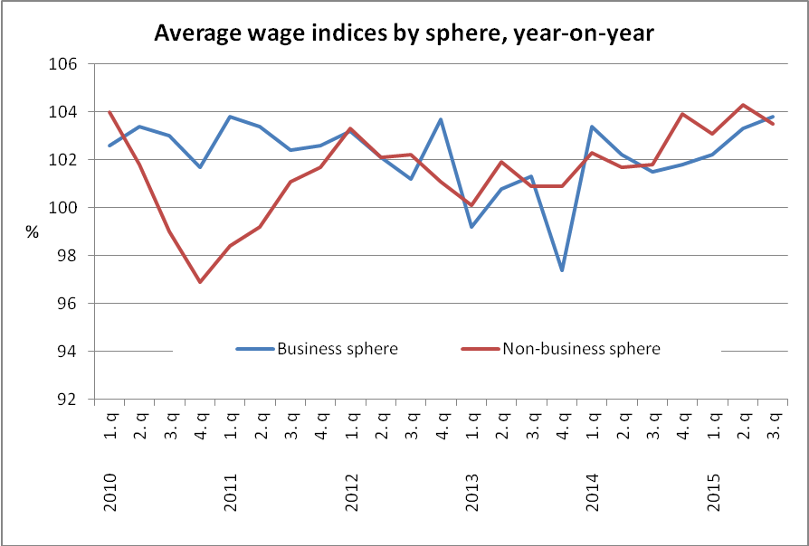
Source: Business statistics of the CZSO

It is necessary to make comparison with a consumer price index (inflation) in order to get the total real purchasing power. The consumer price index in Q3 2015 was at a relatively low level of 0.4%. This, at the aforementioned nominal wage, led to a significant real growth in purchasing power by 3.4%.

In Q3 2015 the average wage in the business sphere increased nominally by 3.8% and by 3.4% in real terms, y-o-y. In the non-business sphere the average ware grew nominally by 3.5% and by 3.1% in real terms, y-o-y.

Respective sections of CZ-NACE also showed rather differentiated developments in wages. There was only one section that saw a decrease in the average wage. All other sections enjoyed a growth in the average wage yet at varied pace. Thus nominal indices were from 99% in the electricity, gas, steam and air conditioning supply to 107.4% in the accommodation and food service activities, which has nevertheless remained the section of economic activities with the lowest level of the average wage.

Among industrial activities the major workhorse of the Czech economy, manufacturing, employing 1 101.5 thousand persons, was doing well and the average wage in manufacturing increased by 3.7%. In the wholesale and retail trade; repair of motor vehicles and motorcycles activities, with almost a half a million employees, the average wage increased by 3.6%. In economic activities dominated by state-owned companies the highest increase in wages (+5.6%) was recorded in the human health and social work activities and then in public administration and defence; compulsory social security (+4.1%). The lowest increase (+1.6%) was in education.

In Q3 2015 the growth in the average wage was highest in the Jihočeský Region (4.7%) followed closely by the Karlovarský Region (4.6%). Conversely, in the Capital City of Prague the increase was the lowest (2.9%) again. A sole region saw a decline in the number of employees – the Karlovarský Region (-0.9%); in other regions the numbers of employees were growing, most significantly in the Olomoucký Region (+2.7%), then in the Capital City of Prague and in the Středočeský Region (identically by 2.4%).

An interesting additional piece of information on the business sphere can be an increase in pay for overtime work, which in Q3 2015 showed almost in every group of economic activities, except for agriculture, yet most in trade followed by construction. The share of extraordinary bonuses grew most in these activities as well. Employers try to compensate the lacking labour force by means of overtime work.
The number of hours worked per employee slightly declined year-on-year, on the contrary the number of not-worked (paid) hours increased due to higher temporary incapacity for disease or injury.

The News Release contains also data on the median wage, which is calculated from a mathematical model of the earnings distribution. The model shows the wage of a middle employee that means a common wage level. In Q3 2015 the median wage was CZK 25 531, by CZK 855 (+3.9%) higher than in the same period of the previous year. This way the wage level of the middle employee grew roughly at the same pace as the arithmetic average of earnings.
The wage interval, cut for ten per cent edges, remained wide: 80% of employees earned from CZK 11 145 to CZK 41 753. Concerning sexes, the wage level in males is significantly higher than that in females - in Q3 2015 the female median wage was CZK 20 014 while the male one was CZK 24 759. Low pays were growing at faster pace than the high ones which may be a result of the state policy of the minimum wage increase.

Author: Dalibor Holý
Labour Market and Equal Opportunities Statistics Department of the CZSO
Tel.: +(420) 274 052 694
E-mail: dalibor.holy@czso.cz

