11 March 2016

Commentary on the Labour Market Development
in Q4 2015
Statistical results for Q4 2015 and for the whole year 2015 demonstrate there is a certain peak on the Czech labour market. Data of the Labour Force Sample Survey (LFSS) in households have brought record-breaking values of the employment rate and, at the same time, the unemployment rate dropped to a level close to the lowest values of the pre-crisis year 2008. The number of vacant jobs reported to the Labour Office of the Czech Republic surpassed the one-hundred-thousand limit as early as in Q3 2015. Results of the Czech Statistical Office business statistics also indicate an important increase in the registered number of employees accompanied with a growing average wage as the lack of labour force happens in some industries.

Results of the LFSS show a permanent increase in employment. In Q4 2015 alone the employment rate in the aged 15-64 years reached the value of 70.8%, which the next record level in history of the independent Czech Republic. The employment growth in males was one percentage point (p.p.) and in females it increased by even 1.1 p.p., year-on-year.

The second side is the declining number of the unemployed. There was a continuing positive trend in it as well, when in the closing period of 2015 the general unemployment rate dropped to 4.5%, which is one of the lowest values in the European Union if compared internationally. Yet the unemployment rate values have still been significantly higher in females and in persons under 25 years of age. The values are also sharply differentiated by educational attainment – while the unemployment rate in university graduates was mere 2.3%, in persons with primary education it was ten times higher (22.8%).

The share of the long-term unemployed persons, that is those that have been unemployed over one year, slightly increased to 48.5% in Q4 2015, even though their absolute number was decreasing. This means that this stock of harder to employed labour force has been utilised as the number of vacant jobs is growing, yet at a lower intensity. Besides approx. 115 thousands of the long-term unemployed, there are still roughly 130 thousand persons, who are classified as economically inactive, yet they state they would like to work. Majority of them, however, is not able to join a job under the current conditions; these are often mothers with little children.

Preliminary data of the business statistics performed by the CZSO have confirmed the prevailing positive trends as follows: the number of registered employees (full-time equivalent - FTE) grew by 1.8% in Q4 2015, compared to the same period of the previous year, and it is by 69 thousand more in number.

What is important is the growing demand for labour force pressed for earnings growth. The whole year nominal growth of the average wage (3.4%) was in the last year, moreover, confronted with solely a minimum increase in consumer prices i.e. inflation (0.3%). This led to a significant increase in the real purchasing power of wages, which grew by 3.1% over the whole year 2015, that is the highest value since 2007. These circumstances got even stronger in Q4 2015 when the average wage increased by 3.9% nominally and by 3.8% in real terms, compared to the same period of the previous year, because inflation grew by mere 0.1%.

It was government which gave the important impulse for the recent development. In the non-business sphere, which in the current practice of the Czech Statistical Office has been defined using the ESA 1995 methodology for the national accounts compiling as the general government and non-profit institutions serving households, wages in the whole year 2015 grew by 3.5% on average, in the business sphere they grew by 3.3%. It is necessary to draw your attention to the fact that wages in the non-business sphere were acting as a brake to the overall wage development for a long time. In the period from 2010 to 2013 the average wages in the public sector were even decreasing in real terms. The sectors became, on the contrary, an impulse for a faster growth in Q4 2014 when the average wage grew by 3.9% nominally due to the Government decision on an increase of wage levels. In the business sphere, the average wage increased by mere 1.8% nominally in the same quarter. Thus still in the first half of 2015 both the average wage indices in the non-business sphere were higher than those in the business sphere, yet in the second half of 2015 the business sphere was already growing at a faster pace. In sole Q4 2015 wages in the non-business sphere grew by 3.7% and wages in the business sphere increased by 3.9%, both nominally.

The long-term time series trend reveals that since the century beginning the pace of the growth of earnings was decreasing and decreasing and then, in 2012 and 2013, earnings even decreased in real terms. This adverse development was reversed in 2014. In the course of 2015 the real purchasing power of earnings got back to the level of 2011 and subsequently surpassed it.

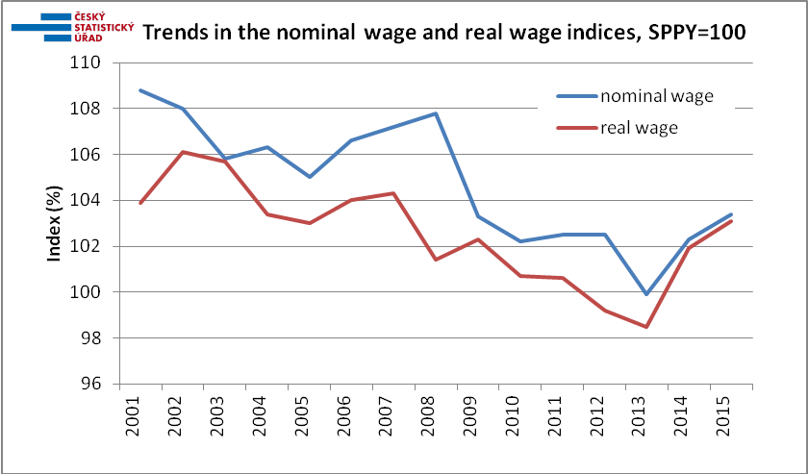

Trends in respective sectors of the economy have been varied and the same holds for the economic activity viewpoints. Mining and quarrying, and especially this activity dominating coal mining and treatment, which is affected by layoffs and earnings decline, arrived in a troublesome position – in the very end of 2015 there was a decrease in the number of employees by 1.4 thousand, which is by 7.0%, and the average wage fell by 0.4%. Agriculture, forestry and fishing saw a drop by 650 employees and the average wage fell by 0.3%.

Construction, after a long crisis, has been still staggering and saw a decline in the number of employees by about 2 000. On the other hand, wages in construction grew significantly, especially in buildings, and it was, first of all, extraordinary bonuses, which increased.

Accommodation and food service activities underwent a similar development and in Q4 2015 lost almost 5000 jobs (-0.5%), year-on-year, while the average wage there increased most of all sections of the CZ-NACE (+7.4%).

Manufacturing was in a perfect shape yet even in it there are certain industries showing better results and other ones worse. The best conditions were in the automotive industry (manufacture of motor vehicles, excluding motorcycles, trailers and semi-trailers), which in Q4 2015 saw the most significant increase by number, +11.5 thousand employees, which is the relative increase by 7.8%, and ,at the same time, the average wage in this activity grew by 4.4%. Over five-percent increase can be found also in the manufacture of computer, electronic and optical products and then in the manufacture of rubber and plastic products. The manufacture of food products was the only industry, in which the number of employees recorded a minute decline. Average wages grew namely in activities, in which they were at a low level, as, for instance, in manufacture of leather and related products where the average wage increased from CZK 16 814 to CZK 18 252, in manufacture of furniture from CZK 19 783 to CZK 21 256, etc., which may indicate a “driving effect” of the minimum wage rise.

The sector of services also showed mostly satisfactory values. Land transport, for example, has been flourishing. There were over three thousand jobs created and simultaneous wage increase by 5.9% in warehousing and support activities for transportation. Information and communication enjoyed a great boom with almost one thousand more employees, that is one tenth of the previous number, and wages grew by 8.3%.

The boom of employment agencies (activities of employment placement agencies), which number of employees grew by over nine thousand (+13.4%) and simultaneously the average wage in the industry increased by 6.1% cannot be overlooked as well. Finally, we can mention an increase in earnings in gambling and betting activities, in which the average wage rose by 9.5% at a simultaneous increase in the number of employees by 1.7%.

In Q4 2015 the year-on-year growth in the average wage was highest in the Středočeský Region (+4.7%) and was also high in the Plzeňský Region (+4.6%), then in the North-West, i.e. in the Ústecký and Karlovarský Regions (identically +4.2%). Conversely, a low wage increase was this time found in the Olomoucký Region (+3.1%) and in the Moravskoslezský Region (+3.3%).

The view from the number of registered employees is different when it was right the Olomoucký Region where the increase in the number of employees was the highest (+2.8%), followed by the Capital City of Prague (2.7%). The sole region that saw a decline in the number of employees was the Karlovarský Region (-0.5%).

The News Release contains also data on the median wage, which is calculated from a mathematical model of the earnings distribution. The model shows the wage of a middle employee that means a common wage level. In Q4 2015 the median wage was CZK 23 745, by CZK 1 206 (+5.4%) higher than in the same period of the previous year. This way the wage level of the middle employee grew more than the arithmetic average of earnings which may indicate the highest earnings are relatively declining.
The wage interval, however, remained wide: 80% of employees earned from CZK 11 226 to CZK 45 830. The year-on-year development shows the highest relative increases in wages occurred in the middle zone of the earnings distribution, and, on the contrary, the tenth of the highest wages demonstrated the slowest growth. Concerning sexes, the wage increase was rather more pronounced in females whose wage level is, however, significantly lower. In Q4 2015 the male median wage was CZK 26 156 while the female one was mere CZK 21 066 and over a quarter of females earned gross wages below CZK 15 000.

* * *

Viewed from the perspective of the whole year 2015 and a longer economic development it is interesting how scissors in between the poor activities and the rich ones has been currently closing. Although a great advancement of the wage level in information and communication and in financial and insurance activities remains, year-on-year indices of these activities were below average (2.1% and 1.1%, respectively). Electricity, gas, steam and air conditioning supply, which feature the third highest average wage, even seen a nominal decrease by 0.5%. Conversely, the lowest average wages in accommodation and food service activities grew at the fastest pace (by 6.6%) and those in administrative and support service activities were also growing fast (by 4.0%), while having the last but one lowest average wage. Wages also grew strong in construction and in human health and social work activities (by 4.9% identically). A similar effect of diminishing the differences has been for a longer term noticed in the breakdown by region as well, when wages in the richest Prague Region have been growing significantly slower.

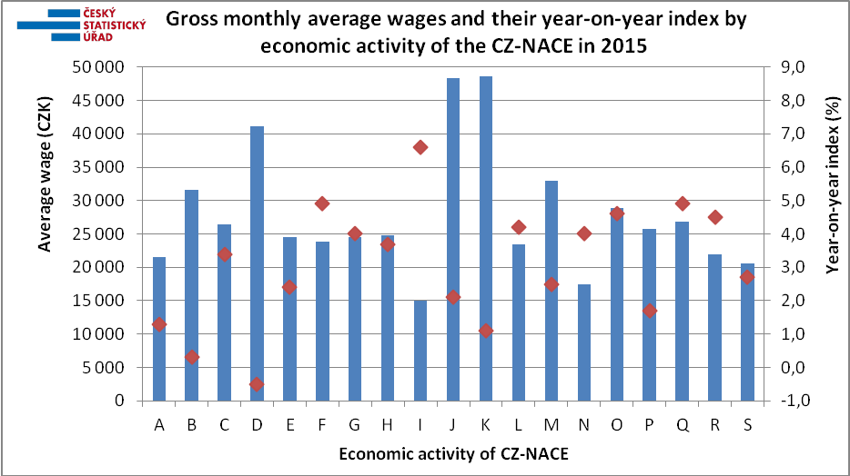

A | Agriculture, forestry and fishing | K | Financial and insurance activities
B | Mining and quarrying | L | Real estate activities
C | Manufacturing | M | Professional, scientific and technical activities
D | Electricity, gas, steam and air conditioning supply | N | Administrative and support service activities
E | Water supply; sewerage, waste management and remediation activities | O | Public administration and defence; compulsory social security
F | Construction | P | Education
G | Wholesale and retail trade; repair of motor vehicles and motorcycles | Q | Human health and social work activities
H | Transportation and storage | R | Arts, entertainment and recreation
I | Accommodation and food service activities | S | Other service activities
J | Information and communication

Author: Dalibor Holý
Labour Market and Equal Opportunities Statistics Department of the CZSO
Tel.: +(420) 274 052 694
E-mail: dalibor.holy@czso.cz

