11 March 2015

Commentary: Labour Market Development in Q4 2014
Results of statistics for Q4 2014 and for the whole year 2014 demonstrate continuing recovery of the labour market. Data of the Labour Force Sample Survey (LFSS) in households have brought record-breaking values of the employment rate. The unemployment rate significantly declined as well; nevertheless, it has still been far from the values for 2008. Results of the CZSO business statistics indicate a substantial growth in the registered number of employees. The growth of the average gross monthly nominal wages has been falling behind the trend yet there has been an agreeable increase in the income purchasing power due to low inflation. The recovery has still been rather shown in employment than in the wage growth. There are only certain specific activities in which demand for labour force is so considerable that it is pressing on price of labour as well.

Results of the Labour Force Sample Survey (LFSS) indicate a permanent growth of total employment. One-and-a-half per cent growth in the employment rate in Q4 2015 itself brought the employment rate value to a record-breaking level for the whole period of the existence of the Czech Republic (69.8%). There was an increase in employment both in males and in females, and in vast majority of categories of employees as well, therefore it was a blanket growth.
A decreasing number of the unemployed is the other side of the trend. The general unemployment rate in final period of 2014 dropped down to 5.8%, it has been, however, still sharply differentiated by educational attainment – while university graduates boast the unemployment rate of mere 2.6%, it reaches 21.7% in persons with elementary education. The share of the long-term unemployed, i.e. those unemployed for over one year, slightly grew to 46.2%, which shows a structural imbalance in between demand and supply of labour force while the number of vacant jobs has been growing. Therefore there is a certain group of persons in the population, who are hard to get employed and often remain unemployed for long years, because they lack competencies required for getting the vacant positions offered.

Preliminary data from business statistics also confirm the prevailing positive trends. Even in 2013 there was a decline in the average registered number of employees converted into FTE by 1.2%. The year 2014 was the time of a positive reversal, in the Q4 2014 the aforementioned number grew by whole one per cent, which, expressed in numbers, means by 39 thousand occupied jobs more.
Respective sections of the economy have been, however, showing different trends. For example, mining and quarrying has been suffering from employees lay-offs – they were reduced by 1.1 thousand (-3.5%) in the end of 2014. Construction has still not got out of a long-term recession and in Q4 2014 saw a year-on-year (y-o-y) decline by 6.2 thousand (-2.9%); in accommodation and food service activities there were four thousand jobs (-3.8%) lost.
On the other hand, manufacturing demonstrated the most important increases in terms of number by 22.3 thousand (+2.1%) in Q4 2014. In the end of 2014 a rapid growth in the number of employees in real estate activities (+1.7%), related to an expansion of financial services of real estate agencies, was slightly dampened. The number of FTE employees in administrative and support service activities significantly grew by 10.4 thousand (+6.7%), which was tied to an increase in the number of employees of labour agencies.
Over three hundred jobs emerged in agriculture, forestry and fishing. Public administration and defence; compulsory social security saw an increase in the number of employees by 4.1 thousand, y-o-y (+1.5%). The growth in the latter was due to increased capacities of labour offices dedicated to combat unemployment where 1 304 jobs were created y-o-y.

Concerning wages in Q4 2014 they were moderate as it was typical for the whole previous year. Results at the beginning of the year (nominal growth by 3.3%) were still affected by the influence of pre-paid managerial bonuses from the end of 2012, which brought an incomparable basis. Otherwise increases, compared to the same period of the previous year, were oscillating around two per cent.
It is important, that whole-year nominal growth in the last year (2.4%) was confronted with a minimum increase in consumer prises, inflation (0.4%). This fact led to a real increase in purchasing power of wages, which grew by 2.0% over the whole year, the highest growth since 2009, even though wage increases were weaker.
This was maintained in Q4 2014 when average wages grew by 2.3% nominally and by 1.8% in real terms, compared to the same period of the previous year. At the end of the year the non-business sphere development diverged from that of the commercial sphere because of a Government decision to raise salary tariffs. Thus salaries in the non-business sphere had been acting as an impediment to wage development for a long time, in 2010 through 2013 salaries in the public sector were continuously declining in real terms, in Q4 2014 they conversely became a stimulus for a faster growth because the average salary grew by 3.8%, which is 3.3% in real terms when inflation is deduced. In the same period the average wage in the business sphere increased nominally by 1.9% and by 1.4% in real terms. Year-on-year increases for the whole year 2014 are, however, still identical for both the spheres – 2.4% nominally and 2.0% in real terms.

In respective activity aggregates (CZ-NACE sections) the wage development in Q4 2014 was substantially differentiated. Nominal increases were from the deeply negative value for mining and quarrying (-5.9%) to five-per-cent growth in public administration and defence; compulsory social security, where the aforementioned increase in salary tariffs brought its effect. More significant drops of average wages can be found, besides the coal mining suffering from phasing out, also in certain activities of market services, especially in labour agencies, travel agencies and security agencies, in insurance companies, and in certain financial consulting activities.
Industrial activities were, on the contrary, doing quite well. In the main motor of the Czech economy, manufacturing, which gives jobs to 1 075 thousand employees, the average wage increased by 3.2%. It was, first of all, employees in casting of metals, manufacture of computer, electronic and optical products, manufacture of machinery and equipment, but also in manufacture of food products, who got better pay.

If viewed over a long term, it is clear (see the graph below), that the fastest growth in wages is in information and communication, which in the last two years almost caught financial and insurance activities. A smaller industrial activity of electricity, gas, steam and air conditioning supply, in which wages have grown by 124% since 2000 while the overall average wage grew by 94%, experienced the highest increase in average wages at all. In absolute figures this activity, however, stays at a distance from the leading double.

In the three activities with the lowest pays there was an interesting development and even their order has changed as well. In 2000 agriculture, forestry and fishing were last but one the worst, administrative and support service activities occupied the rank up, and the worst wages were in accommodation and food service activities. Over the years, wages in administrative and support service activities, dominated by labour agencies, have dropped relatively. They increased the least of all activity sections of the CZ-NACE, just by mere 60%. On the contrary, agriculture, forestry and fishing experienced an above-standard growth when the activities’ wages more than doubled (by 102%).

Graph: Long-term development in average wages in selected economic activities
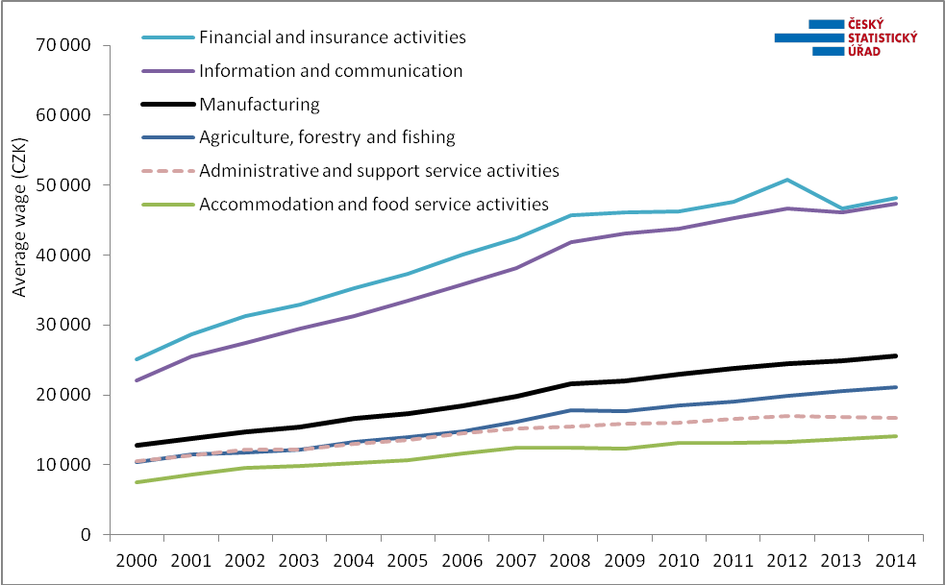
Source: CZSO wage survey

An interesting additional piece of information on increasing demand for labour force in enterprises can be the almost five per cent year-on-year growth of overtime work, which in Q4 2014 showed namely in trade and market services. The four-per-cent growth of extraordinary bonuses in the business sphere compared to the same period of the previous year can also tell a lot. The bonuses were growing faster than common wages, especially in trade; there was no activity experiencing their decline.

The News Release contains also data on the median wage, which is calculated from a mathematical model of the earnings distribution. The model shows the wage of a middle employee that means a common wage level. In Q4 2014 the median wage was CZK 22 847, by CZK 585 (+2.6%) higher than in the same period of the previous year. This way the wage level of the middle employee grew somewhat more than an arithmetic average, which may indicate a relative reduction of extremely high earnings.
The wage interval remained very wide: 80% of employees earned from CZK 10 684 to CZK 44 223. The year-on-year development demonstrates there are higher relative increases in wages in the middle of the span, conversely, the lowest wages were growing the slowest way. Concerning sexes, increases in wages were more pronounced in females, whose wage level, however, is substantially lower. In Q4 2014 the female median wage was CZK 20 552 while the male one was CZK 24 847.

In Q4 2014 the growth in the average wage was highest in the Vysočina Region (4.1%) and there was high in other regions as well. In the Liberecký Region wages grew y-o-y by 3.8%, in the Pardubický Region by 3.7%, in the Jihočeský Region and Zlínský Region identically by 3.6%; conversely, in the Capital City of Prague the increase was the lowest again (0.5%). A sole region saw a decline in the number of employees – the Karlovarský Region (-0.7%); in other regions the numbers of employees were growing, most significantly in the Capital City of Prague and in the Středočeský Region (identically by 1.4%).

Author: Dalibor Holý
Labour Market and Equal Opportunities Statistics Department of the CZSO
Tel.: +(420) 274 052 694
E-mail: dalibor.holy@czso.cz

